Social Life
(Key Stage 1)

Points to note: Promotion of sex education in schools is not to encourage premature love affairs or premarital sexual relationship of students. On the contrary, we expect teachers can take a prudent and objective attitude, be open-minded and listen carefully to understand the needs or problems of their students, so as to help them discuss sexuality issues with a responsible attitude.

Learning Objectives:
- To help students recognise their own feelings, as well as identify kind and unkind body touches by others
- To identify different means of sexual abuse and learn to stop the unkind touches appropriately
- To know that abuser can be a stranger or someone they know, or even someone who is close to them. To raise students’ awareness of sexual abuse so that they can learn how to protect themselves
Life-Event Exemplar: Protect Ourselves, Disclose the Secret
(Prevention of Sexual Child Abuse)
Values & Attitudes:
Respect, Self-regards, Self-protection

Learning Materials:
- Animation: “Protect Ourselves, Disclose the Secret” (Please refer to the animation file)
- Appendix I: “Protect Ourselves, Disclose the Secret” Animation Summary and Discussion Questions
- Appendix II: Reference for Teacher “Protect Ourselves, Disclose the Secret”
- Appendix III: Worksheet “How do I feel – Kind or unkind Touches?”
- Appendix IV: Worksheet “The Sugar-coated poison”
- Appendix V: “Sequel writing” scenario cards
- A3 paper

Procedures:

Procedures (for reference) | Key Learning Points
Activity 1: How do I feel – Kind or Unkind Touches?  - Let students watch the animation “Protect Ourselves, Disclose the Secret” Scene 1 and 2a. (Appendix I)  - Give each student a Worksheet: “How do I feel—Kind or unkind Touches?” (Appendix III) and explain the terms on feelings in accordance with students’ language ability. Discuss with students the feelings of the characters in different scenarios. Regarding students’ answers, bring out the ways to distinguish between kind and unkind body touches. (Appendix II) | - Encourage students to trust their own feelings, and learn to distinguish between kind and unkind body touches.  - To express our own feelings in proper ways, stopping improper touches / sexual abuse from others.
Activity 2: “The Sugar-coated poison”  - Let students watch the animation “Protect Ourselves, Disclose the Secret” Scene 2b. (Appendix I)  - Divide the class into groups of 3-4 to work on the Worksheet: “The Sugar-coated poison” (Appendix IV). Guide students to discuss the methods, tricks and excuses used by Kwong in the animation and write down keys points and suggested responses on the worksheet. Teacher can suggest some key terms in accordance with students’ language ability if necessary.  - Invite students to share their works. Teacher can respond to the answer made by each group to highlight different means abusers may employ, and remind students about the important things they should know when rejecting the abusers. (Appendix II) | - Abusers may use different excuses or means to deceive or lure children into sexual abuse trap. We should bravely reject the improper touches no matter whether it is from a stranger or known person.
Activity 3: Sequel writing “Protect Ourselves, Disclose the Secret”  - The whole class watches the animation of “Protect Ourselves, Disclose the Secret” Scene 3. (Appendix I)  - Each group picks one scenario card (Appendix V), discuss and design the ending of the story, and express it using words or drawings.  - Teacher can invite each group to extend the story, and point out the importance of trusting their own feelings and seeking help if being sexually abused by familiar people according to students’ answers. (Appendix II) | - It is not children’s fault to be sexually abused, and children should not keep it as a secret for the abuser. Take the courage to tell a trusted adult, or more than one, until there is someone who believes you and helps you.

Teacher’s conclusions: (for reference only)

- When we are learning how to protect ourselves, we will learn about the private body parts no one should easily touch or see. We also have to learn how to differentiate between kind and unkind body touches. We have to trust our own feelings as our sense can help us tell whether it is a kind or unkind body touch. When we get along with others, any behaviour that makes us feel uncomfortable, anxious, fearful, disgusted and want to stop may be considered as an unkind touch no matter if it involves both parties’ private body parts. In this case, we should request the person to stop the action bravely no matter if you know that person or not.

- Sometimes, others may try to tease you, saying that you are chicken-hearted, too shy, or not friendly enough to them. They may try to rationalise their behaviour in order to request you to accept them. We do not need to believe in such sayings. We should be clear that we are the owner of our own bodies. We have the responsibilities and rights to protect ourselves, rejecting any abusing behaviour from others. We can leave right away when needed, and seek help from a trusted adult. Mutual respect is a very important element when we get along with others. No one has the right to force us to accept unwanted behaviour from others.

- In real cases, abusers may not be strangers. They may be someone victims know, or even are familiar with. However, only very few of adults or elder boys and girls in society will abuse children. The majority of adults around them would take care of them and therefore they don’t need to lose faith in them!

- Not all body touches are sexual abuse. We should raise our awareness but there is no need to be too sensitive to others. Sometimes, our parents or relatives may use more intimate body touches, like a hug or a kiss, to express their love or intimacy towards us. If we do not like the touches, there is no need to be over reacting. Instead, we can express our feelings frankly and ask them to use some ways more acceptable to us, such as touching our shoulder gently or praising us personally. We do not need to be too worried as long as we can raise our awareness in daily contact with others, knowing how to express our feelings and refusing unnecessary body touches. We should also talk to a trusted adult whenever we are confused or not so sure about it.

Appendix I
“Protect Ourselves, Disclose the Secret”
Animation Summary and Discussion Questions

Theme: Prevention of sexual child abuse

Scene 1 (Housing estate)

Chi (a primary student) and Mrs Cheung (mum) meet their neighbour, Kwong (a University student), near their home. Mrs Cheung suggests Chi ask Kwong to help him with homework. At first Chi shows no interest, but then Kwong manages to entice him with toys to accept his instruction.

Scene 2a (Kwong’s home)

When Kwong is tutoring Chi in homework. Kwong leans forward and touches Chi’s body. Chi backs away from Kwong immediately. Kwong says he is just for fun.

Discussion Questions:
  - What do you think Chi feels about Kwong’s behaviour?
  - Do you think that was a kind touch or an unkind touch?

Scene 2b (at Kwong’s home)

Kwong takes out the latest toys to entice Chi when Chi is doing homework. Kwong asks Chi to take off his clothes to help him finish an assignment and keep secret if he wants to play the toys. Chi hesitates about it.

Discussion Questions:
- What did Kwong do to coax Chi into his request?
- How should Chi react?

Scene 3 (Chi’s home)

Chi looks dazed when doing his homework at home. His mom suggests he ask Kwong for help. Chi refuses. His mom urges him to find Kwong. Chi does not know what to do, recalling what Kwong has done after he took off his clothes.
Appendix II
Reference for Teacher
"Protect Ourselves, Disclose the Secrets"

Differentiate between kind and unkind body touches
- When students are taught to protect themselves, they should learn about the private body parts no one should easily touch or see. Apart from these, they should learn to trust their own feelings in order to differentiate between kind and unkind body touches. When we get along with others, any behaviour that makes us feel anxious, uncomfortable, fearful, disgusted and want to stop may be considered as a unkind touch no matter if it involves touching of private body parts or not. In this case, we should express our feelings, request the person to stop that action, and choose to leave or seek help from a trusted adult when necessary.

- Abusers may make use of children's weaknesses or different means or excuses to sexually abuse them. Therefore, students must be alert, understand the responsibility and rights to protect themselves, and reject any abusing behaviour from others. They can leave right away and seek help from a trusted adult. Mutual respect is a very important element when they get along with others. No one has the right to force us to accept unwanted behaviour from others.

- To avoid causing children excessive fears for the topic of sexual abuse, or making them too sensitive when getting along with others, teachers can explain that only very few of the adults or elder boys and girls in society will abuse children. The majority of adults around them would take good care of them so they don’t need to lose faith in everyone! Sometimes, parents or relatives may use more intimate body touches, like a hug or a kiss, to express their love or intimacy towards us. These are not unkind touches. However, if we don’t like the touches, we can express our feelings frankly, and politely ask them to use some ways more acceptable to us, such as touching our shoulders gently or praising our personalities.

- It may be confusing to some students whose parents or caregivers used to touch their private body parts when helping them bath or clean their bodies after they go to the toilet. Teachers can explain that when the younger children are unable to take care of themselves, parents or caregivers may have intimate body touches with them according to actual needs, which should not be regarded as sexual harassment. However, teachers can also remind students to look after themselves when they have grown up and avoid unnecessary intimate body touches. They can politely reject help from parents and caregivers.

- In activity one, different students may choose different feelings and answers. For example, some of the students may think that Picture 3 in which Kwong helps Chi with his homework represents a kind body touch, while others may regard the behaviour bad. Their opinions are all acceptable with reasonable explanations. Teacher can explain that different people may have different feelings towards the same behaviour. When we get along with others, we should express our feelings frankly if we feel uncomfortable, and hope to get others’ understanding and respect. If others do not take care of our feelings and force us to accept, we should stop the behaviors and protect ourselves no matter if we know the person or not.

- However, teachers should clarify that Kwong pats Chi’s buttock lightly (Picture 4) represents an inappropriate behaviour as it involves touching of private body parts and it is unacceptable even between friends.

Sugar-coated poison
Abusers may use different ways and means to sexually abuse children, for example:

Promise of gain—Use money or children's favorite toys, snacks and so on as give-and-take conditions. For example, Kwong requests Chi to take off his clothes after giving him the game.

Deception—Make use of children's innocence and curiosity to seduce them into allowing some inappropriate body touches. For example, playing an exciting game in which the loser should obey the winner’s orders.

Threat—Threaten children using their weaknesses or fears. For example, reporting to children's parents of their mistakes if they are disobedient.

Make use of feelings—Take advantage of trust and love from children and request them to obey unreasonable orders. For example, "I touch your private body parts because I love you. You should keep the secret if you love me too."

Intimidation—Force children to obey orders and keep the secret with terrible consequences. For example, "If you tell others about this, your family members will get hurt."

Violence—Force children to obey using violence.

What if this happens?
- Teachers should remind students that we are the owner of our bodies and have the responsibility and right to protect ourselves. Anyone, including people we know, or even our relatives, should not easily touch our bodies, especially private body parts. We should reject the person no matter what excuses, interests, or even threats are used as no one has any right to hurt us. We should also reject bravely, leave immediately, and tell a trusted adult.

- Children may be incapable of resisting sexual harassment from adults. Safety considered, they should reduce the chance of being hurt (for example, leave right away or hide themselves). If they are sexually harassed, they should seek help from a trusted adult immediately under safe conditions. Adults should try to record the details of the incident. Children should not blame themselves or keep the secret as it is the abuser's fault.

- Sometimes when children speak out about sexual harassment, adults may not believe that especially when they know the abuser, thinking that the children may have some misunderstandings. However, children should trust themselves and clearly tell others about the condition if it is true. If the adult doesn't believe it, they should tell another person until someone believes in them.

- Teachers can emphasise that only very few of the adults or elder boys and girls in society will abuse children. The majority of adults around them would take good care of them, including their fathers, mothers, grandparents, teachers, principals, social workers and the police, etc.

Appendix III
Worksheet: “How do I feel— kind or unkind touches?”
How would Chi feel in the following circumstances? (Below are some descriptions of feelings for reference) Can you differentiate between kind and unkind touches? Please try to provide your reasons.
Safe Anxious Happy Comfortable Uncomfortable Confused
Excited Nervous Scared Want to continue Want to stop Disgusted

（Picture 1）Chi is holding hands and shopping with his mother  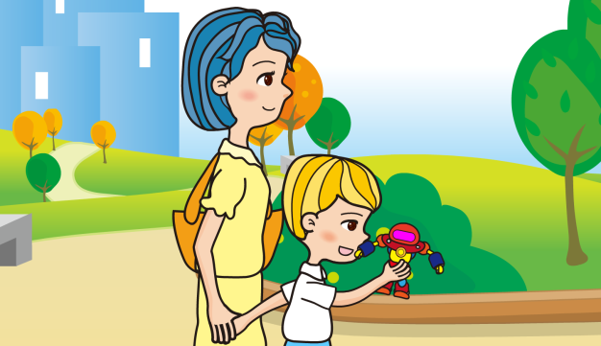 | （Picture 2）Kwong greets Chi  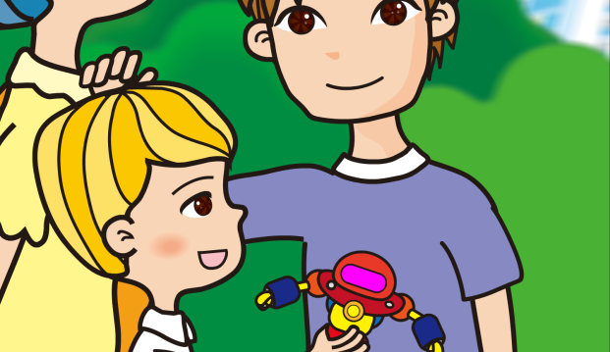
Chi’s feeling： | Chi’s feeling：
Kind / unkind touch? | Kind / unkind touch?
（Picture 3）Kwong leans toward Chi and helps him with his homework  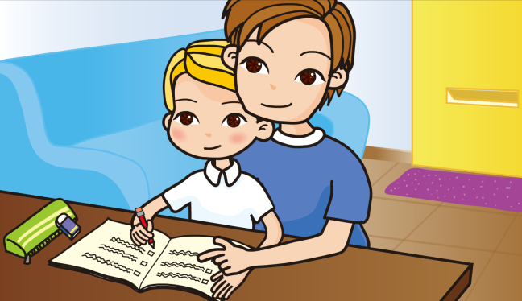 | （Picture 4）Kwong pats Chi’s buttocks lightly
Chi’s feeling： | Chi’s feeling：
Kind /unkind touch? | Kind / unkind touch?
Appendix IV
Worksheet: “The Sugar-coated poison”
In the story, what methods/tricks does Kwong use to make Chi accept his request? Can you give Chi some suggestions?

Kwong’s methods/tricks | Kwong’s excuses | Suggested Solutions
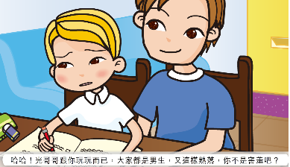  Deception + Make use of feelings | Haha, just for fun! Both of us are boys, and we are close friends! Are you telling me you are shy?
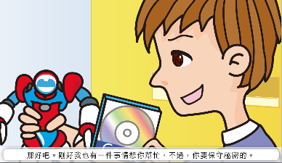  Promise of gain | Okay then. I need your help too, but you need to keep it secret.  (Chi：No problem! So will you lend them to me if I help?)
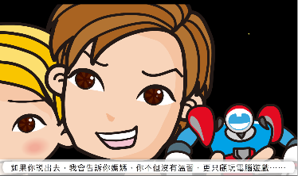  Threat | If you disclose anything, I will tell your mum that you didn’t revise and kept playing computer games…
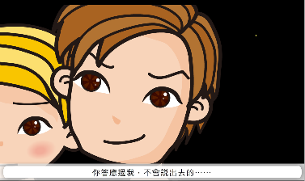  Make use of feelings (1) | You did promise that you won’t say a word…
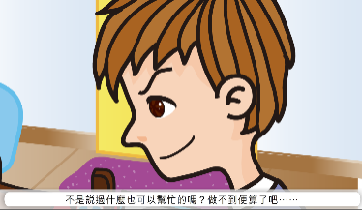  Make use of feelings (2) | I thought you said you can do anything? That’s fine if you can’t though...

Appendix V
“Sequel writing” Scenario Cards

Tell mother and she believes it | Tell mother and she believes it
Tell mother and she does not believe it | Tell mother and she does not believe it
Talk to someone | Talk to someone
Keep the secret | Keep the secret
Discovered by mother | Discovered by mother
Discovered by others | Discovered by others

