Social Life
(Key Stage 4)

Points to note: Promotion of sex education in schools is not to encourage premature love affairs or premarital sexual relationship of students. On the contrary, we expect teachers can take a prudent and objective attitude, be open-minded and listen carefully to understand the needs or problems of their students, so as to help them discuss sexuality issues with a responsible attitude.

Learning Objectives:
- To understand what gender stereotypes and the prejudices are
- To understand that gender stereotypes may limit the way people think and behave
- To learn to respect individual differences, including personality, to build up equal and respectful relationships with others, regardless of gender and not to judge other people on gender alone

Life-Event Exemplar: Lam’s Mistaken Beliefs
(Gender Stereotypes)

Values & Attitudes:
Equality, respect diversity, respect others

Learning Materials:
- Animation: “Lam’s Mistaken Beliefs” (Please refer to the animation file)
- Appendix I: “Lam’s Mistaken Beliefs” Animation Summary and Discussion Questions
- Appendix II: Picture on gender myths
- Appendix III: Worksheet “Common Myths”
- Appendix IV: Discussion Questions “His or Hers?”
- Appendix V: Worksheet “Thinking Outside Gender Stereotypes”
- Appendix VI: Reference for Teachers “Thinking Outside Gender Stereotypes”

Procedures:
Procedures (for reference) | Key Learning Points
Activity 1:“Common Myths”  - Warm Up: Shows one picture and ask students: “What kind of gender ideologies does this picture represent?” (Appendix II)  - Divide the class into groups and watch Scene 1 of the animation “Lam’s Mistaken Beliefs”. (Appendix I) Then guide students to discuss the gender stereotypes found in the animation. (Appendix VI)  - Each group has one worksheet (Appendix III) to discuss how some common gender stereotypes in our society affect people’s lives and why there is gender stereotypes. | - Allow students to understand that gender stereotyping and prejudices are common in our life.  - Encourage students to think about what kind of gender stereotypes they have observed or even accepted in our daily life and how they exist and how they affect their lives.
Activity 2: His or Hers?  - After watching Scene 2 of the animation “Lam’s Mistaken Beliefs” (Appendix I), students will be guided to discuss the questions at the end of this part. They should reflect on the possible adverse effect on individuals and society when there is over generalisation of gender ideologies, ignoring individual uniqueness.  - Students form groups of three (no more than 16 groups). Each group needs to draw a slip of paper from each of the “gender box” and the “scenario box”, and discuss the combination drawn: (Appendix IV: please print and cut the paper into slips beforehand, put the slips of gender into one box, and the slips of the 16 scenario / behaviour / occupation into another box.)  - To individual members of the group, does he/she accept the gender/scenario combination? Why?  - Is the gender/scenario combination generally accepted in our society?  - Will the acceptance level significantly change if the gender in the combination changes?  - Does the reason to accept or reject reflect specific kinds of expectation or stereotypes towards males and females in our society?  - Each group reports the viewpoints in their discussion. Teachers need to respond to their views and guide them to understand that gender stereotypes may lead to inequality and may be an obstacle to development of an individual’s potential. (Appendix VI) | - Gender inequality is shown through the discussion of the marked variation in acceptance and impression of the public when the gender changes in some combination of occupations, behaviour or situations.  - Think about the effects of different gender stereotypes on individuals and society
Activity 3: “Thinking Outside Gender Stereotypes”  - Discuss the questions and students are reminded the importance of respect for others after watching Scene 3 of the animation “Lam’s Mistaken Beliefs”. (Appendix I)  - Fill in the worksheet “Thinking Outside Gender Stereotypes” (Appendix V) with how students would handle if they encounter those situations in their daily lives.  - Share some of the methods students come up with, and guide them to think about what gender equality is. (Appendix VI) | - There are different ways to respond to mockery or inequality arising from gender stereotypes  - Through listening to others’ opinions, students will find that different people have different views on gender stereotypes. Students would learn to think about the same issue from different perspectives and be reminded to respect each other.

Teacher’s conclusions: (for reference)

- It is not difficult to find gender stereotypes in our society. Some unequal treatments based on gender difference, commonly taken for granted, are actually built on gender stereotypes and may have caused inequity, limitation or even discrimination.

- From a social perspective, gender stereotype serves certain functions. For example, it may be a reference framework and one may learn how to be socially accepted by following those commonly accepted or stereotyped models. However, if one understands gender in a narrow and rigid way, regardless of individual uniqueness or social changes, such as insisting to follow the traditional stereotyped gender roles, thinking that males or females should develop certain qualities which meet the expectations of their gender, strictly agreeing the traditional division of labour among males and females in society or even treating people in the same job position differently based on one’s gender, inequity will probably occur. In addition, it would be an obstacle or limitation to the development of an individual’s potential. Some people may also have low self-esteem if he or she cannot reach the norm.
- Does gender equality or a fair situation mean both males and females should be the same in every aspect? In the discussion of gender equality, it is important to let students understand that “equality” should not simply be taken as “always having the same treatment” or as “always getting the same result”. In fact, there are differences between genders, such as genital organs, sexual hormones and body development. The equality here means every individual, based on the diversity in characters, abilities or biological conditions, can fully develop one’s potential and talents without being limited by gender stereotypes.
- We acquire our concepts of gender or gender stereotypes mainly from socialisation, meaning that during the process of growing up, when each of us turns ourselves into an accepted member of our society by learning what is accepted and what the “should be” and “should do” are in our culture. If there are great disputes among students during discussion, it actually reflects that there are different values on gender and different levels of gender stereotype among different people. Students may be encouraged to discuss how socialisation affects their ideologies on gender.
- It may not be easy for us to think out of the gender stereotypes as they have evolved from our history and are subtle. Students are encouraged to reflect on their personal beliefs on gender. If we have the same belief that there can be less gender stereotypes and more autonomous options, people can develop their talent and capacity fully without being limited by gender streotypes.
Appendix I
“Lam’s Mistaken Beliefs”
Animation Summary and Discussion Questions

Theme: Gender Stereotypes

Scene 1 (Outside the cinema)

Lam and Ka Ming (two male students) discuss whether men should cry after watching a movie. Lam says men should not cry while Ka Ming responds that women live longer than men because women tend to express their emotions more easily.

Discussion Questions:
1. Why is Lam proud to have managed to fight back his tears even though he was touched?
2. Please express your thoughts by starting with “I think boys who cry are…”.

Scene 2 (Outside the boutique)

Lam and Ka Ming sees Yuen (male classmate) buy a pink checked polo shirt. Lam says he, as a dancer, should be a homosexual. Ka Ming responds to Lam that he is ignorant.

Discussion Questions:
1. Ka Ming says Lam is “ignorant”. Do you agree? Why or why not?
2. What would be the problem if we classify one’s favourite colours, hobbies, or behaviour as “masculine”, “feminine”, “homosexual”, etc.?

Scene 3 (In the school)

Lam and Ka Ming found that someone among his classmates has taken a photo of them when Lam patted Ka Ming’s back in the mall the previous day and shared it on social networking sites. Lam feels very bad, but says that other people won’t be that ignorant, thinking they are homosexual. Ka Ming responds that the previous day he says the male student with a pink shirt is gay.

Discussion Questions:

1. If we use gender as a criteria to judge how people should behave and laugh at those who deviate from our expectations, how will those people feel and what will be the impacts on them?
2. What are the differences between making fun of a friend and bullying?

Appendix II
Pictures on Gender Myths

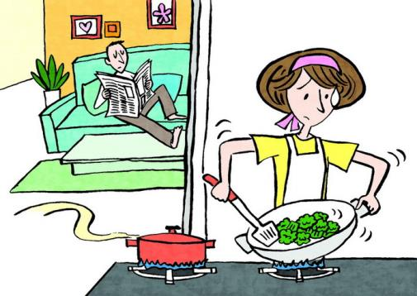

Appendix III
“Common Myths” Worksheet

Referring to the story of Lam and Ka Ming, please list out some stereotypes or prejudices related to gender you have observed in your daily life. Please also try to think about how these stereotypes or prejudices would affect the people concerned.

Gender Stereotypes or Prejudices | Influence

In your opinion, why are there gender stereotypes? Do they help our society in any way?

_________________________________________________________________________

_________________________________________________________________________

_________________________________________________________________________
Appendix IV
Discussion Questions: “His or Hers?”

Students form groups of three. Each group needs to draw one slip of paper from each of the “gender box” and the “scenario box”, and then discuss the combination drawn:
i. To individual members of the group, does he/she accept the gender/scenario combination? Why?
ii. Is the gender/scenario combination generally accepted in our society?
iii. Will the acceptance level significantly change if the gender in the combination changes?
iv. Does the reason to accept or reject reflect specific kinds of expectation and stereotypes towards males and females in our society?
MALE | MALE
MALE | MALE
MALE | MALE
MALE | MALE
FEMALE | FEMALE
FEMALE | FEMALE
FEMALE | FEMALE
FEMALE | FEMALE
Wear Pink  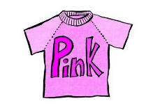 | Going Bald  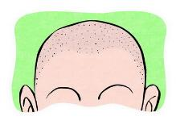
Be a Homemaker and Take Care of children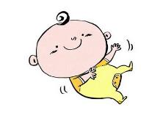 | Teach at a Kindergarten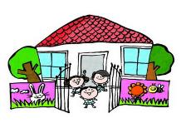
Propose Marriage  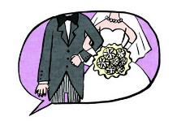 | Staying Single at the age of 40  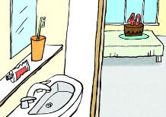
Give Flowers on a Date | Shave One’s Underarms  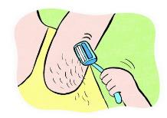
Bodybuilding(Being muscular)  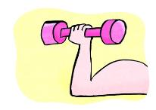 | Wear Makeup
Work at Construction Sites | Initiate Sex  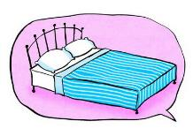
Do Embroidery  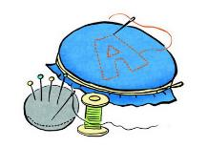 | Move Heavy Objects  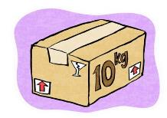
Smoke  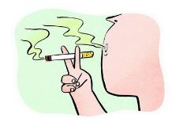 | Being Affectionate  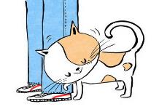

Appendix V
Worksheet: “Thinking Outside Gender Stereotypes”

How can we respond to the following stereotypes or prejudices towards gender?
(Limiting one’s emotional expression) How can you cry? You are a man!

Suggestions:
＿＿＿＿＿＿＿＿＿＿＿＿＿＿＿＿＿＿＿＿＿＿＿＿＿＿＿＿＿＿＿＿＿＿＿＿＿＿＿＿＿＿＿＿＿＿＿＿＿＿＿＿＿＿＿＿＿＿＿＿＿＿＿＿＿＿＿＿＿＿＿＿＿＿＿＿＿＿＿＿＿＿＿＿＿＿＿＿＿＿＿＿＿＿＿＿＿＿＿＿
(Being mocked for personal taste) Come on! You lack femininity. Dress like a lady, please!

Suggestions:
＿＿＿＿＿＿＿＿＿＿＿＿＿＿＿＿＿＿＿＿＿＿＿＿＿＿＿＿＿＿＿＿＿＿＿＿＿＿＿＿＿＿＿＿＿＿＿＿＿＿＿＿＿＿＿＿＿＿＿＿＿＿＿＿＿＿＿＿＿＿＿＿＿＿＿＿＿＿＿＿＿＿＿＿＿＿＿＿＿＿＿＿＿＿＿＿＿＿＿＿
(Limiting one’s occupational choice) Are you kidding me? You want to be a kindergarten teacher? That’s not going to work!

Suggestions:

＿＿＿＿＿＿＿＿＿＿＿＿＿＿＿＿＿＿＿＿＿＿＿＿＿＿＿＿＿＿＿＿＿＿＿＿＿＿＿＿＿＿＿＿＿＿＿＿＿＿＿＿＿＿＿＿＿＿＿＿＿＿＿＿＿＿＿＿＿＿＿＿＿＿＿＿＿＿＿＿＿＿＿＿＿＿＿＿＿＿＿＿＿＿＿＿＿＿＿＿
(Limiting one’s choice of partner)What? (He/She) is (shorter/talker) than you? How could you even consider (him/her)?

Suggestions:
＿＿＿＿＿＿＿＿＿＿＿＿＿＿＿＿＿＿＿＿＿＿＿＿＿＿＿＿＿＿＿＿＿＿＿＿＿＿＿＿＿＿＿＿＿＿＿＿＿＿＿＿＿＿＿＿＿＿＿＿＿＿＿＿＿＿＿＿＿＿＿＿＿＿＿＿＿＿＿＿＿＿＿＿＿＿＿＿＿＿＿＿＿＿＿＿＿＿＿＿
(Being undermined due to gender) You are a girl but your computer homework is so good. Which boy’s work did you copy?

Suggestions:
＿＿＿＿＿＿＿＿＿＿＿＿＿＿＿＿＿＿＿＿＿＿＿＿＿＿＿＿＿＿＿＿＿＿＿＿＿＿＿＿＿＿＿＿＿＿＿＿＿＿＿＿＿＿＿＿＿＿＿＿＿＿＿＿＿＿＿＿＿＿＿＿＿＿＿＿＿＿＿＿＿＿＿＿＿＿＿＿＿＿＿＿＿＿＿＿＿＿＿＿
(Being mocked for sexual orientation) You have so fair complexion. What a waste that you are not a girl. No wonder boys seem to like you so much.

Suggestions:
＿＿＿＿＿＿＿＿＿＿＿＿＿＿＿＿＿＿＿＿＿＿＿＿＿＿＿＿＿＿＿＿＿＿＿＿＿＿＿＿＿＿＿＿＿＿＿＿＿＿＿＿＿＿＿＿＿＿＿＿＿＿＿＿＿＿＿＿＿＿＿＿＿＿＿＿＿＿＿＿＿＿＿＿＿＿＿＿＿＿＿＿＿＿＿＿＿＿＿＿

Personally, the gender stereotype that affects me most is＿＿＿＿＿＿＿＿＿＿＿＿＿＿＿＿＿＿＿＿＿＿＿＿＿＿＿＿＿＿My response is＿＿＿＿＿＿＿＿＿＿＿＿＿＿＿＿＿＿＿＿＿＿＿＿＿＿＿＿＿＿＿＿＿＿＿＿＿＿＿＿＿＿＿＿＿＿＿＿＿＿＿＿＿＿＿＿＿＿＿＿＿＿＿＿＿＿＿＿＿＿
Appendix VI

Reference for Teachers
“Lam’s Mistaken Beliefs”

In the discussion of gender, the following are some of the common topics:
- Socialisation
- Division of Labour
- Stereotypes
- Discrimination

This teaching plan mainly focuses on gender stereotypes, but all these topics are inter-related.

Common Myths on Gender Stereotypes (Activity 1 and Discussion Questions of scene 1)

Gender stereotypes are the expectations our society hold towards different genders so as to establish some characteristics that a male or a female should have, such as behaviour, roles in society, abilities and personality traits.

It is not difficult to find various kinds of gender stereotypes in our daily life. Different treatments to different genders, commonly taken for granted, are actually established on gender stereotypes and may have caused inequality, limitation and even discrimination.

By tradition, many males think that they should be superior to their female counterparts, such as having a stronger body, being more perseverant (e.g. Lam feels that males should not cry) and more intelligent. For adults, examples include having higher income and being more successful in their careers. A male may face tremendous pressure if he is unable to achieve the above. On the other hand, a female may be expected to be gentle and feminine in her appearance and behaviour.

In the story, Lam considers showing emotions or crying as a sign of weakness for males, and is proud of him being a “true man” who would not cry when being touched. This is one typical example of gender stereotypes.

If students encounter difficulties when they are thinking of the examples for gender stereotypes in Activity 1, some suggestions or directions can be given. For example, guide students to think in terms of career path, capability and whether there is any “should be done” and “should not be done” for males and females. The teacher can also guide students to think of some “hidden rules” on gender, in order to help them understand the possible negative impact of gender stereotypes. In the discussion, help students discover that the time and social environment in which the gender stereotypes were formed are very different from our current society. They may also note that there are different kinds of gender division of labour in different eras.

Problems that may be caused by Gender Stereotypes (Activity 2 and Discussion Questions of scene 2 and 3)

From a social perspective, gender stereotype serves certain functions. For example, it may be a reference framework and one may learn how to be socially accepted by following those commonly accepted or stereotyped models. However, if one understands gender in a narrow and rigid way, regardless of individual uniqueness or social changes, such as insisting to follow the traditional stereotyped gender roles, thinking that males or females should develop certain qualities which meet the expectations of their gender, strictly agreeing the traditional division of labour in society or even treating people in the same job position differently based on one’s gender, inequity will probably occur. In addition, it would be an obstacle or limitation to the development of an individual’s potential. It makes some people have low self-esteem or be mocked if he or she cannot reach the norm, leading to discrimination (sex discrimination means unequal treatment to someone solely on the ground of one’s sex, rather than one’s ability, merits or weaknesses) or bullying.

It is natural that differences exist among people. However, gender, family background, upbringing, interests or sexual orientation are just some of the descriptions which cannot represent a person holistically. It is impractical if we just use a narrow scope to determine whether certain colour, interest or behaviour is proper or reasonable for someone, and we would neglect the uniqueness of an individual and also over-simplify the real situation.

Merely using gender to determine whether it is a proper behaviour, and an issue for mocking or teasing people may be a bullying act, no matter if it is in the real world or the cyber world. Even if the person who makes the gender-biased joke does not have a bad intention or thinks it is harmless, the person being teased may feel uncomfortable, upset or even isolated, and it may constitute bullying. It may not only cause hard feelings to the person being teased, but also harm their relationship and stop him from expressing his emotion. People being mocked or teased may suppress their actual feelings to please others which can result in stress to themselves.

Thinking Outside Gender Stereotypes (Activity 3)

Gender Equality
The principle of gender equality is to be people-oriented: respect the uniqueness of every individual. As long as it does not hurt other people, everyone is allowed to have reasonable choice and equal opportunities to realise their potential, without taking gender and other identities as the major factor into consideration. However, the spirit of gender equality does not mean every gender has to do the same thing. Instead, everyone should be free to choose what they like to do based on their interests, ability and needs, without being limited by gender stereotypes.

We should break the limitation of gender stereotypes, realise our potential and seek gender equality with a respectful and rational attitude. Nevertheless, things may not happen as we please. There are certainly differences between genders. As a member of our family, community and society, sometimes the over-all development would be more important and could only be worked out through compromise or division of labour. No matter what the result will be, there should be, in the decision-making process, open and honest communication among the stakeholders on a fair basis. They should try to understand, and consider the needs of each other and cooperate.

How to Face Bullying Caused by Gender Stereotypes
When facing gender stereotypes in daily life, we should believe in ourselves, knowing that we have the right to choose our personal preference such as our appearance, taste, style of dressing, choice of friends, and career path. If there is mockery without hostile intent, we may state our views lightly or even bring out the message of gender equality humorously. This may help others understand gender stereotypes. If malicious bullying is encountered, we must express our feelings clearly and firmly. If there is no improvement to this situation, we should seek help from teachers or social workers. Never bear it silently.

Reference Information
Sexuality Education Website of the Family Planning Association of Hong Kong (www.famplan.org.hk/sexedu/en/index.asp )
RTHK Liberal Studies (www.liberalstudies.tv)

