Appendix 5

Selection, adaptation and designing of teaching
materials to suit student ability

Example One

Focal interest : Varying the question types to suit student ability

Source : Oxford Junior English 1
Chapter 9, Pg. 121 (1996 Edition)

Explanatory Note : The original reading comprehension exercise requires students to supply the missing words in a short dialogue. This is difficult for weak students as the task involves both receptive skills (comprehension) and productive skills (completing sentences).

The modified exercise simplifies the task by asking students to decide whether some statements are true or false. Students also need to write down the relevant line number(s) to justify their answers.

Steps : Have students number every 5th line of the passage (5, 10, 15, and so on) in the left margin before asking them to do the modified exercise.

Modified Version

Your friend, Anne, is preparing for a quiz about plants. She wants to know whether the following statements are true or false. Help Anne by reading the passage on page 121. Give the line number(s) to explain your answers. The first one has been done for you.

 | T(rue) or F(alse)? | Line number(s)
1. We got wood and rubber from trees. | T | 7-9
2. Trees clean the air.
3. One tree has the power of 15 air-conditioners.
4. Scientists know a lot about trees.
5. Trees can protect themselves from insects.
6. Trees join their roots together underground to kill insects.
7. Every year, there are fewer and fewer trees in the world.

Example Two

Focal interest : Selection of materials to suit student ability

Source : Target English 2B (1996 Edition)
Unit 9, Task 2.1, Pg.29

Explanatory Note : The passage is about the work of Project Hope in assisting children in rural China to attend school. It describes the work of Project Hope in general, and the case of Shu Yee in particular. Remedial class teachers can simply concentrate on paragraphs which focus on Shu Yee, and leave out the parts of the text which provide potentially distracting and complex general information.

Suggestion for selection: Mark off parts of the text, i.e. Paragraphs 1 and 4, and the section from “With more money ...” to “blackboards and books” in Paragraph 5, as optional for the mainstream classes.

Example Three

Focal Interest : Introducing smaller steps to bridge gaps in students’ knowledge

Source : Creative English 1
Unit 1, Pg. 12 (1998 Edition)

Explanatory notes : (i) The exercise required students to talk about the names, locations and possible activities of some local spots by simply looking at the given photographs. It pre-supposes that students have knowledge of the places in question as well as the language required to complete the task. The modified version provides variety in practice through a series of graded exercises. Each exercise has a specific language focus. There is also sufficient information input to enable students to concentrate on using the language. The information gap principle has been applied to facilitate pair work for greater student involvement.

(ii) Taking into account the constant developments in Hong Kong and the consequent changes in the landscape, teachers may need to replace or select out certain pictures, where appropriate.

Modified Version

Exercise 1 Matching

Look at the pictures in the course book. Discuss with your partner what place each picture shows and put the corresponding number next to the names of places given below. The first 2 have been done for you.

You can ask and answer questions like this:

Q. What is it in Picture ?
A. It is the .

Low Wu Terminal (8)
Ocean Terminal (9)
Central MTR Station ( )
Space Museum ( )
Ocean Park ( )
Tsimshatsui Star Ferry Pier ( )
Hong Kong International Airport ( )
City Hall ( )
Peak Tower ( )

Exercise 2 Stating the location

Look at the map below. It shows you where the places in Exercise 1 are.
Work with your partner. Ask and answer questions like this:

Q. Where is the ?
A. It is on Hong Kong Island.
in Kowloon.
in the New Territories.

One of you can do the odd numbers and the other the even numbers.

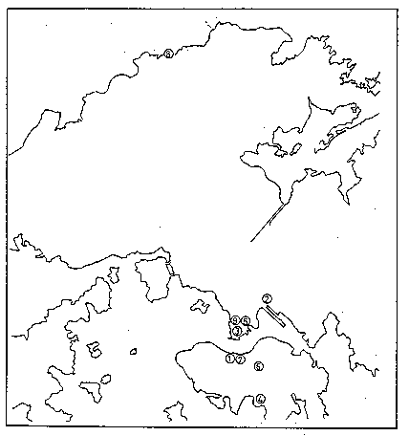
Exercise 3 Pair Work

Study the table on your own worksheet. Some information on what we can see or do in these places is provided but some details are missing.

Work with your partner to complete the table.

You can ask questions like these :

Q. What can we see at the ? A. We can see there.

Q. What can we do at the ? A. We can there.

Do not look at your partner’s worksheet!
(The same set of instructions will appear on Worksheets A and B).

Worksheet A

Place | What we can see | What we can do
Central MTR Station |  | ride on MTR trains
City Hall | a big concert hall
Hong Kong International Airport |  | see our friends off
Low Wu Terminal | a lot of people and trains
Ocean Park |  | ride on the cable cars
Ocean Terminal | big ships and shops
Peak Tower |  | enjoy the view of Hong Kong
Space Museum | an exhibition hall
Tsimshatsui Ferry Pier |  | cross the harbour

Worksheet B

Place | What we can see | What we can do
Central MTR Station | MTR trains
City Hall |  | listen to some music
Hong Kong International Airport | some large aeroplanes
Low Wu Terminal |  | cross over to Shenzhen
Ocean Park | a lot of cable cars
Ocean Terminal |  | do some shopping
Peak Tower | a restaurant and some shops
Space Museum |  | learn about the stars
Tsimshatsui Ferry Pier | ferries and motor-boats

Example Four

Focal Interest : Helping students to handle a difficult listening task by breaking the task into smaller activities

Source : Oxford Junior English 1
Chapter 5, Pg.66 (1996 Edition)

Explanatory Note : The original listening task is based on a dense written text. The tape and the questions use a number of words which will be difficult for weak students.

In the modified teaching procedure, students do a few activities as preparation before they attempt the listening. The original exercise becomes Step 4 below.

Modified Version

Procedure | Remarks
- Pre-teach / revise key words used on the tape, e.g. Nanjing, capital, attractions, memorial, republic, hectares, RMB, repairs, cable car. | This reduces problems which may be caused by difficult vocabulary in listening comprehension.
- Go over the questions (i.e. cloze passage) on page 66. Make sure students understand them. | This frees students from the need to understand the passage when they listen to the tape later.
- Ask students to guess what the answers will be. Point out that in questions like ‘you pay _______ RMB’, the answer will be a number. | This activates students’ background knowledge about Chinese history, which in turn will help them to understand the tape more easily.
- Have students listen to the tape to check whether their guesses are correct or not. | This gives a purpose to the listening task.
- For very weak students, help them listen to only the first three paragraphs on the tape rather than the whole recording. | This caters for the ability of really weak students.

