Bioethics
3. Gender Selection

3.1. Intended Learning Outcomes

By the end of the lessons, the students will be able to:
- Analyze the reasons of gender selection;
- Understand the methods of gender selection, and analyze the moral implications of the methods;
- Evaluate the pros and cons of using embryo technology for gender selection;
- Apply different ethical theories to make moral judgment related to gender selection.

*Prerequisite knowledge: Normative Ethics, the nature of morality, moral principles, moral reasoning, theory of conduct, theory of value & virtue (Refer to ‘NSS Ethics and Religious Studies Curriculum Support Materials - Compulsory Part: Ethics - Module 1: Normative Ethics’)

3.2. Introduction

Gender selection is the attempt to control the sex of the baby to achieve a desired sex. Some common artificial methods include preimplantation genetic diagnosis, intracytoplasmic sperm injection, cryopreservation* etc.

Demographers notice that in communities where male offspring are openly preferred, or where there are limits on the number of children one can legally bear, the sex ratio has been changed. In some countries, like India, China, Bangladesh and Pakistan, the sex ratio difference is quite severe (80 girls per 100 boys, while the biological sex ratio is around 95 girls to every 100 boys).

In the lessons, students will examine the reasons for sex selection. Furthermore, some ethical issues like sex-selective infanticide and embryo technology will be discussed.

Notes:
* Preimplantation genetic diagnosis: to genetic profiling of embryos prior to implantation
* Intracytoplasmic sperm injection: a fertilization procedure in which a single sperm is injected directly into an egg
* Cryopreservation: a process where cells are preserved by cooling to sub-zero temperatures

References:
- Fuse, Kana (2013). ‘Daughter preference in Japan: A reflection of gender role attitudes?’. Demographic Research. Vol. 28, Article 36. Pp. 1021-1051.
- Mudde, Anna (2012). “Before You Formed in the Womb I Knew You’: Sex Selection and Spaces”. Hypatia vol. 25, no. 3 (Summer, 2010). At http://eds.b.ebscohost.com/eds/pdfviewer/pdfviewer?vid=8&sid=f7723a84-b7a7-49ff-a77f-6080360da4b2%40sessionmgr114&hid=108
- http://en.wikipedia.org/wiki/Intracytoplasmic_sperm_injection
- http://en.wikipedia.org/wiki/Cryopreservation
- http://en.wikipedia.org/wiki/Preimplantation_genetic_diagnosis
- http://en.wikipedia.org/wiki/Sex_selection
- http://www.demogr.mpg.de/publications%5Cfiles%5C161_1037176026_1_PDF%20Version.pdf

3.3. Teaching and learning processes
Suggested teaching period: 4 lessons

  - Reasons of gender selection
  - Teacher asks the students, ‘Do you prefer having a son or a daughter in the future?’ After counting the votes, ask them to explain their preferences.
  - Teacher separates students into 5 groups. Ask the group representatives to come out drawing the son/daughter preference cards (i.e. Card A-E). Each group studies the card and then demonstrates a role-play explaining why they prefer having sons/daughters as if they were the parents from the countries indicating on the cards.
  - Teacher shows the 3 banners in ‘Worksheet 1: Gendercide’, and then gather students’ ideas on what messages they convey.
  - Ask students to brainstorm within their groups the reasons for the overall son preference, and then report their answers.

  - Methods of gender selection
2.1. Teacher asks the students to think of any gender selection methods that they know. They may also collect the methods from folk wisdom. Then, teacher goes through with them the methods in ‘Worksheet 2: Methods of gender selection.’
2.2. Ask students to complete Question 1 (and Question 2 if appropriate) in pair or in group. Then teacher facilitates a class discussion.

3. Ethical issues of gender selection
3.1. Teacher plays the video on ‘Gender Selection - 60 Minutes with Dr Daniel Potter’ (~13 mins) at https://www.youtube.com/watch?v=zNoM--mBbC0, and ask the students to complete ‘Worksheet 3: Edison and her frozen sister’. Discuss their answers.
3.2. Teacher divides the class into 2 groups for the debate on ‘Embryo technology for gender selection should be banned.’ Ask them to prepare for their arguments at home. To facilitate their preparation and consolidation, ‘Worksheet 4’ can be used.
3.3. In the debate, students may evaluate the performance of both themselves and their peers using the evaluation tables in Worksheet 4.

- Conclusion and students’ self-evaluation
  - Teacher reviews the key learning points of the topic on ‘gender selection’ with the students.
  - Ask students to consolidate their knowledge and evaluate their learning outcomes by completing ‘Worksheet 5: Summary & self-evaluation’.

Card A: Son preference in China

http://www.voyagesphotosmanu.com/Complet/images/Chinese_youth_gr.jpg
Very obviously in the traditional Chinese society, sons are much more preferred than daughters. Sons are granted more accessibility to educational and medical chances. As a result, the sex ratio in favor of boys grows higher through ages.
The introduction of the One-Child Policy since 1970s, and the spread of sex-selective technology since 1985 sharpen the unbalanced sex ratio.
In the Confucian-influenced and male-centered Chinese society, sons are preferred because of the following reasons:
- Sons can continue the family line and name.
- Sons provide manual labour in traditional agricultural societies.
- Sons are expected to be the financial pillar in the family.
- Sons are legitimate heirs of the family property.
Source: http://www.wikigender.org/index.php/Son_preference_in_China

Card B: Son preference in India

https://hk.images.search.yahoo.com/images/view;_ylt=A8tUwJn9Hg1VFiEAeYG1ygt.;_ylu=X3oDMTIzbjEwc2NvBHNlYwNzcgRzbGsDaW1nBG9pZANiYTIyZGRlYTM4OGE2MTMxODkzNTEzOTk1OTcxNDk0YQRncG9zAzE2BGl0A2Jpbmc-?.origin=&back=https%3A%2F%2Fhk.images.search.yahoo.com%2Fsearch%2Fimages%3F_adv_prop%3Dimage%26va%3DIndian%2Bkids%26fr%3Dyfp-t-403-hk%26tab%3Dorganic%26ri%3D16&w=500&h=338&imgurl=farm1.static.flickr.com%2F24%2F63148453_2a9a2752ee.jpg&rurl=http%3A%2F%2Fwww.indiavision.com%2Fblog%2F2009%2F03%2F130.blg&size=127.0KB&name=Malnutrition+ails+%3Cb%3EIndian+kids%3C%2Fb%3E&p=Indian+kids&oid=ba22ddea388a6131893513995971494a&fr2=&fr=yfp-t-403-hk&tt=Malnutrition+ails+%3Cb%3EIndian+kids%3C%2Fb%3E&b=0&ni=21&no=16&ts=&tab=organic&sigr=11ftmv65g&sigb=13hhr03rg&sigi=11i6uk15a&sigt=114jiit1u&sign=114jiit1u&.crumb=fwNsEPYm9v3&fr=yfp-t-403-hk

In India, gender inequality is shown clearly in a preference for sons over daughters. Lots of parents think that daughters are unvalued, and would stop breeding and raising baby girls at birth, which make a remarkable sex ratio in favor of boys.

Scholars explain the reasons for son preference in India as follows:
- Dowry and wedding expenses: In India, marrying off daughters can become a huge family expense. On the other hand, more sons can eventually mean more resources.
- Support in old age from sons: Sons are living with the parents; while daughters would be married off to some distance from their home village.
- Sons can provide labor force to the family and become the financial supporters.

Sources: http://paa2012.princeton.edu/papers/122478
http://www.icrw.org/where-we-work/son-preference-india

Card C: Daughter preference in Japan

Researchers find out that over the past few decades, gender preference for children in Japan has progressively shifted from son preference to a noticeable daughter preference.

Reasons for the increasingly daughter preference include:
- Mothers want companionship and old-age support from a daughter.
- To avoid obstacles associated with raising a son successfully (e.g. behavioural problems)
- Less pressure from in-laws to have sons due to changes in family structure. Nuclear family structure, instead of extended one with in-laws living together, is prevailing in Japan nowadays. In-laws have fewer chances to urge the couples having sons.

Reference: http://www.demographic-research.org/volumes/vol28/36/

Card D: Increasing Daughter Preference in Korea nowadays

Studies report that more young Korean couples prefer a daughter to a son. 37.4% of fathers said that they wanted to have baby girls rather than boys, while 28.6% gave the opposite response ― the remaining 34% said they didn't care about the sex of their newborns.

Son preference has phased out eventually in Korea. The remarkable increment in the daughter preference in the 21st Century in Korean is a results of the following factors:
- Less influenced by the hierarchical and male-centered Confucian culture
- More young couples feel they will enjoy raising daughters more than sons

Reference: http://www.koreatimes.co.kr/www/news/opinon/2012/12/202_58940.html

Card E: Daughter preference in Hungary

ttp://www.bing.com/images/search?q=Hungarian+baby+girl&qpvt=Hungarian+baby+girl&FORM=IGRE#view=detail&id=6EF79DCB18254C79CC7CFB83C53D6FF0EE690EFC&selectedIndex=127

A study shows that mothers (especially a low-status group) in Hungary have a daughter preference. They "have a female-biased sex ratio at birth, are more likely to abort a child after having had one or more daughters, nurse their daughters longer, and send their daughters to school for longer".

The daughter-associated attributes give an account on this phenomenon. Daughters are deemed to be more affective, attentive in learning, obedient and attached to parents.

Reference: http://en.wikipedia.org/wiki/Trivers%E2%80%93Willard_hypothesis

Worksheet 1: Gendercide

Figure 1: http://newcanadianmedia.ca/media/k2/items/cache/ce60eec033aeb16c14aa1ddcc4628f03_L.jpg

Figure 2: http://www.english-online.at/news-articles/people/girl-abortion-in-india.jpg

Figure 3: http://4.bp.blogspot.com/_zddxS7Nv1Bg/SDzG9BhdDvI/AAAAAAAAAGk/OWNUrI0vZjQ/s400/one+child+policy.jpg
1. What messages do the above banners convey?

2. Why is there a need to design such kind of banner? What phenomena does it reflect?

3. What are the reasons for son preference?

Worksheet 1: Gendercide
(For teachers’ reference)

1. What messages do the above banners convey?
- In Figure 1, it shows that sex selection is gendercide, which must be stopped.
- In Figure 2, the banner advocates that in order to maintain a balance of the sex ratio in India, families should still have girls. From the scene that 4 boys are passing by the banner, it reflects that the male-female ratio is already imbalanced in the country (around 100:80).
- In Figure 3, it shows that there is gender preference in China – sons are more popular than daughters. Under the ‘One-Child Policy’, abortion, killing or abandonment of daughters are common especially in the rural areas.

2. Why is there a need to design such kind of banner? What phenomena does it reflect?
- Banners with the theme of ‘protecting daughters’ or ‘preventing gendercide’ are designed because such phenomena are severe.
- In some countries, like India, China, Bangladesh, Pakistan etc., the sex ratio is 80 girls per 100 boys, while the biological sex ratio is around 95 girls to every 100 boys. Such condition is quite alarming and needs to be stopped.

3. What are the reasons for son preference?
- Sons can continue the family line and name.
- Fathers want to demonstrate their masculinity by having sons.
- Sons provide manual labour in traditional agricultural societies.
- Sons are expected to be the financial pillar in the family.
- Sons are legitimate heirs of the family property.
- Sons may be more employable in the future.
- In some countries, sons are more likely to provide support in their parents’ old age, for they live with the parents; while daughters would be married off to some distance.
- In India, sons do not have to provide dowry payments, but rather being on the receiving end of this practice.
- In some regions, sons enjoy more legal benefits. For example in Hong Kong, only male indigenous villagers are benefited from the ‘New Territories Small House Policy’.

Worksheet 2: Methods of gender selection

Study the following gender selection methods, and answer the questions below:
      - Natural methods – There are various non-scientific traditional methods across different countries attempting to attain the baby with the parents’ desired sex. For example, methods associated with diet control, posture and timing of intercourse, bedroom decoration and feng-shui settings, etc. are used. However, significant empirical successful cases using such methods are hardly proven.

      - Abortion – From 16 weeks after pregnancy, people can predict the baby gender using ultrasound. Some parents would choose abortion after they know that the babies are not of the sex they want. Many medical reports indicate that after removing a 16-week fetus from the mother’s womb, it still moves, and could be regarded as human.

http://www.eehealthbook.com/templates/images/16-week-b.jpg

      - Embryo technology – The development of embryo technology enables people to choose their babies of designated gender. Below are some possible technologies to create the desired baby gender:
- Preimplantation genetic diagnosis: to genetic profiling of embryos prior to implantation
- Intracytoplasmic sperm injection: a fertilization procedure in which a single sperm is injected directly into an egg
- Cryopreservation: a process where cells are preserved by cooling to sub-zero temperatures

      - Neonaticide/infanticide – Neonaticide means killing a child in the first 24 hours of his/her birth; while infanticide refers to killing children under 12-month old. In some countries, like in China, parents might kill newborn daughters because they were unable to transit the family name, and were deemed to be weaker and unhelpful for doing agricultural work in the older days.

      - Baby dumping – It refers to parents (generally mothers) abandoning or discarding a child younger than 12 months in a public or private place with the intent of disposing of them. It often happens in poor societies where parents are not financially capable of taking care of a child of an undesirable sex.

Reference:
- http://en.wikipedia.org/wiki/Neonaticide
- http://en.wikipedia.org/wiki/Child_abandonment

- In your view, which of the above-mentioned gender selection methods are acceptable? Which are not? Explain your answer.

- Challenging level (optional): Applying the theories of ethics, judge the ethicality of these gender selection methods.
Method | Moral/  immoral | Theory of ethics | Justification
Natural methods
Abortion

Embryo technology
Neonaticide / infanticide
Baby dumping

Worksheet 3: Edison and her frozen sister

Watch the video clip on ‘Gender Selection - 60 Minutes with Dr Daniel Potter’ at https://www.youtube.com/watch?v=zNoM--mBbC0, and then answer the questions.

- If you were the couple in the video, would you try using embryo technology to obtain a daughter after having 7 sons? Why or why not?

- If you were the couple, will you tell your daughter how she was ‘created’? Why or why not? What are the potential impacts on her?

- What are the different viewpoints of Dr Daniel Potter and Dr Sandra Hecker towards sex selection? Whose viewpoint do you tend to support? Why?
 | Dr Daniel Potter  (the male doctor helping the couple to create the test-tube embryo) | Dr Sandra Hecker  (the female doctor of Australian Government National Health and Medical Research Council [NHMRC])
For/against
Viewpoints
My viewpoints:

- What do you think about the ‘frozen embryos’? Imagine if you were one of them with thinking and feelings, what if you are in the following situations? Alternatively, you may express your views by drawing, writing a short poem, narration, poster, photo/video production, etc.
Situation | Your thinking & feelings
- You are frozen permanently
- You are destroyed
- You are put into a stranger’s womb
- You are put into your mother’s womb, and are born 5 years after your ‘twin’?

- Challenging level (optional): ‘Gender Selection is a slippery slope to Design Baby.’ Do you agree? Please explain.

Worksheet 3: Edison and her frozen sister
(For teachers’ reference)

- What are the different viewpoints of Dr Daniel Potter and Dr Sandra Hecker towards sex selection? Whose viewpoint do you tend to support? Why?
 | Dr Daniel Potter  (the male doctor helping the couple to create the test-tube embryo) | Dr Sandra Hecker  (the female doctor of Australian Government National Health and Medical Research Council [NHMRC])
For/against | - For | - Against
Viewpoints | - What he has been doing with the embryo technology is ‘to help people connect with their destiny’, and he is the ‘facilitator’ to make the couple’s dream come true.  - Unlike in China where people perform gender selection by infanticide, enabling gender selection through embryo technology is more humane  - It is the trend for the future | - It is sort of commodifying /commercializing a child  - It is a slippery slope to ‘Design baby’ (e.g. designated sex, blond hair, blue eyes, to be very intelligent, etc.)  - The right to pass the embryo into life should be based independent on whether it is male or female  - It may lead to global gender imbalance
My viewpoints:

Worksheet 4: Debate – Embryo technology for gender selection should be banned.

Should not be banned | Should be banned

Self-evaluation
Self-evaluation
5=outstanding , 1=very poor
Am I able to make substantial arguments? | 5 4 3 2 1
Am I able to give concrete examples to support my arguments? | 5 4 3 2 1
Am I able to employ individual ethical theory accurately with appropriate evidence? | 5 4 3 2 1
Am I able to present my view/arguments in a logical and systematical way? | 5 4 3 2 1
Am I able to respond to the arguments made by the counterpart? | 5 4 3 2 1

Peer evaluation
Peer-evaluation
5=outstanding , 1=very poor
Is the counterpart able to make substantial arguments? | 5 4 3 2 1
Is the counterpart able to give concrete examples to support their arguments? | 5 4 3 2 1
Is the counterpart able to employ individual ethical theory accurately with appropriate evidence? | 5 4 3 2 1
Is the counterpart able to present their view/arguments in a logical and systematical way? | 5 4 3 2 1
Is the counterpart able to respond to the arguments made by our side? | 5 4 3 2 1

Worksheet 4: Debate – Embryo technology for gender selection should be banned.
(For teachers’ reference)

Should not be banned | Should be banned
- It is a sign of female empowerment that allows couples to make well-informed family planning decisions.  - It is an expression of reproductive rights. | - It is doubted that whether women could truly express free choice under pressure from family and community.
- It helps prevent occurrences of unintended pregnancy, abortion and child neglect. | - During the process of creating the test-tube embryos, there are ‘extra embryos’. No matter freezing or destroying them would lead to ethical problems as well.  - It may contribute to stronger gender stereotypes.
- It minimizes intimate partner violence if the partner fails to reproduce a baby with the desired sex. | - It is not a solution to domestic violence.
- Some scholars argued that governments should pay couples to choose to have female children in order to ensure population demographic equality (i.e. equal numbers of boys and girls).  - Actual experience in Western cultures provides no evidence for any degree of gender imbalance from technologies which have long been available and legal. | - Empirically, if gender selection is permitted, more parents would choose sons, for example, in Far East, such as India and China, & Eastern Europe such as Albania or Azerbaijan.  - In those gender-imbalanced countries, there is a lack of opportunity for many men to marry. Crimes such as demand for prostitution, mass emigration, and the selling of brides etc. occurred increasingly.

References:
- http://en.wikipedia.org/wiki/Sex_selection
- http://jme.bmj.com/content/27/5/302.full

Worksheet 5
Compare and contrast the view points and consequences on gender selection from the perspectives of morality and law; use arrows and annotate the relationship between the two:

From the perspective of morality From the perspective of law

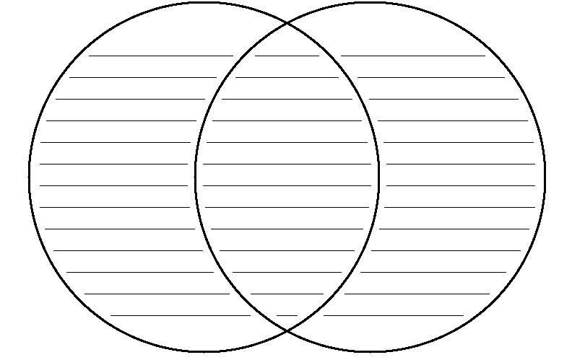
Common view points

Key for Teachers’ reference:

affects how laws are amended

From the perspective of morality From the perspective of law

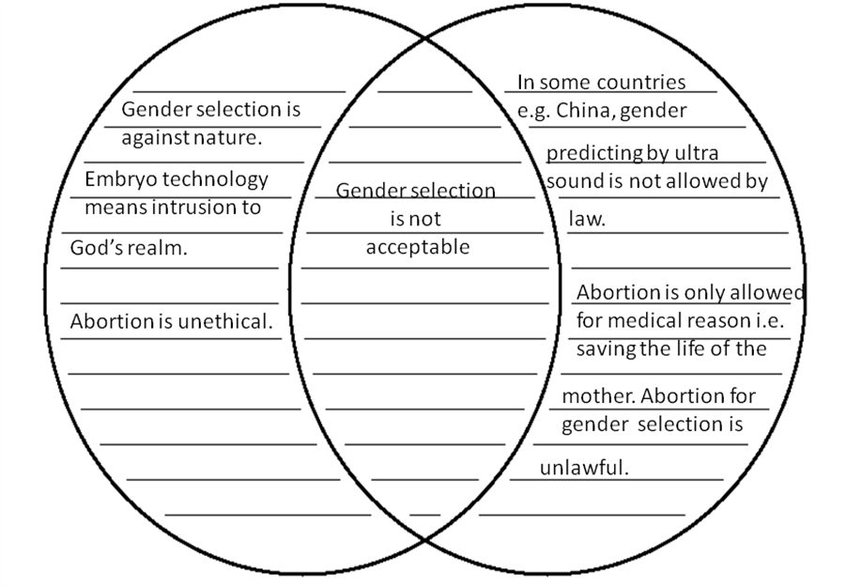Common view points

shapes morality, provides justification for moral judgments
Worksheet 6: Summary & Self-evaluation – Gender Selection

Write down the key learning points of this module.
- Reasons for gender selection
1.

2.

3.

4.

5.

- Methods of gender selection
1.

2.

3.

4.

5.

- Ethical issues of gender selection
1.

2.

3.

4.

5.

Evaluate how well you have learnt (please put a ‘’)
 | Very good | Good | Fair | Poor
- Reasons of gender
- Methods of gender
- Ethical issues of gender selection

What question(s)/area(s) you want to learn more in this module of ‘gender selection’?

