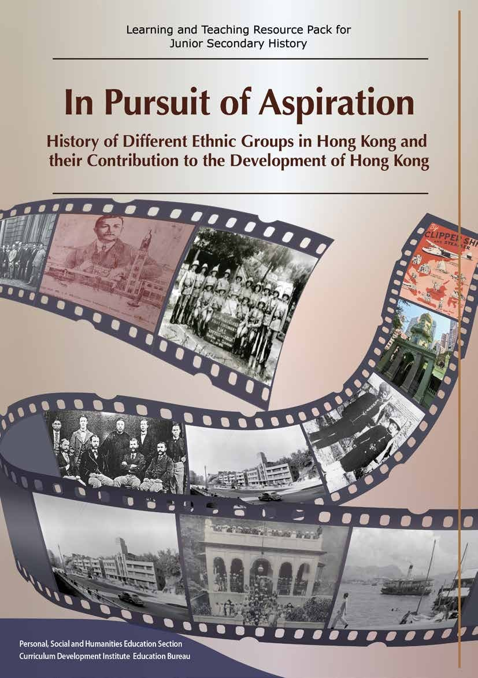

Contents

Contents Page No

Preface 1

Abstract 2

Part A Videos: Source-based History Learning 4
- Abstract: What kind of historical sources can be used to write history? 5

Professor KWONG Chi-man

- Abstract: Historical photographs and historical study:
Are photographs always reliable as historical sources? 7
Professor KWONG Chi-man
Part B 47 Primary Sources
Contents 10

Site Visit : Religious buildings of different ethnic groups in Hong kong
Part C | Learning and Teaching Examples: History of Different
 | Ethnic Groups in Hong Kong and their Contribution to the
 | Development of Hong Kong
 | Example 1 : The Jews | 67
 | Example 2 : The Parsis | 96
 | Example 3 : The Europeans (using the Germans, the Russians and the Portuguese as examples) | 113
 | Example 4 : The Indians, the Sikhs and the Filipinos | 130
 | Extended Learning : Mody, Chater, Nathan, Kadoorie Family and the  Kowloon Peninsula | 142

150

Preface

The learning and teaching resource pack entitled In Pursuit of Aspiration – History of Different Ethnic Groups in Hong Kong and their Contribution to the Development of Hong Kong is published by the Personal, Social and Humanities Section of Curriculum Development Institute, Education Bureau (EDB). It aims to support the learning and teaching of the Revised History Curriculum (S1-3) (2019) and help students trace the historical imprints of different ethnic groups who lived in Hong Kong in the 19th and 20th centuries so that students can understand the lives, cultures of different ethnic groups and their contribution to Hong Kong.

In order to enhance teachers’ understanding of the new topic “Contributions of Europeans, Americans and other ethnic minorities to Hong Kong” in the Revised Curriculum, the EDB commissioned a team led by Professor MAK King-sang and Professor KWONG Chi-man of the Department of History, Hong Kong Baptist University in 2017 to produce this resource pack. The histories of different ethnic groups’ life and experience in Hong Kong, such as those of the Jews, Parsis, Europeans, Indians, Sikhs and Filipinos, are selected to illustrate their contributions to the development of Hong Kong.

This resource pack contains three parts. Part A contains two video clips (with subtitles) and abstracts of the videos by Professor KWONG Chi-man on how to use visual images to study history. The 47 primary sources in Part B, of which 3 sources are interview extracts, mostly come from the government or private sector archives. There is an annotation for each historical source to facilitate students and teachers’ understanding of its background and content. Teachers are expected to read and use these historical sources to design learning and teaching activities so that students can study history through historical sources. Part C contains 6 examples of classroom activities and site visits designed from the primary sources in Part B and other relevant information by front-line history teachers. Teachers may flexibly use and adapt these examples according to their school context and students’ ability and interest. Teachers are advised to read the user guide so as to know more about the e-learning functions provided in this e-learning resource pack. The content of this resource pack has been uploaded to the website of EDB for teachers’ reference.

https://www.edb.gov.hk/en/curriculum-development/kla/pshe/reference-and-resources/index. html

No part of this resource pack may be reproduced in any form for commercial purposes. We are grateful to the publishers/ organisations for permission to quote their publications in this resource. We also express our heartfelt gratitude to The Hong Kong Heritage Project for its generosity for allowing us to use its collections (including texts, photos and interview extracts, etc.), Ms Amelia ALLSOP and the Jewish Historical Society of Hong Kong. Every effort has been made to trace copyright ownership but in the event of accidental infringement, copyright owners are invited to contact us so that we can come to a suitable arrangement.

If you have any comments and suggestions on this resource pack, please send to:

Personal, Social and Humanities Education Section Curriculum Development Institute
Education Bureau
Room 1319, 13/F, WU Chung House 213 Queen’s Road East
Wanchai, Hong Kong or
Fax : 2573 5299 / 2575 4318
E-mail : infopshe@edb.gov.hk
1

Abstract

The resource pack entitled In Pursuit of Aspiration – History of Different Ethnic Groups in Hong Kong and their Contribution to the Development of Hong Kong is produced to support the implementation of the Revised History Curriculum Guide (S1-3) which starts with S1 in September 2020. This e-learning resource pack supports the learning and teaching of Topic 8 ‘Growth and development of Hong Kong up to the late 19th century’ and its extended part ‘Contributions of Europeans, Americans and other ethnic minorities to Hong Kong’. Through this resource pack, students can trace the historical imprints of different ethnic groups who lived in Hong Kong in the 19th and 20th centuries so that students can know about the lives, cultures of different ethnic groups and their contributions to Hong Kong.

Before using this resource pack, teachers are advised to make reference to the curriculum guide so as to understand the rationale, aims and objectives of the revised curriculum. The Curriculum Guide can be downloaded from the EDB website:
https://www.edb.gov.hk/attachment/en/curriculum-development/kla/pshe/Hist_Curr_Guide_ S1-3_Eng_final_10072019.pdf

History Curriculum Guide (Secondary 1-3)

Curriculum Aims

The aims of Secondary 1-3 History curriculum are:

- to enhance and develop students’ interest in studying history;
- to help students understand the present in the context of the past;
- to enrich students’ knowledge of their own community and culture, as well as other major cultures of the world;
- to develop students’ historical skills and generic skills for further studies and life situations;
- to nurture students to become citizens who have global perspectives, knowledge and sense of responsibility.

2

Abstract

Learning Objectives

After completion of the junior secondary History curriculum, students should be able to:

Knowledge and Understanding
- understand and comprehend from a variety of perspectives (political, economic, technological and scientific, social, religious, aesthetic, etc.), the main characteristics of world civilisations in different periods;
- understand and comprehend the main characteristics of the development of Hong Kong and to relate them to the national and world development;
- comprehend basic historical concepts and terms;
- understand the relationship between cause and consequence of historical events; v comprehend change and continuity in major historical issues and developments; vi understand that the past may be interpreted in different ways.

Skills
- use historical terminology in an appropriate way;
- present historical events accurately in chronological order;
- describe characteristics of historical maps, models, diagrams, charts, pictures, tables and cartoons;
- make deductions and inferences from historical sources;
- identify different interpretations of major historical events and personalities; vi distinguish the differences between historical facts and opinions;
- comprehend the implication of sources, question and explore the accuracy and reliability, and then construct fair and impartial personal views;
- make an imaginative reconstruction of past events;
- select, organise and deploy sources, and express in a well-structured way.

Attitudes and Values
i develop an interest in the past and an appreciation of human achievements and aspirations; ii relate the study of history to contemporary life;
- understand views, beliefs and values of different societies at different times so as to develop positive values and attitudes;
- be willing to take up the responsibility of preserving antiquities and monuments, conserving cultural heritage and promoting history and culture.

3

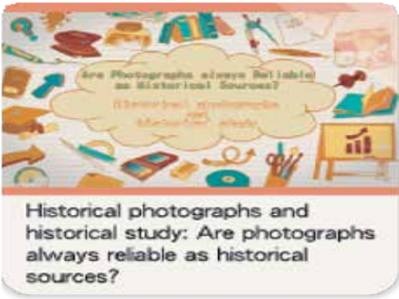Introduction

Part A Videos: Source-based History Learning

In this part, there are two video clips about how to use historical sources to study History. Professor KWONG Chi-man discusses the similarities and differences between history, past and memory, and explains the importance and limitations of using primary sources in studying History in the two video clips respectively.

Teachers can use the video clips as introduction and pre-assessment task to equip students with the basic methods and attitudes in studying History. Students can also watch the video clips to practise self- directed learning in History.

For more details, please visit the following website

https://historye-learning.edb.hkedcity.net/ethnic_minority/intro_e.html

or scan the QR code below to watch the two video clips.

4

- Abstract*: What kind of historical sources can be used to write history?
Professor KWONG Chi-man

What is history?
- History educates us about the past so that we can:
  - Sympathise with different historical experiences
  - Understand the historical contexts that shaped the world we live in
- When studying history, we should know from history that the contexts of various situations are always different from one another
  - We should not reduce history into simple stories and distort history

How is history different from “the past” and “memory”?
- Memories are glimpses of the past that are held by individuals
  - One may simply lose some of his/her memory when time lapses; interpretation and understanding of the past may also change over time
- It is a common pitfall for people to assume that the views of those who had experienced a historical event are unchallengeable facts
  - Two sides of the same event can give very different or contradictory accounts
    - When views are compared, there can be lots of contradictions
    - One may deliberately distort his/her recollections for their own benefits
      - Understanding the difference between history, the past, and memory is crucial for anyone who is trying to study history

Is writing history simply about reconstructing the past?
- Writing history is not an attempt to recreate the past in its entirety
  - Much of the past have not been recorded in any form
  - Therefore, complete recreation of the past is impossible
- The study of history is an attempt to create an interpretive account of selected parts of the past
  - Historians have to judge whether a particular piece should be included in his/her study

5

What are the primary sources? How do historians use primary sources?
- Historians need to collect a certain amount of historical data that allow them to have a clearer view of the past
- Historians have to turn to primary sources or the raw historical data to make original contributions on a specific topic
  - Try to explain causations in historical events or larger historical trends
  - Identify relevant events and trends and seek the linkages between them
  - Evaluate the relative importance of different factors
- There are various kinds of primary sources: historical relics such as historical structures or their remains, archival materials in the form of official documents or public and private correspondents,
contemporary publications and literature, oral history records, or even graphical materials such as paintings and photographs
- Secondary sources include relevant researches of other experts
  - Enable historians to write surveys of a long period or cover a broad topic

Are all primary sources equally reliable? If not, how should we use them?
- Primary sources are created by people from the past who had various motives and operated in a very different historical context
- Primary sources should be critically assessed
  - Keep in mind that some of the primary sources are biased in one way or another
  - One should collect a variety of sources from different perspectives and to cross-check them critically
- “Unreliable” primary sources also offer important clues of how people in the past thought and acted. We can approach primary sources from perspectives that are not thought of by the authors of the
sources or by historians who studied them before us

- Please view the video clip to understand the detailed explanation given by Professor KWONG Chi-man.

With reference to the above sources, how important do you think ‘primary source’ is in the study of history? Explain your answer.
(The following answers are for reference only.)

The importance of ‘primary source’:
Primary sources can allow historians to have a clearer view of the past, such as from surviving pieces of the past, the memories of witnesses, etc.
Primary sources can help historians make original contributions on a specific topic.

6

- Abstract*: Historical photographs and historical study: Are photographs always reliable as historical sources?
Professor KWONG Chi-man

Before the Emergence of Photography
- The use of graphics to depict or commemorate events probably predates writing
  - For example: cave drawings in different parts of the world
- As printing press became more widespread in modern times, pictorials were major means for people to understand current affairs
  - Pictorials on the graphical news reports were not totally reliable. Artists painted these pictorials with some limitations
    - For example: Artists had very limited knowledge of what they were actually drawing, and could only base their creations on faint impressions or fragmented information provided to them
- These “inaccurate” pictures are by no means useless as historical sources. One can understand more about the people and the society that produced them

History in photographs
- The very first photograph appeared in France in 1826
  - At that time, photography was a very troublesome affair
    - For example: the camera had to expose for days in order to take a picture. These cameras could only capture images of unmoved objects
- The first major historical event that was depicted in photography was the Crimean War (1853-56)
  - Reporters equipped themselves with cameras and they used them to shoot the battlefield and the soldiers
    - Photos appeared on major pictorials
      - Presented unadulterated scenes of the battlefield and gave the readers a sense of the “truth” from the front
      - Many of these early photographs were posed photographs
Readers could hardly identify whether the picture was a posed one or not

7

Are photographs unadulterated historical sources?
- Photographs may not be neutral and objective representations of the past
  - They are by nature not more reliable than other historical sources
- Photographers have certain preferences or biases and may want to use their works for different purposes

  - They can always choose what to be included and highlighted in their pictures by positioning and cropping
- People even edit the photographs during post-production stage
  - For example: add different elements in the same image, paint on photographs, or brush away unwanted elements

Pay attention to details, have a questioning attitude and verify the credibility of the photo from different perspectives
- Detail of the photos are unintentionally captured by the photographers. From that, we can spot interesting insights about the past
- When studying historical photos, instead of simply following the lead of the creator of the photograph, one always need to pay attention to detail of a photograph
- Understand more about the historical background of the photo in order to read more from it

- Please view the video clip to understand the detailed explanation given by Professor KWONG Chi-man.

With reference to the above sources, how reliable are photographs as historical sources? Explain your view.
Students can consider the following perspectives:
The producers of historical pictorials have certain preferences or biases and may want to use their works for different purposes.
The photographers of historical photos might produce posed photographs to amplify the impact of the images.
Historical pictorials might be embellished. Some of the contents in these pictorials might be deleted.

8

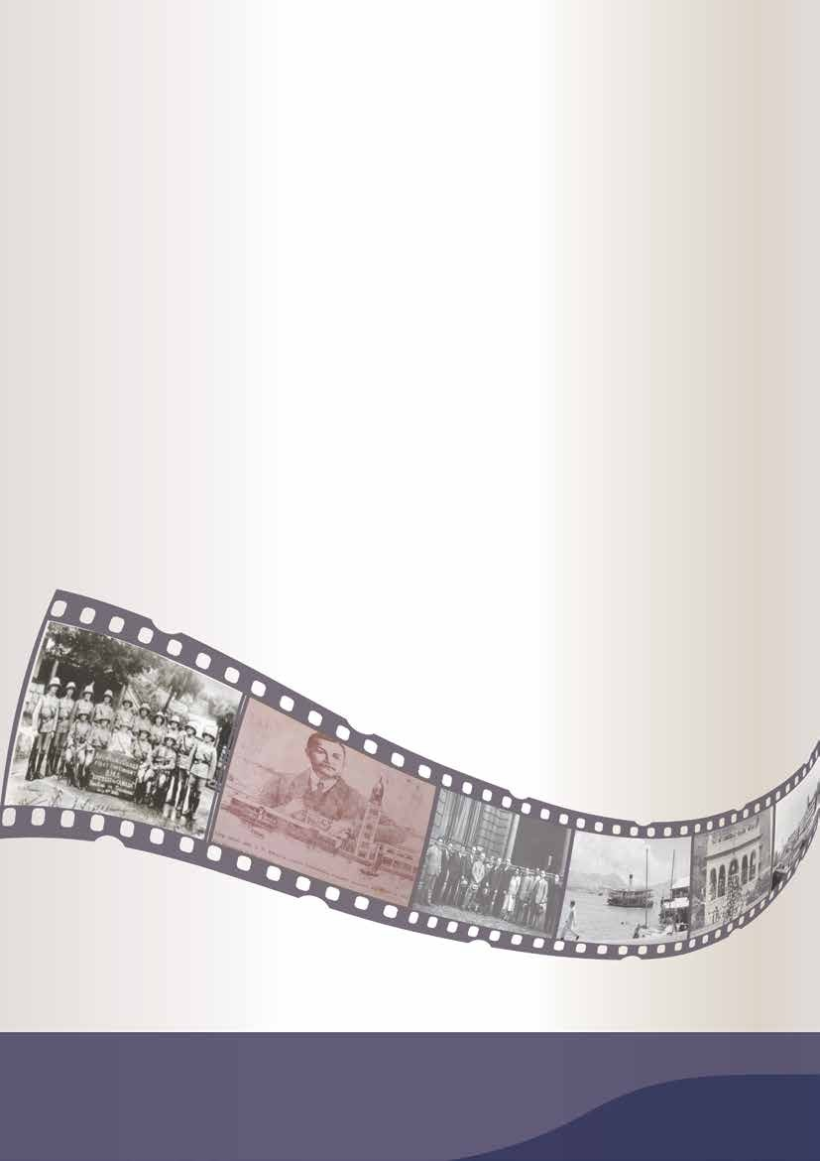

Personal, Social and Humanities Education Section Curriculum Development Institute Education Bureau

