In Pursuit of Aspiration – History of Different Ethnic Groups in Hong Kong and their Contribution to the Development of Hong Kong

Personal, Social and Humanities Education Section, Curriculum Development Institute, Education Bureau

Part B

Contents

- Jewish New Year services 14
- Jewish Recreation Club 15
- Jewish Recreation Club Purim Ball Menu, 1950 16

- Photo of the Ohel Leah Synagogue soon after it was first built in 1902 (Jews) 17

5.

6.

7.

8.

9.

10.
List of subscribers to the Ohel Leah Synagogue, 31 December 1939 (Jews) 18

Governor Matthew Nathan, a Jewish Hong Kong Governor in Hong Kong from
1904 to 1907 19
David Sassoon and his sons (Jews) 20
Photo of Sir Elly K a doorie flanked by his two sons, Horace Kadoorie (left) and Lawrence Kadoorie (right) in the 1920s (Jews) 21
Wartime Records of Lawrence Kadoorie 1 (Jews) 22
Wartime Records of Lawrence Kadoorie 2 (Jews) 23

- Peninsula Hong Kong Hotel with Chinese, European and Indian staff members, 1928 24
- Jewish refugees celebrate Jewish New Year at The Peninsula Hotel, 1946 25

Jews Await Transport to Australia (3 September 1946) 26

The Peninsula Menus, Gaddi's (French/Swiss) 27

Expense summary of Kadoorie Agricultural Aid Association (KAAA) Project for the training of Gurkhas 29
British Gurkha Ex-Servicemen Re-integration Training Scheme Letterhead 30 Cover of agricultural teaching material for Gurkhas in Hong Kong 31 Agricultural Training Course for Gurkha Soldiers 32

- The Head office of the China Light & Power Company (Established by a Jewish family) 33
- CLP Record of an Indian staff member 34

- Police Report on Indians, Sikhs, Europeans and others, 1870 35

- Indian and Chinese police in 1900 36

- Indian Temple and Community, 1905 37

- Photo of the Jamia Mosque for Muslims 38

- Photo of the Hindu Temple 39

- An article about Indian community in Hong Kong, 1941 40

- Hong Kong News on Indian Memorial Service for Gandhi, 13 February 1948 42

- Letter from Hong Kong Governor Sir John Davies to Lord Stanley, Secretary of State for the Colonies, about the Parsis in Hong Kong , July 1845 43

- Photo of Sir Hormusjee Naorojee Mody, a Parsi merchant 44

Hong Kong Government Gazette about the appointment of Sir Robert Hormus Kotewall, a mixed-race of Parsi and Chinese, as member of the Executive Council, 1936 (Parsi) 45

- Star Ferry (Established by Parsi) 46

- Ruttonjee Sanatorium (Parsi donation) 47

Press cutting of JP Braga, an important Portuguese politician and businessman in Hong Kong 48

Photo of the Rosary Church with Portuguese donation for construction 49

Letter from Hongkong Engineering and Construction Company inviting A.V. Skvorsov, a Russian engineer, to join the company 50

Russian water police in Hong Kong, 1930s 52

Number of German residents in Hong Kong from 1871 to 1931 53

- F. Blackhead & Co.'s Soap Factory, a German factory in 1908 54

- Hermann Melchers, the founder of Melchers & Co. (a German company) with his
staff in 1873 55

- The branch house of Carlowitz & Co., a German company in Hong Kong in 1906 56

- Advertisement of The China Clipper (Hong Kong and Southeast Asia) 57

- Number of Filipino, Thai and Indonesians living in Hong Kong, 1979-2011 58

- Extract from the Chinese version of Filipino song “Anak” in Hong Kong 59

The Mission for Migrant Workers(MFMW) cover page of the Documentation
Series ( Filipino), 1983 60

- Interview script about the Swiss Cook Felix Bieger’s description of the early Gaddi’s 61

Interview script about Sarbajit Gurung’s description of Gurkha and their participation in
the Agricultural Training Course 63

Interview script about Christian Ramage’s description of the French community in Hong Kong 65

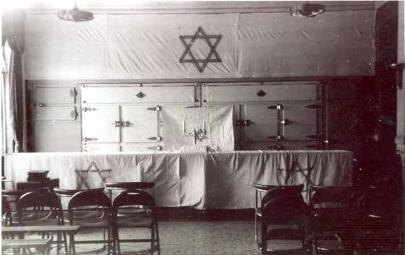

Jewish New Year services

Source: The Hong Kong Heritage Project

Rosh Hashanah (literally meaning the beginning of the year) is the Jewish New Year. It begins in the first day of Tishrei, which is the first month of the Jewish civil year, i.e. the seventh month of the ecclesiastical year and is also the 163 days after the first day of Passover. Except the Torah who define Rosh Hashanah as a one-day celebration, most Jews celebrate it as a two-day festival. Rosh Hashanah is a festival to expiate themselves to the God, therefore one of the celebrating events is praying inside the Synagogue. From the photo we can observe how the Synagogue will be decorated during the Jewish New Year: cloth marked with the Star of David was placed on the wall and the table. In the middle of the table there was also a Menorah placed. Both the Star of David and the Menorah are important symbols for Judaism.

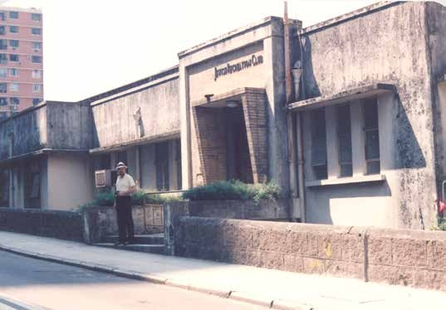

Jewish Recreation Club

Source: The Hong Kong Heritage Project

The Jewish Recreation Club (JRC) was established in 1905. At the very beginning, it only occupied a single room. It was then expanded in 1909 after receiving donations from Elly Kadoorie. As the Club aimed at enhancing exchange between different ethnic and cultural groups, it was open to the Jews of different nationality, as well as members of the community who came from different cultural and religious backgrounds. At the beginning, the Club also provided recreational amenities such as tennis court. When the situation in East Asia and the world deteriorated during the 1930s, it shifted its focus to relief activities for Jewish refugees fleeing to Hong Kong. Two weeks after the Japanese occupied Hong Kong in December 1941, the Recreation Club was forced to close down until the end of the war. It was then reconstructed in 1949.

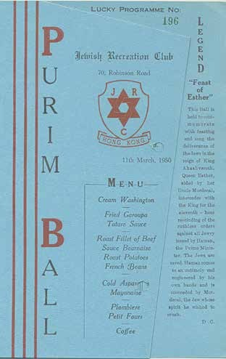

Jewish Recreation Club Purim Ball Menu, 1950

Source: The Hong Kong Heritage Project

According to the Book of Esther, Purim is to remember the Jews that were freed from the plot of the ancient Persian vizier Haman the Agagite, who wanted to exterminate the Jews in Persia. Jewish communities all around the world celebrate this festival every year. The Purim ball held in the Jewish Recreation Club in 1950 was the first social event held in the Club after its reconstruction. From the menu above, we can know the importance of Purim to the Jews by how bountiful the dishes are.

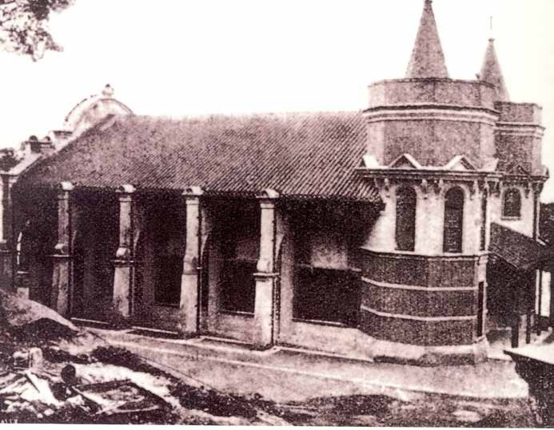

Photo of the Ohel Leah Synagogue soon after it was first built in 1902 (Jews)

Source: Hong Kong Jewish Historical Society

Built in 1902, the Ohel Leah Synagogue was the earliest formal Synagogue in Hong Kong. In appreciation of the donations of Jacob Sassoon and his brothers, the Synagogue was named after their mother, Leah. Although the building was in colonial style, the interior was in classical Sephardi Jewish style as most of the Jews in early Hong Kong were Sephardi Jews from Baghdad. The Synagogue was also separated by gender, with the second floor restricted to female and the ground floor to males. This was arranged according to the religious rules of the Jews. Except being confiscated during the Japanese Occupation, it is one of the very few Synagogues in Asia that was being used for religious purposes throughout its existence.

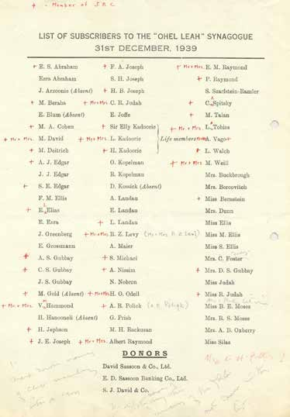

List of subscribers to the Ohel Leah Synagogue, 31 December 1939 (Jews)

Source: Hong Kong Heritage Project

The Jewish community of Hong Kong in the 1930s was a small and dispersed one. Although the core of the community was formed by the wealthy merchants from Baghdad, the community also included Ashkenazi Jews from Eastern Europe who escaped from pogroms and anti-Semitism in the 1880s and 1890s. There were also Russian Jews who came from northeastern part of the mainland, as well as European Jews (mainly German and Austrian) when Hitler’s persecution of the Jews intensified in 1938. From the List of subscribers to the Ohel Leah Synagogue, we can observe the structure of the community as well as the leadership enjoyed by the Baghdad Jews. Apart from the non-Baghdad Jews like Monia Talan, the Sassoon Company was still on the list of donors, although the family had already left Hong Kong.

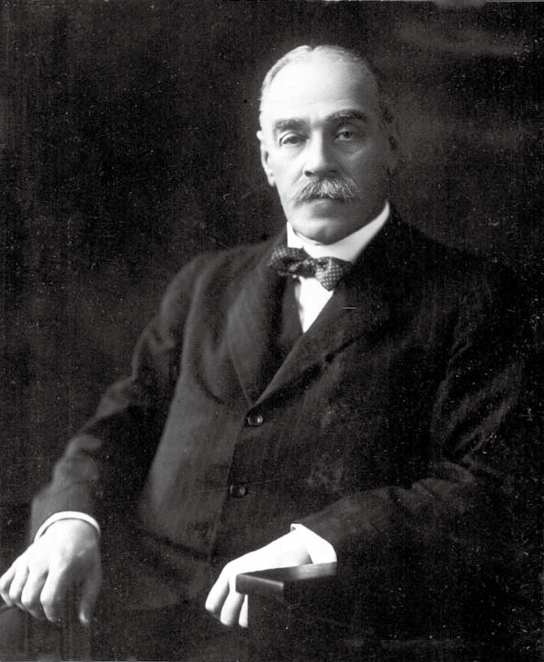

Governor Matthew Nathan, a Jewish Hong Kong Governor in Hong Kong from 1904 to 1907 (This photo was taken when he was the Governor of Queensland in 1925.)

Source: Wikipedia Commons https://commons.wikimedia.org/wiki/File:Queensland_State_Archives_3769_Portrait_of_Sir_ Matthew_Nathan_Governor_of_Queensland_1925.png

Sir Matthew Nathan was the first and the only Jewish Governor of Hong Kong; it is seen as an important milestone for the development of Jewish community in Hong Kong under British colonial rule. He was born in London in 1862. He served as the Governor of Sierra Leone and Gold Coast in Africa, and was appointed as the Governor of Hong Kong in 1904. When he arrived in Hong Kong, Nathan was 42 years of age. Nathan pioneered the early development of Kowloon, and pushed ahead the Kowloon-Canton Railway project. When he was serving as the Governor of Hong Kong, Nathan also served as the Honorary President of the Ohel Leah Synagogue and helped the community to extend the lease on the Jewish Cemetery. He left Hong Kong in 1907 and died in England in 1939. Nathan Road, one of the busiest roads in Kowloon, was named after him.

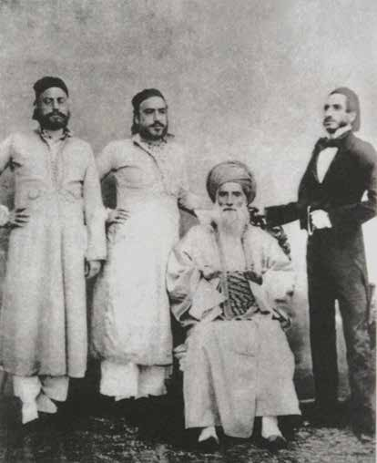

David Sassoon and his sons (Jews)

Source: The Hong Kong Heritage Project

Many Jews arrived in Hong Kong soon after the British colonial rule began. Among them, the earliest and the most successful family was that of David Sassoon, the community leader of the Iraq Jewish. After they had arrived at Canton in 1844, they created a substantial venture along the China coast in five years. When they set up their office in Hong Kong in 1857, almost all the Jews in the Mainland and Hong Kong were working under the Sassoon Family. His son Arthur Sassoon was one of the founders of The Hong Kong and Shanghai Bank Corporations (HSBC). Another son of David Sassoon, Frederick Sassoon, was appointed as a member of the Hong Kong Legislative Council in 1884.

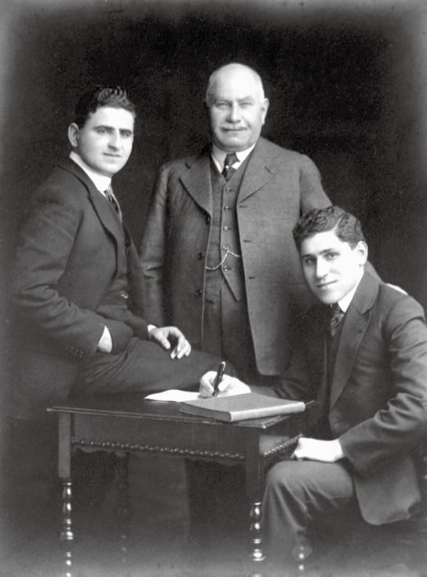

Photo of Sir Elly Kadoorie flanked by his two sons, Horace Kadoorie (left) and Lawrence Kadoorie (right) in the 1920s (Jews)

Source: The Hong Kong Heritage Project

The Kadoorie family, came from Baghdad, was another influential family among the ethnic minorities in Hong Kong. The family had a close tie with the Sassoon Family. Both families could trace their origin to Baghdad, and Elly Kadoorie once worked for the Sassoon family in Bombay, Hong Kong, and the treaty ports in northern part of the mainland. In the 1880s, Elly Kadoorie went to Hong Kong and started his own broker business. When his brother Ellis Kadoorie arrived in Hong Kong in 1883, they invested and eventually established several core family businesses such as the China Light & Power Company (CLP) and the Peninsula Hotel. Later, Elly’s elder son Lawrence Kadoorie took over the family business, while another son Horace Kadoorie concentrated on the family’s philanthropic efforts, such as the Kadoorie Agricultural Aid Association.

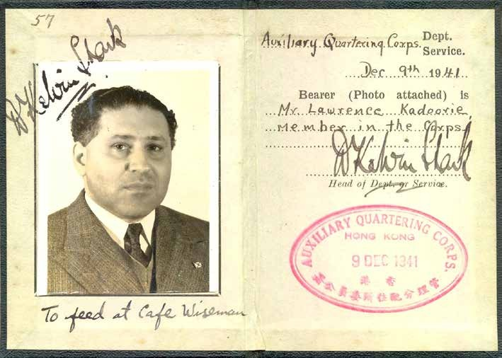

Wartime Records of Lawrence Kadoorie 1 (Jews)

Source: Hong Kong Heritage Project

This record is a document issued to Lawrence Kadoorie by the Auxiliary Quartering Corps on 9 December 1941. The Corps, under the control of Rating and Valuation Office, was responsible for the expropriation of civilian properties during the war. Apart from the photo of Lawrence Kadoorie, the record showed that he was a member of the Auxiliary Quartering Corps when Hong Kong was occupied by the Japanese in 1941. The text below the photo indicated that he was arranged to be fed at Café Wiseman. Such arrangement is related to the food rationing after the outbreak of war.

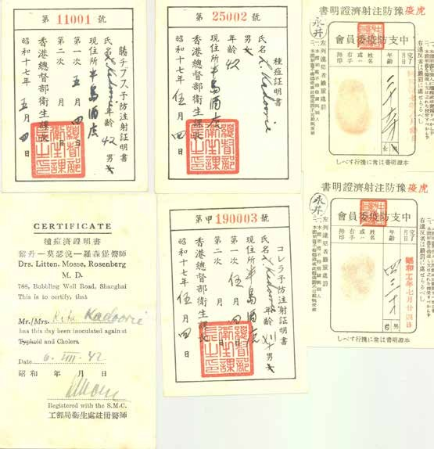

Wartime Records of Lawrence Kadoorie 2 (Jews)

Source: The Hong Kong Heritage Project

These epidemic prevention records during the Japanese-occupation period belonged to Lawrence Kadoorie and her daughter, Rita Kadoorie. Soon after the Japanese occupation of Hong Kong had started, the Japanese established their administration in January 1942. At that time, the main objective of the military government was to ensure Hong Kong as a logistic base for operations in the Southeast Asia. Therefore, the purpose of the health policy was to curb the spread of infectious disease, especially Cholera, which was the most prevailing at that time. The vaccination records of Cholera, Smallpox, and Typhoid fever are also related to this policy.

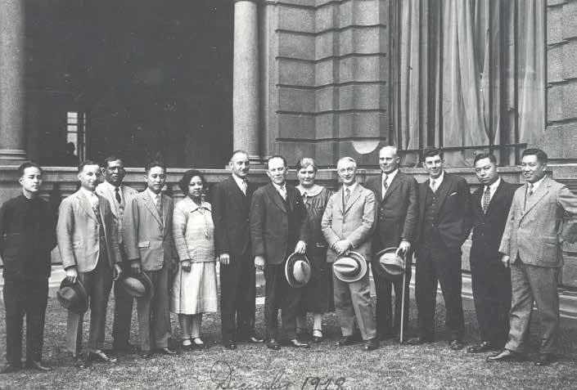

Peninsula Hong Kong Hotel with Chinese, European and Indian staff members, 1928

Source: The Hong Kong Heritage Project

The Peninsula Hotel is located at Salisbury Road, Tsim Sha Tsui, Kowloon. It was opened for business on 11 December 1928, making it the oldest among the existing hotels in Hong Kong. The structure of the hotel is also being classified as a Grade I historic building. With seven floors, it was the highest building in Kowloon before the 1950s. It was also one of the most advanced and luxurious hotels in Asia, and has been titled “Grande Dame of the Far East”. Peninsula Hotel serves as an important socialising space for the elites. The picture shows the Chinese, European, and Indian staff of the hotel.

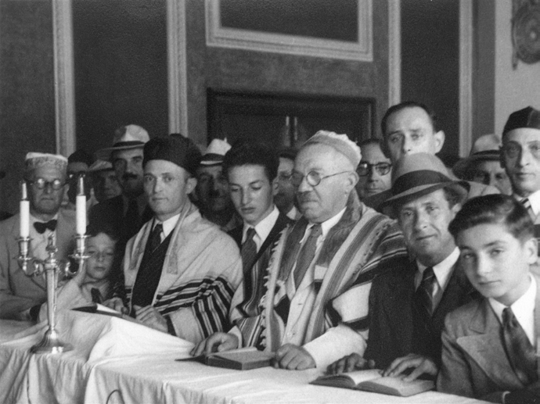

Jewish refugees celebrate Jewish New Year at The Peninsula Hotel, 1946

Source: The Hong Kong Heritage Project

After the end of the Second World War, Hong Kong became a transit port for those Jewish refugees who left Shanghai for new homes in different parts of the world. In 1946, as vessels were mainly used for returning soldiers home, a group of Jewish refugees, who were originally bound for Australia, were forced to stay in Hong Kong. To accommodate them, Lawrence Kadoorie, not knowing how long it would be before another ship could be found, opened the Peninsula’s ballroom for them as a temporary living area. These refugees finally began their journey in the fall of 1946. Still, there was a Jewish community in Hong Kong afterwards.

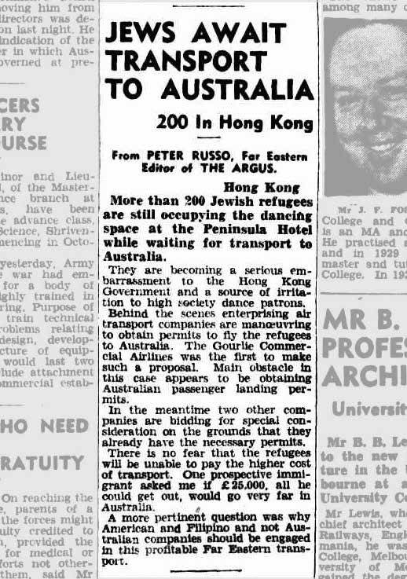

Jews Await Transport to Australia (3 September 1946)

Source: The Argus

According to the news story above, the 200 Jews who were stranded in Hong Kong and billeted in the Peninsula Hotel due to a lack of shipping stayed at Hong Kong until September, 1946. At that time, it was increasingly being seen as an embarrassment to the Government. However, at that time several enterprising airlines started to apply for landing permits from the Australian authorities, so that the Jews who can afford the air fare could travel to Australia by air. Interestingly, the last paragraph of the news showed that only American and Filipino companies were interested in such a highly-profitable business.

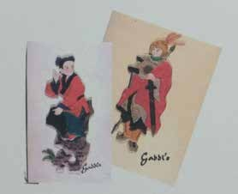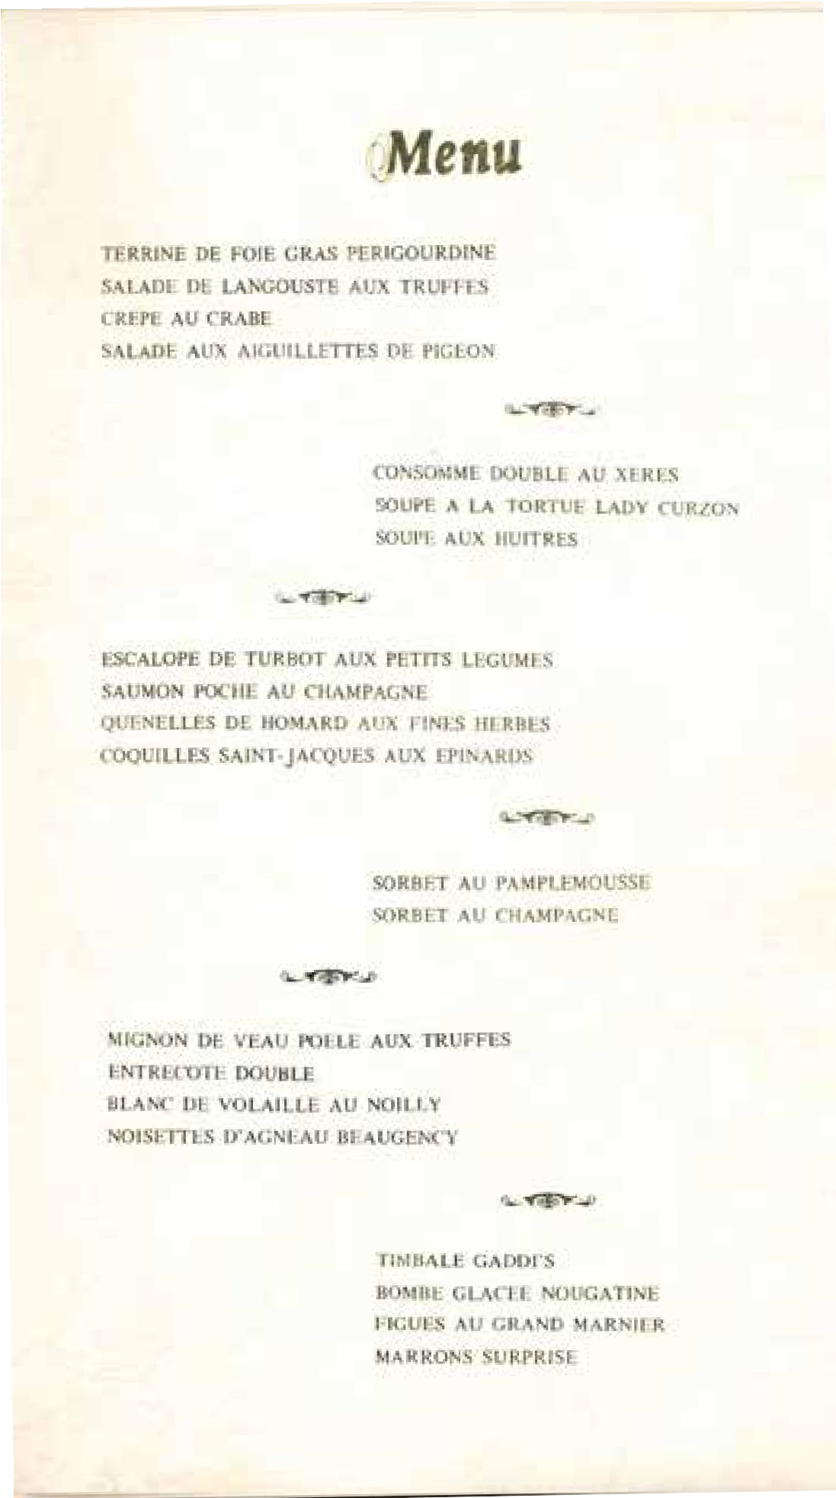

The Peninsula Menus, Gaddi's (French/Swiss)

Source: The Hong Kong Heritage Project

27

The Gaddi's in Peninsula Hotel was opened for business in 1953. As the first of Gaddi's restaurants in the East, it is recognised as one of the few authentic French fine-dining establishments in Hong Kong. It maintains a strict dress code to the customers. From the menu above, we can also see that the menu was written in French. On the other hand, the images of a Chinese boy and an ancient military officer were drawn on the cover, offering a stark and interesting contrast to the content of the menu.

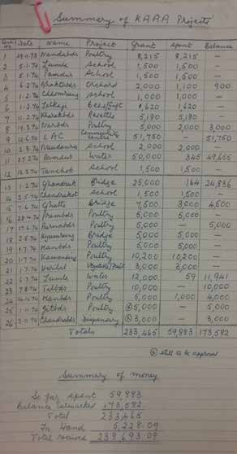

Expense summary of Kadoorie Agricultural Aid Association (KAAA) Project for the training of Gurkhas

Source: The Hong Kong Heritage Project

Kadoorie Agricultural Aid Association (KAAA) was founded by Sir Horace Kadoorie and Lord Lawrence Kadoorie in 1951. It provided agricultural training, interest-free loans, infrastructure for farms, demonstrations of different types of farming and herding methods, and improvements on husbandry. From the Summary of KAAA Project, we can understand the expenses of the project covered various items such as poultry, schools, orchard keeping, bee keeping/gifts, resettlement, community centre, water, bridges and vegetables etc. The scope of support provided by the KAAA was very extensive.

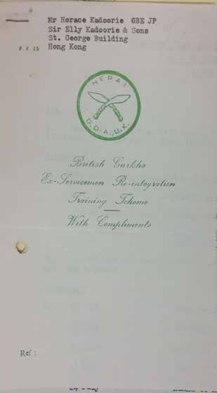

British Gurkha Ex-Servicemen Re-integration Training Scheme Letterhead

Source: The Hong Kong Heritage Project

Gurkha soldiers from Nepal was one of the important components of the British garrison of Hong Kong. Their main duties included interception of illegal immigrants and maintenance of public order. However, the Gurkha veterans, who received elaborate military training, might find themselves unable to adapt after retiring from the military as they were not trained for other vocations. Therefore, the British Army cooperated with the Kadoorie Agricultural Aid Association and introduced a British Gurkha Ex-Servicemen Re-integration Training Scheme. The photo is the letterhead of the program.

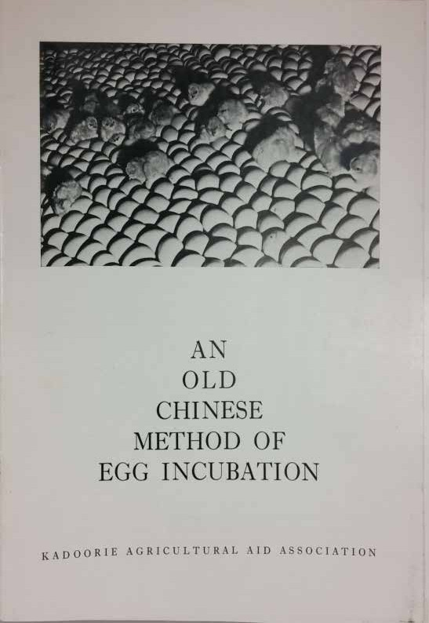

Cover of agricultural teaching material for Gurkhas in Hong Kong

Source: The Hong Kong Heritage Project

To ensure the Gurkha ex-servicemen could be incorporated in society and be able to support themselves economically by enriching their knowledge on farming and livestock keeping, the British Army invited Sir Horace Kadoorie to provide agricultural training for the soon retiring Gurkhas. When providing such training, the Kadoorie Agricultural Aid Association (KAAA) paid much attention to local conditions and contexts. For example, as shown in the cover, the agricultural training material on an old Chinese method of egg incubation with low cost was prepared for Gurkhas.

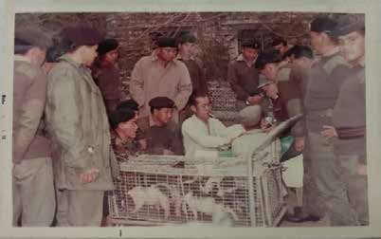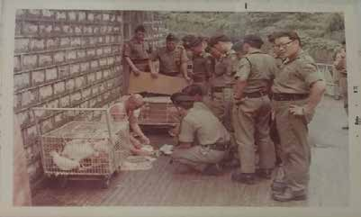

Agricultural Training Course for Gurkha Soldiers

18.1

18.2

Source: The Hong Kong Heritage Project

Brigadier-general Burnett from the 48th Gurkha Infantry Brigade was quite worried about the life of the retired Gurkhas in Hong Kong and Nepal. Therefore, the agricultural training program aimed to provide modern agricultural skills and it was started in 1968 with the aid from Sir Horace Kadoorie. In photo 18.1, an instructor was surrounded by a group of
32
Gurkhas with curious and serious faces. A cage of piglets and a big white barrel were next to them, which seemed that they were having a lesson on piglets feeding. In photo 18.2, an instructor along with cages of chickens and ducks, and also some plates on the floor, who was surrounded by his Gurkha students, might tell us that he was teaching the Gurkhas some skills on chicken and duck feeding. From these photos, we can see the diversity of training offered by Kadoorie Agricultural Aid Association (KAAA).

The Head office of the China Light & Power Company (Established by a Jewish family)

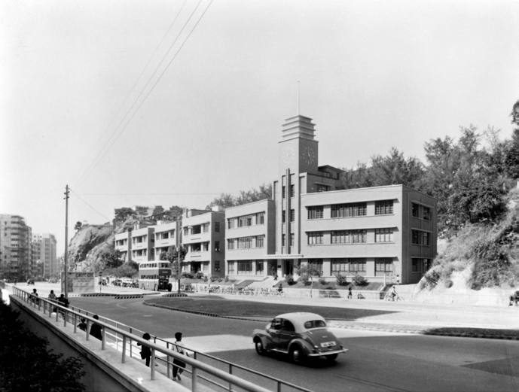

Source: Hong Kong Heritage Project

The China Light & Power Company Syndicate was established by the Kadoorie family in 1901. It aimed at providing electricity to Kowloon and the New Territories. In order to better manage the provision of electricity to the rapidly increasing population in Kowloon in the 1930s, decision was made for a new head office located in 139-147 Argyle Street, Ho Man Tin, Kowloon. The foundation of the new Head Office was laid in 1938, and the building was finished in 1940. The building was known for its conspicuous red bricks. It was a five- storey, modernist-style building with a clean design. The clock tower at the center was the main feature of the building. It is classified as a Grade I historic building in Hong Kong.

CLP Record of an Indian staff member

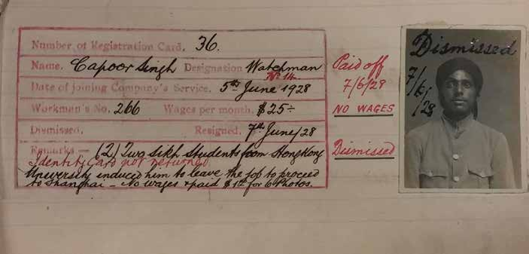

Source: The Hong Kong Heritage Project

The photo was a staff record of China Light & Power Company (CLP) in the late 1920s. CLP was established in 1901 as one of the two electricity suppliers in Hong Kong. The staff record shows that this watchman started his appointment on 5 June 1928 with a monthly salary $25. Remarks on the record show that the staff resigned just only two days after he had reported duty, because two Sikh students induced him to go to Shanghai. Therefore, not only did he receive no wages, he also needed to pay for six photographs.

Police Report on Indians, Sikhs, Europeans and others, 1870

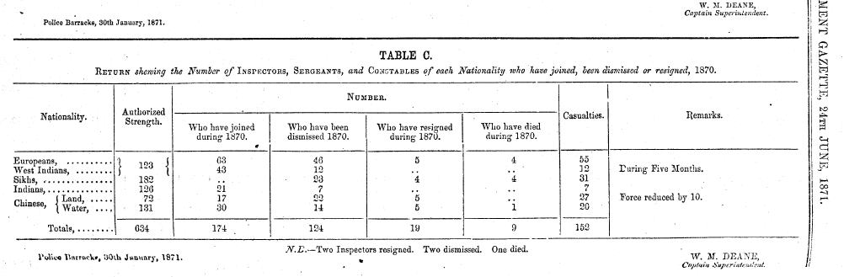

Source: The Hongkong Government Gazette

Chief Magistrate William Caine established the Hong Kong Police in 1844. Chinese policemen augmented the police force one year after the formation of an exclusive European force. In the 1860s, Indians were recruited. From the return shown in 1870, there were 634 Chinese, European and Indian police, including 123 came from Europe and West India, 182 Sikhs, 126 Indians and 203 Chinese (131 of them were Marine Police). This shows the ethnic diversity in the police force to keep public order in early Hong Kong.

Indian and Chinese police officers in 1900

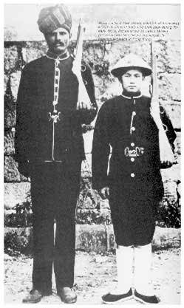

Source: Walk in Hong Kong

In the 1900s, many Indians were recruited by the Hong Kong Police, some of them were veterans of the British Indian Army. The uniform for Indian policemen was similar to that of the European armies, except the use of Indian Turban instead of European headgears. As the Indians were nicknamed as “Moro”（摩羅） by the Chinese in Hong Kong, the Indian
policemen were also called “Morocha”（摩羅差）. Throughout the colonial period, the ratio of Chinese in the police force increased steadily. The Chinese policemen were dressed differently compared with their Indian colleagues. They wore a green tunic, a Chinese style bamboo hat, and cloth shoes.

Indian Temple and Community, 1905

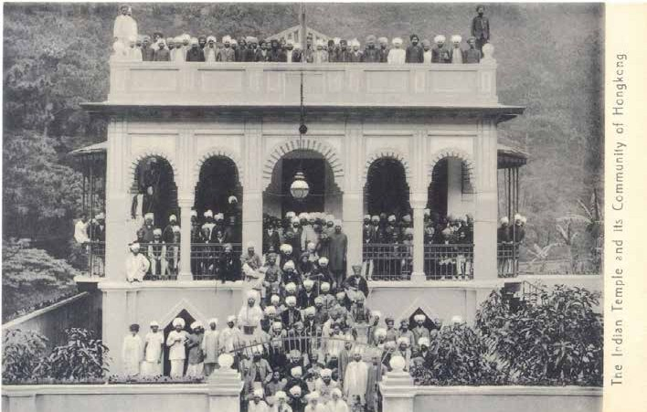

Source: https://Gwulo.com

This photo was taken around 1905. This Indian temple, which was opened in 1902, served as a Sikh and a Hindu temple at the same time. From the outfit of the people in the photo, we can discern the followers of two religions. Except for the few people at the left- hand side of the entrance, most of them were Sikhs with turbans and beard. According to the 1911 census, there were around 2,000 Indians in Hong Kong at that time, around a quarter of them were Sikhs. On the other hand, there were only 70 Hindus. This population
distribution was reflected in the photo.

Photo of the Jamia Mosque for Muslims

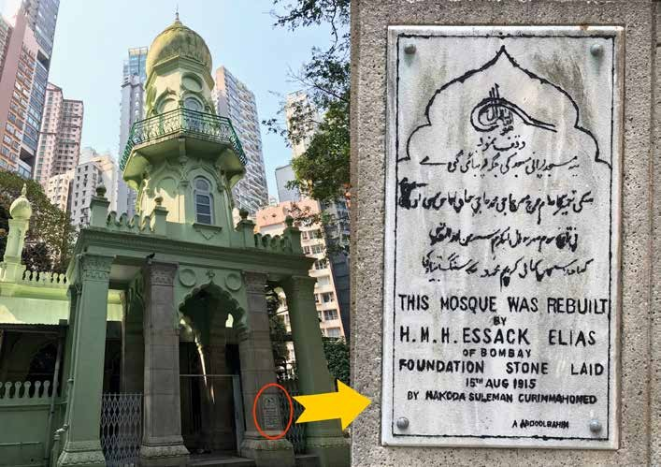

Source: provided by a member of this project

The Jamia Mosque located at 30 Shelley Street, Central, is the earliest Mosque in Hong Kong which is also known as “Moro Temple”（ 摩 羅 廟 ）. The Mosque was a small stone hut built by Muslims for worshiping at the beginning. It was rebuilt as the earliest formal Mosque after the Muslim community successfully obtained the piece of land from the Government. Later in 1915, the Mosque was rebuilt again as Haji Mohamed Essack Elias, a wealthy businessman from Bombay, offered a generous donation. By now the Mosque covers an area of about 4,000 square feet and could serve more than 400 persons at the same time. It has become a Grade I historic building since 2010. The appearance of the Mosque remains almost the same as it was in 1915, for example, its Islamic minaret and columns. The major difference was that its colour changed from grey-white to green.

Photo of the Hindu Temple

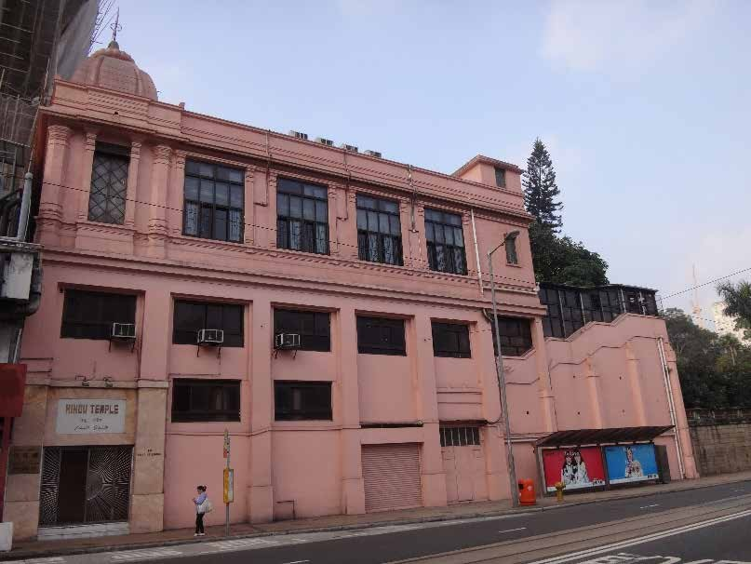

Source: Website of Hindu Association, Hong Kong http://www.hinduassociationhk.com/4-1Photos.html

The Hindu temple located in 1B Wong Nai Chung Road, Happy Valley, was built in 1953. It is the oldest Hindu Temple in Hong Kong, and its construction was largely supported by the Hindu Association Hong Kong founded in 1949. The Temple has a simple “Northern
Indian” architectural style. It serves to worship the principal Hindu deities like Vishnu and Shiva, and also the famous deity Ganesha. Celebrations are being held during important Hindu festivals such as Diwali (Festival of light), Thaipusam, and Songkran Festival. For the Hindus residing in Hong Kong, they can hold a Hindu-style engagement or wedding ceremony in the temple in accordance with the Hong Kong Marriage Ordinance.

An article about Indian community in Hong Kong, 1941

India's contact with China goes back twenty-three centuries when Buddhism was introduced into China from India, and India's association, mainly economic, with the colony of Hong Kong dates from the very date of the foundation of the Colony in 1841.

Prior to this year (1841) Indian firms were carrying on business in Macao and Canton, the pioneer in recent Indo-Chinese trade being the late Sir Jameshetji Jeejeebhoy, Bart, a Parsee adventurer from India. In collaboration with the late Mr. Jardine, they carried on a lucrative trade between India and China, and the Parsee knight introduced into India Chinese bangles, glass bottles, silks, tea, cassia and sugar from China. He almost monopolised the bottle trade and even to this date his House is known in India as 'bottlewala' (owner of bottles). From India, they brought handwoven cotton piecegoods, cotton yarn, spices, and unfortunately also opium.

This trade was continued by other Indians who followed in his footsteps, and they carried on trade from Canton and Macao, but shifted to Hong Kong as soon as the Colony was founded by Great Britain in 1841.

From 1841 to 1880, the firms which did a good deal of business in Hong Kong were
N. Mody & Co. (1842), Abdoolally Ebrahim (1842), who are still carrying on their business in the Colony and will celebrate their centenary next year, Ghandy & Co. (with which were associated the brothers of Sir Pherozshaw Mehta, the great Indian leader of late nineties of the last century and early years of the present century), Currimbhoy Ebrahim & Co., D. Naoroji & Co., Cawasji Pallonji & Co., Bomanjee Karanjia & Co. and others. Messrs. D. Naoroji & Co. were the original owners and pioneers of the ferry service beteen Hong Kong and Kowloon on the mainland, and the later development of this effort is the present Star Ferry.
Source: Vaidya, V.B, "Indian pioneers ," Hong Kong centenary commemorative talks, 1841-1941.
(World News Service, 1941), 108-110.a

40

This speech was written by an Indian merchant who was in Hong Kong in 1941 in order to commemorate the centenary of British colonial rule in Hong Kong. At that time, the Indian merchants in Hong Kong grouped themselves along religious (Hindu, Sikh, or Islam) or regional (such as Bombay) identities. They arrived at Hong Kong and started business as early as in 1841. The Parsi Merchant Hormusjee Ruttonjee from Bombay and Armenian Merchant Sir Catchick Paul Chater from Calcutta were some notable figures among them. At that time there were 4,745 Indians in Hong Kong, but it was not until 1940 did the Indians form the Hong Kong and Southern China Indian Association to build a more cohesive community. In 1952, the Indian commercial community established the Indian Chamber of Commerce Hong Kong which had made economic contribution to Hong Kong.

Hong Kong News on Indian Memorial Service for Gandhi, 13 February 1948

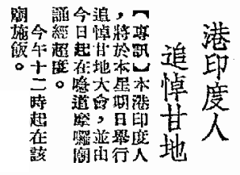

Source: The Kung Sheung Evening News, 13 February, 1948

Gandhi was assassinated on January 30, 1948. Indians in Hong Kong held a memorial service for him in a temple on February 15, the news of which was announced in a Chinese newspaper on February 13. According to the newspaper, the temple was on the Gap Road. As the eastern section of Gap Road which connected with Wan Chai Road was allocated to Queen's Road East in 1948, and the temple mentioned in the notice was the Sikh temple that was in the intersection between Queen's Road East and Stubbs Road. The history of the Sikh temple can be traced back to Sikhs who arrived in Hong Kong with the British Army in 1901. The temple is not only a religious center for Sikhs in Hong Kong, but also a community center with social function. Their identity and social life in Hong Kong are developed from it.

Letter from Hong Kong Governor Sir John Davies to Lord Stanley, Secretary of State for the Colonies, about the Parsis in Hong Kong, July 1845

I am happy to state that the advantages of a British colony have attracted to Hong Kong another very commercial and useful class of men, the Parsis of Bombay, long since actively engaged in the trade with China. They applied to me in a body for the grant of a piece of land at some distance from Victoria as an exclusive place of sepulture for their tribe.

Source: Letter from Sir John Davies to Lord Stanley, Secretary of State for the Colonies, CO129/12, 10 July 1845.

The above passage is quoted from a report submitted in 1845 by John Davies, the Hong Kong governor from 1844 to 1848, to Lord Stanley, the Secretary of State for the Colonies. It reveals that many Parsi merchants moved to Hong Kong due to its desirable environment for trade business. These Parsi merchants accompanied the East Indian Company to conduct their business in Canton since the late 18th Century, and moved their firms to Hong Kong when it was under British colonial rule in 1842. It also shows that most of the Parsis lived in Hong Kong at that time were merchants.

Photo of Sir Hormusjee Naorojee Mody, a Parsi merchant

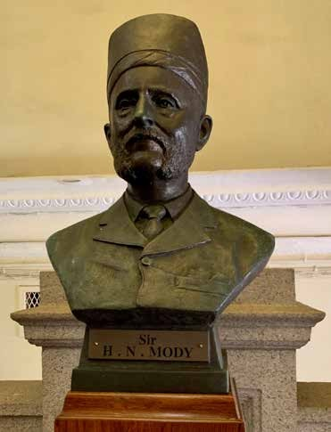

Source: provided by a member of this project

Sir Hormusjee Naorojee Mody (1838-1911) was born in Bombay in 1838; he was an Indian Parsi whose religion was Zoroastrianism. He was the most famous Indian merchant in Hong Kong, and a partner of Sir Catchick Paul Chater (1846-1926), the head of the Hong Kong and Shanghai Bank. In the beginning of the 20th century, Governor Sir Frederick Lugard’s (1858-1945) suggestion for establishing a University in Hong Kong was not approved by the British Government. He then spent great effort to look for capital and fund from the Mainland and Hong Kong. Finally, Mody provided a donation of 150,000 dollars for the construction of the University’s campus and its initial operation. This ensured the establishment of the University and its incorporation with the Hong Kong College of Medicine in 1912.

the Hong Kong Government Gazette about the appointment of Sir Robert Hormus Kotewall , a mixed-race of Parsi and Chinese, as a member of the Executive Council, 1936 (Parsi)

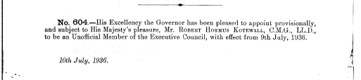

Source: Hong Kong Government Gazette (1936)

Sir Robert Hormus Kotewall was born in Hong Kong in 1880. He is a mixed-race of Parsi and Chinese. He received education at Queen’s College and the Diocesan Boy’s School. Throughout his career, he served in a number of important government posts such as the Hong Kong Police, the Magistrates' Court and the Colonial Secretary. Later he stepped into the business sector as the chairman and consultant for many companies, an experience which made him one of the most important politicians and merchants of Hong Kong during the first half of the 20th century. During the 1925 Canton–Hong Kong General Strike and Boycott, he played an important role to settle the situation which included uniting the commercial sector to maintain economic stability and going to Canton for negotiation. In 1936, he was appointed as an unofficial member of the Executive Council.

Star Ferry (Established by Parsi)

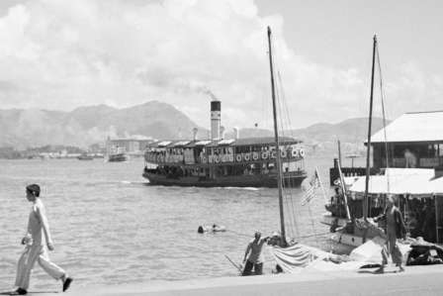

Source: Harrison Forman Collection, American Geographical Society Library, University of Wisconsin-
Milwaukee Libraries https://collections.lib.uwm.edu/digital/collection/agsphoto/id/16317/rec/4

After the conclusion of the Treaty of Beijing in 1860, the Hong Kong Government started the development of the newly-acquired Kowloon Peninsula to solve the problem of land shortage in Hong Kong Island. The number of residents who commuted between Hong Kong Island and Kowloon steadily increased. In 1880, a Zoroastrian established the Kowloon Ferry Company to provide ferry service, with the company’s steam-powered ferries all named with the word “star”. In 1895, Sir Catchick Paul Chater bought the company and renamed it Star Ferry. The ferry service enhanced the development of Kowloon Peninsula, and strengthened its link with Hong Kong Island.

46

Ruttonjee Sanatorium (Parsi donation)

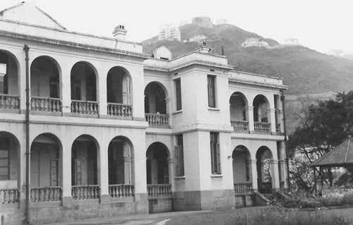

Source: St Columbans Mission Society online resource
https://www.columban.org.au/media-and-publications/the-far-east-magazine/archive/2016/the-far-east- may-2016/a-group-of-valiant-women

Jehangir Hormusjee Ruttonjee (1880-1960) was a Parsi born in Bombay. He settled in Hong Kong in 1892 and enrolled at Queen’s College soon afterwards. He then took over his father’s wine business after his graduation. Being enthusiastic in the prevention of Tuberculosis, he established the Hong Kong Anti-Tuberculosis Association in 1948. He also donated 850,000 Hong Kong Dollars to convert the Royal Naval Hospital into Ruttonjee Sanatorium, which was specially equipped in treating Tuberculosis victims transferred from Hong Kong government clinics. To support the Government’s Bacillus Calmette-Guerin campaign, the Hospital provided free Bacillus Calmette-Guerin vaccines for the citizens, to lower the chances of children infection rate for the disease.

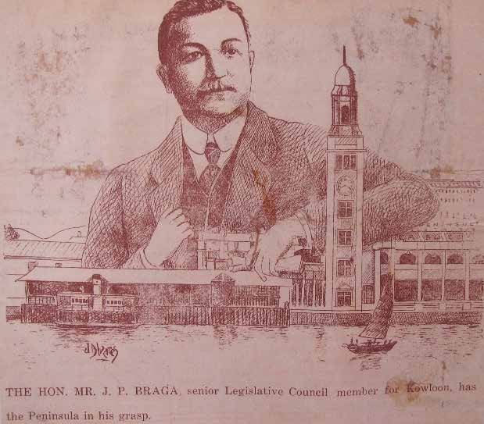

Press cutting of JP Braga, an important Portuguese politician and businessman in Hong Kong

Source: The Hong Kong Heritage Project

Jose Pedro Braga (1871-1944) was an important politician and businessman in Hong Kong before the Second World War. After he had graduated from St. Joseph College, he worked for the Hongkong Telegraph and Reuters as a reporter. Later in 1919 he was commissioned as a Non-Official Justice of the Peace. He was then appointed to the Sanitary Board, the Legislative Council, the Playing Fields Committee, and also the Committee of Broadcasting. Braga was very active in the business circle, serving in leading firms including the Hong Kong, Canton and Macau Steamboat Co., Ltd, Hong Kong Rope Manufacturing Co., Ltd. He also cultivated a close relationship with influential Chinese and European businessmen like Robert Hotung. When the Japanese occupied Hong Kong in 1941, he moved to Macau, and passed away there in 1944. Braga Circuit at Mongkok was named after him.

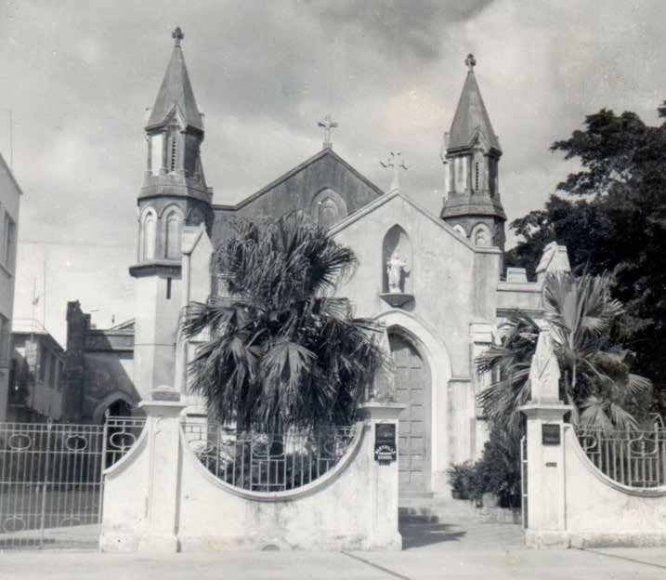

Photo of the Rosary Church with Portuguese donation for construction

Source: Hong Kong Catholic Diocesan Archives

The Rosary Church had the longest history among all the Catholic churches in Kowloon. During the Boxer Uprising, the British Government reinforced the garrison of Kowloon by sending several army units from India. To meet the needs of the Catholics in the army and the nearby area, Father Giovanni M. Spada borrowed a place from the Canossian Sisters to hold a mass. Later a church that was capable to serving about 800 men was built in 1901, but it was deemed inadequate due to the large number of worshippers. Finally, a new church was decided to be built on the land granted by the Canossian Sisters, with the donations from Dr. Anthony Gomes, a Portuguese Catholic. On 10 December 1904, Fr. De Maria laid the foundation stone of the Church. In 1905, the work on the Rosary Church was completed, and the consecration of the Church was also held by Fr. De Maria.

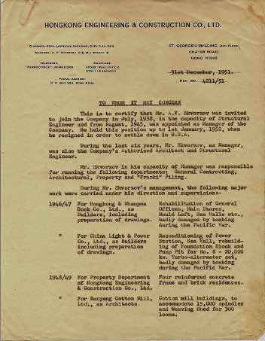

Letter from Hongkong Engineering and Construction Company inviting A.V. Skvorsov, a Russian engineer, to join the company

Source: Hong Kong Heritage Project

50

A.V. Skvorsov was born in Poland under Russian rule in 1893. After he obtained an engineering degree in St. Petersburg in 1918, he worked for the Chinese Eastern Railway. He then turned to Shanghai and worked as an engineer. He moved to Hong Kong in 1938, joining the Hongkong Engineering and Construction Company that was established in 1922. At that time, it was one of the most important engineering companies in Hong Kong. He also joined the Hong Kong Volunteer Defence Crops (HKVDC), and became a prisoner- of-war during the Battle of Hong Kong in December 1941. He spent his time in the prisoner of war camp during the war, and became the General Manager of the company after the war. He then immigrated to the United States in 1952. His career was an example for those Russians who resided in Hong Kong after the Russian Civil War.

Russian water police in Hong Kong, 1930s

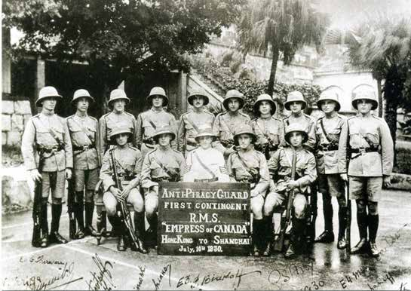

Source: Offbeat, a Hong Kong Police Publication, Issue 777, June 16 to June 29, 2004 https://www.police.gov.hk/offbeat/777/eng/f03.htm

Piracy in the 19th century Southern-China was a serious problem to all authorities of the area, and it could not be easily solved despite the efforts of the colonial government. In the 1920s, the piracy problem came back with a different mode. Instead of operating in pirate ships that could be hunted down by the Royal Navy or the Water Police, the pirates would infiltrate on board by dressing up like ordinary passengers, and hijack the ships when they reached the high seas. They even kidnapped rich passengers for ransoms. At that time, the Hong Kong Police recruited Russians living in Hong Kong to form an Anti-Piracy Guard, which stationed on board to deter the pirates. Some of the Russians were veterans of the Imperial Russian Army who fought against the Bolsheviks during the Russian Civil War. Thus, they were known as “White Russians”. As many of them were forced to flee to Asia after the Civil War, some of them resided in Hong Kong.

Number of German residents in Hong Kong from 1871 to 1931

 | Year | Males | Females | Total
 | 1871 | 152 | 18 | 170
 | 1881 | 138 | 50 | 188
 | 1891 | 149 | 59 | 208
 | 1896 | 203 | 89 | 292
 | 1901 | 232 | 105 | 337
 | 1906 | 237 | 122 | 359
 | 1911 | 214 | 128 | 342
 | 1921 | - | 3 | 3
 | 1931 | 95 | 61 | 156
Source: Periodic Hong Kong Census Returns

A considerable number of non-Chinese residents in Hong Kong during late-19th century was German. From the Census data shown above, although there was a drop in number during the period between 1871 and 1881 and the increase was not apparent until the 1890s, the overall number of Germans in Hong Kong rose steadily during the late 19th century. In 1921, however, there were only 3 German females left in Hong Kong, and the number of German residents remained low. This change was the result of the First World War, during which the Hong Kong colonial government confiscated all German properties and interned all German and Austrian residents.

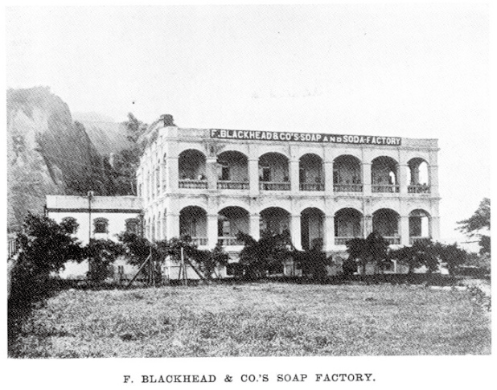
- F. Blackhead & Co.'s Soap Factory, a German factory in 1908

Source: Walk in Hong Kong

F. Blackhead & Co. was established by a German merchant F. Schwarzkopf in Shau Kei Wan in 1890. Schwarzkopf arrived at the West River of Canton in 1855 to start his business in China. He then moved to Hong Kong during the Second Opium War. His business in Hong Kong mainly focused on selling materials and coal for ships, including the German, Russian, and Austrian warships operating in Asia. (The three countries formed the Dreikaiserbund from 1873 to 1887). Schwarzkopf’s company in Hong Kong was named after a direct translation of its original name in English, hence the name “Blackhead”. The company’s name also became the namesake of Signal Hill, which at a time was known as “Blackhead Point”. His son succeeded Schwarzkopf’s business, but the company was confiscated by the Hong Kong Government during the First World War, as Germany was an enemy of the British Empire.

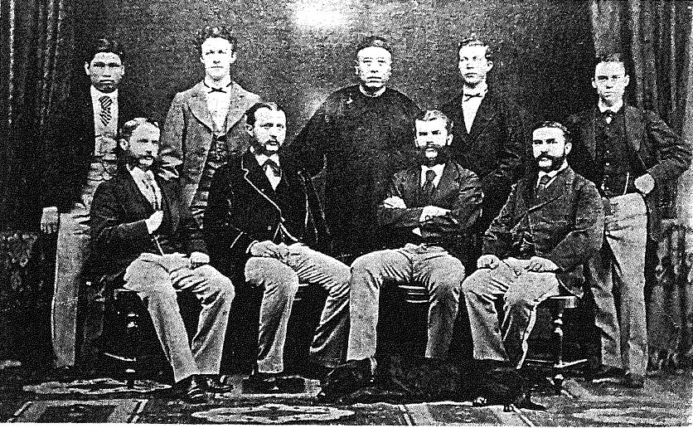

Hermann Melchers, the founder of Melchers & Co. (a German company) with his staff in 1873

Source: Bard, Solomon, Traders of Hong Kong: Some Foreign Merchant Houses, 1841-1899, H.K. Urban Council, 1993, p.102.

Melchers & Co. is a large trading company with a long history. It was established by Carl Melchers and Carl Focke in 1806 in Bremen, Germany. It focused on international trade, and was the earliest European firm to start business with North America. In the mid 19th century, led by Hermann Melchers, Melchers & Co. started to expand its business in East Asia. The first branch in China was established in Hong Kong in 1866. As the photo suggests, it hired both Chinese and European staff, which was a common practice of foreign firms in Hong Kong at that time.

The branch house of Carlowitz & Co., a German company in Hong Kong in 1906

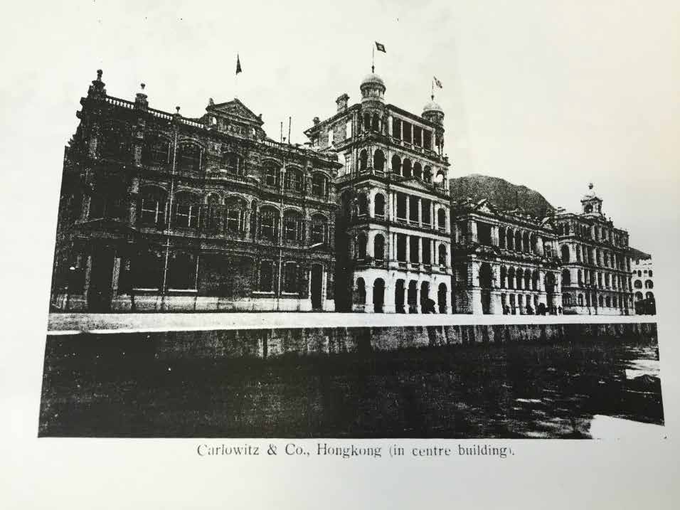

Source: Carlowitz & Co., Hamburg, Hong Kong, New York, China and Japan, p.18

Carlowitz & Co. was one of the most influential German firms in East Asia. It was founded by Richard von Carlowitz, the first Consul of the Kingdom of Prussia and Kingdom of Saxony in Canton, and German merchant Bernhard Harkort. In 1855, Carlowitz took over the company after Harkort returned to Germany. A decade later, he established a branch office in Hong Kong. Carlowitz & Co. was famous for importing German-made heavy machinery, mining equipment, and weapons to Asia. It was also the agent in China for Krupp in Germany and Bofors in Sweden, both major producers of arms at that time. At the time this photo was taken, the headquarters of Carlowitz & Co. was already relocated to Shanghai.

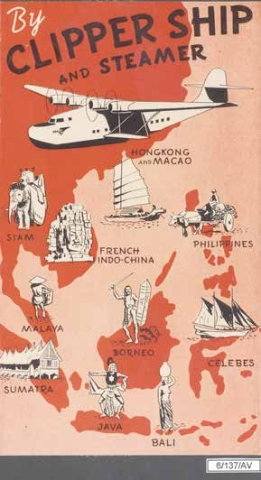

Advertisement of The China Clipper (Hong Kong and Southeast Asia)

Source: Hong Kong Heritage Project

Pan American World Airways was one of the major aviation companies in the US during the 1930s-1990s. In the 1930s, most of the aircrafts of the company were named after “clipper”, one of them was the “China Clipper”, which operated between China and America. In the beginning Pan American adopted Martin M-130 for the Trans-Pacific flight, but later switched to the Boeing 314. One of the selling points of Pan American World Airways was their Trans-Continent air fleet. When the passengers arrived in Hong Kong, they could go to other China’s main cities by the planes of China National Aviation Corporation, which was also operated by the Pan American. The accessibility of Hong Kong made it one of the most desirable destinations for expatriates who wished to stay in Asia.

Number of Filipinos, Thais and Indonesians living in Hong Kong, 1979-2011

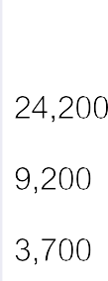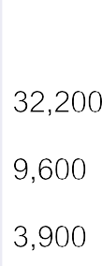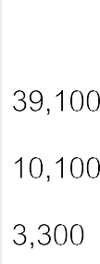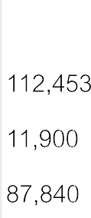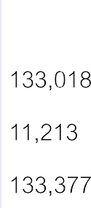

Number of Filipinos, Thais and Indonesians living in Hong Kong, 1979-2011

Thais
Filipinos

Source: Hong Kong 1980 (Hong Kong: Hong Kong Government Printer, 1981); Hong Kong 1982 (Hong Kong: Hong Kong Government Printer, 1983); Hong Kong 1984 (Hong Kong: Hong Kong Government Printer, 1985); Hong Kong 1986 (Hong Kong: Hong Kong Government Printer, 1987); Hong Kong 1988 (Hong Kong: Hong Kong Government Printer, 1989); Census and Statistics Department, Hong Kong 2011 Population Census Thematic Report: Ethnic Minorities (Hong Kong: Census and Statistics Department, 2012). website: https://www.censtatd.gov.hk/hkstat/sub/sp170_tc. jsp?productCode=B1120062

After the Second World War, many Southeast Asian countries became independent states, such as the Philippines and Indonesia. Some of the nationals migrated to Hong Kong to settle. Thailand was the only independent country in Asia during the age of colonialism; the Thai people also settled in many Asian cities, including Hong Kong, forming numerous unique communities. As Hong Kong experienced a period of rapid economic growth after the war, many Southeast Asian people chose to live in the city. From the above chart, one can see that in the late 1970s there were around 18,400 people from the Philippines, Thailand, and Indonesia living in Hong Kong. The figure rose to 280,000 in 2011. The increase was largely due to the influx of domestic helpers from the Philippines and Indonesia.

Extract from the Chinese version of Filipino song “Anak” in Hong Kong(1979)

孩兒出生一聲哭叫 曾替你兩老慰寂寥 曾是願望夢幻的化身時時刻刻關心相指引教你養你已成人……
切記跌了你要快快起番身

Source: Composers and Authors Society of Hong Kong Ltd.

Since the 1950s, many Filipino musicians who stayed in Hong Kong played Western music in nightclubs. Filipino music influenced the development of pop songs in Asia. “Anak” is a song written by Filipino singer Freddie Aguilar. He was a finalist for inaugural 1977 Metropop Song Festival held in Manila. The song became an international hit and was translated into many different languages. The lyrics was about parental love. The Chinese version of this song, with lyrics composed by Cheng Kwok Kong and sung by Alan Tam, was released in 1979.

The Mission for Migrant Workers (MFMW) cover page of the Documentation Series (Filipino), 1983

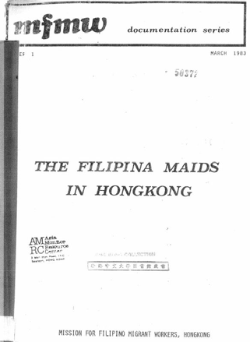

Source: Mission for Filipino Migrant Workers, Hong Kong

The Mission for Migrant Workers (MFMW) Ltd. is a registered charitable organisation. Established in 1981, the MFMW is an outreach program of the St. John's Cathedral of Hong Kong Anglican Church. It provided services in the aspects of religion, social welfare and education for Filipino domestic workers in Hong Kong. One of the purposes of this document was to show why there was an increasing number of Filipino maids in Hong Kong. Before the 1970s, the number of the Filipino maids was only a few hundred but it grew rapidly after 1982 to over 19,000 by the end of that year. In the 1980s, Hong Kong needed female labour force to participate in service and manufacturing industries. The government purposely encouraged the input of foreign domestic helpers. Since then, the Filipinos have gradually become part of the Hong Kong society and contributed to the development of Hong Kong.

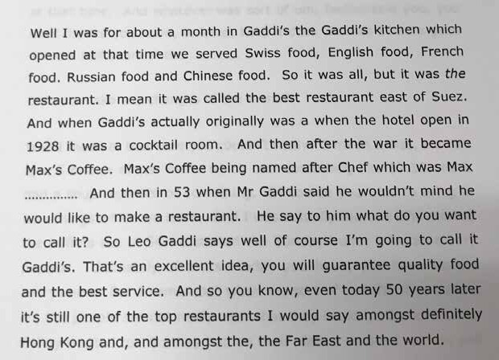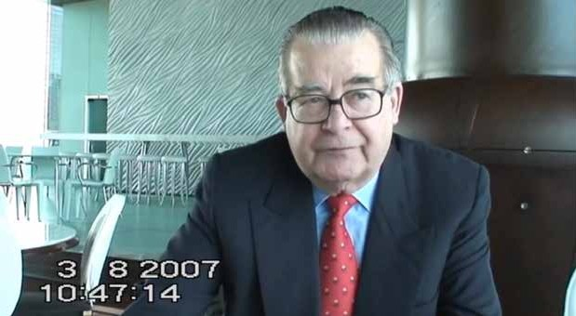

Interview script about the Swiss Cook Felix Bieger’s description of the early Gaddi’s

Source: The Hong Kong Heritage Project

For details, please watch the video clip about the interview to understand more about Felix Bieger’s description of the early Gaddi’s.
https://historye-learning.edb.hkedcity.net/video/source-51.mp4

Felix Bieger became one of the cooks in Gaddi’s in July 1945, and later he had become the manager of the restaurant. From the interview script above, we can have some ideas about the early Gaddi’s. Gaddi’s was just a cocktail room when Peninsula Hotel started in 1928, and became Max’s Coffee named after Chef Max. In 1953, agreed by Mr Gaddi, the restaurant started to serve Swiss, British, French, Russian and even Chinese dishes.

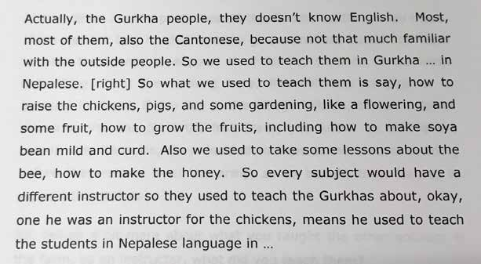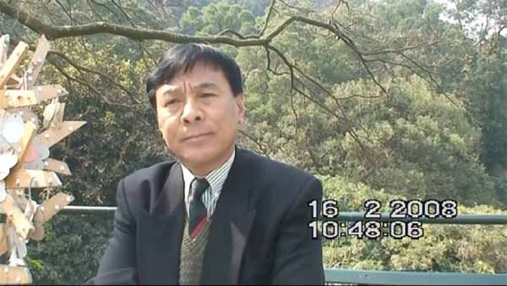

Interview script about Sarbajit Gurung’s description of Gurkha and their participation in the Agricultural Training Course

Source: The Hong Kong Heritage Project

For details, please watch the video clip about the interview to understand more about Sarbajit Gurung and the training provided by The Kadoorie Farm.
https://historye-learning.edb.hkedcity.net/video/source-52.mp4

The above text was the interview of Sarbajit Gurung who talked about his experience in the Agricultural Training Course for Gurkha soldiers. Gurung joined the British Army in 1974 and retired in 1994 after 20 years of service. He not only attended the agricultural training programme, but also became its Gurkha Chief Instructor between 1994 and 1996, after the sudden death of his predecessor. From the interview above, we can observe the range of the training offered: in addition to pig and chicken rearing, the programme also offered other commercial farming skills such as market gardening, fruits growing, and honey making. As the Gurkhas usually had a limited command of English or Cantonese at that time, instructors like Gurung were essential for the programme.

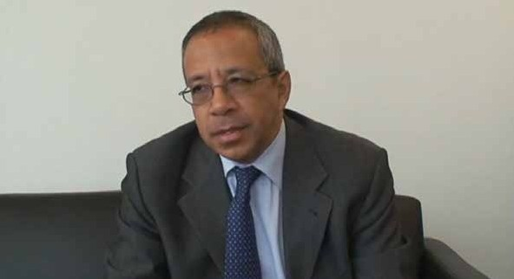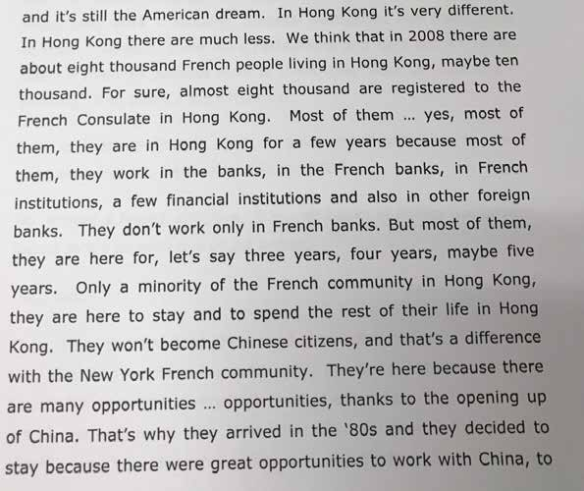

Interview script about Christian Ramage’s description of the French community in Hong Kong

Source: The Hong Kong Heritage Project

For details, please watch the video clip about the interview to understand more about Christian Ramage’s description of the French Community in Hong Kong.
https://historye-learning.edb.hkedcity.net/video/source-53.mp4

65

Christian Ramage, a career diplomat, was born in France. Before working for the United Nations, he received his education at the École Navale (French Naval Academy). At the time of the interview, he was Acting Consul General of France in Hong Kong and Macao. He pointed out that the French community in Hong Kong is quite different from that of other international metropolises such as New York. The French in New York involved in almost every aspect of professions, and they mostly aimed to obtain a citizenship. However, most of the French in Hong Kong were involved in the financial sector and only few of them became citizens. Many of them came to Hong Kong because of the availability of opportunities as a result of Reform and Opening-up of China since the 1980s. In 2008, the French community in Hong Kong had around 8,000 to 10,000 people.

66

