Teaching Manual for Enhancing Students’ English Writing Skills through Language across the Curriculum
in Life and Society (Secondary 1-3)

Module 15

An overview of the Chinese economy:
Macro-economy of the Mainland

Reading & Writing Unit

Hong Kong secondary school students studying subject contents in English typically find it challenging to express what they want to say in writing. This is especially the case for subjects where language competences are an integral part of learning, such as Life and Society (Secondary 1-3) in the PSHE KLA.

The “Teaching Manual for Enhancing Students’ English Writing Skills through Language across the Curriculum in Life and Society (Secondary 1-3)” (the Manual) aims to demonstrate how the learning of subject contents and development of academic writing skills can be interweaved in carefully designed scaffolding activities and tasks. The Manual contains 10 sample units. Educationally sound practices such as “Catering for Learner Diversity”, ”Peer Evaluation” and “Assessment as Learning” are incorporated in these sample units to facilitate learning and teaching. Upon completion, students are expected to develop an enhanced understanding of the topics taught, sharper writing skills for answering questions and better knowledge of the language functions covered.

For Life and Society teachers, we hope that the Manual will provide them with useful teaching resources for direct, selective or adaptive use. For other PSHE subject teachers, we hope that the Manual will demonstrate one possible way of how Language across the Curriculum practices can bring greater benefits to learning and teaching.

Edward Y.W. Chu
April Liu
The Open University of Hong Kong

Unit Overview
An overview of the Chinese economy: Macro-economy of the Mainland
Strand | 5
Module | An overview of the Chinese economy: Macro-economy of the Mainland
Learning Objectives | Content:  Students can:  - understand using Gross Domestic Product and Gross Domestic Product per capita as indicators to evaluate the economic performance of China  - compare the economic performance of China with that of other developed countries  Language:  Students can use the following language functions correctly and appropriately:  - describing rankings  - comparing and contrasting

Module 15
An Overview of the Chinese Economy:
Macro-economy of the Mainland
Content

Part 1: Economic development of China

Task 1 Indicators used to evaluate the level of economic performance of China

Task 2 Level of economic performance of China, compared with that of other developed countries

Language Support I: Describing rankings

Language Support II(a): Comparing and contrasting –

Using the word “times”

Language Support II (b): Comparing and contrasting –

Using comparative adjectives

Language Support II (c): Comparing and contrasting –

Using the phrase “compared with”
Part 2: My vocabulary piggy-bank and learning record
Task 1 Finding useful expressions for “An Overview of the Chinese Economy: Macro-economy of the Mainland”
Task 2 My choice of the most useful words and expressions
Task 3 My learning record of “An Overview of the Chinese Economy: Macro-economy of the Mainland”

Do you know …
The reform and opening-up policy was introduced in the Mainland of China by Mr. Deng Xiaoping (鄧小平), leader of China, in 1978. There were two focuses on the economic reforms of the policy. First, it gave the enterprises autonomy to make their own decisions about production and investment. Second, it allowed the setting up of the Special Economic Zones and the opening up of coastal cities to attract foreign investment and increase exports. Because of the implementation of reform and opening-up policy, the Chinese economy has been growing rapidly in the recent four decades.
Source: https://www.scmp.com/topics/40-years-reform-and-opening

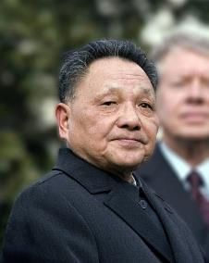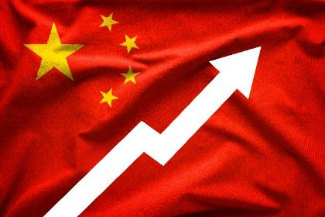
Notes to teachers:
To facilitate the learning of this module, teachers may review Module 13 ‘Ups and downs of Hong Kong Economy’ with students. In particular, revision of ‘GDP’ and ‘Language Support I: Describing the changes and trends using verbs and adverbs’, is recommended for understanding the concept and answering the questions in this unit.

Part 1: Economic development of China

Economic development is the process by which a country has an economic growth and improves its living standard. Economic growth refers to an increase in the level of Gross Domestic Product. With economic growth, people have more income to consume more goods and services, and the government has more resources to improve the infrastructure and social services. For the people, they have greater access to education, medical care and quality housing. Their living standard is improved. What indicators can be used to evaluate the economic development of China?

Adapted from: https://marketbusinessnews.com/financial-glossary/economic-development/

Task 1 Gross Domestic Product and Gross Domestic Product per capita as indicators to evaluate the level of economic performance of a country?

1. Gross Domestic Product

“Gross Domestic Product”, or “GDP” for short, is the total value of goods and services produced in a country or region in a specified period. GDP data can help us understand the economic situation of a place. If the GDP or GDP growth rate of a country is high, it means that the economy of that country or region is doing well.

2. Gross Domestic Product per capita

" Gross Domestic Product per capita ", or “GDP per capita " for short, is calculated by dividing the GDP by the total population. GDP per capita can reflect the average income level of the people in a country or region. Generally, the higher the average income of people, the higher their living standard.

The following is a graphical presentation of calculating one of the indicators mentioned above. Write down the correct indicator in the box on the left.
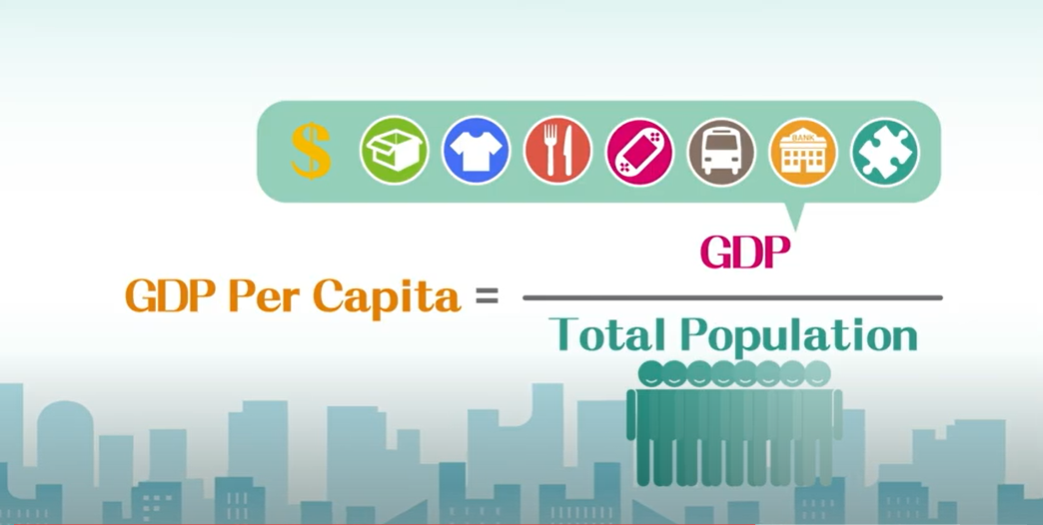

GDP per capita

Task 2 Level of economic performance of China, compared with that of other developed countries

- Was the GDP of China high in 2018, compared with that of other developed countries?
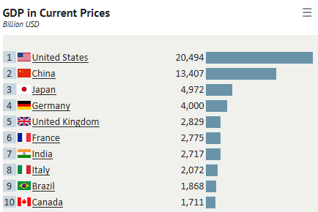
The data of the following charts was drawn from IMF’s World Economic Outlook (WEO) Database. The charts below show the top ten countries in terms of GDP in 1980 and 2018 respectively.
(in 2018)
(in 1980)
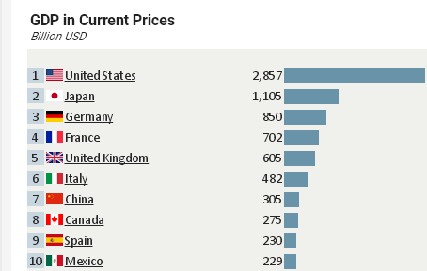

Source: IMF: World Economic Outlook (WEO) Database, April 2019
https://knoema.com/nwnfkne/world-gdp-ranking-2019-gdp-by-country-data-and-charts
- Complete the table to show the economic performance of China in 1980 and 2018. [Note: 1 billion is 1,000 million.]
 | GDP (US$ billion) | Ranking  305 7  13,407 2
1980
2018
Do you know …
One thousand = 1,000
Ten thousand = 10,000
Hundred thousand = 100,000
Million =1,000,000
Billion = 1,000,000,000
Trillion = 1,000,000,000,000

- Describe the changes in the economic performance of China during the period from 1980 to 2018 based on the answers in Question (a).
Language support I: Describing rankings

The verb ‘rank’ is commonly used to describe a particular position in a group of people or things under certain criteria (e.g. GDP).

Subject | Verb | Position | Place | Time
The GDP of Country (X) | ranked | fifth | in the world | in 2018.
When the criterion (e.g. GDP) is not the subject of the sentence, the phrase “in terms of” followed by the criterion is used to describe which particular area of a subject you are discussing.
Subject | Verb | Position | Place | ‘in terms of’ | Time
Country (X) | ranked | first | in the world | in terms of GDP | in 2018.
 |  |  | out of 150 countries
 |  | above / below | many other developed countries
Hints
increased rapidly during the period from 1980 to 2018
US$305 billion seventh
in terms of GDP second in the world in terms of GDP US$13,407 billion

1. Write a topic sentence describing the trend.
The GDP of China _______________________________________________________. In 1980, it was ______________________ and only ranked ___________ in the world______________________. In 2018, China ranked _______________________
2. Give supporting details.
_____________________, reaching _______________________________________.

- Compare the GDP of China with that of other developed countries in 2018. Give examples from the two GDP charts on p.7 to support your answer.
Language support II (a): Comparing and contrasting – Using the word “Times”

We can compare the difference in the amount of two things using the word ”times”.
Noun phrase with possession | Verb | Amount | ”times” | Noun phrase with possession
The GDP of the United States | was | 7.5 | times | that of the United Kingdom.
Notice the use of the words “that of”, which replaces “the GDP of” in the second noun phrase.
It is also possible to specify the amount of the GDP in two countries. Comparison is made in the relative clause that consists of a relative pronoun “which” to modify the amount of GDP before it. The sentence box below illustrates how to do so:
Noun phrase with possession | Verb | Amount | Relative pronoun | Verb | Amount | ”Times” | Noun phrase with possession
The GDP of the United States | was | US$20.5 trillion, | which | was | 7.5 | times | that of the United Kingdom (US$2.8 trillion).
Notes to teachers:
Phrases like “such as”, “for example”, and “for instance” are good for giving examples. Note that they are all followed by nouns or noun phrases.
Relative clause

China ranked _____________________________________________________in 2018.
second in the world in terms of GDP
US$13,407 billion, about 2.7 to 3.4 times
Japan (US$4,972 billion) Germany (US$4,000billion) United States
(US$20,494 billion).
Its GDP was _____________________ which was ____________________ that of other developed countries, such as _____________________________and _____________
________________. However, China was still right behind ______________________
______________________________________________________________________

- Was the GDP per capita of China in 2018 high as compared with that of other developed countries?
The table below shows the economic performance of selected countries in terms of GDP and GDP per capita in 2018.
Country | Ranking in terms of GDP (US$) | GDP per capita
 |  | Ranking | Value (US$ per person)
United States | 1 | 9 | 62,606
China | 2 | 71 | 9,608
Japan | 3 | 26 | 39,306
Germany | 4 | 18 | 48,264
United Kingdom | 5 | 22 | 42,558
Adapted from: https://knoema.com/atlas/ranks/GDP-per-capita
Language support II (b): Comparing and contrasting - Using comparative adjectives

Comparative adjectives are used when two items are compared.
We add “er” to form one-syllable comparative adjectives:
e.g. high – higher; low – lower
For adjectives ending in –e, add “r”:
e.g. large – larger
For adjectives with a short vowel (e.g. ‘i’) followed by a consonant (e.g. ‘g’), double the consonant and add –er:
e.g. big - bigger

The comparative adjectives are usually followed by than.
Item 1  (noun phrase with possession) | Verb | Comparative adjective | Conjunction | Item 2  (noun phrase with possession)
The GDP per capita of the United States | was | higher | than | that of the United Kingdom.
The example below compares the GDP per capita of the United States (US) and the GDP per capita of the United Kingdom (UK).
It is also possible to specify the amount of the GDP per capita in two countries.

Comparison is made in the relative clause that consists of a relative pronoun “which” to modify the amount of GDP per capita before it. Also, comparative adjectives can be modified by the adverbs such as much, a bit, a little and so on.
The sentence box below illustrates how to do so:
Subject | Verb | Amount | Relative pronoun | Verb to be, Adverb & Comparative adjective | Conjun-ction | Noun phrase
The GDP per capita of the United States | was | US$62,606, | which | was much higher | than | that of  China (US$9,608 per person).
The United States | had | GDP of US $62,606 per person, | which | was much higher | than | China (US$9,608 per person).
Relative clause

- Compare the GDP per capita of China with that of other developed countries in 2018. Give examples from the table above to support your answer.
Notes to teachers:
Phrases “and so on” and “and so forth” that come afterwards are used to show that the things mentioned are not the only examples.
71st in the world in terms of GDP per capita in 2018. It had GDP of US$9,608 per person, which was much lower than other developed countries, such as United States (US$62,606), Japan (US$39,306), Germany (US$48,264) , and so on.
China ranked ____________________________________________________
_______________________________________________________________
_______________________________________________________________
_______________________________________________________________

- What can you infer from the answer in Question (a) concerning the living standard of Chinese citizens? [Hint: Consider GDP per capita and what it shows.]
The GDP per capita of China in 2018 was much lower than that of other developed countries. This showed that the Chinese citizens were not richer than those living in other developed countries and their living standard was actually lower.
______________________________________________________________
_______________________________________________________________
_______________________________________________________________
_______________________________________________________________

- With the help of the data in the table below, explain why the GDP per capita of China was much lower than that of Japan despite China’s higher GDP. [Hint: Refer to the definition of GDP per capita.]
 | China (2018) | Japan (2018)
Population | 1,427,647,786 | 127,202,192
GDP (US$ billion) | 13,407.40 | 4,971.93
GDP per capita (US$) | 9,608 | 39,306

Sources: http://worldpopulationreview.com/countries/; https://knoema.com/atlas/ranks/GDP;
https://knoema.com/atlas/ranks/GDP-per-capita
Hint:
- state the calculation of GDP per capita
- Use the conjunctions “although” or “but” to show the contrast.
GDP per capita is calculated by dividing the GDP by the total population of a country. Although the GDP of China (US$13,407 billion) in 2018 was 2.7 times that of Japan (US$4,972 billion), China had a population of 1,427.6 million, which was about 11.2 times the population of Japan (127.2 million). As a result, the GDP per capita of China was lower than that of Japan.
_______________________________________________________________
_______________________________________________________________
_______________________________________________________________
_______________________________________________________________
_______________________________________________________________
_______________________________________________________________
_______________________________________________________________
_______________________________________________________________
_______________________________________________________________

- Describe the economic performance of China in 2018 using GDP and GDP per capita. Support your answer with the data discussed in Questions (1) and (2).
Our country was the second largest economy in the world in terms of GDP (US$13,407 billion) in 2018, but the living standard of Chinese people was not considered to be high because GDP per capita of China (US$731) was still at a low level and only ranked 71st among other countries in the world.

______________________________________________________________________________________________________________________________________________________________________________________________________________________________________________________________________________________________________________________________________________________________________________________________________________________________________________________________________________________________________________________________________________________________________________________________________________________________________________________________________________________________________________________________________

Notes to teachers:
Given the importance, this part will be included in every unit.
Part 3: My vocabulary bank and learning record
In this part, you will revise the topic vocabulary and assess your learning.
My vocabulary bank
Do you want to write better answers to questions in Life and Society (Secondary 1-3)?
Good writing comes from well-written paragraphs and sentences. And well-written
paragraphs and sentences are built with proper English vocabulary. Generally, English
vocabulary can be sorted into three groups: subject-specific (專科的) vocabulary,
general academic vocabulary, and logical connectors (linking words).
- Subject-specific vocabulary: key concepts specific to a subject, namely Life and
Society or Integrated Humanities.
- General academic vocabulary: Words that are used more often in written texts
rather than informal conversations. They help us express ideas more precisely.
- Logical connectors (linking words): conjunctions and phrases that connect ideas.

Task 1 Finding useful expressions for “An Cverview of the Chinese economy: Macro-economy of the Mainland”
Fill in the blanks of the subject-specific vocabulary, general academic vocabulary and linking words from two parts in the unit. Some are already done as examples.

Economic development of China
Subject-specific vocabulary | General academic vocabulary | Linking words
Economic de____________ (n. ph.)  velopment  owth  Economic gr____________ (n. ph.)  dicators  Economic im_____________ (n. ph.)  formance  Economic per_____________ (n. ph.)  Goods and ser____________ (n. ph.)  vices  mestic  Gross do__________ product (n. ph.)  ita  Per cap_________ GDP (n. ph.)  veloped  Re___________ sales (compound n.)  form  Re______ (n.) and opening-up policy  nomic  Special Eco__________ Zones (n. ph.)  Standard of li____________ (n. ph.)  ving | Making comparisons  pared  Com_________ with  Being specific  In terms of  Ranking  Ra_______  nk  First  Se_______  cond  Third  Amount  A bit  ttle  A li_____  ch  Mu_______  Others  luate  Eva____________(v.) | Showing reasons  Because of  Showing results  Therefore  Showing contrast  Despite

Task 2 My choice of the most useful words and expressions
etail
eform

In the space below, write:
- THREE top most useful subject-specific words,
- THREE general academic words, and
- TWO linking words you have learnt in this unit.
Compare your choice with your neighbouring classmate; see if there are similarities and differences and discuss.

- Subject-specific words
____________________________________________________________________
Students’ own answer.
____________________________________________________________________
- General academic words
Students’ own answer.
____________________________________________________________________
____________________________________________________________________
- Linking words
Students’ own answer.
____________________________________________________________________

Task 3 My learning record of “An Overview of the Chinese Economy: Macro-economy of the Mainland”
Put a tick (√) if you think you can manage the item in this unit.
 | Item | Yes (√)/No ()
1. | using GDP and GDP per capita to evaluate the economic performance of China?
2. | how to use rankings to describe a country’s economic development?
3. | how to compare China’s and other developed countries’ economic development using ‘that of’?
4. | how to compare and contrast?
Do I know …

