Teaching Manual for Enhancing Students’ English Writing Skills
through Language across the Curriculum
in Life and Society (Secondary 1-3)

Module 21
Rights and Responsibilities of Citizens

Reading & Writing Unit

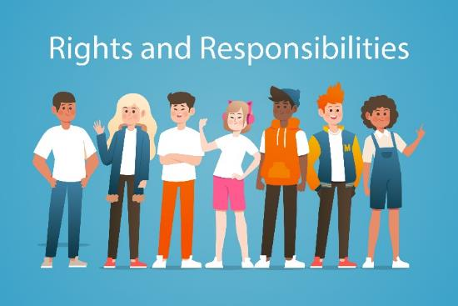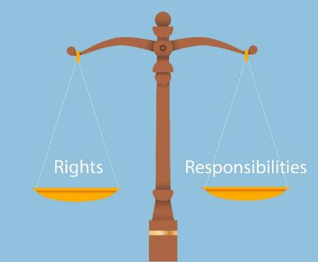

Hong Kong secondary school students studying subject contents in English typically find it challenging to express what they want to say in writing. This is especially the case for subjects where language competences are an integral part of learning, such as Life and Society (Secondary 1-3) in the PSHE KLA.

The “Teaching Manual for Enhancing Students’ English Writing Skills through Language across the Curriculum in Life and Society (Secondary 1-3)” (the Manual) aims to demonstrate how the learning of subject contents and development of academic writing skills can be interweaved in carefully designed scaffolding activities and tasks. The Manual contains 10 sample units. Educationally sound practices such as “Catering for Learner Diversity”, ”Peer Evaluation” and “Assessment as Learning” are incorporated in these sample units to facilitate learning and teaching. Upon completion, students are expected to develop an enhanced understanding of the topics taught, sharper writing skills for answering questions and better knowledge of the language functions covered.

For Life and Society teachers, we hope that the Manual will provide them with useful teaching resources for direct, selective or adaptive use. For other PSHE subject teachers, we hope that the Manual will demonstrate one possible way of how Language across the Curriculum practices can bring greater benefits to learning and teaching.
Edward Y.W. Chu
April Liu
The Open University of Hong Kong

Module 21

Rights and Responsibilities of Citizens
Part 1: Different categories of Hong Kong residents
Task 1 Identifying Hong Kong permanent residents
Part 2: Protection of the rights of Hong Kong residents by major principles of the rule of law
Task 1 Reading I: Rights, responsibilities complementary
Task 2 Video-watching: The need for a balance of rights and
responsibilities among residents
Language support I: Describing responsibilities using modal verbs
Part 3 My right? Your right? Our rights
Task 1: Different viewpoints on the rights of pigeon feeders
Language support II: Sequencing and linking ideas
Task 2: Who says what?
Language support III: Reporting people’s opinions
Language support IV: Sequencing ideas in a text
Task 3: Writing task on pigeon feeding
Part 4: My vocabulary bank and learning record
Task 1 Finding useful expressions for “Rights and
Responsibilities of Citizens”
Task 2 My choice of the most useful words and expressions
Task 3 My learning record of “Rights and Responsibilities
of Citizens”

Unit Overview
Rights and Responsibilities of Citizens

Strand | 6
Module | Rights and Responsibilities of Citizens
Target class level | S3
Learning Objectives | Content:  Students can:  - tell different categories of Hong Kong residents  - justify the citizen’s rights and responsibilities according to the Basic Law as well as the International Covenant on Civil and Political Rights  - describe the responsibilities they shoulder as junior secondary students  - explain the problem when there is imbalance between rights and responsibilities.  Language:  Students can:  - tell and use the key terms about rights and responsibilities of citizens (e.g. nationality, residents, freedom);  - use the following language functions correctly and appropriately:  - describing responsibilities using modal verbs  - reporting people’s opinions formally (e.g. hold the view that)  - sequencing and linking ideas using linking words

Part 1: Different categories of Hong Kong residents
Task 1 Identifying Hong Kong permanent residents
- Chinese citizens born in Hong Kong.
- Chinese citizens who have ordinarily resided in Hong Kong for a continuous period of 7 years or more.
- Persons of Chinese nationality born outside Hong Kong to a parent listed in (1) or (2)^{Note}.
- Persons not of Chinese nationality who:
- have entered Hong Kong with valid travel documents,
- *have ordinarily resided in Hong Kong for a continuous period of seven years or more, and
- have taken Hong Kong as their place of permanent residence.
- Persons under 21 years of age born in Hong Kong to a parent listed in (4).
- Persons other than those residents listed in (1) to (5), who had the right of abode in Hong Kong only before the establishment of HKSAR.
According to the Basic Law, six types of people are considered as permanent residents of Hong Kong Special Administrative Region (HKSAR).
Permanent Residents of Hong Kong

Non- Chinese citizens
Chinese citizens

Source: https://www.immd.gov.hk/eng/services/roa/eligible.html
*With the exception of foreign domestic helpers as stated in Section 2(4) of the Immigration Ordinance. Source: https://www.elegislation.gov.hk/hk/cap115
Note: From the Standing Committee of the National People's Congress (NPCSC), the provisions of category (3) regarding the “persons of Chinese nationality born outside Hong Kong of those residents listed in categories (1) and (2)” mean both parents of such persons, whether born before or after the establishment of the HKSAR, or either of such parents must have fulfilled the condition prescribed by category (1) or (2) of Article 24(2) of the Basic Law at the time of their birth.
Do you know…
The definition of Chinese citizens related to the right of abode in the HKSAR: Hong Kong residents who are of Chinese descent and born in Chinese territories (including Hong Kong) are regarded as Chinese citizens. Their citizenship is not affected by whether they hold, or have held, any passport of overseas countries.
Source: https://www.immd.gov.hk/eng/services/roa/term.html

Read the background information of the following people. Are they eligible to be Hong Kong permanent residents? Circle “Yes” or “No” and provide explanations. The first is done as an example.
Notes to teachers:
For further discussion of using “because/as/since” for explanations, refer to Module 4 “Cyber-friendship”.

Name  Hint:  Start with the “stem”. | Background | Can the person be a Hong Kong permanent resident?
- Chung Siu Man | I was born in Japan. I met my husband, who is a Hong Kong resident, during a study trip. After marriage, I have lived in Japan with him. We travel to Hong Kong to meet our relatives and friends at least once a year. | Hint:  This is the “stem”, which can be formed by rearranging the words “Can the person be a Hong Kong permanent resident?”  Yes / No (circle where appropriate)  The person cannot be a Hong Kong permanent resident because she has not resided in Hong Kong for a continuous period of seven years or more, and has not taken Hong Kong as her place of permanent residence  ___________________________________  ___________________________________  ___________________________________  ___________________________________  ___________________________________  ___________________________________  ___________________________________
Do you know …

Article 24 of the Basic Law specifies that permanent residents of the Hong Kong Special Administrative Region are qualified to obtain permanent identity cards which state their right of abode. They are also guaranteed many other rights such as freedom of speech and of association.
(4) Lee Mei Ling | I was born in Guangzhou and have been living in South Korea since I was two. I am running a beauty shop in Taiwan. I travel to Hong Kong for a few days every month in the last seven years to buy goods for my shop. | Yes / No (circle where appropriate)  The person cannot be a Hong Kong permanent resident because she has not resided in Hong Kong for a continuous period of seven years or more.  ___________________________________  ___________________________________  ___________________________________  ___________________________________  ___________________________________  ___________________________________
(2) Edwin Medeiros | The person cannot be a Hong Kong permanent resident because he is a non-Chinese who was not born in Hong Kong.  Also, his mother does not have permanent residence of Hong Kong either.  I am fifteen years old. I was born in Switzerland. Last year, my mother came to work in Hong Kong through the ‘Quality Migrant Admission Scheme’. I followed her to live in Hong Kong. | Yes / No (circle where appropriate)  ___________________________________  ___________________________________  ___________________________________  ___________________________________  ___________________________________  ___________________________________  ___________________________________  Hint:  Start with the ‘stem’.
(3) Simon Sankey | I was born in the UK. I came to work in Hong Kong 9 years ago. I have been living here since then. I love this city so much that I regard it as my home. | Yes / No (circle where appropriate)  The person can be a Hong Kong permanent resident because he is a non-Chinese who has resided in Hong Kong for a continuous period of seven years or more. Also, he has taken Hong Kong as his permanent residence.  ___________________________________  ___________________________________  ___________________________________  ___________________________________  ___________________________________  ___________________________________
Hint:
Start with the “stem”.
Part 2: Rights and responsibilities applicable to Hong Kong residents
Task 1 Reading: Rights, responsibilities complementary
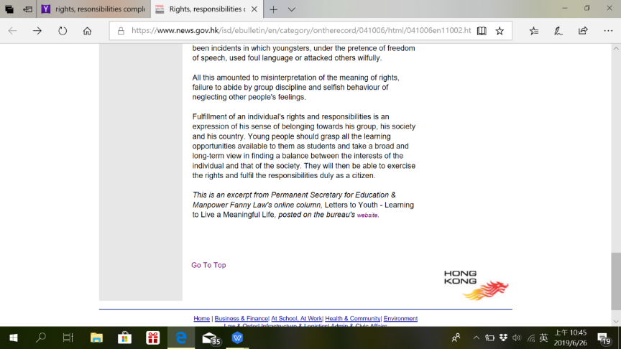
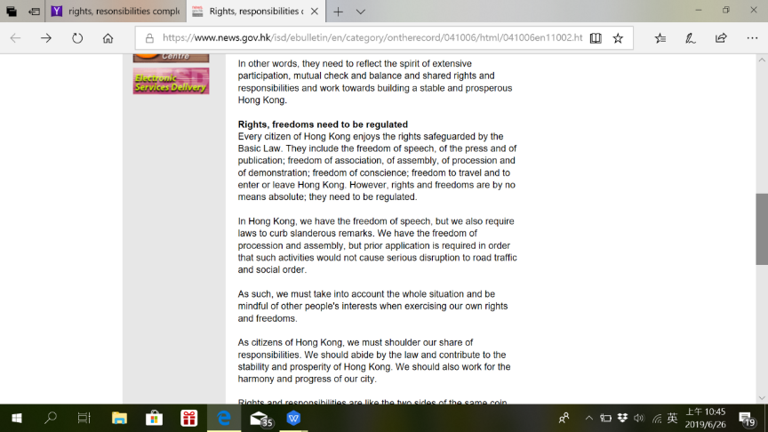
The article “Rights, responsibilities complementary” discusses some of the rights enshrined by the Basic Law and our responsibilities when exercising rights and freedoms. The article is split into three excerpts with different focusses.

1. Rights and freedoms
Read Excerpt 1 and answer the questions.

A. Identifying the rights
Excerpt 1

Rights, responsibilities complementary
Rights, freedoms need to be regulated
Every resident of Hong Kong enjoys the rights safeguarded by the Basic Law. They include the freedom of speech, of the press and of publication; freedom of association, of assembly, of procession and of demonstration; freedom of conscience; freedom to travel and to enter or leave Hong Kong. However, rights and freedoms are by no means absolute; they need to be regulated.
(a)
(d)
(c)
(b)
Source:
From former Permanent Secretary for Education & Manpower Fanny Law’s online column, Letters to Youth - Learning to Live a Meaningful Life, posted on the government’s website.
https://www.news.gov.hk/isd/ebulletin/en/category/ontherecord/041006/html/041006en11002.htm

- The rights mentioned in Excerpt 1 are extracted below. Read Excerpt 2 which follows and identify the Article number which corresponds to those rights.
 | Rights | Article number
 | freedom of speech, of the press and of publication | 27  27  32  31
 | freedom of association, of assembly, of procession and of demonstration
 | freedom of conscience
 | freedom to travel and to enter or leave Hong Kong

- Give two more rights with Article numbers which are enjoyed by Hong Kong residents and stated in the Basic Law.
[Student answer] Possible answers: The two rights are that all Hong Kong residents shall be equal before the law (Article 25) and have freedom of choice of occupation (Article 33).

____________________________________________________________________
____________________________________________________________________
____________________________________________________________________
Excerpt 2: Articles of the Basic Law related to fundamental rights and duties of the residents
Chapter III : Fundamental Rights and Duties of the Residents
Article 25
All Hong Kong residents shall be equal before the law.
Article 26
Permanent residents of the Hong Kong Special Administrative Region shall have the right to vote and the right to stand for election in accordance with law.
Article 27
Hong Kong residents shall have freedom of speech, of the press and of publication; freedom of association, of assembly, of procession and of demonstration; and the right and freedom to form and join trade unions, and to strike.
Article 28
The freedom of the person of Hong Kong residents shall be inviolable.
No Hong Kong resident shall be subjected to arbitrary or unlawful arrest, detention or imprisonment. Arbitrary or unlawful search of the body of any resident or deprivation or restriction of the freedom of the person shall be prohibited. Torture of any resident or arbitrary or unlawful deprivation of the life of any resident shall be prohibited.

Excerpt 2 (Con’t)
Chapter III : Fundamental Rights and Duties of the Residents
Article 29
The homes and other premises of Hong Kong residents shall be inviolable. Arbitrary or unlawful search of, or intrusion into, a resident's home or other premises shall be prohibited.
Article 30
The freedom and privacy of communication of Hong Kong residents shall be protected by law. No department or individual may, on any grounds, infringe upon the freedom and privacy of communication of residents except that the relevant authorities may inspect communication in accordance with legal procedures to meet the needs of public security or of investigation into criminal offences.
Article 31
Hong Kong residents shall have freedom of movement within the Hong Kong Special Administrative Region and freedom of emigration to other countries and regions. They shall have freedom to travel and to enter or leave the Region. Unless restrained by law, holders of valid travel documents shall be free to leave the Region without special authorization.
Article 32
Hong Kong residents shall have freedom of conscience.
Hong Kong residents shall have freedom of religious belief and freedom to preach and to conduct and participate in religious activities in public.
Article 33
Hong Kong residents shall have freedom of choice of occupation.

B. Restrictions on rights and freedoms
Read the following agreement adopted by the United Nations for all member states on the restrictions on rights and freedoms. Answer the question which follows.

International Covenant on Civil and Political Rights
Article 19
1. Everyone shall have the right to hold opinions without interference.
2. Everyone shall have the right to freedom of expression; this right shall include freedom to seek, receive and impart information and ideas of all kinds, regardless of frontiers, either orally, in writing or in print, in the form of art, or through any other media of his choice.
3. The exercise of the rights provided for in paragraph 2 of this article carries with it special duties and responsibilities. It may therefore be subject to certain restrictions, but these shall only be such as are provided by law and are necessary:
(a) For respect of the rights or reputations of others;
(b) For the protection of national security or of public order… or of public health or morals.

- “Rights and freedoms are by no means absolute; they need to be regulated” (Excerpt 1, p. 9). What are the conditions for restricting rights and freedoms as are provided by law as stated in Article 19 in International Covenant on Civil and Political Rights?
The conditions for restricting rights and freedoms are for respect of the rights or reputations of others and for the protection of national security or of public order, or of public health or morals.

________________________________________________________________
________________________________________________________________
Do you know …

“I disapprove of what you say, but I will defend to the death your right to say it.”
By VOLTAIRE,
French Enlightenment thinker
________________________________________________________________

2. Identifying the rights and responsibilities

We learned some rights and their restrictions in the previous activity. Excerpt 3 will focus on responsibilities when exercising rights and freedoms.

Excerpt 3

Rights, responsibilities complementary

Rights, freedoms need to be regulated
….
In Hong Kong, we have the freedom of speech, but we also require laws to curb slanderous remarks. We have the freedom of procession and assembly, but prior application is required in order that such activities would not cause serious disruption to road traffic and social order.

As such, we must take into account the whole situation and be mindful of other people's interests when exercising our own rights and freedoms.

As [residents] of Hong Kong, we must shoulder our share of responsibilities. We should abide by the law and contribute to the stability and prosperity of Hong Kong. We should also work for the harmony and progress of our city.
Do you know …

On “the rule of law”:
‘Thus, no one is above the law, and all are subject to the same law administered in the same courts…So, if you maltreat a penguin in the London Zoo, you do not escape prosecution because you are Archbishop of Canterbury’ (p.4).
The Rule of Law
Tom Bingham
Britain’s former senior Law Lord

In each of the following statements, underline the words related to residents’ responsibilities. Rewrite them in the boxes on the right following the first example.
Residents’
Responsibilities

Statements extracted from Excerpt 3
We have the freedom of speech, but we also require laws to curb slanderous remarks.

We have the freedom of procession and assembly, but prior application is required.

We must take into account the whole situation and be mindful of other people's interests when exercising our own rights and freedoms.
As citizens of Hong Kong, we should abide by the law and contribute to the stability and prosperity of Hong Kong.

Hong Kong residents should also work for the harmony and progress of our city.

Not making slanderous remarks

Applying for permission before organising
procession and assembly

Do you know …

Civil rights of Hong Kong residents are included and enshrined in the Basic Law.
Working for the harmony and progress of our city

Abiding by the law and contributing to the stability and prosperity of Hong Kong

Taking into account the whole situation and being mindful of other people's interests
3. Rights and responsibilities of students

Excerpt 4 discusses rights and responsibilities of students. Read Excerpt 4 and answer the questions.

Excerpt 4

Rights, responsibilities complementary
Students should contribute to school development
The school is a miniature of a society. It is also a place where one experiences social life and learns to relate to others. A student has the right to learn, whereas the school has the responsibility to teach and guide them.

A student also enjoys civil rights. But as a member of a school, they also have a responsibility for the overall interests of the school. They have to make a contribution to the long-term development of the school.

There have been incidents in which students insisted on colouring their hair under the pretext of "human rights" and neither the schools nor the students were willing to budge. There have also been incidents in which youngsters, under the pretence of freedom of speech, used foul language or attacked others wilfully.

All this amounted to misinterpretation of the meaning of rights, failure to abide by group discipline and selfish behaviour of neglecting other people's feelings.

Fulfillment of an individual's rights and responsibilities is an expression of [his/her] sense of belonging towards [his/her] group, [his/her] society and [his/her] country. Young people should grasp all the learning opportunities available to them as students and take a broad and long-term view in finding a balance between the interests of the individual and that of the society. They will then be able to exercise the rights and fulfil the responsibilities duly as a [resident of the HKSAR].
- According to Paragraphs 1 and 2, what right(s) does a student have? You may choose more than one answer.
□a). the right to learn
√
□ b). the right to teach and guide others
□ c). civil rights
√

- What are the two examples of students abusing their rights at school given by the writer?
The two examples are that students insisted on colouring their hair under the pretext of “human rights”, and students used foul language or attacked others willfully under the pretence of freedom of speech.

_________________________________________________________________
_________________________________________________________________
_________________________________________________________________

- According to the writer, what are the reasons for those students’ misbehaviours?
misinterpretation of the meaning of rights;
failure to abide by group discipline;
selfish behavior of neglecting other people’s feelings.
- ___________________________________________________________
- ___________________________________________________________
- ___________________________________________________________

- According to the last paragraph, what is fulfillment of an individual's rights and responsibilities?
Fulfillment of an individual's rights and responsibilities is an expression of his/her sense of belonging towards his/her group, his/her society and his/her country.

________________________________________________________________
________________________________________________________________
_________________________________________________________________

- What should young people do to exercise their rights and fulfil the responsibilities as residents of the HKSAR?
Young people should grasp all the learning opportunities available to them as students and take a broad and long-term view in finding a balance between the interests of the individuals and those of the society.

_________________________________________________________________
_________________________________________________________________
_________________________________________________________________
Task 2: Video-watching: The need for a balance of rights and responsibilities among residents

Watch the following video “Keynote Address by the Honourable Andrew Li Kwok-nang (李國能), CBE, GBM, JP.” (8:24-9:37)* and answer the questions.
YouTube Link: https://video.law.hku.hk/tthe-honourable-andrew-li-kwok-nang-%E6%9D%8E%E5%9C%8B%E8%83%BD-cbe-gbm-jp-keynote-address/

* The keynote address delivered by the Honourable Andrew Li Kwok-nang took place in the 200th Congregation of the Faculty of Law, the University of Hong Kong on November 30, 2018, in Hong Kong Convention and Exhibition Centre
.
Do you know …

In Hong Kong, the prefix "The Honourable" is used as the salutation of very important people, especially those who are from the law profession and government, such as Judges of the Court of Final Appeal, Judges of the High Court, the Chief Executive of Hong Kong, and members of the Legislative Council.
Get to know The Honourable Andrew Li Kwok-nang
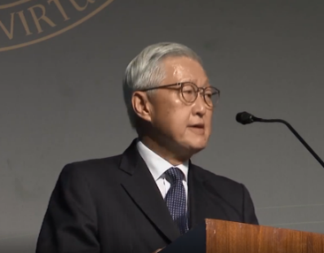 | Background:  - Former Chief Justice of Hong Kong (1997-2010)  - The first Chief Justice who presided over the Hong Kong Court of Final Appeal, established on 1 July 1997

Transcript of the keynote address delivered by the Honourable Andrew Li Kwok-nang
We must develop a strong sense of responsibility. Today, people all around the world are very conscious of their rights. They talk about their entitlements. Some even think and act in terms of what society owes them. But all rights should be exercised responsibly. It is high time for the balance to be redressed and that we recognise and accord at least equal importance to our responsibilities, responsibilities at various levels: to our country, China, to our community in Hong Kong, to our profession and to our family. I believe that developing a strong sense of responsibility by all citizens (residents) is of fundamental importance in our strive for a better future.
- What must we develop for our country, China, to our community in Hong Kong, to our profession and to our family, according to Andrew Li Kwok-nang?
We must develop a strong sense of responsibility to our country, to our community in Hong Kong, to our profession and to our family.
_________________________________________________________________
_________________________________________________________________
_________________________________________________________________
- “Today, people all around the world are very conscious of their rights. They talk about their entitlements. Some even think and act in terms of what society owes them” (Andrew Li)
What will happen if all the people in Hong Kong just concern about their rights and neglect others’? (Hint: the relationship between people and the development of Hong Kong)
Suggested answer: More conflicts will occur among people, which will adversely affect the development and future of Hong Kong.
_________________________________________________________________
_________________________________________________________________
_________________________________________________________________
- In order to redress a balance between rights and responsibilities, what should we do when we exercise our rights ? Give an example to help explain your point. (Hint: Excerpt 4)
Suggested answer: We should exercise our rights responsibly. For example, when we exercise our rights, we should also concern about others’ rights. / find a balance between our interests and the interests of the society.
_________________________________________________________________
_________________________________________________________________
_________________________________________________________________
_________________________________________________________________
- According to Andrew Li, what is the importance of developing a strong sense of responsibility by all residents of the HKSAR?
Developing a strong sense of responsibility by all residents of the HKSAR is of fundamental importance in our strive for a better future.
in our strive for a better future.
_________________________________________________________________
_________________________________________________________________
_________________________________________________________________

- Write a short paragraph to point out four responsibilities you as a junior secondary student should shoulder. You may refer to some of the answers you wrote in this task for ideas. Language Support I which follows is also helpful.

The responsibilities I should shoulder
Hint:
Use linking words such as first, second, to link the points.
There are a few responsibilities that I as a junior secondary student should shoulder. _____________________________________________________________________
[Student answer] Possible answers: First, I should recognise our responsibilities at various levels: to our country, China, to our community in Hong Kong, and to our family. Secondly, I must develop a strong sense of responsibility. Thirdly, I need to exercise my rights responsibly. Finally, I ought to study well so as to contribute to the society in the future.

,
_____________________________________________________________________
_____________________________________________________________________
_____________________________________________________________________
_____________________________________________________________________
Language Support I: Describing responsibilities using
modal verbs

NOTE: Language Support on “Using modal verbs” was first presented in Module 5
“Enhancing Family Life” with different examples.
Describing roles and responsibilities: Modal verbs
We use modal verbs to talk about obligations. As roles and responsibilities are essentially obligations, modal verbs are useful when describing them. Look at the following examples:
We | must | develop | a strong sense of responsibility.
modal verb |  | verb
All rights | should | be exercised | responsibly.
modal verb |  | verb

Rights and freedoms |  | need to | be regulated | and by no means are absolute.
 | modal verb verb

What modal verbs do you know? Fill in the chart below.
may | can  ught to  o_____ ___  ould  sh_____  eed to  n____ __ | have to  ust  m____  etter  had b_____
weak obligations | medium obligations | strong obligations

Notice how meaning is changed with different modal verbs used:

We must study very hard. | Strong
You have to study very hard. | Obligation
We had better study very hard.
We can study very hard.
We ought to study very hard.
You should study very hard.
We need to study very hard.
We may study very hard. | Weak

Part 3 My right? Your right? Our Rights

Task 1: Different viewpoints on the rights of pigeon feeders

1. Below is a letter from a newspaper reader who shares his view about feeding pigeons in Hong Kong. Underline the supporting opinions and double underline the opposing opinions. One is done as an example.
City Watch February 2019

1. Sympathy for pigeon feeders
2. Some people are feeding feral pigeons in urban areas. The feeders believe that they have the right to feed the pigeons. However, the public is concerned about the environmental hygiene and nuisance caused. I am a pigeon feeder and lover and want to share my view on feeding pigeons.
3. Let’s talk about the common criticism first. Some people say that all residents of the HKSAR have the responsibility to keep Hong Kong clean. Feeding the pigeons, especially in large amounts of food in the same place every day, inevitably causes what is called a "congregation" of pigeons. Left behind are bread crumbs, feathers and droppings, which is unsightly.
4. Many people also comment that there is an increased risk of disease transmission. It is a common sense that pigeons may spread disease in the city. When the pigeon’s population grows and the areas are overcrowded with pigeons, the risk may be fatal.
5. However, some people have a different point of view and they think that giving food is actually an act of kindness. Weren’t we taught when we were young to help those in need whenever possible? How can we turn a blind eye to those pigeons which now reside in the city where we live?
6. Some people hold the view that feeding the pigeons can also be a pleasant experience for some, especially those who lack companion. It is a habit for many elderly people, for example, to feed the pigeons regularly. Imagine if their freedom of doing so was taken away, how would they feel?
7. It is acceptable that people living in the western countries can feed ducks, for example, in city park ponds. Why can’t we have the same freedom of feeding animals like pigeons? They are appealing birds and some will stand in front of you and look you straight in the eye, hoping that you are a kind person that will feed them. This is something that I can't resist, so whenever I am likely to come across feral pigeons I take a little food with me.
8. While I understand that there are good reasons against feeding feral pigeons, I hope people can be more sympathetic to we pigeon feeders.

- More arguments rejecting feeders’ rights to feed the pigeon can be found in a poster issued by Agriculture, Fisheries and Conservation Department (AFCD). Circle those arguments and put them in Table 1.
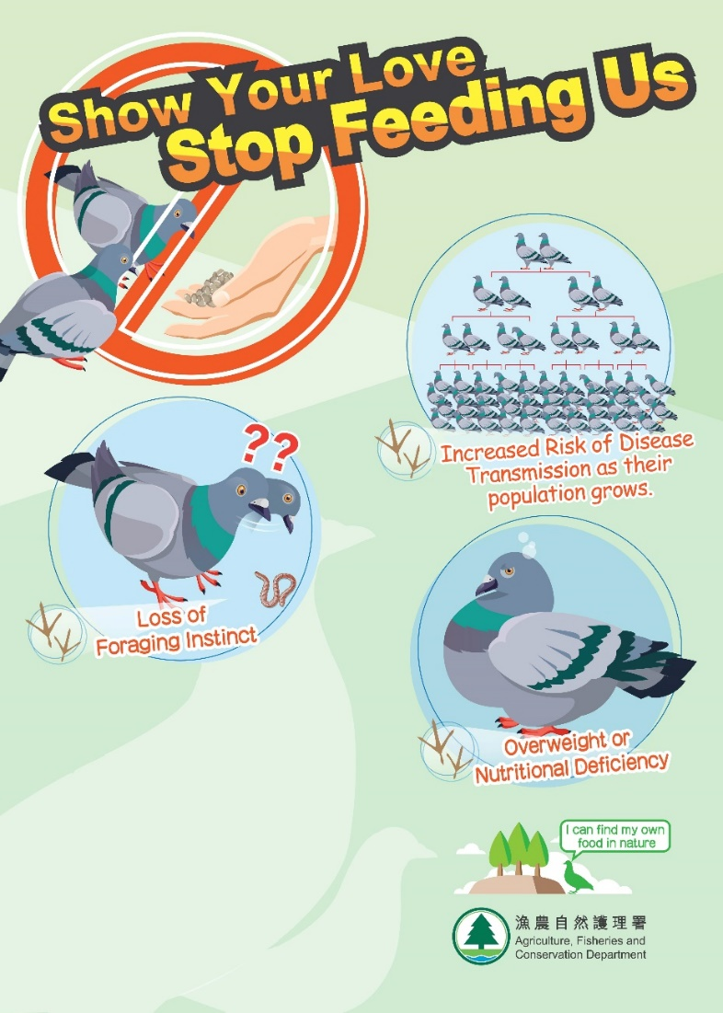

- From the letter and the poster above, jot down arguments in complete sentences which reject and justify feeders’ rights to feed the pigeons. Write in complete sentences. An example is given.

Table 1
Arguments rejecting feeders’ rights to feed the pigeons | Arguments justifying feeders’ rights to feed the pigeons
*R1. All residents have the responsibility to keep Hong Kong clean. | Feeding pigeons is an act of kindness.  *J1.
There is an increased risk of disease transmission.  R2. | Feeding pigeons is a pleasant experience for some.  J2.
Feeding pigeons can make them overweight or suffer from nutritional deficiency.  R3. | Like people in the West, we should have the freedom of feeding animals.  J3.
Feeding feral pigeons makes them lose the foraging instinct.

R4.
Abbreviations:
R1= Argument rejecting pigeon feeding
J1= Argument justifying pigeon feeding

- With reference to Table 1, present the arguments rejecting and justifying feeders’ rights to feed the pigeons, using the linking words suggested in the following Language Support II. Use abbreviations to save the time of copying. The first has been done for you as an example.

There are several arguments rejecting feeders’ rights to feed the pigeons. First, R1. Second(ly), R2. Third(ly), R3. Finally, R4
On the other hand, there are arguments justifying feeders’ rights to feed the pigeons. First(ly), A1. What is more/Also/In addition, A2. Also/ What is more/Also/In addition, A3.

_____________________________________________________________________
_____________________________________________________________________
_____________________________________________________________________
_____________________________________________________________________
_____________________________________________________________________

Language support II: Sequencing and linking ideas

In academic writing, it is often necessary to present ideas in an orderly way. The following linking words can be used at the beginning of each sub-point to connect ideas and sentences effectively:
- “Firstly/First”  - “Secondly/Second” | - “Thirdly/Third”  - “Finally/Lastly”

Other linking words which are commonly used and look less mechanical include:
- “What is more”
- “In addition”
- “Also”

Task 2: Who says what?
From Task 1 above, we learn that there are different opinions towards the rights of pigeon feeders. How do we report others’ opinion?
Language support III: Reporting people’s opinions

There are times when we need to report somebody’s opinions in our writing.
The bolded words/phrases below are useful:
♦Some (people) say/ comment/ point out/ think /argue/query that...
Some (people) say that all citizens have the responsibility to keep Hong Kong clean.
Many (people) also comment that there is an increased risk of disease transmission.

¨Some (people) have a different point of view and they think...
Some (people) have a different point of view and they think that giving food is actually an act of kindness.

¨Some (people) hold the view that....
Some people hold the view that feeding the pigeons can also be a pleasant experience for some, especially those who lack companion.
With reference to Table 1 and Language Support III, report ONE argument rejecting feeders’ rights to feed any birds and ONE argument justifying feeders’ rights to do so. Arguments mentioned in Language Support III cannot be used again.
Argument rejecting feeders’ right to feed any birds
[Student answer] Possible answer: Some (people) say that feeding birds near the roadside may cause accidents to birds easily.

[Student answer] Possible answer: Some (people) hold the view that feeding birds which are in danger of extinction is desirable.

Argument justifying feeders’ rights to feed any birds

Language support IV: Sequencing ideas in a text

In most formal reading texts, writers follow certain rules to logically organise their writing. For example, after describing a historical background of a topic, its future development shall be discussed. Or after describing a problem, the writer will normally discuss the solutions.
Understanding the sequence of ideas in a text
Here are the main ideas of the letter “Sympathy for pigeon feeders” which you
have read in Task 1 of this part. Try putting down into a logical order. The first
has been done for you as an example.

Main ideas | Order
- Background information about the topic of discussion | 2  8  5, 6  3, 4  7
- Conclusion
- Title of the text | 1
- Views of people who support pigeon feeding.
- Views of people who oppose pigeon feeding.
- Discussion of the issue, with elaboration and details

Task 3: Writing task on pigeon feeding

Now write an article on pigeon feeding. The points to be included in the article are as follows:
a) some arguments justifying the rights to feed feral pigeons
b) at least three arguments rejecting the rights to feed feral pigeons
c) your objection to feeding pigeons

For support, hints are given in the margin to guide you to the relevant parts in this Module. The introduction has already been written.

Use the phrases of reporting people’s opinions in Language Support III and the conditions for restricting rights and freedoms mentioned in International Covenant on Civil and Political Rights in Task 1 of Part 2.

Pigeon feeding: Your right? Your responsibility?

Some people are feeding feral pigeons in urban areas. The feeders believe that they have the right to feed the pigeons. However, the public is concerned about the environmental hygiene and nuisance caused.
Hint:
Use linking words. Refer to Language Support II.
Hint:
Use phrases like “Some (people) say that” where appropriate. Refer to Language Support III.
feeders’ rights to feed the pigeons. First, feeding pigeons is an act of kindness. Second, feeding pigeons is a pleasant experience for some. Finally, some say that like people in the West, people should have the freedom of feeding animals.

There are arguments justifying ______________________________________

_________________________________________________________________________________________________________________________________________________________________________________________________________________________________________________________________________________________________________________________________________________________
feeders’ rights to feed pigeons. First, feeding feral pigeons makes them lose the foraging instinct. Second, there is the increased risk of disease transmission as the pigeon’s population grows. Also, feeding pigeons can make them overweight or suffer from nutritional deficiency. What is more, all citizens have the responsibility to keep Hong Kong clean.

On the other hand, there are several arguments rejecting _____________________

____________________________________________________________________________________________________________________________________________________________________________________________________________________________________________________________________________________

____________________________________________________________________________________________________________________________________________________________________________________________________________________________________________________________________________________
This may cause a nuisance to the residents living in the neighborhood. Feeding pigeons may also make them depend on the feeders for all their food.

Hint:
Based on the paragraph above, state your opposing view for feeding feral pigeons.

In my view, feeding pigeons in the urban area is not recommended. ______________ _____________________________________________________________________

____________________________________________________________________________________________________________________________________________________________________________________________________________________________________________________________________________________
Hint:
Remind the readers the restrictions of rights and freedoms. Refer to the “International Covenant on Civil and Political Rights” in Task 1 of Part 2.

_____________________________________________________________________
To conclude, I object to feeding pigeons in the urban area. While feeders claim that they have the right and freedom of feeding pigeons for pleasant experience, I would like to remind them that _________________________________________________
when we exercise our rights, we should also concern
others’ rights and the interests of the society.
____________________________________________________________________

Part 3: My vocabulary bank and learning record
In this part, you will revise the topic vocabulary and evaluate your learning.
My vocabulary bank
Do you want to write better answers to questions in Life and Society (Secondary 1-3)?
Good writing comes from well-written paragraphs and sentences. And well-written paragraphs and sentences are built with proper English vocabulary. Generally, English vocabulary can be sorted into three groups: subject-specific (專科的) vocabulary, general academic vocabulary, and logical connectors (linking words).

- Subject-specific vocabulary: key concepts specific to a subject, namely Life and Society or Integrated Humanities.
- General academic vocabulary: Words that are used more often in written texts rather than informal conversations. They help us express ideas more precisely.
- Logical connectors (linking words): conjunctions and phrases that connect ideas.

Task 1 Finding useful expressions for “Rights and Responsibilities of Citizens”
Fill in the blanks of the subject-specific vocabulary, general academic vocabulary and linking words in the unit. Some are already done as examples.

Part 1: Different categories of Hong Kong residents
Subject-specific vocabulary  sic  ionality  manent  bode | General academic vocabulary  zens  tinous | Linking words
Ba__________ Law (n. ph.)  Chinese nat__________ (n. ph.)  Per__________ residents (n. ph.)  Right of a__________ (n. ph.) | Citi__________ (n.)  a con__________ period (n. ph.) | Also

Part 2 Rights and responsibilities applicable to Hong Kong residents
Subject-specific vocabulary | General academic vocabulary  ide  bution  fill  ction | Linking words
Freedom (n. ph.)  eech  lication  ciation  bly  onstration  vel  of sp____________,  of the press and of pub____________  of asso____________,  of assem____________  of procession and dem____________  of conscience  to tra____________  to enter or leave Hong Kong  urity  der  ponsibilities  National sec____________ (n. ph.)  Public or____________ (n. ph.)  Rights and res____________ (n. ph.) | Ab___________ by  (phr. v.)  Contri____________  Duties (n.)  Ful____________ one’s responsibilities (v. ph.)  Restri____________ (n.) | As such,  But  Then

Part 3 My right? Your right? Our Rights
Subject-specific vocabulary | General academic vocabulary | Linking words
Rights (n.)  cern  cise  Con___________ the rights (v. ph.)  Exer__________ the rights (v. ph.)  Have the right (v. ph.) | Reporting people’s opinions:  ment  int  ld  Com____________ (v.)  Have a different po__________ of view (v. ph.)  Ho____________ the view that (v. ph.)  Think (v.) | Sequencing and linking ideas  Firstly/First  Secondly/Second -Thirdly/Third  Finally/Lastly  What is more  In addition  Also

Task 2 My choice of the most useful words and expressions
In the space below, write:
- FIVE top most useful subject-specific words,
- FIVE general academic words, and
- THREE linking words you have learnt in this unit.

Compare your choice with your neighbouring classmate to see if there are similarities and differences.

- Subject-specific words
[Student answer]
__________________________________________________________________
__________________________________________________________________

- General academic words
[Student answer]
__________________________________________________________________
__________________________________________________________________
- Linking words
[Student answer]
__________________________________________________________________
__________________________________________________________________

Task 3 My learning record of “Rights and Responsibilities of Citizens”
Put a tick (√) if you think you can manage the item in this unit.
Do I know …
 | Item | Yes (√)/No (✗)
1. | different categories of Hong Kong residents
2. | rights applicable to Hong Kong residents
3. | responsibilities applicable to Hong Kong residents
4. | protection of the rights of Hong Kong residents by major principles of the rule of law
5. | the need to maintain a balance between enjoying our rights and respecting the others’ right

