General Studies for Primary Schools (Key Stage 2)
Self-learning Worksheet (Together, we fight the virus)
Worksheet 2: Maintaining hygiene to prevent diseases

Read and watch the video and pamphlets of Department of Health, then fill in the blanks.

Item | Content | Website and QR code
Video | 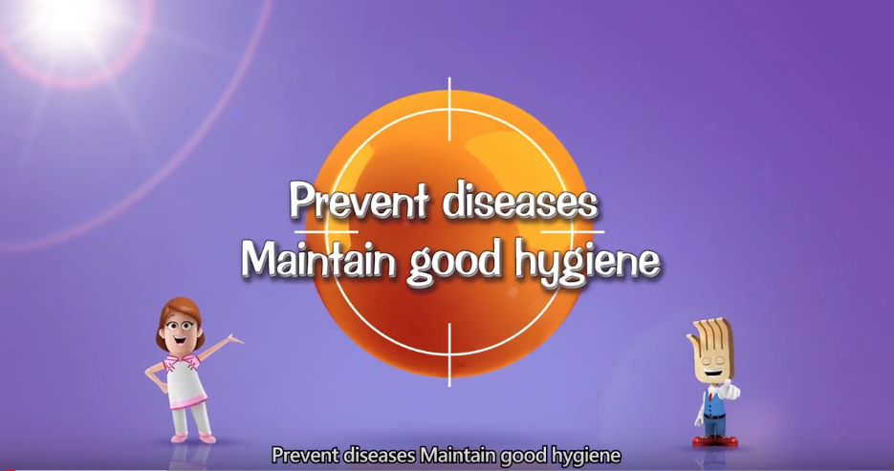 | https://bit.ly/2UeNxMp
Pamphlets | 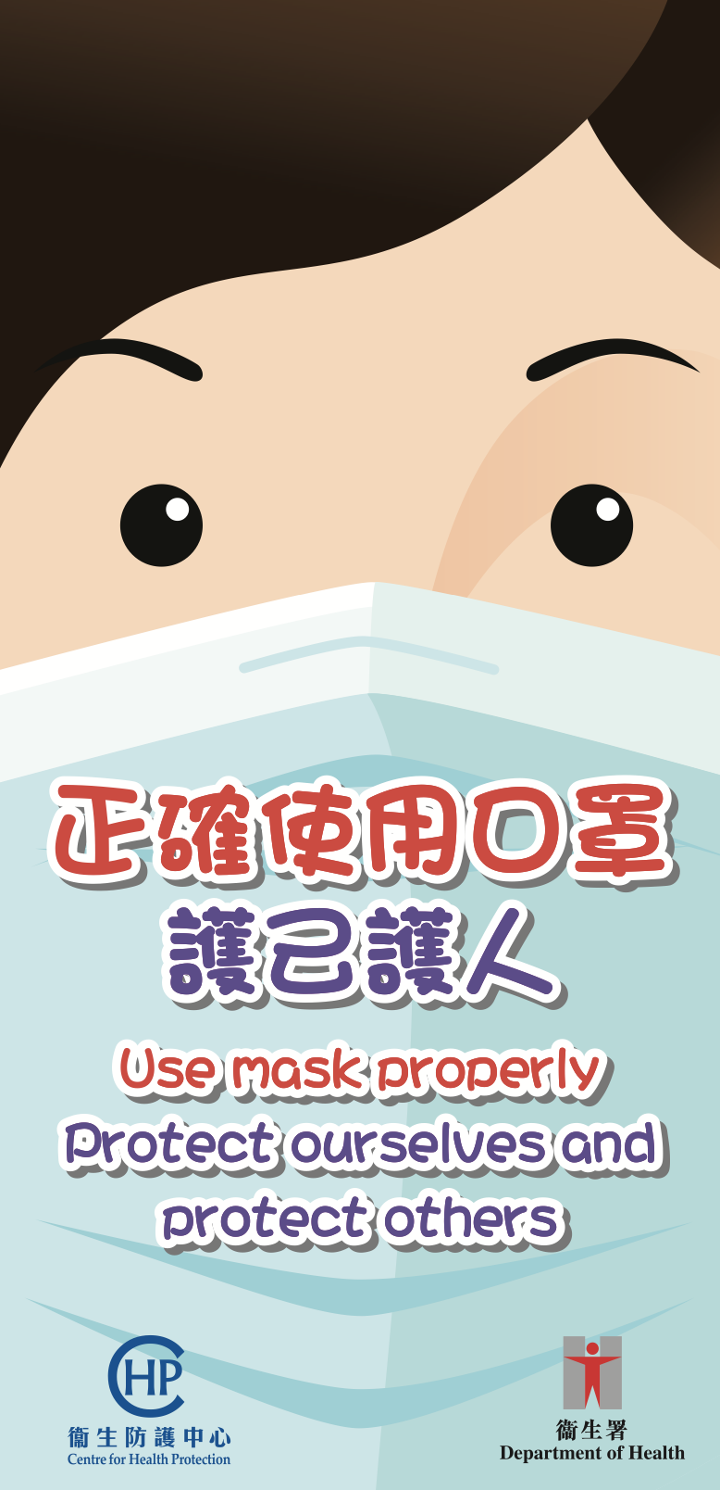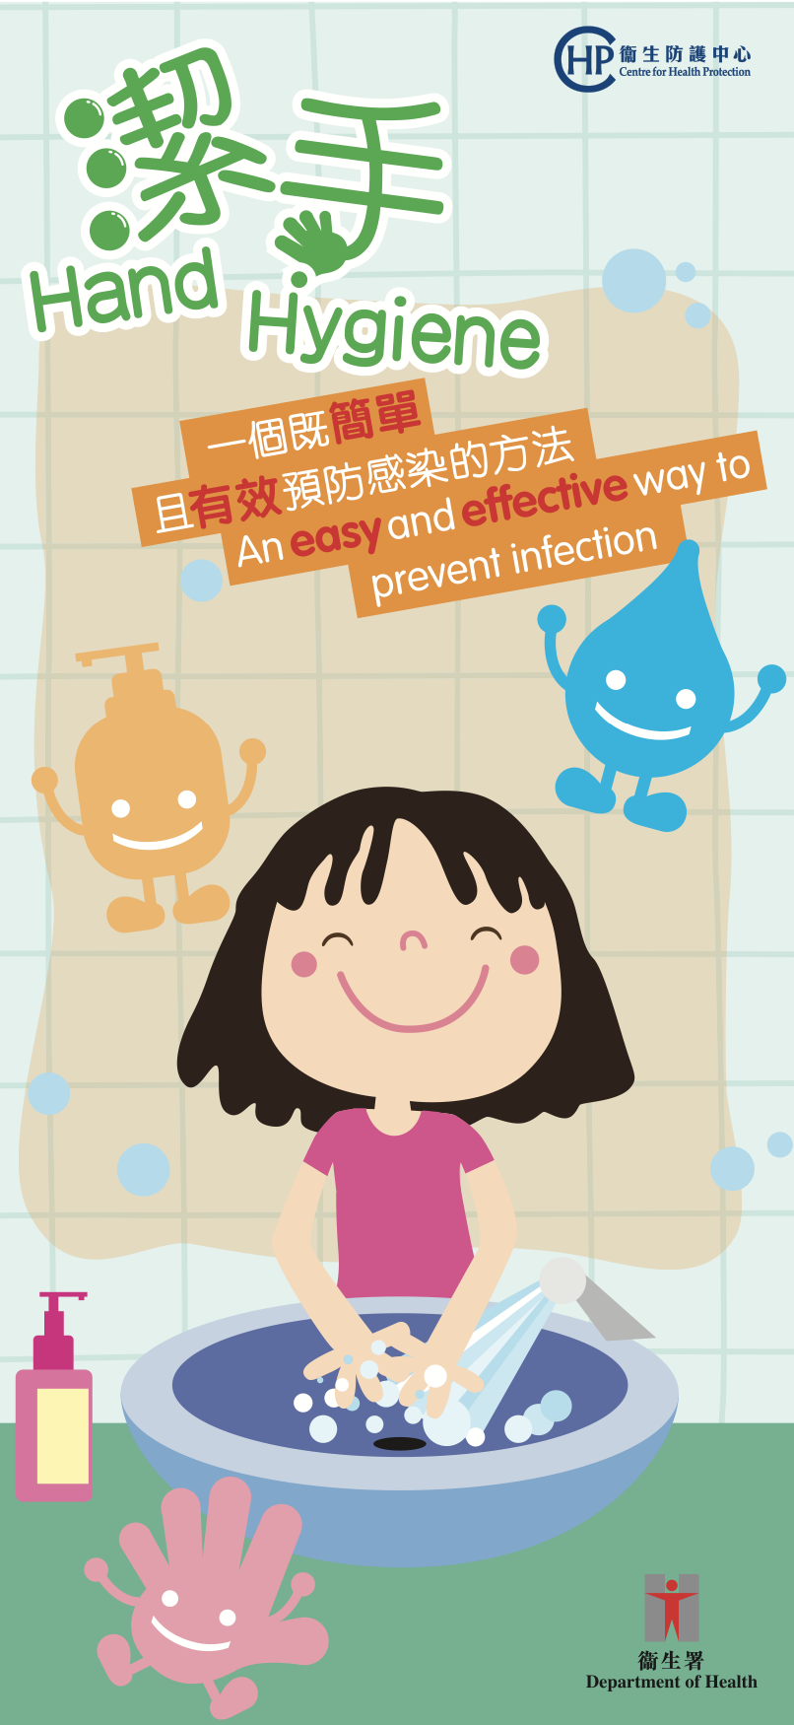 | https://bit.ly/37Eg4zg  https://bit.ly/2tYOluo

(1) Points to note for hand hygiene and wearing a mask

- Rub seven parts of our hands, including palms, back of hands, between fingers, back of hands, thumbs, finger tips and wrists.

- Rub your hands for at least 20 seconds.

- Dry hands thoroughly with a clean cotton towel or a paper towel until the hands are completely dry.

- Wearing a mask can protect ourselves, prevent the spread of infection to others and the spread of virus transmission in the community.

- Perform hand hygiene before putting on a mask.

- Make sure the metallic strip should face (upwards / downwards) and the coloured side should face (inwards/ outwards).

- Before taking off the mask, perform hand hygiene. Discard the mask into a lidded rubbish bin and perform hand hygiene immediately.

(2) Below is the structure of a surgical mask, please write down the use of different parts on the lines provided.
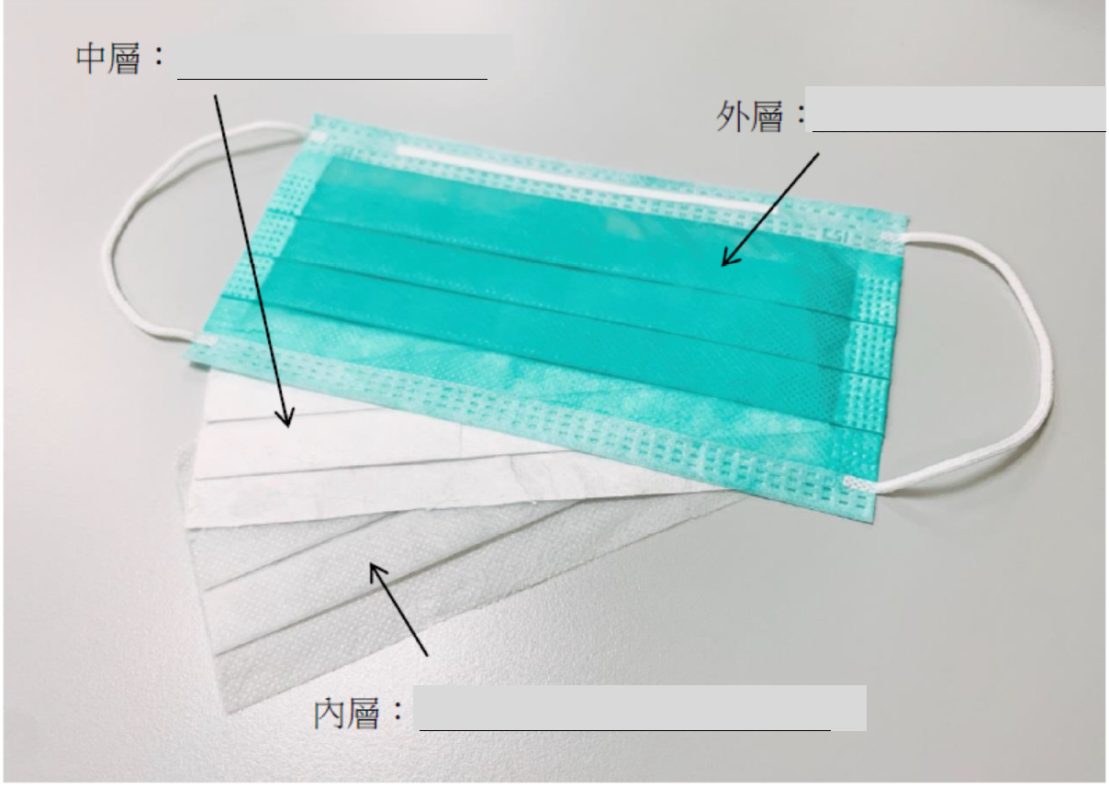
Outer layer: ______________________
Middle layer: ______________________

(Answer Key)
Inner layer: ______________________

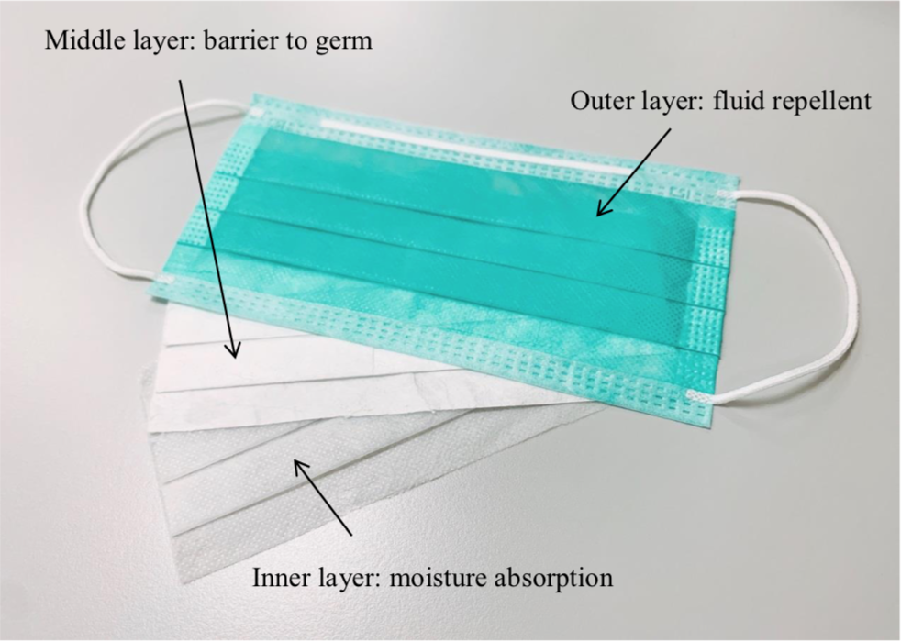(Source: CHP, Department of Health)

