Primary School Drama Education

Session 5
The Victims: Flashback – “If I were Little Lam”

Objectives﹕ | - To help students understand the responsibilities of the victims.  - To equip students with the “NOT” (see Appendix 5a) approach to handle bullying incidents.
Target: | Primary 4 to 6 students
Suggested  duration: | 1 lesson (35 minutes)
Teaching aids: | Appendix 3a “Storyline”, Appendix 5a “Use the ‘NOT’ Approach to handle Bullying”, Appendix 5b “Improvement Advice for Little Lam (For Students’ Discussion)”, Appendix 5c “Improvement Advice for Little Lam (For Teachers’  Reference)”

Duration | Teaching steps | Remarks
8 minutes - Warm-up exercise | - Revision:  - Teacher asks questions about the story in the previous 2 lessons.  - School bullying – “Big bullies small”  - After telling the story “Big bullies small”, Teachers asks all students to act out in the form of still images how Little Lam is bullied by Big Ko. Teacher should choose a few students and interview them about their feelings.  - Teacher’s questions / Group discussion topics:  - “What character traits does Little Lam show? What skills does she lack, making her vulnerable to being bullied by Big Ko?”  - “How can Little Lam change this situation?” | See Appendix 3a  “Storyline”

20 minutes - Activity | - Teacher first explains how to use the “NOT” approach to handle bullying, and then posts it on the blackboard.  - N: NO – Say “No” firmly. For example: “I don’t like you calling me names.”  - O: OFF – Get off the scene and go to a safe place.  - T: TELL – Tell someone. Seek help until someone takes charge of the situation.  - Flashback – “If I were Little Lam”:  - Form groups of 4-6 students.  - Each group spends 10 minutes discussing how Little Lam could use the “NOT” approach to handle bullying and predicts the result of this reaction.  - Each group records their conclusions on ‘Improvement advice for Little Lam (for students’ discussion)’.  - Teacher invites three students to re-enact the incident, using the “still image” approach for each scene, then invites a student to stand behind Little Lam and speak on her behalf to see what the outcome is.  - Between group performances, Teacher asks, “What would happen if Little Lam did not say that?”  - Each group displays their “Improvement advice for Little Lam” around the classroom.  - Teacher’s questions / Group discussion topics:  - What did Little Lam do this time?  - How does her behaviour affect the outcome of the incident? How will it affect Little Lam? (Reduce the number of bullying incidents and prevent escalation). | See Appendix 5a  See Appendix 5b and 5c “Improvement Advice for Little Lam (For Students’ Discussion / Teacher’ Reference)”.  Teacher may invite several students to conduct a few more rounds of role play to achieve the most ideal result.

7 minutes - Reflection and conclusion | - Reflection:  - Students are given one minute to reflect on what they have learnt in this lesson from the incident.  - Teacher invites students to share their views.  - Teacher’s conclusion:  - Remaining silent, showing weakness or giving in to unreasonable requests only encourages bullying behaviour. We should improve our communication skills and cultivate a strong personality to cope with and prevent bullying incidents from happening.  - The victim should use the “NOT” approach to firmly refuse and stop hostile treatment.  - We will discuss the responsibilities of the bystanders in the next lesson.

~~The end~~

Storyline
Appendix 3a

Time： | Recess
Location： | Classroom
Characters & props： | Big Ko / the bully(wearing a cap), Little Lam / the victim (wearing big glasses), Noisy Sheung and  Silent Ng / the bystanders.
Plot as follow
EXCERPT | CONTEXT
1 | - Little Lam is eating Mammy Noodles in her seat alone.  - Noisy Sheung, Silent Ng and other students are chatting, chasing each other and taking a rest.
2 | - At recess, Big Ko has nothing to do and feels bored. He wants to make fun of somebody. So he comes over to Little Lam and calls her “Four-eyes”.  - Little Lam is deeply troubled by the remark, but dare not say a word.  She lowers her head and remains silent.
3 | - Big Ko thinks Little Lam’s pack of Mammy Noodles looks really tasty and it will be alright for him to eat together. Without hesitation, Big Ko snatches the pack of Mammy Noodles from her.  - Little Lam feels helpless and can only remain silent.
4 | - Upon discovering there are not many Mammy Noodles left, Big Ko is disappointed and annoyed. He hits Little Lam on the head to vent his anger.  - Little Lam thinks Big Ko is unreasonable, but she dare not take any action.
5 | - Big Ko wants to buy another pack of Mammy Noodles, but he has no money. When he sees a 10-dollar note in Little Lam’s pocket, he asks for it. “Hey! Lend me 10 dollars! You can’t refuse your classmate.”
6 | - Little Lam doesn't want to lend it to Big Ko, so she grips her pocket tightly. Big Ko feels humiliated and angry, so he pushes her rudely in the hope that she will lend him the money.  - Little Lam is still reluctant and she grips her pocket tightly, repeatedly pleading Big Ko for mercy.

7 | - Seeing this situation, Noisy Sheung and other classmates yell in fascination. Big Ko becomes increasingly annoyed and snatches Little Lam’s 10-dollar note without a word.  - Little Lam is at a loss to understand her classmates’ behaviour. She does not know how to get out of the mess and all she does is to hold on to Big Ko’s arm.  - Silent Ng stands by in silence.
Outcome (presented by teacher verbally) | - Lastly, a teacher on patrol finds out that Little Lam is injured by Big Ko. The teacher calls the police. Little Lam is taken to the hospital while Big Ko is brought to the police station for questioning…..

Appendix 5a
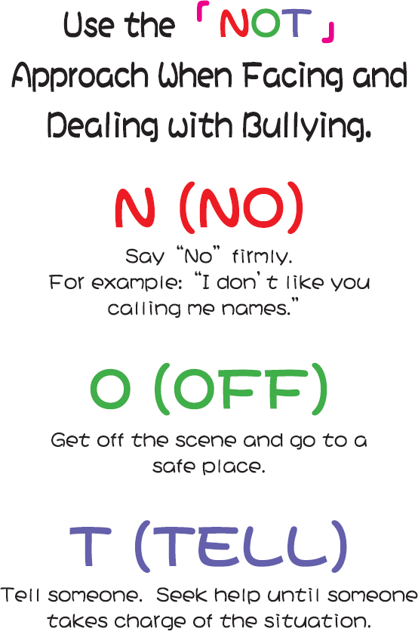

Appendix 5b Improvement Advice for Little Lam (For Students’ Discussion)
In order to prevent the incident turning into a bullying case, if you were Little Lam, what would you say to Big Ko in the following scenarios? What kind of facial and verbal expressions and gestures would you use in your speech?

Please pay attention to the words in bold in the following scenarios and think it through!

Scene | Scenario | Little Lam should say with determination…
1 | - Little Lam is eating Mammy Noodles in her seat alone.  - Noisy Sheung, Silent Ng and other students are chatting, chasing each other and taking a rest.
2 | - At recess, Big Ko has nothing to do and feels bored. He wants to make fun of somebody. So he comes over to Little Lam and calls her “Four-eyes”.  - Little Lam is deeply troubled by the remark, but dare not say a word. She lowers her head and remains silent. | If Little Lam did not want Big Ko to tease her, she should have told him immediately, “My name is Little Lam, not ‘Four-eyes’. I don’t like what you said! Please use my real name.” Then Little Lam should leave at once.
3 | - Big Ko thinks Little Lam’s pack of Mammy Noodles looks really tasty and it will be alright for him to eat together. Without hesitation, Big Ko snatches the pack of Mammy Noodles from her.  - Little Lam feels helpless and can only remain silent.

4 | - Upon discovering there are not many Mammy Noodles left, Big Ko is disappointed and annoyed. He hits Little Lam on the head to vent his anger.  - Little Lam thinks Big Ko is unreasonable, but she dare not take any action.
5 | - Big Ko wants to buy another pack of Mammy Noodles, but he has no money. So when he sees a 10-dollar note in Little Lam’s pocket, he asks for it. “Hey! Lend me  10 dollars! You can’t refuse your classmate.”
6 | - Little Lam doesn't want to lend it to Big Ko, so she grips her pocket tightly. Big Ko feels humiliated and angry, so he pushes her rudely in the hope that she will lend him the money.  - Little Lam is still reluctant and grips her pocket tightly, repeatedly pleading Big Ko for mercy.
7 | - Seeing this situation, Noisy Sheung and other classmates yell in fascination. Big Ko becomes increasingly annoyed and snatches Little Lam’s 10-dollar note without a word.  - Little Lam is at a loss to understand her classmates’ behaviour. She does not know how to get out of the mess and all she does is to hold on to Big Ko’s arm.  - Silent Ng stands by in silence.

~~The end~~

Appendix 5c Improvement Advice for Little Lam (For Teachers’ Reference)

In order to prevent the incident to develop into a bullying case, if you were Little Lam, what would you say to Big Ko in the following scenarios? What kind of facial / verbal expressions and gestures would you use in your speech?
Please pay attention to the words in bold in the following scenarios and think it through!

Scene | Scenario | Little Lam should say with determination……
1 | - Little Lam is eating Mammy Noodles in her seat alone.  - Noisy Sheung, Silent Ng and other students are chatting, chasing each other and taking a rest.
2 | - At recess, Big Ko has nothing to do and feels bored. He wants to make fun of somebody. So he comes over to Little Lam and calls her “Four-eyes”.  - Little Lam is deeply troubled by the remark, but dare not say a word. She lowers her head and remains silent. | If Little Lam did not want Big Ko to tease her, she should have told him immediately, “My name is Little Lam, not ‘Four-eyes’. I don’t like what you said! Please use my real name.” Then Little Lam should leave at once.
3 | - Big Ko thinks Little Lam’s pack of Mammy Noodles looks really tasty and it will be alright for him to eat together. Without hesitation, Big Ko snatches the pack of Mammy noodles from her.  - Little Lam feels helpless and can only remain silent. | After Big Ko had snatched Little Lam’s pack of Mammy Noodles, she should have told him immediately, “You shouldn’t grab my things without my permission. I don’t like the way you acted. If you do it again, I will report to the teachers.”

4 | - Upon discovering there are not many Mammy Noodles left, Big Ko is disappointed and annoyed. He hits Little Lam on the head to vent his anger.  - Little Lam thinks Big Ko is unreasonable, but she dare not take any action. | After being hit by Big Ko, Little Lam should have stood up and said, “You shouldn’t have hit me. Either you apologise to me, or go away. Otherwise, I’ll report to the teachers.” After this, she should leave immediately.
5 | - Big Ko wants to buy another pack of Mammy Noodles, but he has no money. So when he sees a 10-dollar note in Little Lam’s pocket, he asks for it. “Hey! Lend me 10 dollars! You can’t refuse your classmate.” | If Little Lam did not want to lend any money to Big Ko, she should have made it clear by saying, “It is my pocket money, and I need to save it to buy bread after school, so I can’t lend it to you.”
6 | - Little Lam doesn't want to lend it to Big Ko, so she grips her pocket tightly. Big Ko feels humiliated and angry, so he pushes her rudely in the hope that she will lend him the money.  - Little Lam is still reluctant and grips her pocket tightly, repeatedly begging Big Ko to go away. | Little Lam should have stopped Big Ko. She could have made it clear again by saying, “I have told you I can’t lend you the money. Other classmates have seen how you treated me. If you still behave this way, I’ll go straight to the teachers.” After this, she should look for the teachers.
7 | - Seeing this situation, Noisy Sheung and other classmates yell in fascination. Big Ko becomes increasingly annoyed and snatches Little Lam’s 10-dollar note without a word.  - Little Lam is at a loss to understand her classmates’ behaviour. She does not know how to get out of the mess and all she does is to hold on to Big Ko’s arm.  - Silent Ng stands by in silence. | If Little Lam thought the reactions of Noisy Sheung and other classmates were inappropriate, she should have told them, “All of you saw how he treated me. He hit me, snatched my pack of Mammy noodles and even took my 10-dollar note. If you don’t help me, you are likely to be bullied by him some day!”
Depending on the situation, Little Lam should leave the scene as soon as possible (OFF), tell someone (TELL) and seek help (from classmates, prefects or teachers) until someone takes charge of the situation.
~~The end~~

