Primary School Drama Education
Session 7
“Stop Bullying”, I Can Do it Too

Objective: | To have revision on various techniques, and use them to deal with bullying positively.
Target: | Primary 4 to 6 students
Suggested  duration﹕ | 1 lesson (35 minutes)
Teaching aids﹕ | Session 4 Appendix 4c “Self Help tips”, Appendix 7a “Keypoints”, Appendix 7b “Cards on Types of Bullying”, water-colour pens, posters, cellotapes

Duration | Teaching steps | Remarks
5 minutes - Warm-up exercise | Students form into groups to write / draw different roles and their ways in handling bullying. Teacher should ask students to jot down the details and then spend 30 seconds to share their ideas with others.  - The Bully:  - Get along with others in a friendly manner (The “3N Approach”);  - Manage self-emotion (Manage your temper ABC)  - The Victim or the bystander: Use the “NOT” approach to stop bullying.  - N: NO  Say “No” firmly. For example: “I don’t like you calling me names.”  - O: OFF  Get off the scene and go to a safe place.  - T: TELL  Tell someone. Seek help until someone takes charge of the situation. | Appendix 4c  “Self Help tips”

25 minutes - Activities | Put into practice:  - Form groups of 4-6 students.  - Teacher distributes “Keypoints” and “Cards on Types of Bullying” and tells students to set the bullying scenarios accordingly. Then students try to handle the bullying cases with what they have learnt.  - Each group has 2 minutes to perform. | Refer to Appendix 7a “Keypoints” and Appendix 7b “Cards on Types of Bullying”.  Teacher may distribute different cards accordingly.
5 minutes - Reflection and conclusion | Design a slogan  - Teacher encourages students to do reflections in groups. Then, invite each group to conclude by designing a slogan and write it on a poster.  - Each group posts the poster around the classroom.  - Teacher’s conclusion:  We all have the responsibility to reduce and prevent bullying incidents from happening. | Water-colour pens  Poster Blue tag

~~The end~~

Appendix 4c
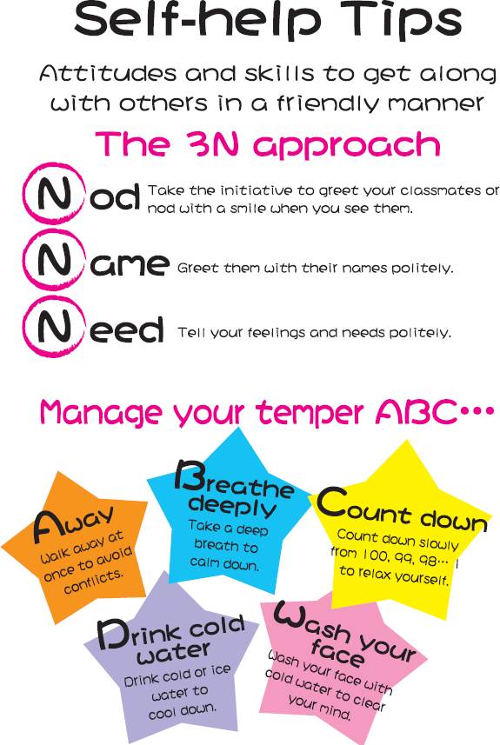

Appendix 7a

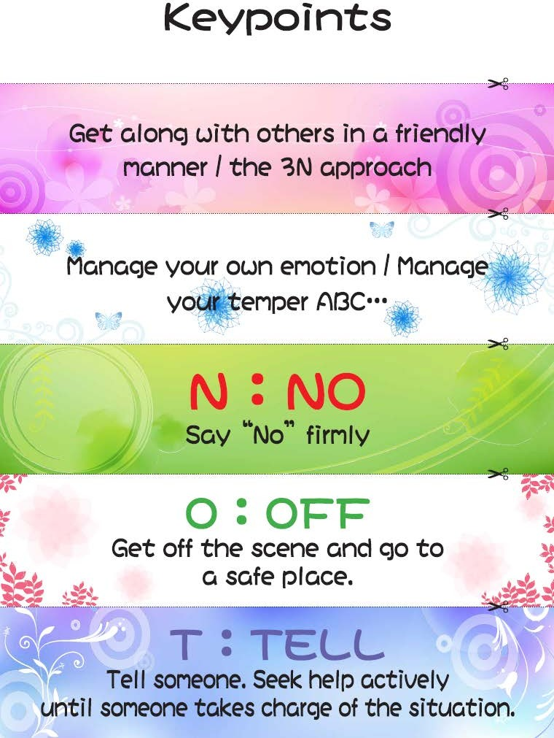

Appendix 7b

