Primary School Drama Education
Session 8
“Stop Bullying -Everybody’s Responsibility” Charter
Objective: | To encourage students to take actions to reduce or stop bullying incidents through contracting.
Target: | Primary 4 to 6 students
Suggested duration: | 1 lesson (35 mins)
Teaching aids: | Session 7 Appendix 7a “Keypoints”, music, Appendices 8a “Stop Bullying Charter” (in A4 and A3 format) and 8b “Stop Bullying” Motto

Duration | Teaching steps | Remarks
5 minutes - Warm-up exercise | 1. Teacher and students review the content of Sessions 1-7. Students share their views on the bullying incidents. | Appendix 7a  “Keypoints” from session 7
25 minutes - Activity | Establish the “Stop bullying, Everybody’s Responsibility” Charter  - Teacher points out to students:  Everybody should take an action to prevent or reduce bullying incidents from happening, so we need to establish the “Stop bullying, Everybody’s responsibility” Charter together.  - Form groups of 4-6 students to draft the charter.  - Every group reports the content of the charter.  - Teacher and students choose and write down the ten most representative items. Then, the whole class will sign their names on the charter.  - Students can also discuss other measures to advocate the charter’s spirit “Stop bullying, Everybody’s responsibility”, such as making posters or caring cards, setting up caring teams and so on. | Play music  See Appendix 8a ‘“Stop Bullying, Everybody’s Responsibility” Charter’ (A4) See Appendix 8a ‘ “Stop Bullying, Everybody’s Responsibility” Charter’ (Enlarge to an A3 poster)

5-minutes - Reflection and conclusion | - Bullying behavior is not tolerated in schools. Therefore, in order to tackle the problem, students should bear the responsibility and fulfill the commitment in the charter.  - Students finish their own “Stop bullying” motto. | See “Stop Bullying, Everybody’s Responsibility” Motto in  Appendix 8b.

~~The end~~

Appendix 7a

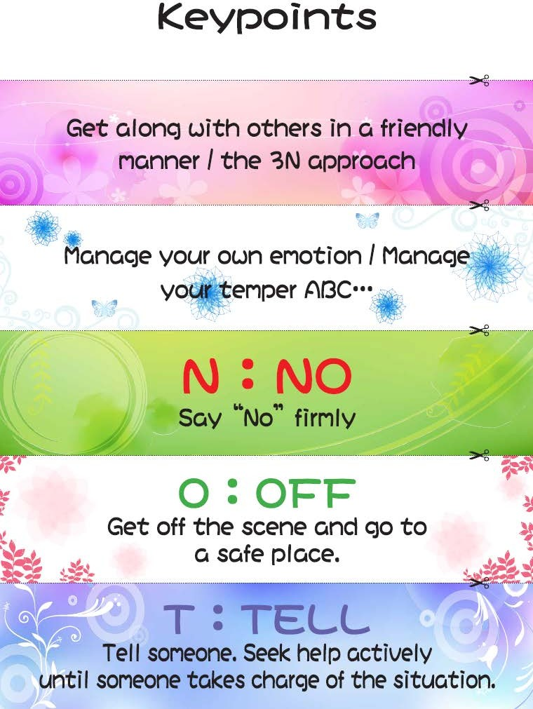

Appendix 8a

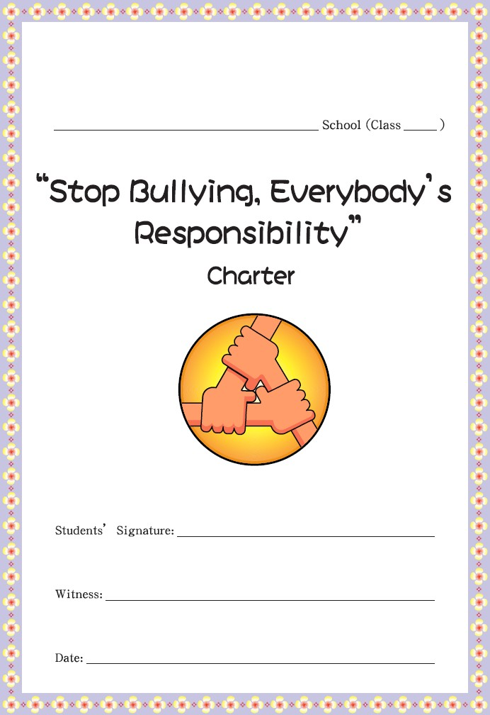

Appendix 8b

