Personal Development and Healthy Living
(Key Stage 1)
Points to note: Promotion of sex education in schools is not to encourage premature love affairs or premarital sexual relationship of students. On the contrary, we expect teachers can take a prudent and objective attitude, be open-minded and listen carefully to understand the needs or problems of their students, so as to help them discuss sexuality issues with a responsible attitude.

Learning Objectives:
- To understand that gender roles stereotype limits one’s individual development and choices and may bring about harm to others
- To appreciate the uniqueness of oneself; to understand gender equality and that everybody, regardless of gender, is precious, independent and should be respected

Life-Event Exemplar: Stay-at-Home Dad
(Gender Equality in Daily Life)

Values & Attitudes:
Respect, self-love, gender equality

Learning Materials:
- Animation: “Stay-at-Home Dad” (Please refer to the animation file)
- Appendix I: “Stay-at-Home Dad” Animation Summary and Discussion Questions
- Appendix II: Reference for Teacher “Stay-at-Home Dad”
- Appendix III: Worksheet “Play with Fun”
- Appendix IV: Reference for Teacher “Play with Fun”

Procedures:
Procedures (for reference) | Key Learning Points
Activity 1: Watching Animation and  Discussion  - Let students watch Scene 1 of the animation “Stay at Home Dad”. (Appendix 1: Scene 1)  - Invite students to express their views on the discussion questions for scene 1. (Appendix II) | - To understand that every family member plays a part in the family and should cooperate and shoulder their responsibilities regardless of gender.  - To understand that all of us have different qualities, and should appreciate and respect each other rather than simply assign family roles to people by gender. We should keep our positive qualities or learn from others’, and further develop these good qualities.
Activity 2:“Play with Fun” (Boys/ Girls  should play…)  - Let students watch scene 2 of the animation “Stay-at-Home Dad”. (Appendix I)  - Invite students to express their views on the discussion questions for scene 2. (Appendix II)  - Distribute the “Play with Fun” worksheet (Appendix III) to students. Ask students to pick their favourite toys and state the reasons.  - Find out what toys boys and girls pick. With reference to the distribution, see if boys and girls have preference for a particular type of toys. Drive home the message that toys should not be gender-specific. We should learn to respect the choice of others. (Appendix IV) | - Reject gender stereotypes. Students should choose toys based on their own preferences and develop hobbies they are really interested in.  - Respect the choice of other people. Do not tease others about their qualities to avoid making them feel inferior or humiliated.

Teacher’s conclusions: (for reference)

- In society, some people think that boys and girls “should” have certain qualities. For example, it is expected that boys do not cry. They are expected to be strong, courageous and independent and the weak ones are teased. Girls are expected to be gentle and elegant and have an eye for detail. They will be considered as different if they are straightforward. In fact, this is not right: Everyone possesses different qualities. Girls can be brave and boys can have an eye for detail. We all, regardless of gender, should try to develop good qualities. For instance, both boys and girls should learn to be strong and do not whine easily. However, it is unreasonable to forbid boys to cry if they feel sad. Crying is a natural way to express emotions and sometimes it helps soothe ourselves.

- In the world of work, most jobs can be taken up by males and females. One’s interests and abilities should outweigh gender. Females can be doctors or police officers and males can be nurses or teachers. It is so unfair if you are capable of performing a job but denied access to it because of your gender. Is it fair for females to do all the domestic work? Every family member plays a part in the family. Everyone, regardless of gender, should shoulder their responsibilities and fulfill their duties at home. There are full-time fathers looking after their families. Their contribution to their families is just as significant as full-time mothers’ and they should be respected. At the same time, breadwinning is not the responsibility of men only. Many mothers and daughters go to work and are able to support their families. (Remark: Points 1 and 2 can be used to conclude Activity 1.)

- Besides, some people classify hobbies, toys, etc., into two categories, “for boys” and “for girls”. Girls are expected to wear skirts and pink is a girlie colour. Boys are expected to play guns, toy cars, football while girls only dolls. These are all gender stereotypes. If the roles of boys and girls are stereotyped, all boys will be the same and all girls will be identical. Then, the world will be so boring. More importantly, it is unacceptable if we are prohibited from doing something we like because of our gender. It is normal for boys to wear brightly coloured clothes and for girls to put on black or dark blue pants. If boys and girls can play together and share toys, the fun will be doubled! (Remark: Point 3 can be the explanation for Appendix IV.)

- Above all, we should know how to respect the choices of others and not tease them about their choices. We should love ourselves, accept our strengths and weaknesses, explore and further develop our potential and good qualities.

Appendix I
“Stay-at-Home Dad”
Animation Summary and Questions for Discussion

Theme: Gender Equality in Daily Life

Scene 1 (In the classroom)

Elaine (a student)’s father just becomes a stay-at-home Dad. Pearl (Elaine’s classmate) thinks that traditionally men should play the role of breadwinners and women housewives. Elaine feels unhappy for what Pearl has said.

Discussion Questions:
- Elaine’s dad stays at home to do the housework while her mom goes to work. Do you think this arrangement is appropriate? Why?
- If social standards are imposed on the behaviour and life of men and women, what will be the problems?

Scene 2 (In Elaine’s home)

Elaine remembers Pearl’s word on her stay-at-home Dad. She discusses this topic with father when she returns home and then discusses with mother whether she should join dancing or Taekwondo extra-curricular activity at school.

Discussion Questions:
- If you were Elaine, would you choose dancing or Taekwondo? Why?
- If your classmates laugh at you because you choose a hobby group that is said to be “unsuitable” for your gender, what will you do?

Appendix II
Reference for Teacher:“Stay-at-Home Dad”
Scene 1 (In the classroom)
- Elaine’s dad stays at home to do housework while her mom goes to work. Do you think this arrangement is appropriate? Why?

(Let students share their views freely)
In the past, fathers went to work and mothers stayed at home to do housework. “Men are breadwinners and women are housewives” was a very typical belief. However, earning money to support the family and doing housework are just different duties. They are suitable for both sexes. It does not matter who goes to work or stays at home. Due to societal changes and economic development, women receive equal opportunity for education and work as men. Careers with financial advantage have changed. Women do not necessarily have to rely on men. They can be financially independent with their own careers. Nowadays, in order to meet the family expenses, both men and women go to work in many families. Hence, having a “stay-at-home dad” and a “working mom” can be an appropriate arrangement if it is mutually agreed upon by the couple.

- If social standards are imposed on the behaviour and life of men and women, what will be the problems?

If the roles of boys and girls are stereotyped, all boys will be the same and all girls will have no differences. Then, the world will be so boring. More importantly, if we are prohibited from doing something we like because of our gender, our choices and the development of individual potential will be limited. In this case, gender stereotyping can be harmful. Pearl’s comments on Elaine’s father and Jim are obviously influenced by gender role stereotypes. Pearl’s parents belong to the “Men-are-breadwinners-and-women-are-housewives” type. Influenced by traditional thoughts and media, she has misconceptions about full-time stay-at-home dads and says something that makes Elaine feel humiliated and angry. Apart from this, calling Jim “Lady Jim” and disapproving of Jim’s crying are examples of gender stereotypes. She does not respect Jim’s character. Although Jim says he is not annoyed, Pearl may have hurt his self-esteem. We should not make casual criticism of people because of their gender.

Scene 2 (In Elaine’s home)
- If you were Elaine, would you choose dancing or Taekwondo? Why?

Elaine’s mother is right. Both boys and girls should not limit their interests because of their genders. One’s preference or talent matters. No matter whether Elaine chooses dancing or Taekwondo, it is fine as long as she takes her preference but not her gender into consideration. If Elaine finally gives up Taekwondo, which she loves, due to the lack of other girls, she will not be happy. If a boy loves dancing but eventually follows other boys to choose Taekwondo, he will lose the chance to learn and know more about dancing. In this case, his development is hindered by gender stereotyping.

- If your classmates laugh at you because you choose a hobby that is said to be “not suitable” to your gender, what will you do?

We should not be affected by the opinions of other classmates and should stick to our interests. Besides, we should express our preference to them and ask for their respect for our choice. If they still tease us and we feel emotionally disturbed, we should not remain silent and promptly seek help from trustworthy adults.

Appendix III
Worksheet: “Play with Fun”
Please circle THREE toys that you like most.
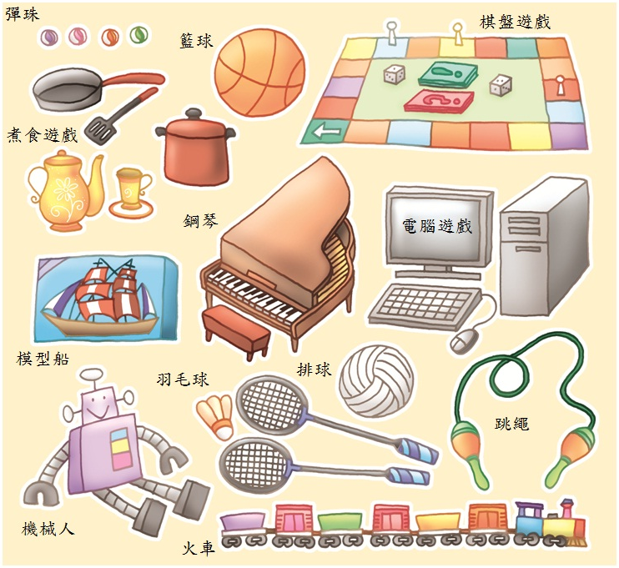
Badminton
Cooking Set
Skipping Rope
Basketball
Model Ship
Train
Robot
Volleyball
Computer Game
Piano
Board Game
Marble

Appendix IV
“Play with Fun” Reference for Teacher

There are many kinds of toys, some particularly attractive to you. In fact, toys should not be classified into “Boys’ Toys” and “Girls’ Toys”. All toys can bring fun and develop certain potential for both boys and girls. Therefore, both boys and girls can enjoy role-play games to play brave police officers. They can also play the cooking set game together to sow the seeds of being a great chef in the future!

Toys are not gender-specific. Boys and girls will have greater fun if playing together. Different people have different interests and hobbies. We should respect but not sneer at other people. Everyone wish to freely choose their favourite toys and games without discrimination of others.

