Social Life
(Key Stage 2)
Points to note: Promotion of sex education in schools is not to encourage premature love affairs or premarital sexual relationship of students. On the contrary, we expect teachers can take a prudent and objective attitude, be open-minded and listen carefully to understand the needs or problems of their students, so as to help them discuss sexuality issues with a responsible attitude.

Learning Objectives:
- To encourage students to develop healthy values towards sexuality and learn to respond to sexuality-related social phenomena
- To have self-respect and respect for others as the principle; understand the consequences or impacts of public display of affection to others
Life-Event Exemplar: The Intimate Couple
(Public Display of Affection)

Values & Attitudes:
Respect, Civic Awareness, Responsibility

Teaching Materials:
- Animation: “The Intimate Couple” (Please refer to the animation file)
- Appendix I: “The Intimate Couple” Animation Summary and Discussion Questions
- Appendix II: Reference for Teacher “The Intimate Couple”
- Appendix III: Worksheet “The Degree of Intimacy”
- Appendix IV: Reference for Teacher: “The Degree of Intimacy”
- Appendix V: Worksheet “If I were…”
- Appendix VI: Reference for Teacher “If I were…”

Procedures:

Procedures (for reference) | Key Learning Points
Activity 1：“The Intimate Couple” Animation  - The whole class watches the first part of the animation “The Intimate Couple”: Scene 1. (Appendix I)  - Divide the class into 3-4 persons per group and give a blank paper to each group. Invite the groups to discuss the questions in the animation and write down important points.  - Invite students to respond and remind them about the impacts of public display of affection according to their answers. (Appendix II ) | - To think and understand the consequences of public display of affection and the impacts on others from a third party’s point of view (e.g. passenger)
Activity 2：“The Degree of Intimacy”  - Continue the discussion for Activity 1  - Give the worksheet “The Degree of Intimacy” to each student and request them to complete it individually. (Appendix III)  - Students share their viewpoints on “Intimate Behaviour” and “Acceptance Level” with their group members and try to find out the similarities and differences between their viewpoints and discuss the reasons.  Invite each group to give a presentation; remind them that people have different acceptance levels towards various behaviour, and emphasise the importance of mutual respect according to students’ answers. (Appendix IV) | - To understand that people have different acceptance levels towards various behaviour. It is important to respect others’ standpoints and feelings, and learn to properly express one’s own feelings.
Activity 3：“If I were…”  - The whole class continues to watch the second part of the animation “The Intimate Couple”: Scene 2 (Appendix I).  - Invite students to respond to the discussion questions by raising their hands to indicate their choices, and express their opinions. (Appendix II)  - Distribute the Worksheet: “If I were…”. (Appendix V) Each group represents either “the couple” or “the person who recorded or uploaded the video without the consent of the people involved” (i.e. A or B) and carries out group discussion.  - Invite different groups to express their opinions, respond to students’ discussions and make conclusion, remind students to handle intimate behaviour in public places with a prudent attitude and understand that photography without consent may be unlawful. (Appendix VI) | - To take a rational and respectful attitude, and be aware of citizen’s rights and responsibilities when they encounter public display of affection. Although citizens have the rights to use public places, it may be unlawful and harmful to record, upload or share photographs or videos on the Internet without the consent of the people involved.

Teacher’s conclusions (for reference)

- Hong Kong is a liberal society in that every individual possesses freedom towards love and emotion expressions. Yet, we should take care of others’ feelings while enjoying the freedom.

- There are different intimate boundaries and different levels of acceptance towards intimate behaviour for different people. Even if intimate behaviour is accepted by the couple, they should avoid the behaviour in public places. It is not only to avoid causing uneasy feelings and embarrassment to others, but also to show self-respect and respect for your lover as well as other people.

- With the popularisation of smartphones, it is much easier to take photographs, record videos, and share them on the Internet. We may not be aware that our words and deeds may have been recorded by others secretly and uploaded on the Internet for public comments. Therefore, we should behave prudently and properly in public places to protect ourselves and people we care, and think about whether our intimate behaviour in public places would cause embarrassment to ourselves, our friends and family members. In addition, exposing private body parts and having sexual intercourse in public places may contravene the Crimes Ordinance of “Indecency in public”. Anyone who uploads sex-related videos or photos on the Internet and public forum may also contravene the "Control of Obscene and Indecent Articles Ordinance", and shall be liable on conviction to a fine and to imprisonment.

- We should maintain a rational and respectful attitude if we encounter intimate behaviour in public places. We can express our opinions to the responsible staff besides leaving the place. Under proper and safe conditions, we may remind the people involved politely to raise their awareness.

- Despite others' intimate behaviour in public, we should not respond by causing disturbances such as taking photographs without the consent of the people involved, uploading or sharing them on the Internet. It may be harmful to both sides (e.g. identities of both parties being searched and disclosed) and violate the law.

Appendix I
“The Intimate Couple”
Animation Summary and Questions for Discussion

Topic: Public Display of Affection

Scene 1 (In the restaurant)

Chun Yin (a senior primary boy) is having breakfast with his mum in a restaurant, his attention is caught by a teenage couple nearby, hugging and caressing each other.

Discussion Questions:
1. If you were Chun Yin, what would you think if you encountered intimate behaviour of others in the restaurant? How would you respond? What elements would you consider?
2. Why does Chun Yin’s mum have different responses towards intimate behaviour of the old and young couples?

Scene 2 (In the park)

Chun Yin sees the young couple again in the park, kissing and touching each other. Chun Yin’s classmates encourage him to take photos or record videos of their intimate behavior.

Discussion Questions:
- What do you think Chun Yin should consider when he decides whether it is appropriate to record others’ intimate behaviour?
- Do we have the right to upload, share, or publicly comment on the photos or videos of others’ intimate behaviour on the Internet?

Appendix II
Reference for Teachers
Discussion Questions of "The Intimate Couple"

- Honey and Baby are kissing and touching each other's body affectionately in the restaurant which may be embarrassing to other people. What kind of intimate behaviour should be considered as inappropriate? It is hard to reach a consensus as the levels of acceptance vary in different societies and cultures.

- Nevertheless, public places are not exclusively for couples. People of different ages, gender and nationalities may have different levels of acceptance towards intimate behaviour. Over-intimate behaviour may cause embarrassment or even grievances to others. They should have self- respect and consider others' thoughts and feelings, as well as exercise self-control.

- Similarly, as passers-by or customers, we should also respect the rights of the responsible staff and other customers. If we feel disturbed by others’ behaviour, we can express our opinions to the responsible staff and request their follow-up action instead of initiating a conflict (e.g. criticising each other loudly or taking photographs/recording videos of their behaviour).

- If no follow-up action is taken or the couple's behaviour are regarded as over-intimate, we can express our dissatisfaction (students can further discuss the ways to express their opinions) to the couple depending on the environment (students can discuss other factors such as safety and time), or even seek help from police.

- Despite the intimate behaviour of Honey and Baby in public, it is an invasion of other's privacy if bystanders record and upload the related photos or videos on the Internet because of their self-satisfaction or enjoyment. In fact, the uploading means exposing others' privacy on the Internet. It will become cyber-bullying if Internet users search and disclose information of the people involved including the couple and the person who uploads the video or photo, causing harm to both sides.
Appendix III
Worksheet: “The Degree of Intimacy”
How would you assign the degree of intimacy to the following behaviour? What is your acceptance level? Please circle the number representing your view (a larger number represents a higher degree of intimacy/level of acceptance) and answer to the discussion questions.

(Picture 1)  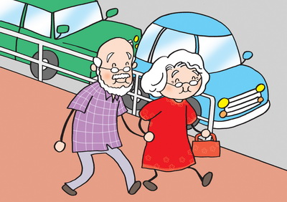  An old couple walking hand in hand in the street | (Picture 1)  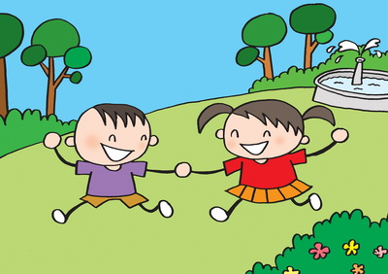  Two kids holding hands in the park | (Picture 3)  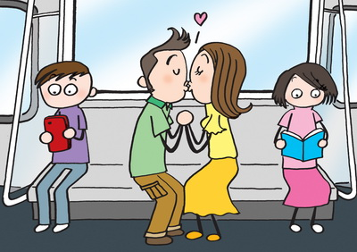  A pair of adult couple kissing in the compartment
Degree of Intimacy： | Degree of Intimacy： | Degree of Intimacy：
My Acceptance Level： | My Acceptance Level： | My Acceptance Level：
(Picture 4)  A father kissing his baby  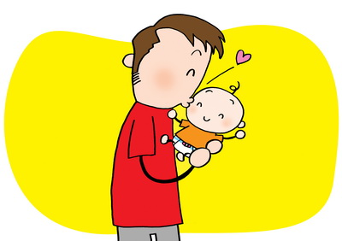 | (Picture 5)  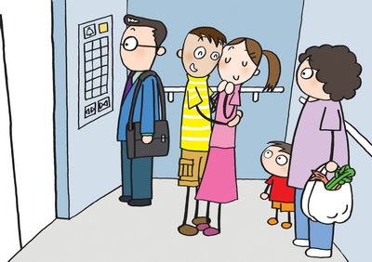  Two local teenagers hugging each other in the lift | (Picture 6)  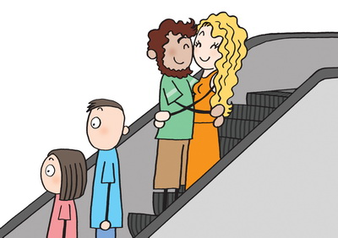  Two foreigners hugging each other on the escalator
Degree of Intimacy： | Degree of Intimacy： | Degree of Intimacy：
My Acceptance Level： | My Acceptance Level： | My Acceptance Level：

Discussion Questions:

- In the above scenarios, does your acceptance level vary towards different people conducting the same act? Would you regard some scenarios as "a high degree of intimacy with a low acceptance level" or vice versa? Why?
__________________________________________________________________
___________________________________________________________________
___________________________________________________________________

- What factors would influence your acceptance level towards the behaviour?

__________________________________________________________________
___________________________________________________________________
___________________________________________________________________

Appendix IV
Reference for Teacher: “The Degree of Intimacy”

- When judging whether to accept a certain kind of intimate behaviour or its acceptance level, we would consider many kinds of factors such as the degree of intimacy and environment.

- Generally, people have a higher level of acceptance towards milder behaviour (such as holding hands) than vigorous intimate behaviour (such as kissing and hugging). Certainly, the acceptance level of intimate behaviour is very personal. Some people may regard kissing and hugging as ordinary.

- Factors affecting the acceptance level include the age of the witness and the people involved, their relationship, race, culture, the environment, etc. To some people, intimate behaviour between adults, couples, family members, as well as western people is more acceptable.

- In addition, intimate behaviour in a narrow space or a public area with designated purposes/businesses (such as compartment, lift, campus and office) would have greater impacts on others. The acceptance level might be lower if the behaviour is beyond people’s expectations.

- Anyhow, people’s feelings and levels of acceptance towards intimate behaviour differ. It is our responsibility to be careful and respectful to our words and deeds in public. We should also take care of others’ feelings and avoid causing embarrassment to show self-respect and respect for others apart from enjoying individual freedom.

Appendix V
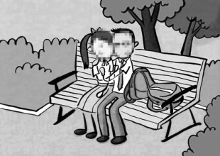
“If I were…”

Please read the case below and answer the questions as if you were the characters.
News Summary

Affectionate young couple in the park becomes an Internet controversy: “Identity disclosed!” Complained by the couple

Recently, a video of a young student couple who were in school uniform and caressing each other in the park has been widely shared after being uploaded to the Internet two days ago. It has become a controversy with disclosure of the couple’s photos. While some people criticise the younger generation for their open attitude towards sex and inappropriate behaviour, others regard it as an invasion of the couple’s privacy so the identity of the person who recorded the video should also be disclosed. The couple’s information including their names, school names, social media accounts and even the districts where they live were revealed. The couple have deleted their social media accounts because of these disturbances and the girl also suffers from emotional distress and has taken sick leave from school.

Group A: The young student couple

How would you feel if you were the young couple? Would you insist on having those intimate behaviour if you had a second chance? Why?
_______________________________________________________

_______________________________________________________

_______________________________________________________

_______________________________________________________

_______________________________________________________

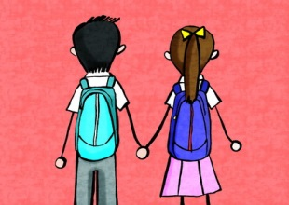
"If I were..."
Please read the case below and answer the questions as if you were the characters.
News Summary

Affectionate young couple in the park becomes an Internet controversy: “Identity disclosed!” Complained by the couple

Recently, a video of a young student couple who were in school uniform and caressing each other in the park has been widely shared after being uploaded to the Internet two days ago. It has become a controversy with disclosure of the couple’s photos. While some people criticise the younger generation for their open attitude towards sex and inappropriate behaviour, others regard it as an invasion of the couple’s privacy so the identity of the person who recorded the video should also be disclosed. The couple’s information including their names, school names, social media accounts and even the districts where they live were revealed. The couple have deleted their social media accounts because of these disturbances and the girl also suffers from emotional distress and has taken sick leave from school.

Group B: The person recording or uploading the video without the consent of the people involved

What do you think about recording or uploading the video without consent? Does the result meet your expectation? Would you insist on recording or uploading the photo/video without consent if you had a second chance? Why?
_______________________________________________________

_______________________________________________________

_______________________________________________________

_______________________________________________________

_______________________________________________________

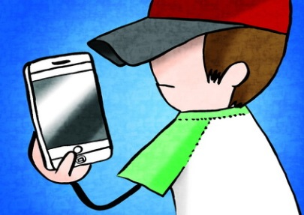
Appendix VI
Reference for Teacher: “If I were…”

This activity aims to encourage students to carefully consider the consequences of having or recording intimate behaviour in public from different perspectives. There is no standard answer for this part. Teacher can guide students to consider the pros and cons of people’s behaviour, and learn to behave prudently through understanding the pressure of the people involved. Some perspectives are listed below for reference:

Points to note for the young couple:
- Being too intimate in public places, ignoring social morality and causing embarrassment to others
- Behave recklessly without taking the consequences into account
- Neglect the impacts of their behaviour on their image as a student wearing school uniform
- Face a lot of criticism and social pressure

Points to note for the person who recorded or uploaded the video without the consent of the people involved:
- Informing the responsible staff or leave the place if you encounter any unacceptable intimate behavior where appropriate
- Taking photographs or recording videos without the consent and uploading the related videos/photos to the Internet is an invasion of others’ privacy
- Uploading the records of others’ intimate behaviour to the Internet or public forum may contravene the "Control of Obscene and Indecent Articles Ordinance"
- Causing disturbances to others simply because of fun

Control of Obscene and Indecent Articles Ordinance (Chapter 390)
According to the "Control of Obscene and Indecent Articles Ordinance", an article can be classified as Class I (neither obscene nor indecent); Class II (indecent) or Class III (obscene). If an article is classified as Class II, it should be published in accordance with conditions. If an article is classified as Class III, it should not be published to anyone.

Any person who publishes, possesses or imports Class III article, including publishing it to the Internet and public forum, will commit an offence and is liable to a fine of $1,000,000 and to imprisonment for 3 years. Any person who publishes any indecent article to a juvenile will commit an offence and is liable to a fine of $400,000 and to imprisonment for 12 months on his first conviction, and to a fine of $800,000 and to imprisonment for 12 months on a second or subsequent conviction.

(Reference: Webpage of Bilingual Laws Information System, Department of Justice http://www.legislation.gov.hk/index.htm )

