Social Life
(Key Stage 2)

Points to note: Promotion of sex education in schools is not to encourage premature love affairs or premarital sexual relationship of students. On the contrary, we expect teachers can take a prudent and objective attitude, be open-minded and listen carefully to understand the needs or problems of their students, so as to help them discuss sexuality issues with a responsible attitude.

Learning Objectives:
- To learn about the meaning of sexual harassment and how to protect themselves as well as to understand how to get along harmoniously with others
- To understand the importance of gender equality and mutual respect, learn to be self-disciplined, care about other’s feelings and avoid using sex and pornography as topics for gossip or joke
- To get along with others with a peaceful mind, and learn to build social relationships based on mutual respect
Life-Event Exemplar: Intimacy Boundary
(Sexual Harassment among Peers)

Values & Attitudes:
Self-protection, Respect for Others, Responsibility

Learning Materials:
- Animation: “Intimacy Boundary” (Please refer to the animation file)
- Appendix I : “Intimacy Boundary” Animation Summary and Discussion Questions
- Appendix II : Worksheet “My Feelings ”
- Appendix III : Reference for Teacher - Activity 1
- Appendix IV : Worksheet “Picking out Sexual Harassment”
- Appendix V : Reference for Teacher - Activity 2

Procedures:

 | Procedures (for reference) | Key Learning Points
Activity 1: My Feelings  - The whole class watches the animation: “Intimacy Boundary” Scene 1. (Appendix I)  - Divide the class into 4 groups and give one copy of the worksheet “My Feelings” (Appendix II) to every student. Each group plays one of the roles (Shan Shan, Man Chai and Chi Ming, Tze Wai or Tze Long) to think from that character’s perspective and then records his/her feelings on the worksheet.  - After collecting the worksheets from all the groups, the teacher can invite students to draw the worksheets from another group and read out that character’s feelings. For example, the group of Man Chai and Chi Ming will read out Shan Shan’s feelings, and so on.  - Conclusions (for reference only): (Appendix III)  4.1 When we get along with others, we will find that people’s feelings towards same treatment may be different. You may not care about being teased or called nicknames but making fun of others’ bodies, calling others nicknames or having inappropriate body touches can cause embarrassment, sadness or anger of other classmates.  4.2 Make use of these behaviours as examples to explain the definition of sexual harassment. Clarify that any sex-related words, conduct and acts which lead to embarrassment, uneasiness or sadness of others are unwelcome behaviour towards others and may be sexual harassment. |  | - Encourage students to think from the victim’s perspective regarding the feelings when being teased about their bodies or called nicknames. Through sharing of personal feelings among students (attend to students’ emotional responses, and arrange counselling or follow-up actions if necessary) teachers can raise students’ empathy and help them understand the importance of respecting others’ feelings.  - Use the examples in the animation to clarify the definition of sexual harassment as well as remind students not to use sex and pornography as topics for gossip or joke.
 | Activity 2: Picking Out Sexual  Harassment  - The whole class watches the animation “Intimacy Boundary” Scene 2. (Appendix I)  - 3–4 students work as a group and get the worksheet of “Picking out Sexual Harassment”. (Appendix IV) Students discuss and give suggestions about the ways the characters get along with peers.  - Each group sends one representative to share their conclusions after discussion.  - Continue to play the animation  Scene 3. (Appendix I)  - Conclusions (for reference only): ( Appendix V)  When we get along with others, we should hold an equal and respectful attitude. Teasing others may cause their embarrassment, sadness or anger. If we are not familiar with a person or unable to predict his/her feelings (no matter the gender), we should pay more attention to our words and deeds and avoid building our happiness on others’ suffering. When encountering impolite behaviour, we should protect ourselves, properly express our personal feelings or seek help. | - Encourage students to think about the ways to handle impolite wordings and behaviour of classmates. Through analysis and discussion, teachers can clarify that we should keep calm, express our feelings or seek help if encountering sexual harassment.  - Draw conclusions about the importance of gender equality and mutual respect, help students establish healthy attitude towards sexuality and learn how to get along with others so as to avoid sexual harassment.

Teacher’s conclusions: (for reference)

1. During puberty, boys and girls start getting curious about sexuality and look for recognition of their peers. However, when handling social relationships in reality, teenagers may not know how to get along with others. Sometimes they may exaggerate their words and deeds, call others nicknames or use sex as a topic for joke in order to attract others’ attention, show off themselves or just make fun in the way at the expense of others’ feelings.

2. Nevertheless, sexuality often relates to personal privacy which should not be used as a topic for joke. It is also not an open subject for everyone. Therefore, sexuality should be taken seriously with a respectful attitude. Sexuality topics include discussing others’ bodies, gender images, emotional relationships, etc. Since everyone is unique, different people may have different feelings towards the same treatment. When getting along with others, we should care about their feelings; otherwise, sexual harassment will result when we cross the intimacy boundary.

3. Sexual harassment is any offensive, humiliating, and unwelcome attention or physical conduct of a sexual nature. People may be confused when they encounter sexual harassment from peers, wondering if they are too sensitive. Would it hurt their friendships after they express their own feelings or make themselves the target of sexual harassment if they blame others openly? These doubts are unnecessary since everyone has the right to protect themselves and mutual respect is the basic principle in getting along with classmates or friends. If encountering sexual harassment, students should keep calm, properly express their feelings or leave immediately. They can also seek help from teachers or parents if necessary.
Appendix I
“Intimacy Boundary”
Animation Summary and Discussion Questions

Theme: Sexual Harassment among peers

Scene 1 (In the classroom)

Male students Man Chai and Chi Ming make fun of their classmate Shan Shan which embarrassing her. Her female classmate Tze Wai, standing up for Shan Shan, uses hard words to respond. Both sides are accusing one another. In the end Tze Long (male classmate), joining the conversation in support of the girls, is ridiculed by the boys.

Discussion Question:
How would you feel if you were Shan Shan/ Tze Wai/ Tze Long / Chi Ming or Man Chai?

Scene 2 (On the playground)

Shan Shan is upset with what has happened. May (female classmate) tries to comfort Shan Shan. Shan Shan thinks that she can stay away from Man Chai and Chi Ming if she ignores them, but May thinks Shan Shan does not mind them as she has not expressed refusal. Tze Wai and Tze Long joins the discussion, Tze Long advising Shan Shan to courageously express her true feelings to protect herself in next embarrassment she may encounter.

Discussion Question:
How do you handle jokes or sexual harassment among classmates? Do you think it is effective?

Scene 3 (In the classroom)

Chi Ming and Man Chai, asking Shan Shan to help them with homework, make fun of her again. Shan Shan expresses her hard feeling, urging them to stop saying weird things or nicknames about her and stop calling others’ nicknames again as classmates should respect to each other. Man Chai and Chi Ming promise not to call their nicknames and say weird things.

Discussion Question:
What do you think about the ways classmates should get along with each other?

Appendix II
Worksheet: “My Feelings”
If I were Shan Shan, when my classmates Chi Ming and Man Chai always call me Babe Shan Shan and comment on my figure, I would feel...

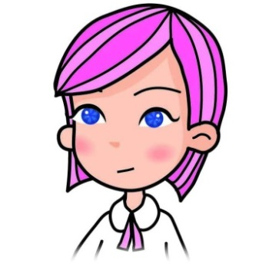

Do you think this should be regarded as sexual harassment? Why?

Worksheet: “My Feelings”
If I were Tze Wai, when my classmates Chi Ming and Man Chai call me “scrawny girl” and tease me that I am dating a boy in the class, I would feel...

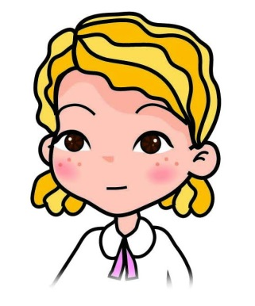

Do you think this should be regarded as sexual harassment? Why?
Worksheet: “My Feelings”
If I were Chi Ming or Man Chai, when my classmate Tze Wai calls me “dirty boys”, I would feel...

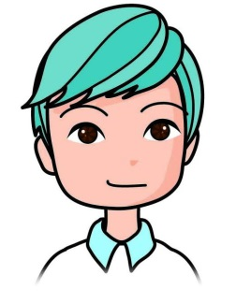
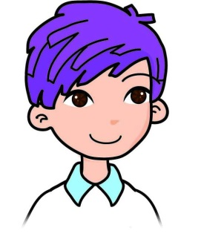

Do you think this should be regarded as sexual harassment? Why?

Worksheet: “My Feelings”
If I were Tze Long, when my classmates Chi Ming and Man Chai tease me that I am dating a girl in the class, I would feel...

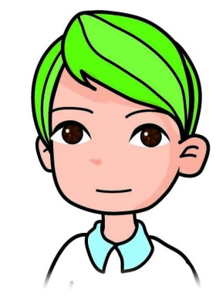

Do you think this should be regarded as sexual harassment? Why?

Appendix III
Reference for Teacher: Activity 1

What is sexual harassment?

Sexual harassment means a person makes an unwelcome conduct of a sexual nature to you. The unwelcome conduct includes unwelcome sexual attention, physical contact, talking about issues of a sexual nature, or making a sexual advance. It also amounts to sexual harassment if you find the environment you work or study is sexually hostile, in which you feel intimidated.

In general, sexual harassment can be classified into physical contact, verbal behaviour, non-verbal behaviour, and any bribery or threatening behaviour using sex.

Physical contact─Unnecessary touching, stroking or deliberate rubbing others’ bodies, forcing to put hands over others’ shoulders or arms, staying close to others physically, etc. For example: leaning on other’s body on the bus intentionally.

Verbal behaviour─Talking about unnecessary sex-related topics on purpose, asking about others’ personal sexual privacy, making sexual comments about others’ clothing, looks or figures, telling sexual jokes or stories, etc. For example: asking sex-related questions using telephone interview as an excuse.

Non-verbal behaviour─Whistling or making kissing sounds intentionally, using body movements or hands to make gestures involving sexual meanings, gazing at others in a sexual way, showing sex-related items such as pornographic magazines and posters. For example: showing pornography to classmates.

Briberies or threatening behaviour using sex
Offering sexual favour as a means of exchange for interest or threatening others for sex. For example: implying a request for a date with promises of some advantages in return.

Who commit sexual harassment?
Sexual harassers can be strangers or acquaintances, no matter males or females. Sexual harassment cases are usually (but not necessarily) related to abuse of “authority”. Harasser makes use of his/her authority to harass others. People who possess or assume themselves to possess authority can be classified into three categories:

(1) People who possess or assume themselves to possess authority (such as social or official status). For example: senior relatives, bosses, teachers, coaches, or even peers who use authority to intimidate or threaten others to commit sexual harassment.
(2) People who obtain authority as they are the majority
(3) People who consider themselves superior because of their gender

Who would be sexually harassed?
Anyone may encounter sexual harassment regardless of their gender, age, appearance, characteristics or background. Don’t think that only females or young people with outstanding appearances or figures would be sexually harassed. Therefore, boys should also beware of it.

Laws and Regulations about Sexual Harassment

According to Hong Kong local laws, sexual harassment is regarded as a civil offence and regulated under the “Sex Discrimination Ordinance” (SDO). The SDO is an anti-discrimination law passed in 1995. Discrimination on the basis of sex, marital status and pregnancy, and sexual harassment is made unlawful under this law. Its protection covers seven different fields, including employment, education, provision of goods, facilities or services, disposal or management of premises, participation in clubs and activities of government, etc. The law applies to both males and females.

Subsequent to the amendment to the SDO that came into effect on 3 October 2008, sexual harassment involving creation of a hostile or intimidating environment for others by any person’s conduct of sexual nature also applies to educational settings. Therefore, schools should develop their own school-based policy for handling sexual harassment, set up a mechanism to resolve sexual harassment complaints, heighten the understanding of different parties in the schools about sexual harassment through sexuality education, and develop the positive value of respect for others.

(Reference: Webpage of Equal Opportunities Commission http://www.eoc.org.hk)

Appendix IV
Worksheet: “Picking out Sexual Harassment”

Characters | Is sexually harassed? | How to handle sexual harassment properly? | Your comments on the ways to get along with peers (e.g. with proper manner) | Suggested ways to get along with peers
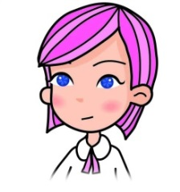
Shan Shan
Man Chai &
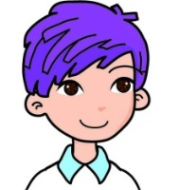
Chi Ming
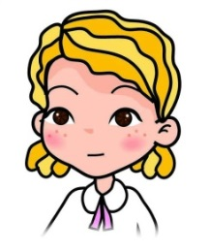
Tze Wai
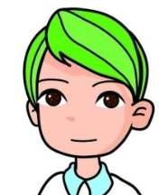
Tze Long
Discussion Question:
Who do you think has behaved most appropriately when getting along with peers? Why?
_____________________________________________________________________
_____________________________________________________________________

Appendix V
Reference for Teacher: Activity 2

In the animation “Intimacy Boundary”, there are disputes and even sexual harassment among the four characters. Some of them lack awareness of respecting others or have not thought for themselves and others. Owing to curiosity or a moment of fun, they have made unwise decisions impetuously. At the end they have caused themselves and others hurt and troubles far beyond their imagination. The following are some viewpoints for reference which can be shared with students:

Shan Shan
Is sexually harassed?
- Man Chai and Chi Ming gaze at her body, whistle, call her indecent nickname, and comment on her appearance and figure recklessly. Although they do not have any bad intention, it can be sexual harassment as Shan Shan feels embarrassed and uneasy.

How to handle sexual harassment?
- Shan Shan is scared and thinks that Man Chai and Chi Ming will leave her alone when getting no response. She stays passive to avoid making the situation worse. However, Shan Shan’s classmates, including Chi Ming and Man Chai, misinterpret her “no response” as acceptance of those behaviours and continue to get along with her with the same attitude.

Comments on the ways to get along with peers:
- Too timid, tolerant for the sake of harmony

Suggestions for prevention of sexual harassment:
- Shan Shan should try to be more confident and assertive when getting along with others. This can help not only protect herself but also deepen the understanding between one another and avoid unnecessary quarrels.

Tze Wai
Is sexually harassed?
- Man Chai and Chi Ming laugh at her figure, call her “scrawny girl”, and tease her about dating her classmate Tze Long. These are disrespectful behaviours which make Tze Wai feel humiliated and can be regarded as sexual harassment.

How to handle sexual harassment?
- Tze Wai is very angry when she encounters sexual harassment. She uses hurtful words (openly calls others “dirty boys”) and even wants to hit Man Chai and Chi Ming hard. Her feelings are understandable. Nevertheless, arguing with them is not a desirable solution because it will not only hurt others, but may also result in sexual harassment of each other. In fact, this cannot solve the problem and will only cause another quarrel instead.

Comments on the ways to get along with peers:
- Too impetuous, and try to take revenge which results in another quarrel

Suggestions about getting along with peers:
- Tze Wai should keep calm and polite when expressing her feelings or seek help from teachers. There is no need to get entangled with the harassers.
- When she witnesses sexual harassment among classmates, her courage to offer help should be appreciated. When getting along with others, we need to help each other and treat everyone equally. We should not harm others even if they say some hurtful words.

Man Chai/ Chi Ming
Is sexually harassed?
- Tze Wai openly calls Chi Ming and Man Chai “dirty boys”, making Chi Ming embarrassed and uncomfortable. This behaviour can be regarded by Chi Ming as sexual harassment.

How to handle sexual harassment?
- Man Chai and Chi Ming are not aware that what they have done to Shan Shan could be regarded as sexual harassment. They think that Tze Wai’s blame is a misunderstanding and they feel helpless and angry when being called “dirty boys”. Therefore, they fight back by verbally abusing Tze Wai. This is not a healthy solution and would deepen their misunderstanding, as well as result in negative emotions of all the people involved.

Comments on the ways to get along with peers:
- Man Chai and Chi Ming hold a playful attitude without taking careful consideration of their classmates’ feelings, and recklessly use sex and other’s body as a topic for joke, resulting in negative feelings of their classmates.

Suggestions about getting along with peers:
- When getting along with others, they should pay careful attention to their own words and deeds and others’ feelings. They should think from others’ perspectives and harmful behaviour would be avoided. If they encounter sexual harassment, they should keep calm and polite when expressing their dissatisfaction or seek help from teachers.

Tze Long
Is sexually harassed?
- Chi Ming and Man Chai tease him that he is dating his classmate Tze Wai, making him embarrassed. This could also be sexual harassment.

How to handle sexual harassment?
- Tze Long is calm and emotionally unaffected by Chi Ming and Man Chai. He thinks that the truth speaks for itself and it is no use arguing with the harassers.

Comments on the ways to get along with peers:
- Tze Long handles sexual harassment calmly. He clarifies his own feelings for his classmates when needed to avoid unnecessary misunderstanding.
- Tze Long gets along with his classmates peacefully and is willing to make friends with classmates of both genders. He also offers help when his classmates are teased and cares about Man Chai and Chi Ming’s feelings. It shows that he can get along well with his classmates with an equal and respectful attitude.

Suggestions about getting along with peers:
- Continue to treat others with an equal and respectful attitude

Conclusions for handling sexual harassment among peers
- Keep calm, and trust your own feelings
- Express your feelings to the harassers bravely and politely
- Choose to leave the area
- Seek help from teachers, parents or older relatives if sexual harassment continues

When getting along with peers, here are some conclusions:
- Get along with others with a peaceful mind
- Mind your personal manners and behaviour
- Respect others’ feelings and accept that opinions can be different
- Take sexuality seriously and never use sex or others’ body as topics for joke
- Clarify misunderstanding and bravely express personal feelings

