Personal Development and Healthy Living
(Key Stage 2/3)

Points to note: Promotion of sex education in schools is not to encourage premature love affairs or premarital sexual relationship of students. On the contrary, we expect teachers can take a prudent and objective attitude, be open-minded and listen carefully to understand the needs or problems of their students, so as to help them discuss sexuality issues with a responsible attitude.
Learning Objectives:
- To help students understand the impact of pornography on themselves, establish prudent attitude and understand that one should avoid contact with it
- To encourage students to face and cope with online sexual temptation in a rational and responsible attitude through exploring the reasons of accessing pornography among young people
- To help students establish a healthy and harmonious interpersonal relationship with a rational and respectful attitude

Life-Event Exemplar: Temptation of Online Pornography
(Impacts of Browsing Online Pornography)

Values & Attitudes:
Respect, prudence, rationality

Learning Materials:
- Animation “Temptation of Online Pornography” (Please refer to the animation file)
- Appendix I: “Temptation of Online Pornography” Animation Summary and Discussion Questions
- Appendix II: Worksheet “Say Your Views”
- Appendix III: Worksheet “Rewrite the Story ‘Temptation of Online Pornography’”
- Appendix IV: Reference for Teachers “Temptation of Online Pornography”

Procedures:

Procedures (for reference) | Key Learning Points
Activity 1: Discussion on “Temptation of  Online Pornography”  - Watch scene 1 of “Temptation of Online Pornography”. (Appendix I)  - Divide the class into groups of 3-4 students and distribute 1 piece of paper to each group. Ask students to discuss the questions of scene 1 and put down their views on the paper.  - Invite some students to share their views. Guide them to think about the reasons in browsing pornographic websites. Help them have self-reflection and develop vigilance against pornography. (Appendix IV) | - Young people should cope with the temptation of online pornography with a rational and responsible attitude
Activity 2: “Say Your Views”  - Give each student a “Say Your Views” worksheet (Appendix II), and ask them to work on their own.  - Ask students to share their views with their group members, and try to understand the views of one another.  - Invite each group to report. Sum up the reasons why young people browse pornographic materials. Encourage students to cope with and resist online sexual temptation with a rational and responsible attitude. (Appendix IV) | - Reflect on personal attitude to pornography and explore the reasons why young people like to browse pornographic websites
Activity 3: Discussion on “Temptation of Online Pornography” (Continued)  - Watch scene 2 of “Temptation of Online Pornography”. (Appendix I)  - Invite students to answer the questions and express their views freely. Give feedback on their answers to highlight the influence of pornography on oneself. Guide them to reflect on how they should cope with the overflowing pornographic materials. (Appendix IV)  - In groups of 3-4, students complete the worksheet of Rewrite the Story “Temptation of Online Pornography”. (Appendix III)  - Students rewrite the story and write down the development of the story if Wai Man could stay away from the pornographic websites for the first time.  - Invite each group to share their story rewrite. Guide them to think about the proper response to the temptation of online pornography.  - If time is available, teacher may turn the classroom into a drama stage. Invite the group with the best story rewrite to role-play in order to enhance students ’impression. | - Recognise the impact of pornography on oneself  - Reflect on ways to cope with and resist the temptation of online pornography rationally and responsibly

Teacher’s conclusions: (for reference)
  - Pornographic websites or other pornographic-related content are intended to arouse people’s sexual desire by sensory stimulation. Exaggerating and unreal content is produced solely for commercial considerations. It is difficult, sometimes for adults too, to tell whether the content in online pornography is real. Driven by sexual fantasy, some people even commit sexual offences and eventually have to bear the legal responsibility. Young people are still developing their self-restraint and discernment. In addition, they are curious and more vulnerable to stimulation, thus it is easier for them to indulge in and be addicted to pornography. As a result, their daily life and personal development will inevitably be affected, including their conceptions of and attitudes towards sex. For example, they may mistakenly believe that sexual needs must be satisfied, sexual competence represents personal achievement or women should have sensational figures.
  - If young people indulge in pornography, they are advised to expand their social circle, to take part in more group activities and interact with others more often. It is hoped that by getting along with others, they will be more mature, be able to observe themselves and understand different genders during the process. Taking the initiative to learn correct sex knowledge and develop independent analytical and thinking skills will also help them cope with pornography rationally. Young people are advised to obtain correct sex information through reliable channels: to discuss with their families and teachers, borrow books on sex education from libraries or browse healthy sex education websites when they have enquiries.
Appendix I
“Temptation of Online Pornography”
Animation Summary and Discussion Questions

Theme: Impacts of browsing online pornography

Scene 1 (In the classroom and Wai Man’s home)

Wai Man (male student) and Wing Kee (female student) are paired up for a project, emailing each other the information they collected separately. Wai Man finds that one of the links in Wing Kee’s email is a pornographic website. He then browses the website many times.

Discussion Questions:
- If you were Wai Man, what would you consider before entering the pornographic website?
- Wai Man thinks that it will not do any harm if he just visits the pornographic websites once. Do you agree with him? Why?

Scene 2 (In the school corridor and the counselling room)

Wai Man, after browsing the pornographic website, always leers at other female classmates, making them feel discomfort. Wing Kee urges him to reply to her email, but Wai Man only leers at her from head to toe, causing argument and separation. Mr Wong (teacher) asks Wai Man to meet him in the counselling room and talks to Wai Man about the risks and effects of browsing online pornographic materials.

Discussion Questions:
- If Wai Man continues to be addicted to pornography, what do you think the impacts on him will be?
- It is normal to feel curious about sexuality. What do you think are the appropriate ways for youngsters to understand more about sexuality? Surrounded by temptations and indecent articles, what attitudes should young people develop to face this challenge?

Appendix II
Worksheet: “Say Your Views”
Do you agree with the following 4 statements about the motives of accessing pornography? Please put down your views:
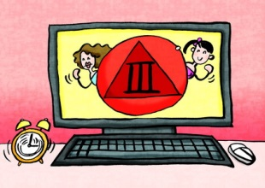
Statement 1: If you feel bored, you can pass the time by browsing pornographic websites.
Your Views:

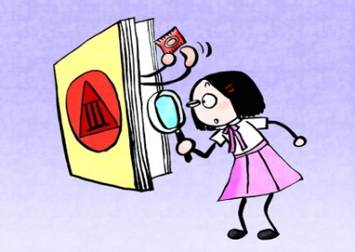
Statement 2: Correct sex knowledge can be obtained from pornography.
Your Views:

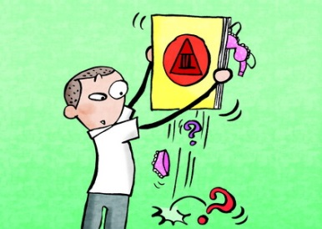
Statement 3: Pornography is a desirable way to satisfy sexual curiosity.
Your Views:

Statement 4: If your friends are using pornography, you would inevitably follow.
Your Views:

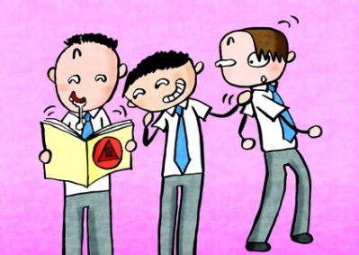

Appendix III
Worksheet: Rewrite the Story
“Temptation of Online Pornography”

Being lured by pornographic websites, Wai Man in “Temptation of Online Pornography” has made an improper decision and it results in getting him addicted to online pornography, affecting his daily life and causing him difficult in developing healthy relationships with classmates.

Please rewrite Wai Man’s story by means of writing or drawing. What if Wai Man clicks “No” and stops browsing the pornographic photos, still obsessed with the images? Think about how the story goes.
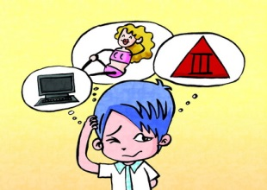
Story introduction: Wai Man clicks the link in Wing Kee’s email to find it is actually a pornographic website. Looking at those sexy photos, Wai Man blushes, his ears redden, and his heart races. Still, he manages not to continue browsing the pornographic photos. However, those images linger in his mind. How should he cope with his curiosity towards sex and other genders? How will his story continue? (Please rewrite the story by means of writing or drawing)

Appendix IV
Reference for Teachers
“Temptation of Online Pornography”

Should young people visit pornographic websites? (In response to Activity 1)
A wide range of information is available on the Internet, but at the same time, it is also having a lot of pornographic content. The false and dangerous sex conception in it can have severe impacts on young people. Therefore, young people should think twice before accessing online pornography.
Clarify the motive: It is normal for young people approaching puberty to be curious about a lot of things (including sex-related issues). Yet, young people may be prompted by impulse or some wrong reasons or concepts to browse pornographic websites. Hence, it is necessary to help them clarify what is driving them to browse these websites, and try to break their myths and misunderstandings.
Easy to indulge: Online pornography is everywhere and can be accessed simply by a tap on the keyboard. It is undoubtedly a trap of addiction to young people who are immature in mentality or have low self-control. To those with a weak will and self-control, it would be wise to stay away from online pornography.
Profound influence: Sex is exaggeratedly described in pornography for sensational and erotic effect, so the content carries lots of distorted and inaccurate messages. It can easily lead to misunderstandings of sex, gender and interpersonal relationships among young people. It may even have adverse psychological effects or disrupt one’s interpersonal relationship if the user is identified with the misconceptions.
The reasons for young people to access pornography and ways to resolve their confusion (In response to Activity 2)
Feel bored: Young people who rarely participate in group activities have little substance in life. Being idle, they are prone to the temptation of pornography. Think about it: are there any fun and interesting activities that can make life more fulfilling?
Enhance sex knowledge: Since sex education may not be conducted in every family, some young people seldom or never talk to their parents about sex. In this case, they may tend to seek answers from others when queries about physical changes arise, or turn to pornography, presuming there may be proper sex knowledge to be obtained. Yet, think about it: What kind of motives do pornography providers have? Is their content reliable?
Out of curiosity: Sex can be mysterious and attractive to those who seldom have the opportunity to talk about it. In addition, the media tends to sensationalise sex in order to draw audiences’ attention, which in turn has left young people feeling even more curious towards it. However, if satisfying one’s curiosity may result in addiction to pornography, is it worth it?
Peer influence: With puberty starting, peer pressure is getting more influential to young people. They may access pornography under the influence of friends. One needs to know what a true friend is by distinguishing between good and bad influences.

Recognise the negative impact of pornography on oneself (In response to Activity 3)
Incorrect sex information: The credibility of sex information provided by pornography is questionable. The information may not have any basis on medical science and the provider may not bear any relevant professional qualifications. Moreover, the aim of pornography is solely to attract users. It is hardly about passing on correct information or assuming any educational responsibility. Therefore one should not take the pornographic information seriously. Teenagers may easily be misled if they have inadequate knowledge on sex, and thus may develop a false perception of sex.
Distort the standard of beauty: Pornography often highlights the female body (such as breasts, thighs, buttocks) for sensational impact and to create sexual arousal of consumers. However, early exposure to pornography may subtly lead to gender stereotypes in the users and the users may then fail to acknowledge the good qualities, not to say the inner beauty, of others.
Pervert the meaning of sex: In pornography, interpersonal relationships and emotional factors are often detached from sexual relationships, while consequences of sex such as legal considerations, unwanted pregnancy, termination of pregnancy and sexually transmitted infections are never mentioned. For a holistic sexual relationship, sexual activities are not simply to satisfy sexual desire. Sex should be seen as part of one’s whole personality, an extension of love and the most intimate behaviour between couples. Therefore, it is necessary to consider whether it is consistent with yourself, all the responsibilities and consequences in order to make the right decision.
Attitudes and ways to cope with pornography (In response to Activity 3)
Legal restrictions: According to Hong Kong legislation, publishing indecent articles to juveniles is prohibited. It is illegal to distribute, circulate, sell, hire, give or lend indecent articles to anyone under the age of 18 years. It is also illegal to show, play or project indecent articles to anyone under the age of 18 years. Even though it is not an offense for people under the age of 18 years to view pornography, the legislation is aimed at protecting children and teenagers from being influenced by the exaggerating, unreal and false content in pornography. Thus, young people should be law-abiding and stay away from pornographic articles. (Reference: Control of Obscene and Indecent Articles Ordinance (Chapter 390) - Webpage of Bilingual Laws Information System, Department of Justice http://www.legislation.gov.hk/index.htm )
Enhance sex knowledge: Young people are advised to seek sex knowledge from proper channels such as reference books or healthy sex education websites in the company of family members. If questions about sex arise, one should discuss with parents, teachers, social workers or classmates, and develop independent thinking and analytical skills to resist the biased content in pornography.
Use the Internet properly: Young people should learn to handle and use the Internet properly. Guard against pornographic content by selecting the websites carefully, being prudent when using online search engines and avoiding unhealthy websites. If necessary, one may consider installing a filtering software to block out pornographic content.
Maintain healthy interpersonal relationships: Young people should learn how to get along with people of different genders, and maintain healthy and harmonious interpersonal relationships in the course of adolescence. One has to understand that relationships are not built upon sex, but on care, respect and love for each other.

