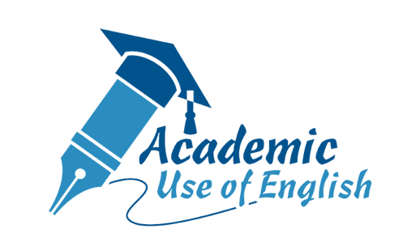

Preface

This resource pack on Academic Use of English is developed by the English Language Education Section, Curriculum Development Institute, Education Bureau. With explanatory notes and a variety of learning activities, it serves to enhance senior secondary students’ understanding of the academic use of English.

Aims
This resource pack aims to
- heighten senior secondary students’ awareness of the academic use of English, which is essential for study and research at the secondary level and beyond;
- support the promotion of the academic use of English through Reading across the Curriculum (RaC) and Language across the Curriculum (LaC) to stretch students’ potential in English learning; and
- foster students’ self-learning outside class through the explanatory notes and learning activities.

Contents
This resource pack comprises six chapters on the common features and skills related to the academic use of English. Each chapter includes an introduction, brief notes on the topic and learning activities, which guide students to explore the academic use of English. An outline of the six chapters is as follows:

Chapter 1: What is Academic English?
- Academic English vs Everyday English
- General Features of Academic English
Chapter 2: Academic Vocabulary
- Academic Vocabulary vs General Vocabulary
- Subject-specific Words and Technical Terms
- Word Formation
Chapter 3: Useful Sentence Structures and Language for Academic Writing
- Passive Construction
- Hedging Language
- Noun Phrases and Clauses
- Adjective Phrases and Clauses
Chapter 4: Paraphrasing, Summarising and Quoting
- Paraphrasing
- Summarising
- Quoting
Chapter 5: Paragraph Structure
- A Five-paragraph Essay
- Paragraph Purposes
- Topic Sentences
- Supporting Details
- Concluding Sentences
- Paragraph Cohesion
Chapter 6: Common Academic Text Structures
- Cause and Effect
- Comparison and Contrast
- Procedure/Sequence
- Problem and Solution

How can this resource pack be used?
This resource pack aims to provide learning materials for developing students’ awareness of the academic use of English. With explanatory notes and easy-to-follow guidelines, teachers can use the resource pack to supplement their lessons, while students can use it to enrich their self-learning experience outside class. To maximise the learning opportunity, it is recommended that teachers and students consult relevant grammar and reference books for more examples and related forms and functions of the target language items.

It should be noted that the content of this resource pack is not all-inclusive. The activities and items designed may not capture a full range of assessment modes and question types. Teachers are advised to use it to complement grammar learning and LaC activities. The explanatory notes and practice provided are by no means an end in themselves. They should be used as a means to an end for developing students’ understanding of the academic use of English and the related skills for application. It is, therefore, crucial to provide further exposure and opportunities for students to apply the relevant knowledge and skills in subjects not limited to English Language.

The six chapters featured in this resource pack are available in both PDF and MS WORD formats for ease of use and adaptation. To motivate students and help them acquire the skills in the academic use of English more effectively, a collection of six posters with different focuses has been produced. Teachers can access relevant resources on the academic use of English from the following webpage:
www.edb.gov.hk/Academic_English
Teachers are encouraged to select and adapt the resources to suit their students’ needs, interests and abilities. For more ideas on curriculum planning related to the promotion of LaC, teachers may make reference to the resource package Connecting Students’ Learning Experiences through Promoting Reading and Writing across the Curriculum in the Junior Secondary English Classroom.

