Reading Task: Perform Hand Hygiene Properly

Suggested Level: S2 – S3

Task Description
You will read an article about how to perform hand hygiene properly and answer the related questions.

Perform Hand Hygiene Properly  Many infectious diseases can be transmitted through contact. If hands are contaminated with pathogens, especially when they are soiled with respiratory discharge or faecal matters, diseases including dysentery, cholera, hepatitis, influenza, and hand, foot and mouth disease can be spread easily. Observance of hand hygiene is the prerequisite of the prevention of the spread of communicable diseases. Using soap and water or alcohol-based handrub can achieve hand hygiene.  When to perform hand hygiene?  (a) Before and after touching eyes, nose and mouth;  (b) Before eating and preparing food;  (c) After using the toilet;  (d) When hands are contaminated by respiratory secretions, e.g. after coughing or sneezing;  (e) After changing diapers or handling soiled items from children or the sick;  (f) After touching animals, poultry or their droppings;  (g) After handling garbage;  (h) After touching public installations or equipment, such as escalator handrails, elevator control panels or door knobs;  (i) Before and after visiting hospitals, residential care homes or caring for the sick; and  (j) Any time you find your hands are dirty.  How to select appropriate agents for hand hygiene?  It is advised to clean hands with liquid soap and water when hands are visibly dirty or visibly soiled with blood and body fluid, after using the toilet or changing the diapers. When hands are not visibly soiled, hand hygiene with 70-80% alcohol-based handrub is also an effective alternative. According to World Health Organization’s recommendation, most alcohol-based handrubs contain either ethanol, isopropanol or n-propanol, or a combination of two of these products. Always check the expiry date before purchasing and using alcohol-based handrub.  Steps for hand hygiene  (a) Hand hygiene with liquid soap and water:  (i) Wet hands under running water.  (ii) Apply liquid soap and rub hands together to make a soapy lather.  (iii) Away from the running water, rub hands according to the 7 steps of hand hygiene technique for at least 20 seconds (refer to point (c) for detail). Do not rinse off the soap while rubbing.  (iv) Rinse hands thoroughly under running water.  (v) Dry hands thoroughly with either a clean cotton towel or a paper towel.  (vi) The cleaned hands should not touch the water tap directly again. For example, use a paper towel to wrap the faucet before turning it off.  (b) Hand hygiene with alcohol-based handrub:  (i) Apply a palmful of alcohol-based handrub to cover all surfaces of the hands. Rub hands according to the 7 steps of hand hygiene technique for at least 20 seconds until the hands are dry.  (c) Hand hygiene technique:  (i) Proper hand hygiene technique should follow the 7 steps and rub hands for at least 20 seconds.  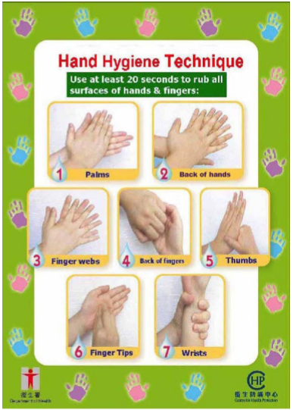 | 5  10  15  20  25  30  35  40

(Adapted from an article on the website of the Centre for Health Protection, Department of Health: https://www.chp.gov.hk/files/pdf/guidelines_for_hand_hygiene.pdf)
Refer to the text and answer the following questions.

- According to paragraph 1, why is observance of hand hygiene important for the prevention of the spread of communicable diseases?
__________________________________________________________________________________________________________________________________________________________________

- Decide whether the following statements are True (T), False (F) or Not Given (NG) according to the article. Put a tick () in the correct boxes:

 | T | F | NG
i) We perform hand hygiene only when our hands are dirty.
ii) Cleaning hands with liquid soap and water is better than using alcohol-based handrub.
iii) Alcohol-based handrub may cause skin allergy.
iv) We should perform hand hygiene when we leave a hospital.
v) When washing our hands with soap and water, we should not rinse off the soap until we have rubbed our hands for 20 seconds.

- What does “their” in line 13 refer to?
_________________________________________________________________________________

- Fill in each blank with ONE word according to the steps for hand hygiene in lines 27 to 42. The words may or may not appear in the text.

When you wash your hands with liquid soap and water, you should first i)__________ your hands under running water. After ii)__________ liquid soap, rub hands thoroughly for a iii)__________ of 20 seconds before rinsing off the soap and drying your hands. Don’t only rub your palms. You should also rub the back of your hands and fingers, your finger webs and tips, iv)__________ and v)__________. When you finish cleaning your hands, vi)__________ touching the water tap directly again. You are vii)__________ to use a paper towel to wrap the faucet before turning it off.

- Who do you think are the target readers of the article?
_________________________________________________________________________________

Speaking Task

In view of the recent outbreak of COVID-19, your school would like to raise students’ awareness of hand hygiene. Discuss with your partner ways to promote hand hygiene at school.

Reading Task: Perform Hand Hygiene Properly

Answer Key

1. Observance of hand hygiene is important for the prevention of the spread of communicable diseases because many infectious diseases can be transmitted through contact. Communicable diseases can be spread easily if hands are contaminated with pathogens.

2. i) F ii) NG iii) NG iv) T v) T

3. Animals and poultry’s

4. i) wet ii) applying iii) minimum
iv) thumbs/wrists v) wrists/thumbs vi) avoid
vii) advised

5. The general public (or any other acceptable answers)

