Reading Task: Use Masks Properly

Suggested Level: S1-2

Task Description
You will read an article about the proper use of face masks and answer the related questions.

Use Masks Properly  Face masks provide a physical barrier to fluids and large particle droplets. Surgical masks are a type of face mask commonly used. When used properly, surgical masks can prevent infections transmitted by respiratory droplets.  People should wear a surgical mask when they have respiratory infection, take care of patients with respiratory infection, or visit clinics/hospitals during the pandemic/peak season for influenza in order to reduce the spread of infection.  Most surgical masks adopt a three-layer design which includes an outer fluid-repelling layer, a middle layer that serves as a barrier to germs, and an inner moisture-absorbing layer. Masks without the above functions are not recommended as they cannot provide adequate protection against infectious diseases transmitted by respiratory droplets. Wearers should follow the manufacturers’ recommendations when using surgical masks, including proper storage and procedures for putting on surgical masks.  Procedures for putting on and taking off surgical masks:  1. In general, the coloured side/the side with folds facing downwards of the surgical mask should face outwards with the metallic strip uppermost.  2. For tie-on surgical masks, secure upper ties at the crown of head. Then secure lower ties at the nape. For the ear-loops type, position the elastic bands around both ears.  3. Extend the surgical mask to fully cover the mouth, nose and chin.  4. Mould the metallic strip over the nose bridge. The surgical mask should fit snugly over the face.  5. When taking off tie-on surgical masks, unfasten the ties at the nape first and then unfasten the ties at the crown of head. For the ear-loops type, hold both ear loops and take off gently from the face.  Points to note on wearing a surgical mask:  - Choose the appropriate mask size. Child size is available for selection as indicated.  - Perform hand hygiene before putting on a surgical mask.  - The surgical mask should fit snugly over the face.  - Avoid touching the surgical mask after wearing it. Perform hand hygiene before and after touching the mask.  - Avoid touching the outside of the surgical mask during taking-off as it may be covered with germs.  - After taking off the surgical mask, discard it in a lidded rubbish bin and perform hand hygiene immediately.  - Change surgical masks in a timely manner. In general, surgical masks should not be reused. Replace the mask immediately if it is damaged or soiled.  To minimise the risk of infection, apart from using surgical masks properly, we should adopt the following preventive measures vigilantly:  - Perform hand hygiene frequently and properly.  - Perform hand hygiene before touching the eyes, nose and mouth.  - Maintain respiratory etiquette/cough manners.  - Stay at home if sick and minimise contact with others.  - Stay away from possible sources of infection. | 5  10  15  20  25  30  35  40  45
(Adapted from an article on the website of Centre for Health Protection, Department of Health: https://www.chp.gov.hk/files/pdf/use_mask_properly.pdf)
Refer to the text and answer the following questions.

- What is the main purpose of this article?
___________________________________________________________________________
___________________________________________________________________________

- Refer to paragraph 3 and fill in the blanks below.

Middle layer (a) _________ layer
Function: barrier to (b) _____________ Function: repel fluids
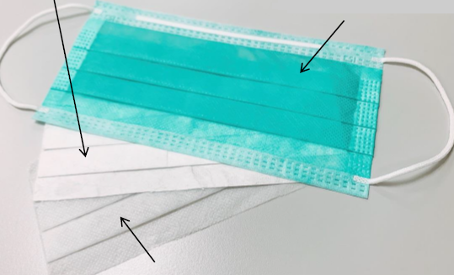
Inner layer
Function: (c)_______________________

- In paragraph 3, it is mentioned that wearers should follow the manufacturers’ recommendations when using surgical masks, including storing and putting on the masks. Why is this important to prevention of infections?
___________________________________________________________________________
___________________________________________________________________________
- Which of the following best describes the meaning of “snugly” in lines 22 and 30?
gently
closely
tidily
loosely

- Give another word which has a similar meaning to the word “soiled” in line 38.
___________________________________________________________________________

- Decide whether the following statements are True (T), False (F) or the information is Not Given (NG). Put a tick () in the correct boxes:

 | T | F | NG
i) Only surgical masks are suitable for preventing infections transmitted by respiratory droplets.
ii) People should wear a surgical mask only when they are sick.
iii) Tie-on surgical masks are more effective than surgical masks with ear loops in preventing infections transmitted by respiratory droplets.

- Which of the following measure(s) help(s) people stay away from possible sources of infection (line 45)?
Minimise unnecessary social contacts
Avoid visiting crowded places
Minimise the length of stay in crowded places whenever possible
Avoid close contact with infected persons

(i) & (iii) only
(ii) only
(iv) only
All of the above

- Which of the following groups of people would find the article most useful?
Doctors who work in hospitals
Manufacturers of face masks
The general public
Students

Writing Task
You are the chairperson of the Student Union of your school. To help prevent infections transmitted by respiratory droplets, you are working on promoting respiratory etiquette/cough manners among your schoolmates. Write descriptions for the pictures below and come up with a slogan for promoting respiratory etiquette/cough manners.

Slogan: __________________________________________________________________
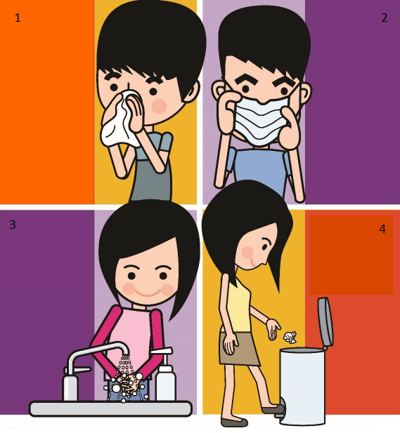
Picture 1: __________________________________________________________________________________
__________________________________________________________________________________
Picture 2: __________________________________________________________________________________
__________________________________________________________________________________
Picture 3: __________________________________________________________________________________
__________________________________________________________________________________
Picture 4: __________________________________________________________________________________
__________________________________________________________________________________

(The four pictures are adapted from the website of the Centre for Health Protection, Department of Health: https://www.chp.gov.hk/en/index.html)
Reading Task: Use Masks Properly

Answer Key

- To provide information about the proper use of masks and how to prevent infections transmitted by respiratory droplets
- (a) Outer
(b) germs
(c) absorb moisture
- It is important because failing to follow the manufacturers’ recommendations may reduce the effectiveness of surgical masks in preventing infections transmitted by respiratory droplets (or other possible answers).
- B
- Dirty (or other possible answers)
- (i) F
(ii) F
(iii) NG
- D
- C

