Presentation Skills

Learning Activity 1: Getting the vacant place

Situation
A staff quarter on the top floor of the school premises is now vacant and different interest clubs can bid to move into it. They need to convince the school authority why their club, and not others, should be given the place.

- The teacher will now get you into groups. One group will be the school authority and the other groups will decide what club they represent. Some examples are as follows:

Drama Club
English Club
Science Club
Sports Club
Music Club
Art Club

- Task for the school authority
Your group’s task is to come up with the criteria for choosing who to use the vacant place. Before the other groups start their discussion, your group will present to them the selection criteria so that they can prepare their presentations appropriately.

- Task for the other groups
In groups, convince the school authority to give the place to your club. You will be given 10 minutes to prepare and 1 minute to present. You should convince the school authority with sound reasons.

- The groups present their arguments to the school authority and they may ask questions as they listen to the presentations of the other groups. After the presentations, the school authority will make a decision and announce the winner.

Learning Activity 2: Identifying good and bad body language

Look at the pictures below and decide whether they show good or bad examples of body language when delivering a speech. Give your reasons in the boxes provided.

1.  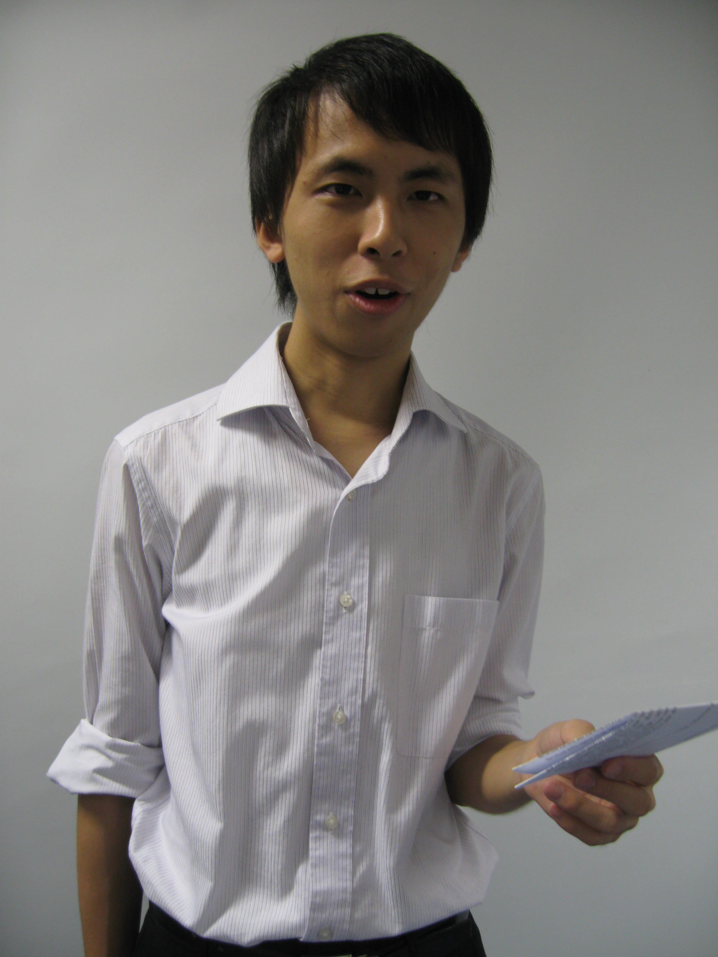 |  | 2.  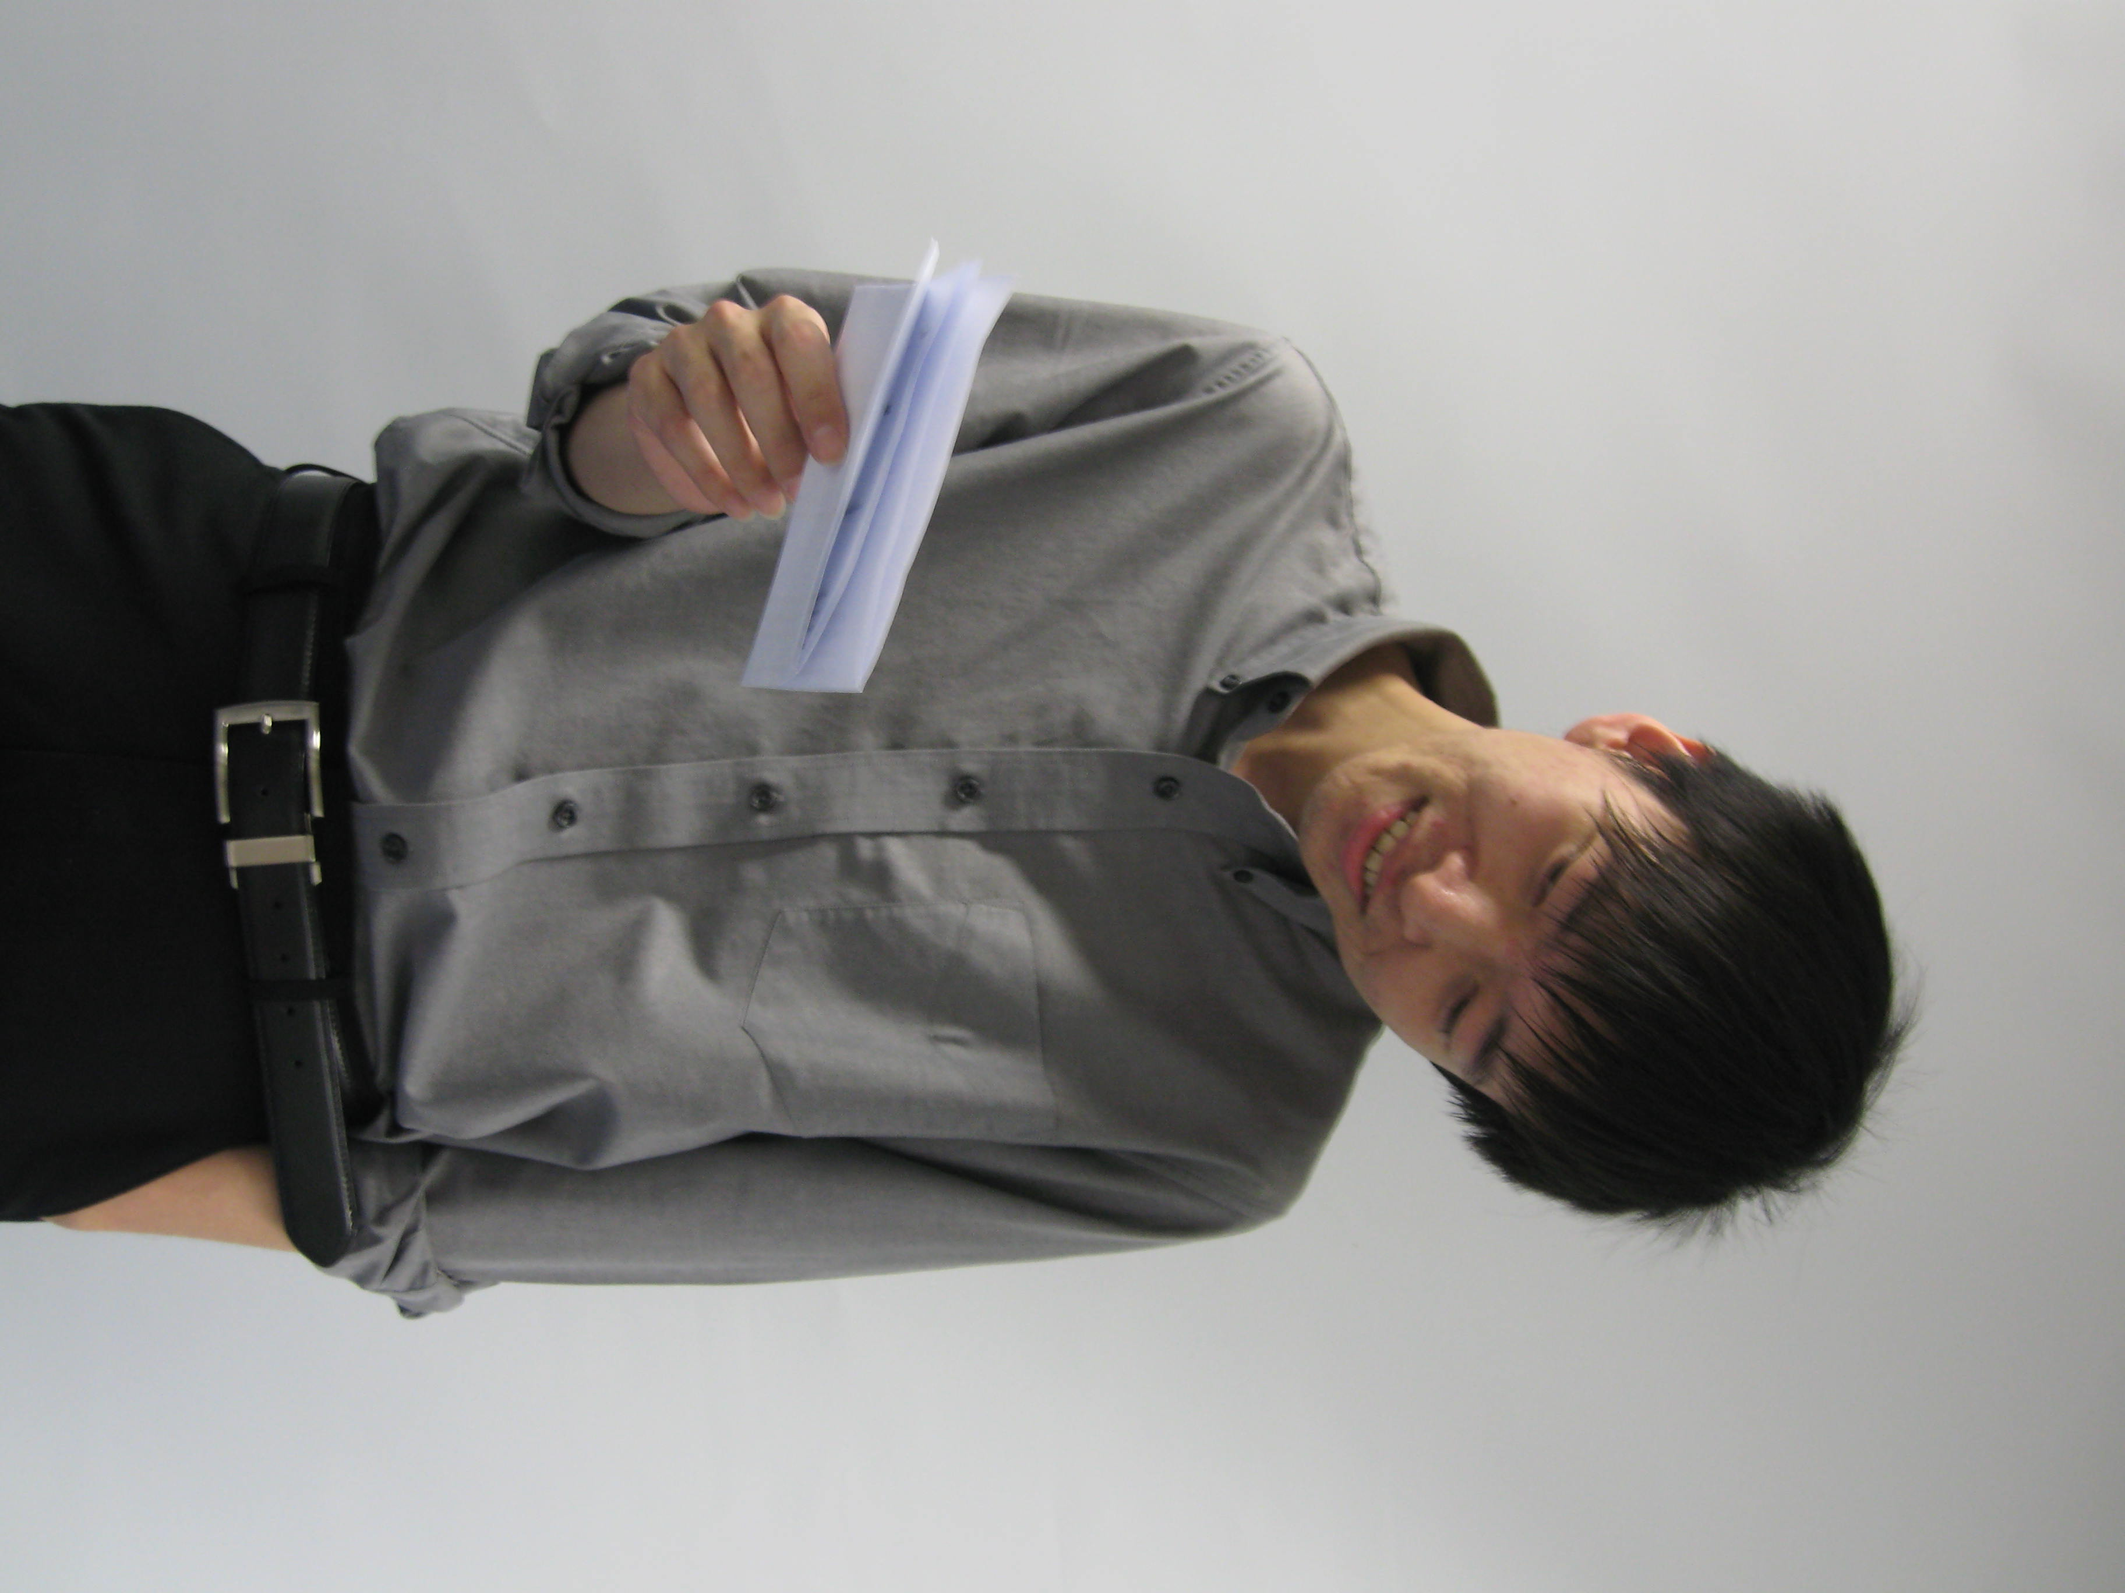 |  | 3.  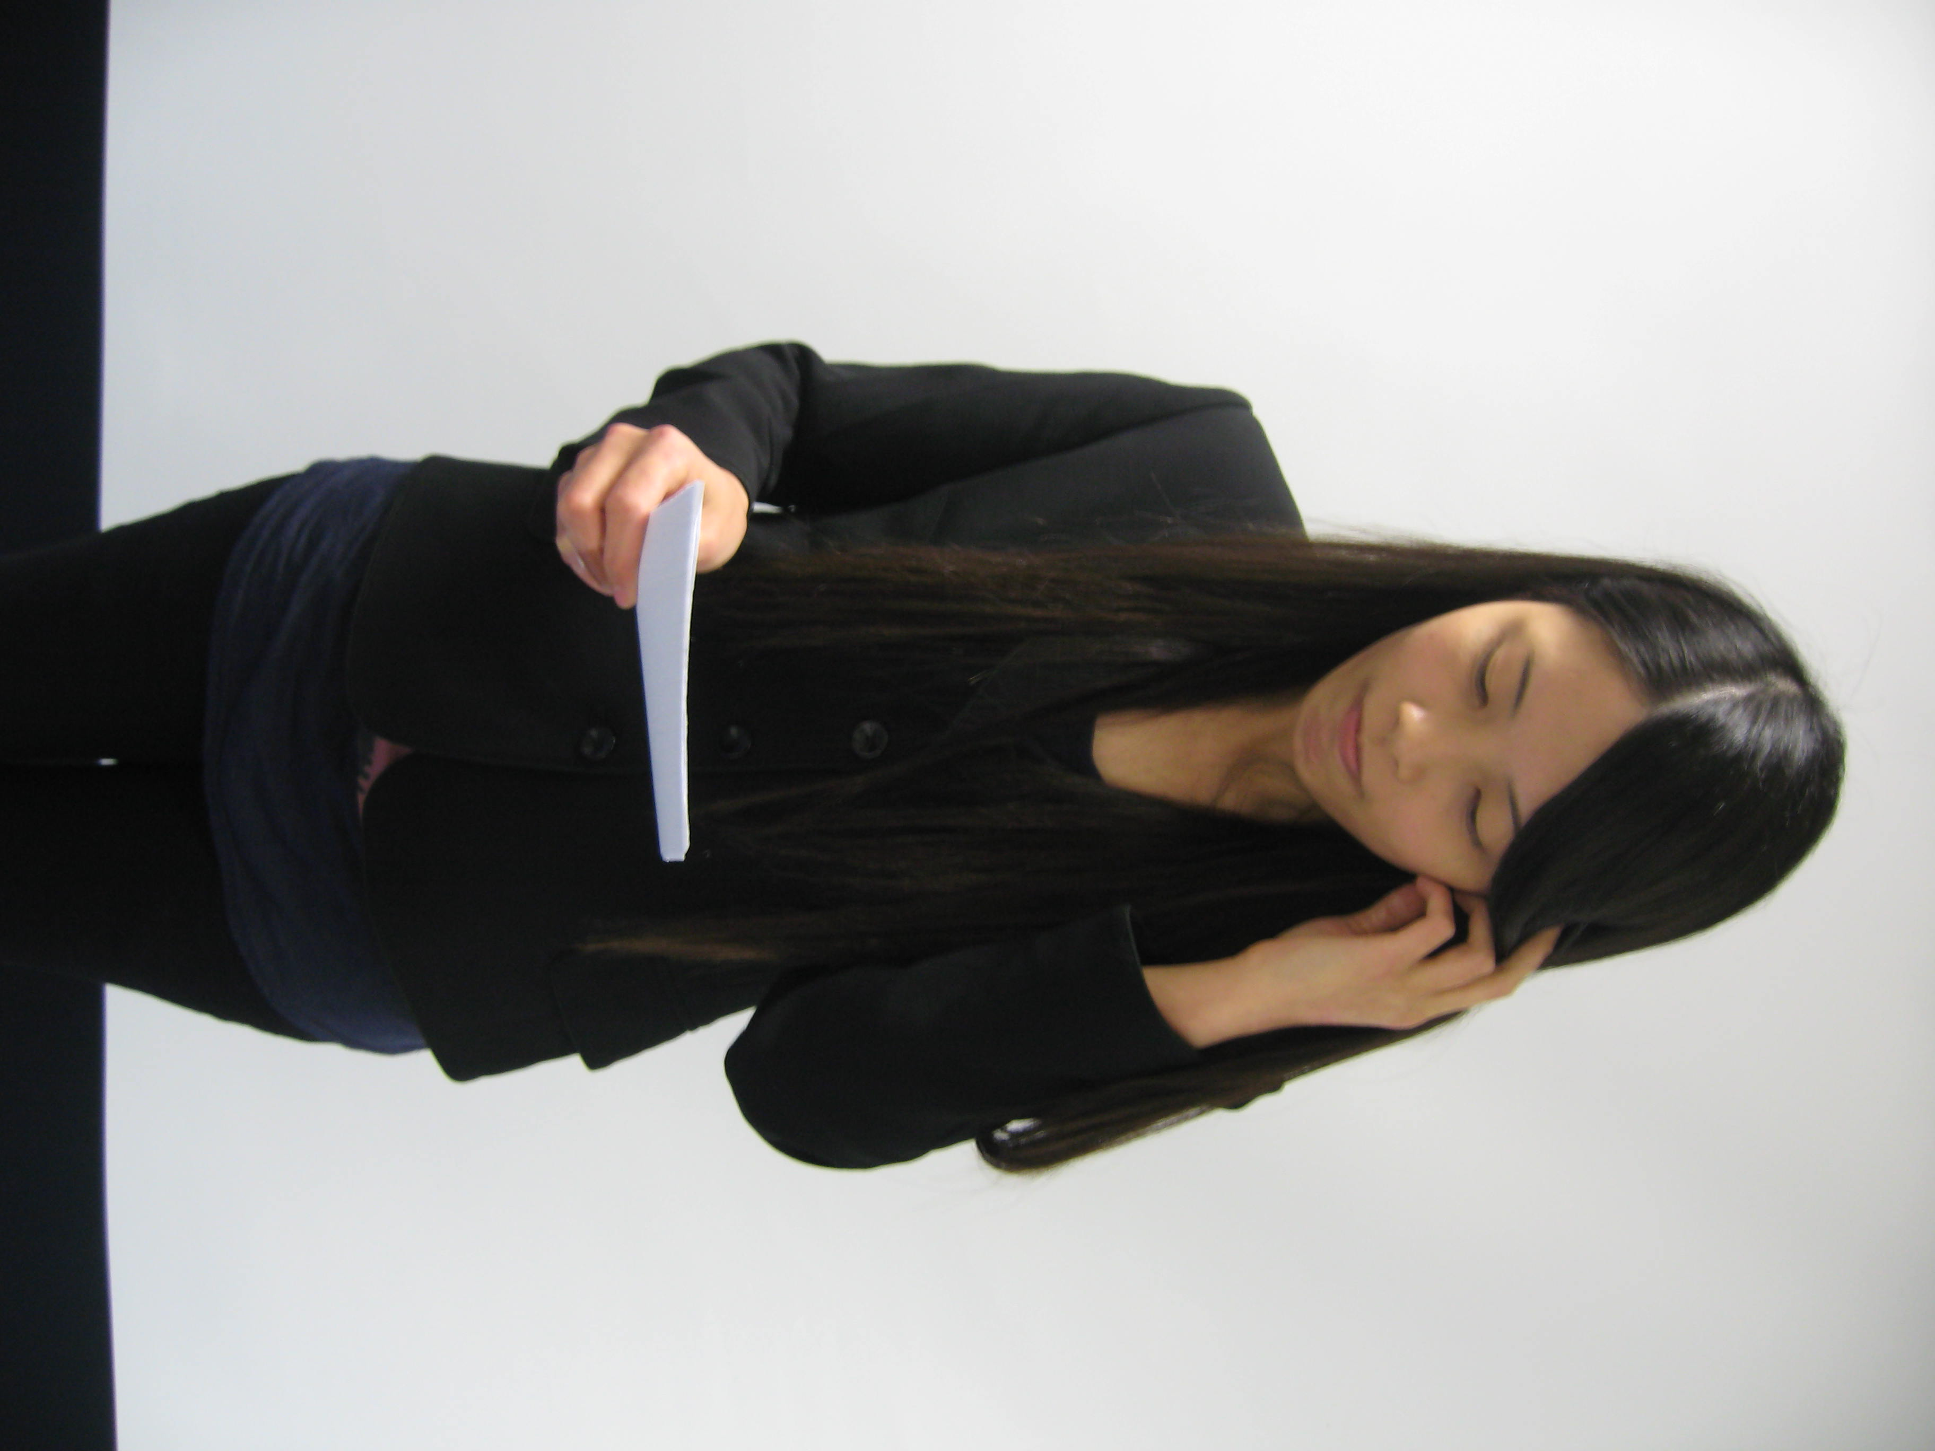
4.   |  | 5.   |  | 6.  

Learning Activity 3: Delivering a speech with poise

A. Video watching

You will now watch videos of a student delivering a speech. As you watch, consider the student’s strengths and weaknesses as a speaker. Complete the worksheet below.

You may wish to focus your comment on some of the following areas:
TOTAL
300 pts
- Pronunciation
- Projection of voice
- Delivery pace
- Use of stress and intonation
- Body movement
- Facial expressions
- Eye contact
- Confidence

Strengths | Weaknesses
B. Practice

Read the transcripts of the two speeches below. Then work with a partner and take turns to read out the speech to each other. One of you should deliver the first speech while the other should read out the second one.

Use the “Peer Evaluation Form” (page S132) to assess each other’s delivery.

Smoking Should Be Banned in Public Places
Recently, I was waiting for a bus. It was in a large bus station, the kind everybody in Hong Kong knows. The air was dirty already, because of the exhaust fumes from the buses, and it was hot. A man came up behind me and lit a cigarette. I have a problem with that. If he chooses to shorten his own life, he can make that choice. But why should he shorten my life? I asked him to put it out, and he simply told me that he was allowed to smoke there, and if I didn’t like it, I could move somewhere else. The problem is – he was right. In law, he has the right to smoke there, and I had no authority to tell him he couldn’t. I want to argue in this speech that the law should be changed. He should not have that right. My right to life is more important.

Exams Do Not Effectively Test Student Learning
Ladies and gentlemen, I would like to talk to you today about exams. I mean the large-scale formal exams such as the HKDSE, HKCEE and A-Level exams, the ones organised at territory-wide level. The exam system we have follows the British system, which has been reformed many times. At one time, a big exam at the age of eleven determined a child’s whole future, whether he or she would be a doctor or a factory worker. Mercifully, that exam is gone, but in this speech, I will argue that the problem is not with any specific exam. The problem is that exams, besides being stressful, are ineffective in assessing student learning.
Peer Evaluation Form
Evaluator | :
Name | :

Use this form to give feedback to your classmate’s presentation. Indicate what you think about his / her performance by ticking the appropriate boxes. Provide your views on his / her performance in the “Overall Comments” section.

 | Good | Satisfactory | Needs improvement
- The words were clearly pronounced and easy to understand. |  |  | 
- The volume was suitable. |  |  | 
- The speaker used an appropriate pace / speed. |  |  | 
- The speaker stressed words and phrases effectively. |  |  | 
- The body movement was natural. |  |  | 
- The speaker’s facial expressions were appropriate. |  |  | 
- There was good eye contact with the audience. |  |  | 
- The speaker appeared confident. |  |  | 

Overall Comments
What did you like most about the speaker’s performance?
____________________________________________________________________________________________________________________________________________________
What areas could be improved on?
____________________________________________________________________________________________________________________________________________________

* This is a general list of feedback criteria. Teachers might like to adapt it for use in their own classrooms.

