Talking about Drama
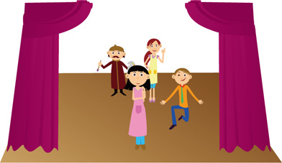

Learning Activity 1
Discussion

Work with a partner or in a small group. Discuss the following and make notes in the space provided.

 | My answers | My partner’s answers
- How do you think drama can help your English? What areas of English do you think we will be working on?

- What do you know about drama, acting and/or script writing? Have you had any experience in these areas?

- Name two of your favourite films. Why do you like them?

- Name two of your favourite actors. Why do you like them?

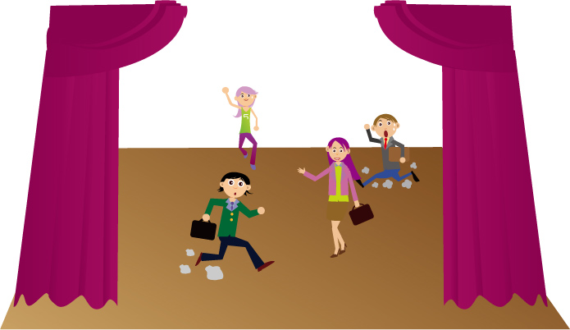

Learning Activity 2
Vocabulary

- Match the words and phrases on the left with the definitions on the right. Some examples have been done for you.

Nouns

1. People

audience |  | Someone who tells the actors in a film or play what to do
cast |  | A person in a story, film, etc.
character |  | The person who tells the story in a book, film, play, etc.
director |  | All the actors in a film or play
narrator |  | The people who watch a play, film or TV show

2. Physical Things

costumes |  | The written text of a film or play
make-up |  | The “paint” that actors put on their faces
props |  | Clothes that actors wear
script |  | The raised area in a theatre where actors perform
stage |  | Objects used in a film or play

3. Concepts

acts (n.) |  | A story that is written for actors to present, usually in a theatre
dialogue |  | The short parts of a film, play or story in which the events happen in one place
play (n.) |  | A character played by an actor or actress
role/part |  | The place where the story happens
scenes |  | The longer parts a play is divided into
setting |  | The words in a play that describe where the action takes place, the way the characters speak, etc.
stage directions |  | The words that characters say in a book, play or film

Verbs

express |  | To make your voice loud, so that people can hear you easily from far away
learn your lines |  | To show an emotion by using your voice and body language
perform |  | To practise the words and actions of a play
project |  | To entertain people by acting, singing, dancing, etc.
rehearse |  | To memorise the words you have to say in a play

- Fill in the blanks in the following sentences, using words from the previous activity. One has been done for you as an example.

  - I didn’t like the show, because there were only four people in it. I prefer shows with a bigger cast.

  - On The Simpsons, I like Bart the best – he’s my favourite ________________.

  - The ________________ is the person in charge of a theatre production. He or she decides on many things: what ________________ the actors will wear, what kind of ________________ they’ll have on their faces and what ________________ they will carry.

  - In order to write ________________ that sounds realistic, it’s important to listen to the way people talk in real life. Also, you’ll find it easier to ________________ if they seem natural.

  - If you want the ________________ to hear you when you’re standing on the ____________, you need to ________________ your voice.

  - I like watching movies and TV, but I haven’t been to see a live ________________ for years – it’s always so expensive! Still, it’s very exciting to watch actors ________________ in person.

  - The text of a piece of drama is known as a ________________. It’s usually divided into big sections, called ________________ and each of these is divided into smaller sections known as ________________.

  - If you don’t ________________ many times, you won’t be able to play your ______________ well. As the old saying goes, practice makes perfect!

  - A: “The whole movie takes place in a kitchen.”
B: “Really? What a boring ________________!”

  - A good actor can ________________ a wide range of emotions, using his voice, his face and his body language.

  - Sometimes a play has ________________ in the script, which describe the location, the appearance of the characters and the way they say their lines. In a radio play, this information can be spoken by a _____________, who helps to tell the story.

