Version A

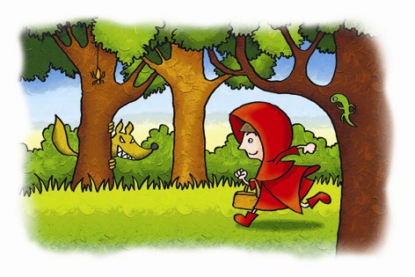

Learning Activity 1
Reading and Discussion

- Read the following outline of the story “Little Red Riding Hood”.

Little Red Riding Hood

- A girl called Little Red Riding Hood is told by her mother to take some food to her grandmother, who lives in the woods.
- Riding Hood’s mother tells her to go directly to grandmother’s house, and not to talk to any strangers.
- The girl walks through the woods to deliver food to her grandmother.
- A wolf (called the Big Bad Wolf) sees the girl and wants to eat her but is afraid to do so in public because there are woodcutters watching.
- He approaches the girl, and she – silly girl! – tells him where she is going.
- He suggests that she should pick some flowers, which she does.
- In the meantime, the Big Bad Wolf goes to the grandmother's house and gets into her house by pretending to be the girl.
- He eats the grandmother and waits for the girl, disguised as the grandmother.
- When the girl arrives, he eats her too.
- A woodcutter, however, comes to the rescue and cuts the wolf open.
- Little Red Riding Hood and her grandmother are still alive inside the wolf’s stomach.
- They fill the wolf's body with heavy stones, which kills him.
- They all celebrate together.

- Work in your pair or group to divide the outline into scenes. If you wish, you may decide to add or take out details from the outline.

Example:

Scene 1
- A girl called Little Red Riding Hood is told by her mother to take some food to her grandmother, who lives in the woods.
- Riding Hood’s mother tells her to go directly to grandmother’s house, and not to talk to any strangers.

Scene 2…

3. Compare your work with those of other groups. Did you divide the outline in the same places?
Explain why you divide the outline into acts and scenes the way you did.

Learning Activity 2
Discussion

Work with your partner(s) to enrich your outline. You should do at least two of the following:

- You should decide what characters will appear in your script. You may want to add some characters that are not mentioned in the outline. (For example, perhaps Little Red Riding Hood talks to someone else in the woods before she meets the Big Bad Wolf.)

- You may want to add more details to the story. (For example, perhaps Little Red Riding Hood has an adventure with another character before meeting the Wolf.)

- You may also want to add a narrator – i.e. someone who tells parts of the story, rather than acting them out.

Learning Activity 3
Group Writing

Re-read the outline you have further developed and then identify two important scenes. For each scene, work together to write:

- the narrator’s narration
- the characters’ dialogue
- some simple stage directions following the example below (optional)

Example:

Introduction

Narrator: | This is a story about a very silly girl who couldn’t follow instructions and almost got killed. Watch and learn!
ACT ONE, Scene 1

The scene takes place in mid-afternoon at the home of Little Red Riding Hood and her mother. It is a small but comfortable place. Little Red Riding Hood is wearing her favourite piece of clothing: a red cape with a hood. She is about 10 years old, and very innocent. Her mother is strict but we can see that she loves her daughter.

Mother: | (She gives Riding Hood a basket.) Now, do you remember what you have to do?
Riding Hood: | (After thinking hard) Yes, Mum. I have to take this food somewhere. (She can’t remember where – she scratches her head.) To… to…
Mother: | (Impatient) To grandmother’s house! Didn’t you listen?
Riding Hood: | (Embarrassed) Sorry, Mum. I won’t forget again.
Mother: | (More friendly now. She puts her hand on Riding Hood’s shoulder.) You’re a good girl. Just a bit forgetful. Now, what was my other instruction?
Riding Hood reaches into her pocket. She has written the instruction on a piece of paper. She reads from the paper:

Riding Hood: | Don’t talk to strangers! (She feels very clever for remembering, gives her mother a big smile and does a little dance.)
Mother: | (She laughs.) Good for you! Now off you go – it will be dark soon, and the woods can be dangerous at night.
Riding Hood: | (Confident) Yes, Mum. Don’t worry about me. (She kisses her mother on the cheek.)
End of Scene 1

The story outline is taken from the website: http://en.wikipedia.org/wiki/Little_Red_Riding_Hood

