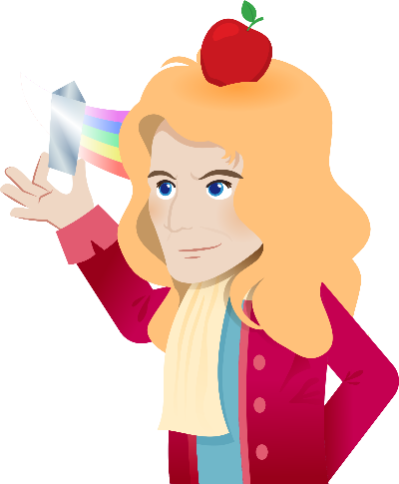
The Biography of Isaac Newton

1. Isaac Newton was one of the most important scientists in the 17th Century. He was a British scientist in the field of mathematics, physics and astronomy.

Early life
2. Newton was born in England in 1643, where he grew up on a farm. His father died before his birth and his mother remarried when he was only three. So his grandparents took care of him. When he was twelve, his mother pulled him out of school and asked him to work as a farmer. He refused and focused on his studies.

Achievements
3. When Newton was 18, he studied at Cambridge University and became a professor of mathematics. In 1665, the Great Plague, which was a terrible disease and epidemic, spread in England, and Cambridge University had to close down. Newton left Cambridge and spent two years studying and doing experiments at his home. One day, when he was drinking a cup of tea in the garden, he saw an apple fall from a tree. He carried on with the studies and formed the theory of gravity. Newton was also curious about light. He discovered that white light is made up of colours of the rainbow. In 1668, he invented the reflecting telescope, which used mirrors to reflect light and form an image.

4. In 1684, he invented a new type of mathematics which he called “fluxions”. Today we call this maths “calculus” and it is an important type of maths used in advanced engineering and science. In 1687, Newton published a book called “Mathematical Principles of Natural Philosophy”, in which he described the three laws of motion and the law of universal gravity.

5. In 1696, he became the warden of the Royal Mint. He took the duty seriously and tried to get rid of corruption in order to reform the currency of England.

Final years
6. Newton became rich and famous because of his discoveries. However, he did not get married or make many friends. He died in 1727 and was remembered as one of the greatest scientists.
1

Glossary

- physics: (noun) the study of matters and energy

- astronomy: (noun) the study of the Sun, moon, stars, planets, etc.

- a professor: (noun) a teacher especially at a college or university

- the Great Plague: (noun) the outbreak of a disease that spread rapidly in London and across parts of Europe in 1665, and caused many deaths

- gravity: (noun) the force that attracts objects towards one another, especially the force that makes things fall to the ground

- a telescope: (noun) an instrument that allows people to see distant objects. Telescopes are important tools in astronomy, or the study of planets, stars, and other objects in outer space.

- calculus: (noun) a system of calculation in mathematics, as of rates of change, lengths, or volumes

- motion: (noun) the action or process of moving or being moved

- reform: (verb) make an improvement/a good change to something

- currency: (noun) the money that is used in a country

2

- Complete the graphic organiser which summarises the life and achievements of Isaac Newton.
Job: a _________
Name: Isaac Newton
Family and education:
- He grew up on a ____________.
- His father died before his birth and his mother ____________.
- His ____________ took care of him.
- When he was twelve, his mother wanted him to work as a ____________, but he refused.
- When he was eighteen, he studied at ________________ University.

Place and date of birth:
Born in ____________
in 1643

Achievements as a scientist

in 1665 during the Great Plague:
- He formed the theory of ____________.
- He discovered that light is made up of colours of the ____________.

in 1668:
- He invented the reflecting ____________.

in 1684:
- He invented a new type of ____________ called fluxions.
- Today, people call it ____________.
- He also invented the three laws of ____________ and the law of____________ ____________.

3
Achievements as the warden of the Royal Mint
Final years:

Although he was rich and ____________, he did not get married or have many friends. He died in ____________.

- He fought against corruption.
- He reformed the ____________ of England.

- Answer the following questions. For the multiple choice questions, circle the best answer.

- Which of the following about Newton’s early life is true?
- Newton’s father took care of him.
- Newton worked in a farm.
- Newton studied hard.
- Newton lived with his mother.

- When did Newton study at the University of Cambridge?
- in 1643
- in 1661
- in 1668
- in 1684

- What happened in the period of the Great Plague?
- He studied and did experiments at the university.
- He felt sick.
- He formed the theory of gravity.
- He invented the reflecting telescope.

- What is “calculus”?
- It is a new type of mathematics.
- Newton called it “fluxions”.
- It is used in advanced engineering and science.
- All of the above

- Why was Newton remembered as a great and important scientist? Give three reasons.

- What made Newton a great scientist?

4

(Answer Key)
- Complete the graphic organiser which summarises the life and achievements of Isaac Newton.

Job: a scientist
Name: Isaac Newton
Family and education:
- He grew up on a farm.
- His father died before his birth and his mother remarried.
- His grandparents took care of him.
- When he was twelve, his mother wanted him to work as a farmer, but he refused.
- When he was eighteen, he studied at Cambridge University.

Place and Date of birth:

Born in England
in 1643

Achievements as a scientist

in 1668:
- He invented the reflecting telescope.

in 1665 during the Great Plague:
- He formed the theory of gravity.
- He discovered that light is made up of colours of the rainbow.

in 1684:
- He invented a new type of mathematics called fluxion.
- Today, people call it calculus.
- He also invented the three laws of motion and the law of universal gravity.

5
- He fought against corruption.
- He reformed the currency of England.
Final years:

Although he was rich and famous, he did not get married or have many friends. He died in 1727.

Achievements as the warden of the Royal Mint

- Answer the following questions. For the multiple choice questions, circle the best answer.

- Which of the following about Newton’s early life is true?
- Newton studied hard.
(Prompt: You can find clues in paragraph 2.)

- When did Newton study at the University of Cambridge?
- in 1661
(Prompt: You can find clues in paragraph 3.)

- What happened in the period of the Great Plague?
- He formed the theory of gravity.
(Prompt: You can find clues in paragraph 3.)

- What is “calculus”?
- It is a new type of mathematics.
- Newton called it “fluxions”.
- It is used in advanced engineering and science.
- All of the above
(Prompt: You can find clues in paragraph 4.)

- Why was Newton remembered as a great and important scientist? Give three reasons.
He formed the theory of gravity. He discovered that white light is made up of colours of

the rainbow. He invented the reflecting telescope and a new type of mathematics.
(Accept any reasonable answers.)

- What made Newton a great scientist?
He had keen interest in his studies, a strong sense of curiosity and eagerness to learn more. (Accept any reasonable answers.)

6

