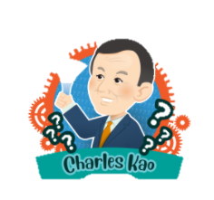
D1. Complete the timeline of Charles Kao using the information on the Internet.
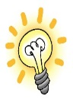
Remember to visit reliable websites with your teacher’s guidance if necessary, take notes, use your own words as far as possible and avoid direct copying of chunks of information.

born in _______________, China
1933

1948

1957

1960s

1970-1974

1987-1996

2002

2009

2010

2018

moved to Hong Kong with his family and studied in Hong Kong

- completed his studies in a university in _______________
- worked as an engineer

invented ways to transmit digital data using ____________ ____________

founded the Department of Electronic Engineering for the Chinese University of Hong Kong

served as the vice-chancellor of the Chinese University of Hong Kong

suffered from a brain disease
- became forgetful
- had ____________ ____________

received the Nobel Prize in ____________ for his contributions to the use of optical fibres in _____________________

established a non-profit making charity in Hong Kong, Charles K Kao Foundation, running different programmes to raise people’s awareness of Alzheimer’s ____________ and supporting those suffering from the disease and their caregivers

passed away in Hong Kong
1

D1. Complete the timeline of Charles Kao using the information on the Internet.
(Answer Key)
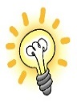
Remember to visit reliable websites with your teacher’s guidance if necessary, take notes, use your own words as far as possible and avoid direct copying of chunks of information.

1933

1948

1957

1960s

1970-1974

1987-1996

2002

2009

2010

2018

born in Shanghai, China

moved to Hong Kong with his family and studied in Hong Kong

- completed his studies in a university in the UK
- worked as an engineer

invented ways to transmit digital data using optical fibres / fibre optics

founded the Department of Electronic Engineering for the Chinese University of Hong Kong

served as the vice-chancellor of the Chinese University of Hong Kong

suffered from a brain disease
- became forgetful
- had speech difficulty

received the Nobel Prize in Physics for his contributions to the use of optical fibres in telecommunications

established a non-profit making charity in Hong Kong, Charles K Kao Foundation, running different programmes to raise people’s awareness of Alzheimer’s disease and supporting those suffering from the disease and their caregivers

passed away in Hong Kong

(Accept any reasonable answers.)
2

