


CD Track Listing

Track  number | Text-type Focus | Recording | Page reference and  description of text-type
Track 1 | Photo captions | Conversation 1 | T2 Description of a photo  S1
Track 2 | Photo captions | Conversation 2 | T2 Description of a photo  S1
Track 3 | Photo captions | Conversation 3 | T2 Description of a photo  S1
Track 4 | Comic strips | - | T24 Description of a comic strip  S19
Track 5 | Advice columns | - | T44 Pronunciation model  S32
Track 6 | Fashion columns | - | T50 Lost property report  S36
Track 7 | Horoscope columns | - | T62 Dictation  S46
Track 8 | Gadget columns | Speaker 1 | T74 Expression of preferences  S53
Track 9 | Gadget columns | Speaker 2 | T74 Expression of preferences  S53
Track 10 | Gadget columns | Speaker 3 | T74 Expression of preferences  S53
Track 11 | Gadget columns | Speaker 4 | T74 Expression of preferences  S53
Track 12 | Advertisements & Commercials | Commercial 1 | T86 Radio advert  S64
Track 13 | Advertisements & Commercials | Commercial 2 | T86 Radio advert  S64
Track 14 | Advertisements & Commercials | Commercial 3 | T86 Radio advert  S64
Track 15 | Advertisements & Commercials | Conversation 1 | T91 Shopping mall interview  S71
Track 16 | Advertisements & Commercials | Conversation 2 | T91 Shopping mall interview  S71
Track 17 | Previews & Reviews | Movie trailers (Audition 1) | T106 Audition  S81
Track 18 | Previews & Reviews | Movie trailers (Audition 2) | T106 Audition  S81
Track 19 | Previews & Reviews | Movie trailers  (Complete trailer) | T106 Movie trailer  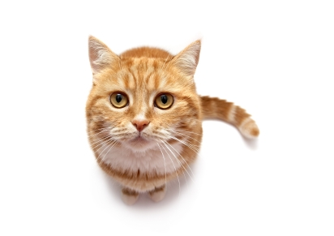  S81
Track 20 | Previews & Reviews | TV shows | T123 Description of a bar chart  S89
Track 21 | Previews & Reviews | Music Reviews |   T137 Conversation  S101
Track 22 | Previews & Reviews | Video games | T145 Discussion about  S106 essay writing
