Introducing Comic Strips
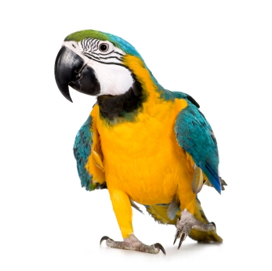
Learning Activity 1
Speaking
What do you know about comic strips?

Instructions

You need: four people, a counter each, a coin
To play: Toss the coin. Heads: move two places. Tails: move one place.
Winner: The person to answer the most questions

Start | 1 Ask two people in your group about what comics they read and why they like them. | 2 True or False?  Comics started to appear in the 1800s and were meant to be funny.
3 True or False?  A small comic-like book appeared in China  as early as the 1900s. | 4 What was the first animal comic cartoon character?  a) a dog b) a mouse  c) a cat | 5 What do the following three words mean?  a) Manga b) Manhua  c) Anime
6 True or False?  McMug is sillier than  McDull.  Why / Why not? | 7 Which one is a superhero and how do you know?  a) Crayon Shin-chan*  b) Doraemon  c) Astro Boy  d) Calvin (and Hobbes) | 8 Which type of comic strip do you think is most popular with teenagers these days?  a) action b) funny  c) relationship stories  d) stories about society
* Also known as Laap Bat Siu San

Learning Activity 2
Reading and Speaking
Character and Story

Read some information about two characters you will see in a comic strip in Learning Activity 3. Answer the questions in pairs.

A Reading – Characters
Calvin is a young American boy. He has a toy tiger called Hobbes. He also has a very good imagination. In the story you’re going to read, it’s evening time, and Calvin doesn’t want to go to bed.
How does a little boy avoid going to bed?
Calvin
Calvin’s mother cares about her son and wants to make sure he has a healthy daily routine, including going to bed on time.
What does Calvin’s mother do to make him go to bed?
Calvin’s mother
comic strips
comic strips
comic strips

B Vocabulary – Preparing for the story


Vocabulary check
Match the words to make phrases. What do phrases 1–3 mean?

Example: (1) say | (1) (d) say goodnight | (a) motion
(1) A broom |  | (b) for bed
(2) Slow |  | (c) stick
(3) Get ready |  | Example: (d) goodnight

All these phrases are used in the comic strip. What happens in the story?

Learning Activity 3
Reading, Speaking and Grammar
Working with the story

A Reading – What happens in the story?

You need: six story strips from your teacher for your group.
Activity: Read the strips. Can you guess the order of the story? Your teacher will show you the comic strip after you have finished.
Maybe this strip goes first...
And then,
this one?

B Reading – Preparation for role-play

Look below at the lines used by Calvin and his mother. Use the phrases to describe the way they are speaking at different moments in the story. Two phrases have the same meaning.
whispering softly✓starting to get louder speaking slowly
speaking normallyraising her / his voice speeding up

e.g. whispering softly
1. Mother: ‘Good night, Calvin.’

4. Mother: ‘Now hurry up!’

2. Mother: ‘All right, where are you?!’

5. Calvin: ‘Ahh! Time snap!’

3. Calvin: ‘I can’t! I’m trapped in...’

C Speaking – Role-play

You need: to see the Calvin and Hobbes comic strip
Activity: Work in pairs. Choose a character to play. Read out the dialogue in the cartoon using speed, volume (be quiet or be loud) and body movements to bring the story to life.
Feedback: Role-play the comic strip to another pair of students.
Get feedback from them about (a) pronunciation (b) speed and loudness (c) use of face and body.

Say ‘good night, Calvin’ more sweetly next time.
Try saying ‘all right, where are you?!’ a little more loudly.
Pronounce Calvin’s first line more slowly and deliberately.
Pronounce the ‘p’ in ‘time snap’ more clearly.

D Grammar and Vocabulary – Summarising the story

Circle the correct phrases below to complete a summary of the story.

Calvin is supposed to be (1) on the sofa / in bed.

He doesn’t feel like going to bed, (2) so / then he puts a broomstick in his bed (3) instead / as well. His mother comes (4) to speak / to say goodnight, and finds the broomstick.
She (5) has / starts to shout for Calvin.
In a different part of the apartment,
Calvin is (6) moving in / going on
slow motion. He (7) prevents / pretends
he cannot move any quicker to avoid
(8) to go / going to bed.
Calvin!
Calvin!
When Calvin’s mum (9) loses / raises her voice, Calvin quickly changes pace
(10) but / and runs to bed saying that
he has had a ‘time snap’.
comic strips

Features of Comic Strips

Learning Activity 1
Speaking and Vocabulary
How do comic strips work?

A Vocabulary – Parts of a comic strip

Draw lines from the labels to the parts of the comic strip.
Panels These are the boxes that show the action and dialogue.
Gutters These are the spaces between the panels. They mark changes in time and place.
Speech balloons These shapes are used to show who is speaking and what they are saying. They are made of the balloon / bubble and the tail.
Speed lines These lines show the speed and direction the character is moving in. They can also sometimes show you how a character is feeling.

Please refer to the print version
for the comic strip used in this activity.

Calvin and Hobbes comic strip

B Speaking – One-minute challenge

You need: four people to play this speed game
Activity: Write your names in the column. Answer all the questions next to your name within one minute. The tallest person in the group starts first.

Your names | Panels | Gutters | Balloons | Speed lines
 | Does every image have a panel? | What’s a gutter? | Which character speaks most? | What do the speed lines in panel 2 show?
 | Which panels show the setting? | How are gutters used in panels 1, 2 & 3? | How is speech shown in ‘slow motion’? | Are there any lines in panels 4-10? Why / Why not?
 | How many panels show Mum, Calvin and both? | How does the gutter show time between panels 4-8? | Which character has coloured speech balloons? | What do the speed lines show in the last panel?
 | How many panels show ‘slow motion’? | Difference between panel and gutter? | Why is ‘NOW’ in capitals and larger? | Are speed lines always straight?


Learning Activity 2
Listening and Note-taking
Use of comic strip features

Listening and Note-taking – Describing a comic strip

Read the comic strip below. The three characters are Lucy (the girl), Linus (the boy), and Snoopy (the dog). Did you enjoy the story? Which parts did you like?
Now listen to a description of the strip and make notes about storyline and comic strip features. Before you listen, number the panels from left to right so you can follow easily.

Panels
1-2

Please refer to the print version
for the comic strip used in this activity.

Peanuts comic strip

Panels
3-6

Panels
7-9

words to use

glove ✓
Example:
Panels 1-2 show setting and introduce Snoopy’s nose-boxing glove

Lucy

Lucy makes fun of Snoopy’s nose-glove.
Linus ________________ her that Snoopy is a champ.
Lucy needs a ___________________ to win.
Panels 3-4

WHAM!

strategy

show the beginning and ______________ of the fight.
The gutters divide the fight into three ______________ .
Panels 7-8 also use onomatopoeia: POW! and _____________.
Panels 5-8

warns

middle

This time, it’s ______________ wearing the boxing glove on her nose.

Panel 9 (the last panel)

stages

Learning Activity 3
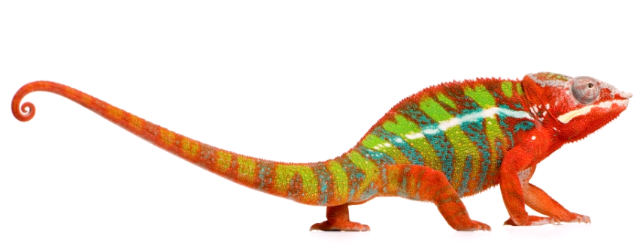
Writing
Working with dialogue

A Reading – Balloons and captions

Below you can see some speech balloons (a-b), a thought bubble (c), and a caption box (d). Match the phrases to the shapes and explain your choices to your partner.

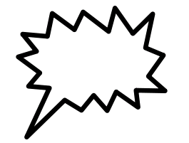
a
c
d
b
b.

(1) Calvin isn’t in bed, she thought. | (2) One minute later… | (3) ‘Get to bed this minute, Calvin!’, she shouted. | (4) She said, ‘Calvin, where are you?’.

B Vocabulary – Words to describe speech

(a) Put the words below under the correct comic shape. The words are in four groups: ‘said’, ‘shouted’, ‘thought’ or ‘time / place’. You may look up the words from a dictionary if you need to.

remarked imagined guessed

wondered the following day screamed

later that day shrieked in the kitchen

yelled mentioned told (me / you)

= said | = shouted | = thought | contains  time / place

(b) Why are all the verbs in past simple tense?
C Writing – Dialogue

You need: to write the thoughts and speech for panels 7, 8 and 9 of the strip.
Activity: Work in pairs. Look at panels 7, 8 and 9 on S19. Think about, discuss and decide what Linus (the boy) is thinking and might say.

Make notes on how Linus is feeling here:

Example: Panel 7 – shocked and afraid

Panel 7 – The fight starts
Look at Linus’ hair. It’s standing on end! What is he thinking?

Panel 8 – In the middle of the fight
Linus is standing back from the fight. What’s he thinking now?

Panel 9 – The fight ends
What is Linus thinking now: what does he want to say to Lucy? What does Linus actually say to Lucy?

Learning Activity 4*
Writing
Superhero profiles

Read the descriptions of these two female superheroes. Write (H) next to descriptions of Hypatia and (C) next to descriptions of Calista.
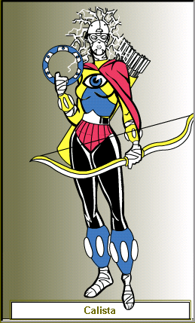
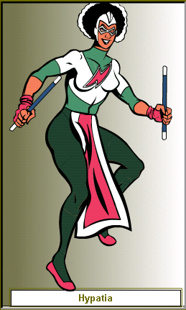
Example: She’s got a two-colour top on and her insignia is a bolt of lightning. (H)
(1) She’s wearing dark leggings with protective boots, which form an electric field around her legs. ____
(2) Her weapons are ‘zoom wands’, which are hand-held magnetic tools. ____
(3) She has a cape which makes her invisible. ___
(4) She’s wearing magnetic ballet flats, which allow her to fly near the ground. ___
(5) Her weapons are a bow and arrows, which are strong enough to go through walls, and a ‘transfixer disc’, which can freeze a person instantly. ___
Write a description of each character’s helmet or mask. What are they for?

★ Superheroes always have bad characters to fight against and protect people from. For example, Batman often protects people from Catwoman. These characters are called ‘villains’, ‘baddies’, and the worst one is called ‘the arch enemy’.
★ Superheroes usually have one weakness, for example, Superman loses all his powers when he’s near the mineral kryptonite. Villains often exploit these weaknesses.

Write a description of either
Hypatia’s or Calista’s arch enemy.
What’s her / his name? What does s/he wear? Any special powers? What is your superhero’s one weakness, and how does her / his arch enemy use it?

These images provided courtesy of UGO Entertainment, Inc. and Heromachine.com
`

Hypatia (pron: hi – PAY – sha) the name of a 4th century female Greek-Egyptian mathematician, philosopher and astronomer.
Calista (pron: ka – LIS – ta) means ‘most beautiful’ in Greek. Calista was a huntress in a Greek myth.
Learning Activity 5
Writing
Tips for comic strip writing

A friend has written some points for new ‘family and relationship’ comic strip writers at your school. Unfortunately, she made some factual mistakes. Read her list and improve it, changing the mistakes.

Guidelines for comic strip writing
POW!!
WHAM!

Comic strip stories – make sure there are lots and lots of problems.

Family characters – have around ten characters and make sure they are all different, e.g. different clothes and hair. The story should involve all of them.

Panels – use panels to show the action. Every panel should have an action scene in it: conflict, drama, conflict, drama!

Gutters – don’t worry about gutters. They’re not important.

Speed lines – use as many speed lines as you can to create action and adventure. Use as many stars as possible.

Speech balloons or thought balloons – every panel should have a speech or thought bubble to keep the readers interested. Put in a lot of dialogue.

Sounds – if you have action, make sure you include at least ten sorts of sounds (onomatopoeia), like ‘smash!’, ‘thwack!’ and ‘pow!’

