



Name:Julia ChenJob: Marketing consultant in Hong KongLifestyle: Always busy; often works late. When she is free, she goes walking in the hills.Likes: Gadgets, reading
Manhua comicsSpecial comments: Has a bad back condition.

Name:Martha AbdouJob: School girl in Cameroon, AfricaLifestyle: Likes playing, with friends and learning about the world through photos. Wants to be a journalistLikes: Gadgets, photographySpecial comments: Parents are not well-off

Name:Murat BradleyJob: Chef in Libya, North AfricaLifestyle: Owns his own restaurant; often works until late; loves his familyLikes: Gadgets, the outdoorsSpecial comments: Needs ways to speed up in his kitchen



In front of her house
In the office
Teacher’s Flashcards to cut up for Gadget Columns
Learning Activity 2 Meeting a person’s gadget needs (S50)



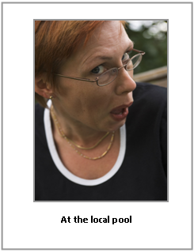
Name:Nina ChristiansenJob: Retired swimming coach in DenmarkLifestyle: Supports her local swimming club with over a 100 members Likes: Gadgets, swimmingSpecial comments: Is helping to run a local swimming gala

In the park with his son
At the local pool

