Horoscope Columns
Teacher’s Notes

Objectives
By the end of the lessons, students will be better able to:
- use vocabulary to describe personality
- read and understand horoscope predictions
- write predictions using appropriate language
- produce horoscopes that adhere to the typical structural features of this text-type

Time Needed
- 2-3 forty-minute periods

Learning / Teaching / Assessment Tasks / Activities
- Students practise vocabulary to describe Western and Chinese horoscope signs
- In pairs, students exchange information to complete a table about horoscopes
- In pairs / small groups, students complete a multiple-choice vocabulary definition quiz on adjectives of personality
- Students add to descriptions of star signs using the adjectives of personality
- Students read 3 Chinese horoscopes and answer noticing questions focussing on comprehension, language and structure
- Students complete sentences to make predictions, then use these sentence starters to compile horoscopes for classmates / teacher

Materials Required
- Student’s handouts S44-S48
- CD Track 7

Horoscope Columns
Teacher’s Notes

 Introduction:
These activities are designed to support students in producing a magazine column: horoscopes. They begin by focussing on vocabulary typically used to describe the characteristics of each star sign, using both Chinese and Western horoscopes for cultural balance (plus students may be more familiar with the Chinese ones). They work on defining adjectives by guessing from a given context, an important skill for students to learn in order to develop their reading and vocabulary skills. To check and consolidate their understanding of these items, they read descriptions of the Western star signs which use synonyms and then students add the appropriate adjective from the previous activity. They follow this with a reading activity focussing on comprehension, language features and structure and content designed to raise their awareness of this text-type. The final activity is for students to write their own horoscopes. They practise the necessary grammatical structures by completing sentences to make predictions. These are then incorporated into horoscopes for classmates or their teacher.

S44
 Learning Activity 1 Vocabulary and Speaking
A Vocabulary – Horoscope signs (5 minutes)
This activity provides students with practice of animal vocabulary related to Chinese horoscopes and introduces the theme of horoscopes.

Students identify the animals and discuss what they represent. Ask them what the year is now and which animal their birth year is. Introduce the words horoscope (“a description or prediction of things that will happen to you and of your personality according to the position of the stars / planets at your time of birth”) and star signs (“one of the 12 signs of the zodiac – the system that uses birth dates to say what will happen to you in the future”).

Answers: The animals (clockwise from top left) are rat, ox, tiger, rabbit, dragon, snake, horse, sheep, monkey, rooster, dog and pig. There are many versions of the origin of the 12 Chinese zodiac animals. According to legend, one day the gods tried to develop a calendar system to keep track of time and decided to hold a race for the animals on the earth. The first 12 animals to cross the river would be the signs of the zodiac calendar, and would appear according to their order in finishing the race. They represent what others think of you or how you present yourself. For interest, students may visit http://12zodiac.com/learnsigns/
learnsign.shtml for what personality each of them represents. Check current year and students’ years of birth at http://chinese.astrology.com/sign.aspx or in an issue of the South China Morning Post.

Catering for Learner Diversity

For students who need more support
- You may decide to supply the animal names for students to match to the pictures. Here is a list to enlarge and cut up:

rat | ox | tiger | rabbit
dragon | snake | horse | sheep
monkey | rooster | dog | pig

S44
B Vocabulary – Personality adjectives quiz (10 minutes)
This activity is designed to introduce / revise adjectives of personality associated with character descriptions of star signs.

This can be done in pairs or groups (this might make it more competitive – you could also set a time limit). Discuss whether the adjectives are positive or negative. Follow up with pronunciation practice of the adjectives, perhaps focussing on syllable stress (in bold below).

Answers: 1. laid-back (c) +; 2. stubborn (c) -; 3. frank (c) - / + (depending on context); 4. generous (a) +; 5. bossy (b) -; 6. shy (c) - / neutral (depending on context); 7. optimistic (b) +; 8. romantic (a) +; 9. intelligent (c) +;
10. sensible (a) +; 11. patient (b) +; 12. adventurous (c) +

Catering for Learner Diversity

For students who need more challenge
- You could challenge students more by supplying the sentences with the words missing (perhaps providing just the first letter) for them to guess and fill in as well as choose the correct definition.

S46
C Speaking, Listening and Pronunciation – Horoscope dictation and information exchange (25 minutes+)
CD Track 7
These activities (a) allow students to listen to and practise pronunciation of horoscope vocabulary and (b) give students practice in listening and speaking in pairs in order to share information.

a) Before class, copy the column dictation sheet on T63 so that there is one for each student. Using the CD (Track 7 - 3:03 minutes) as a model, allow students to listen to the horoscope names being pronounced correctly. As they listen, they should distinguish between the names for Chinese horoscopes and those for Western star signs and fill in the correct columns (Chinese / Western). The words are supplied below the table to assist with spelling. You may like to drill the words as a class afterwards to reinforce the listening practice and prepare students for the next speaking activity.

    Chinese | 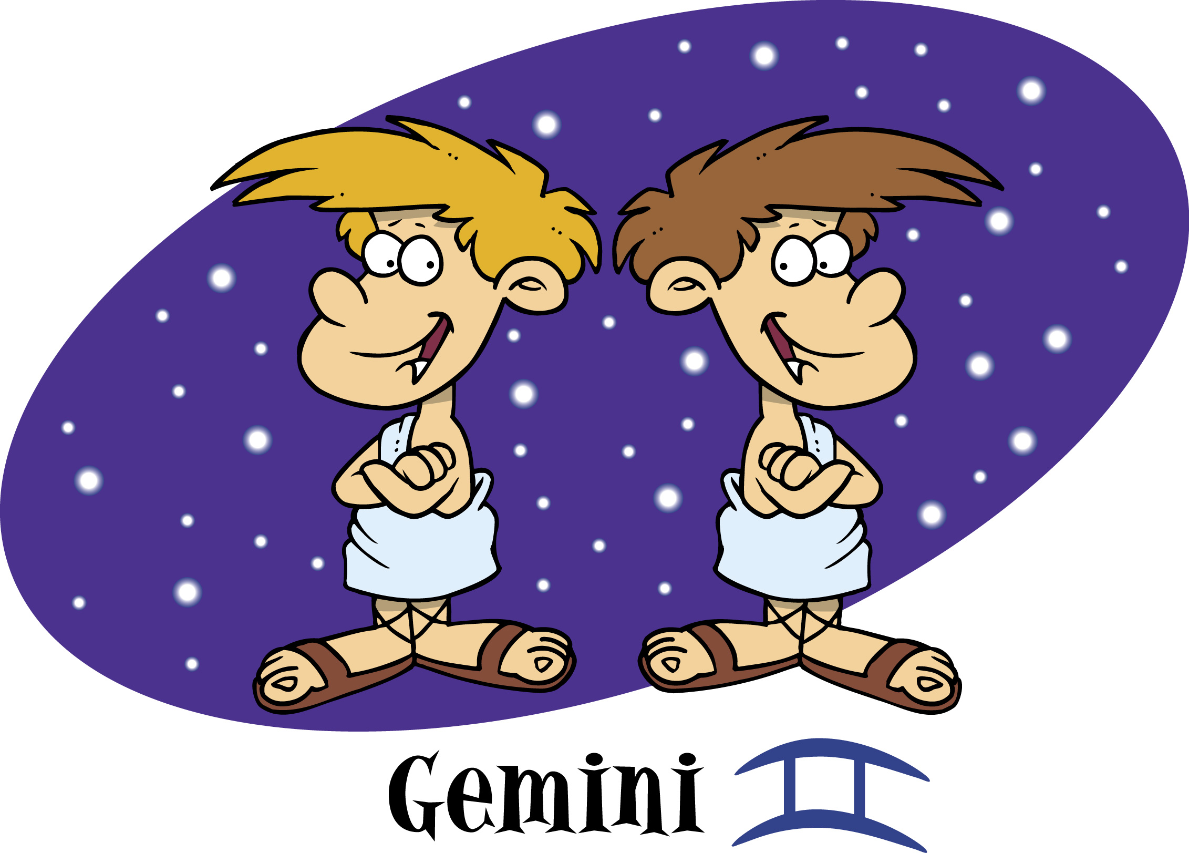  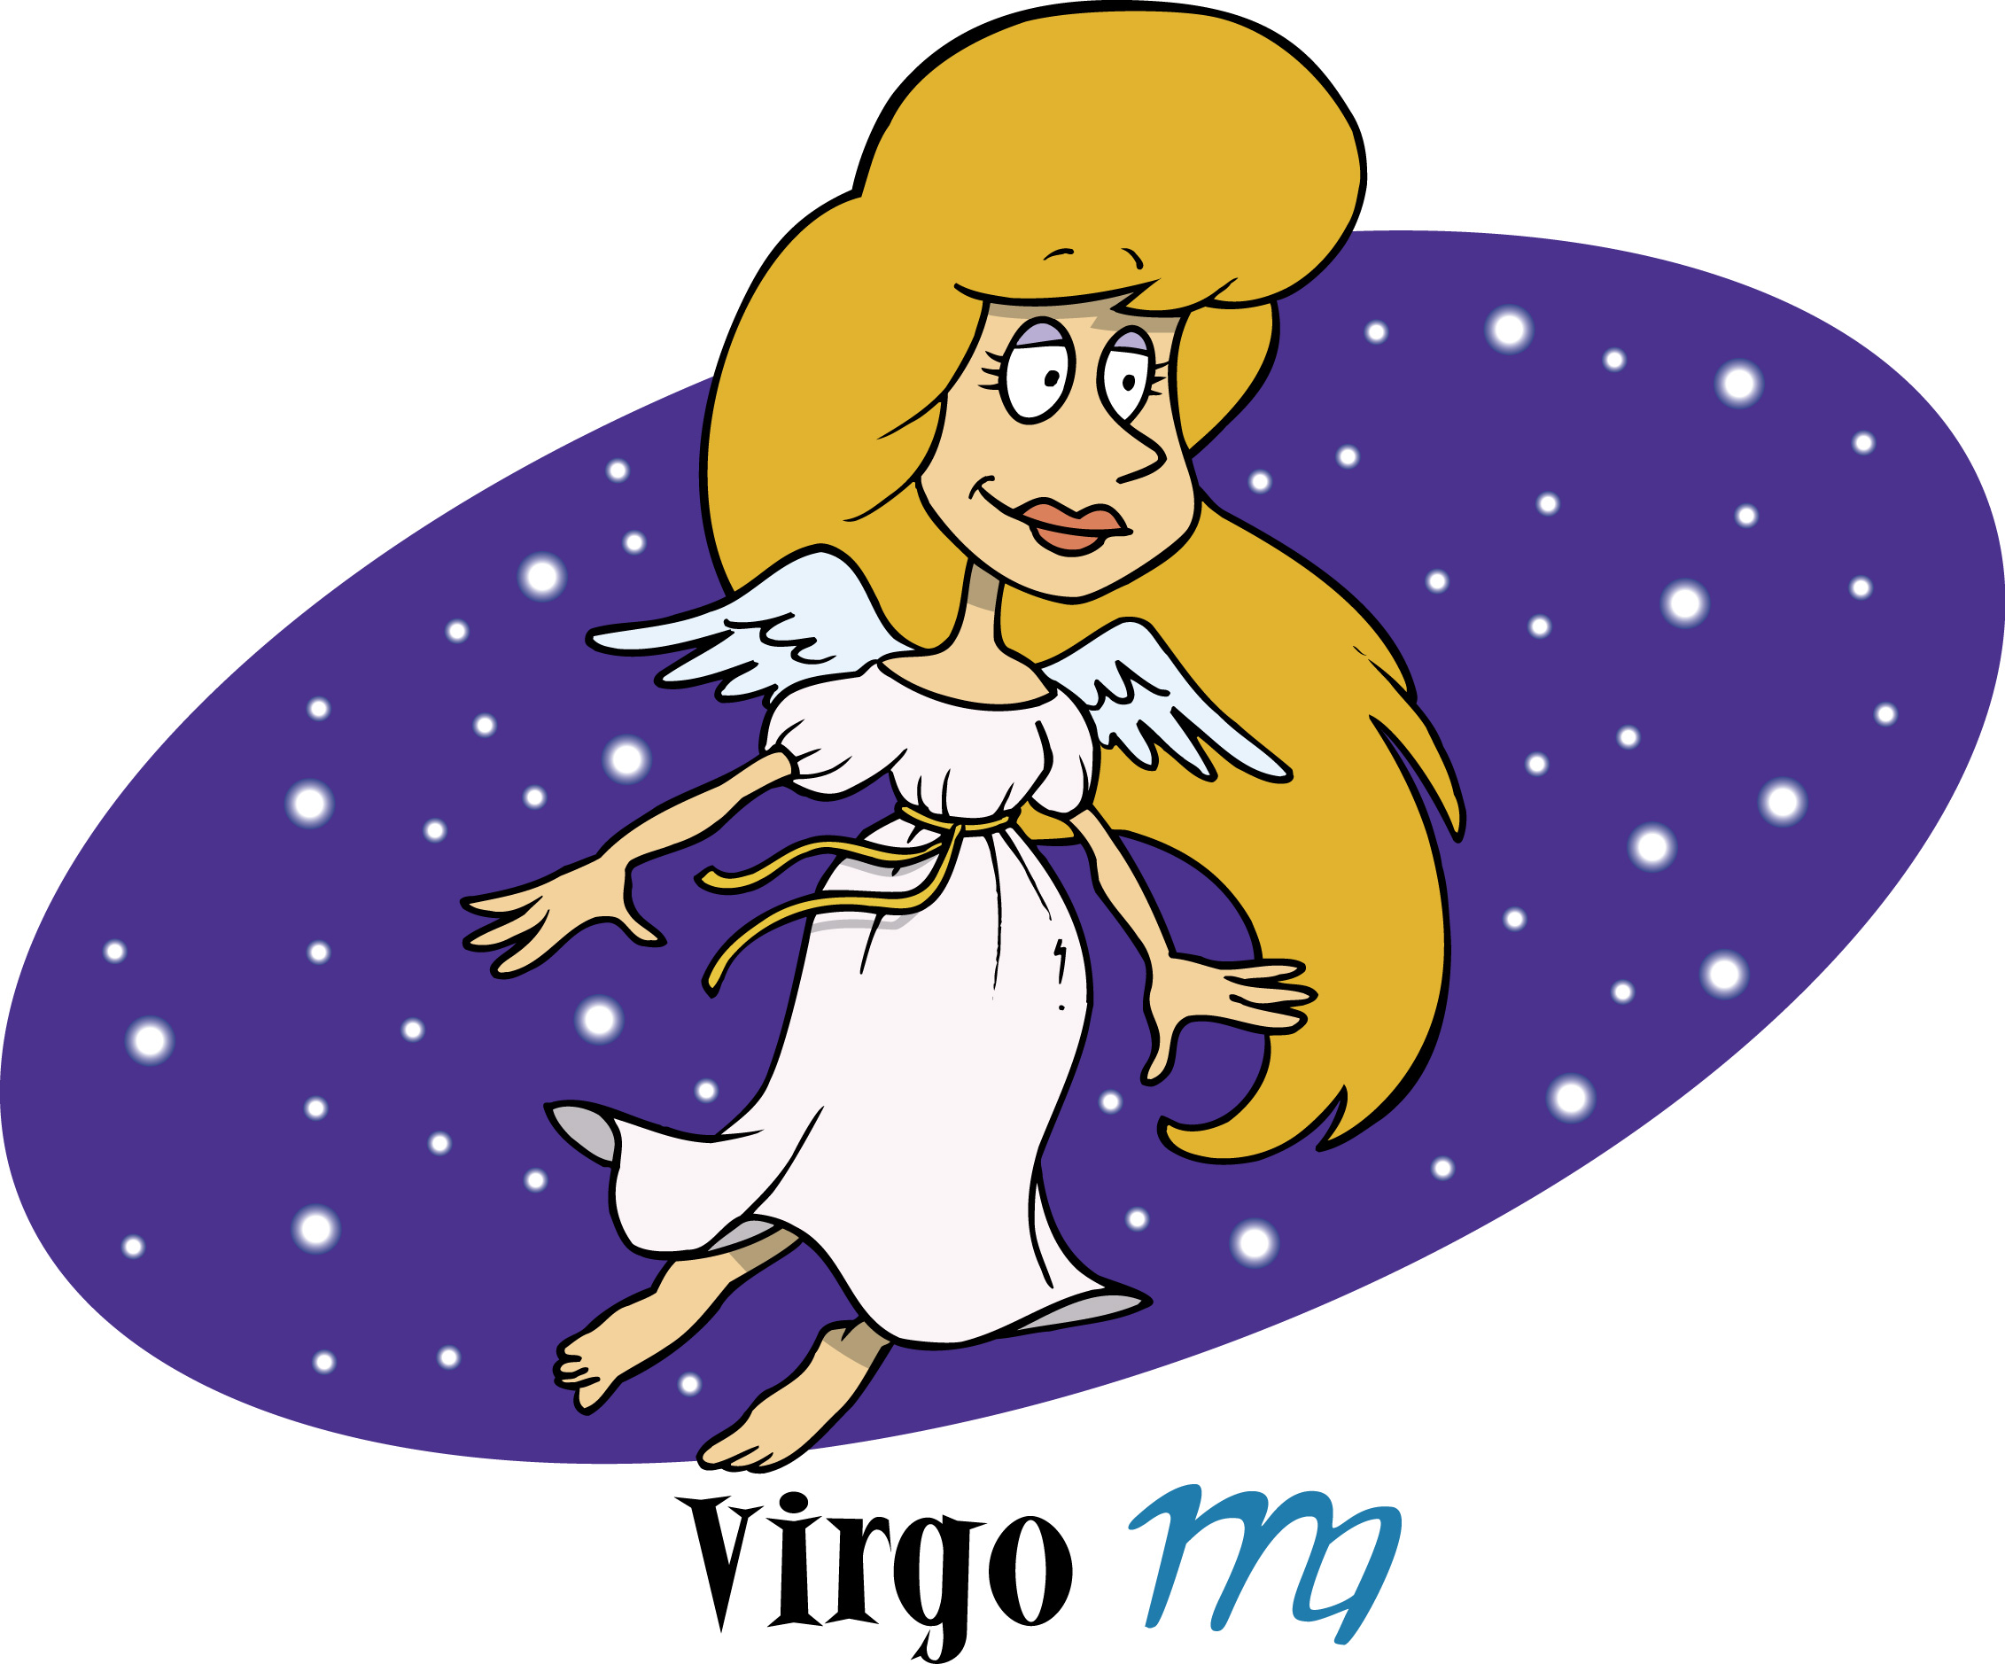  Western
1.  2.  3.  4. Horse  5.  6.  7.  8. Tiger  9.  10  11.  12. Monkey | 1.  2. Virgo  3.  4.  5.  6. Aquarius  7.  8.  9.  10.  11. Taurus  12.
Here are all the words you will need. Some have been filled in for you.

Rat Monkey Pisces Leo Pig Aries Tiger Rabbit Cancer Capricorn Horse Scorpio Snake Virgo Gemini Rooster Taurus Libra Sagittarius Dog Ox Dragon Sheep Aquarius



Answers:
The students should have filled in the words in the following order as heard on the CD (Track 7):

Chinese | Western
1. Rat  2. Dragon  3. Sheep  4. Horse  5. Dog  6. Pig  7. Ox  8. Tiger  9. Snake  10. Rabbit  11. Rooster  12. Monkey | 1. Libra  2. Virgo  3. Capricorn  4. Pisces  5. Scorpio  6. Aquarius  7. Sagittarius  8. Aries  9. Cancer  10. Leo  11. Taurus  12. Gemini

Catering for Learner Diversity

For students who need more challenge
- You may decide not to supply the words with the dictation table so that students have to rely on existing knowledge and deduction from sounds to spell the words correctly.

b) Before class, copy the charts below so that there are enough to give one to each student (half the class=A, the other half=B). Students work in pairs. Tell them they must not show their information to each other but that they should ask questions in order to fill in the missing information on their sheet. Elicit the types of questions they need to ask, e.g. Which is the animal or symbol for (Aries)? Which star sign is the (bull)? What are the dates for (Leo)?


STUDENT A

Example question: Which is the animal or symbol for (Aries)?

Star sign | Animal / Symbol | Dates
Aries |  | March 21 - April 19
 | bull
 | twins | May 21 - June 21
Cancer
Leo | lion | July 23 - August 22
 |  | August 23 - September 22
 | scales | September 23 - October 22
Scorpio | scorpion
 |  | November 22 - December 21
Capricorn |  | December 22 - January 19
 | water carrier | January 20 - February 18
 | fish


STUDENT B

Example question: Which star sign is the (ram)?

Star sign | Animal / Symbol | Dates
 | ram (a male sheep)
Taurus |  | April 20 - May 20
Gemini
 | crab | June 22 - July 22
Leo | lion | July 23 - August 22
Virgo | woman
Libra
 |  | October 23 - November 21
Sagittarius | archer
 | goat
Aquarius
Pisces |  | February 19 - March 20


Catering for Learner Diversity

For students who need more support
- You could supply pictures of the respective star sign symbols so that students have an idea of the meaning of the word before they tell their partner, then they may be able to define it for their partner more clearly.

For students who need more challenge
- This could be prefaced with dictionary work to identify and define the star sign symbols.

D Vocabulary and Speaking – Personality adjectives
S46
(10 minutes)
In this activity, students consolidate vocabulary from the previous tasks (adjectives of personality and western star signs).

Students read the descriptions of the 12 star signs and choose one of the adjectives from Learning Activity 1B that is most similar in meaning to add to the description. Ask students to discuss if they are typical of their star sign’s description. Note: these are not meant to be scientifically correct descriptions of the 12 signs – they’re just for fun!

Answers: Aries – bossy; Taurus – patient; Gemini – intelligent; Cancer – romantic; Leo – optimistic; Virgo – sensible; Libra – laid-back; Scorpio – frank; Sagittarius – adventurous; Capricorn – stubborn; Aquarius – generous; Pisces – shy

S47
 Learning Activity 2 Reading Magazine horoscopes (15 minutes)
This activity exposes students to the topical areas typically appearing in horoscope columns.

There are three example horoscope texts provided which students should read, then they can discuss the questions in pairs / groups (circling the correct animal), or if you prefer, you could lead it as a whole class discussion so that you can ensure they are focussing on the correct language, etc. In question (h) ensure that you draw students’ attention to the structures that follow these forms so that they are aware of the correct usage for their own production later.

Answers: a) dog; b) rooster; c) dog; d) pig; e) pig; f) will; g) modal verbs e.g. may, might; h) imperative e.g. be (+adjective), try (+to infinitive), avoid (+verb+ing); i) about 40 words; j) ‘you’; k) topics not included in texts are crossed through in boxes below; l) see boxes below

emotions (feelings)  pig, rooster, dog | relationships  rooster, dog | school / work | finance (money)  dog, pig
decisions  rooster | health  rooster, pig | entertainment | the past

Catering for Learner Diversity

For students who need more support
- The questions could be turned into simple yes / no questions concentrating on one text at a time, e.g. Rooster – Will s/he make good decisions today? Y / N. This reduces the load on students having to read and understand all three texts and questions together and simplifies the task.

 Learning Activity 3 Writing
S48
Horoscopes for your classmates (25+ minutes)
This activity consolidates the language features of horoscopes by providing an opportunity for students to write predictions.

Students can work individually to complete the sentences. Monitor carefully to check they are using the correct forms after each verb. They then choose classmates or someone else (e.g. teacher, favourite pop star) to write a horoscope for. Agree with students on the number of horoscopes they should write. They should write the star sign (they can select Western signs or Chinese animals) at the top and add a symbol / picture if they want to. Remind them to write about 40 words for each horoscope and to decide if it is a generally good or bad day for that person so that their horoscope is appropriate. They should also try to include some of the vocabulary learnt in the lessons to describe the person’s personality or behaviour for that day.

Catering for Learner Diversity

For students who need more challenge
- This activity could be extended by asking students to produce more horoscopes and setting criteria for them to conform to, e.g. one horoscope should be negative about money; another must have good news about relationships.
Alternatively, they could try to produce horoscopes which illustrate that star sign’s personality according to the previous work done on adjectives, then other students have to guess which star sign it is for. More able students could also be encouraged to produce longer texts incorporating all aspects of a person’s life (e.g. money, love, health, work, travel) for prediction.

Resources for Horoscopes

Websites for Horoscopes:

General astrology ¶¶
This site covers all aspects of astrology, including Chinese horoscopes. The language is quite challenging. It has a section aimed specifically at teens. http://horoscopes.astrology.com/index/dailyteenindex.html
http://www.astrology.com

Teenage horoscopes ¶¶
This site has descriptions of each star sign in very colloquial language so it is quite challenging.
http://www.atomicteen.com/horoscopes

Teenage horoscopes ¶¶
This is a slightly more mature / serious teen horoscope site which although containing colloquial language and abbreviations, has fairly short manageable texts of about 40 words.
http://www.alloy.com/astro

Teaching ideas for teachers:

A site with lots of practical ideas based on magazines for teachers to try out in the classroom.
http://www.teachingenglish.org.uk/try

