Reviews: Music

Learning Activity 1
Speaking and Vocabulary
Expressing opinions about music

A Vocabulary – A - Z dictionary race
Use a dictionary to find the correct word related to music for each letter of the alphabet (not every letter is used). Some have been done for you.

A
A (n.) a collection of songs / music, usually on a CD
B (n.) a simple, romantic song
B
C (adj.) pleasant and easy to remember
Catchy
D (adj.) a synonym of ‘boring’
D
F (adj.) simple with a strong rhythm that is easy to dance to
Funky
G (n.) a musical instrument with six strings
G
I (adj.) music produced by a small independent company
Indie
L (n. pl.) the words of a song
L
M (n.) a song or tune
Melody
N (n.) a piece of music that forms part of a longer performance
Number
P (n.) a large musical instrument with 88 black and white keys
P
R (n.) a regular repeated pattern of sounds or movements
R
S (n.) the recorded music from a film
S
T (n.) one of the pieces of music on a CD
Track
U (adj.) the only one of its kind; very special and unusual
U
miss
hit
B Speaking – Your opinions of songs
Write these words on two big pieces of paper:
Listen to some song clips and hold up the
paper to show your opinion about each song.
Tell your partner why you like / dislike each song.

How do you choose what music to listen to?
Do you ever read reviews? If yes, do they affect what music you buy? What other factors influence your decision?

C Vocabulary – Describing music
Here are some more words to use when referring to music. Put them in the correct column. Can you add any more words?

rubbish not bad great terrible a flop fantastic
so-so brilliant just OK awful a winner
Hit 
Miss



Learning Activity 2
Reading
Vocabulary in context

A Reading – A music review

Read this extract from a music review and answer the questions.

This 19-year-old Taiwanese newcomer has a distinctive voice and the combination of her songwriting skills and singing ability will help her to make it to the top. She was discovered just six months ago in a karaoke bar but her debut album ‘Remember’ is a brilliant collection of funky tracks which will make you move your feet.
The first number ‘Fly away’ is a catchy song with a strong rhythm. It is followed by ‘Red Leaves’, a great tune about her childhood. The piano ballad ‘Blue’ has a soft melody and beautiful lyrics. As the first CD of her career, this is an impressive beginning.

- Does the reviewer like the album?
- What are the special talents of this singer?
- Has this singer produced any other albums?
- What genre of music do you think it belongs in?
(a) rock / indie (b) film soundtrack (c) dance / pop
5. What does the reviewer predict about this singer’s future?

B Vocabulary – Collocations

Underline the adjective + noun phrases in the music review above. Cover them up. Can you remember the phrases? Match the adjectives and nouns.

1. beautiful |  | (a) melody
2. strong |  | (b) voice
3. catchy |  | (c) tracks
4. soft |  | (d) rhythm
5. funky |  | (e) song
6. distinctive |  | (f) lyrics



Learning Activity 3

Listening and Speaking


Analysing music reviews

A Listening – Useful phrases from music reviews

Listen to the three music reviews and complete the phrases with a verb or preposition.

- The first song ‘We Get On’ ________ a happy piano melody.
- ‘Play’___ a dull song.
- It’s not an easy album to listen ___.
- It’s ___ a Japanese singer-songwriter.
- Her voice sounds ______ an angel.
- An instrumental version ____ the song.
- This is the newly–released sequel ____ ‘High School Musical’.
- It kicks off ______ the funky song ‘What Time Is It?’.
- Good ______ dancing ____.
- ‘Fabulous’ ______ an infectious melody.
- Will _______ you move your feet.
- It’s _____ a good selection of different tunes.

B Listening – Positive or negative?

Listen to three reviews being discussed and write notes in the correct column below.

 | + Positive comments | - Negative comments
Album 1  Song 1  Song 2 | Number ___?  Piano? ___________________
Album 1  Song 1  Song 2 |  | Song lyrics?_________________  How is it to listen to?__________
Album 2  Song 1  Song 2 | Talent? __________________  Voice? ___________________  Lyrics? ___________________
Album 2  Song 1  Song 2 | Version? __________________
Album 3  Song 1  Song 2 | Tunes? ___________________  _________________________
Album 3  Song 1  Song 2 | What will it make you do?  _________________________
Album 3  Song 1  Song 2 | Version?__________________

 Music reviews often use a rating system to give their opinion, e.g. stars (usually from one to five) or thumbs up / thumbs down.
Fabulous! Quite good Average Just OK Awful
C Speaking – Ranking

How many points on the ratings board do you think these reviews were given? You can give from one to five.
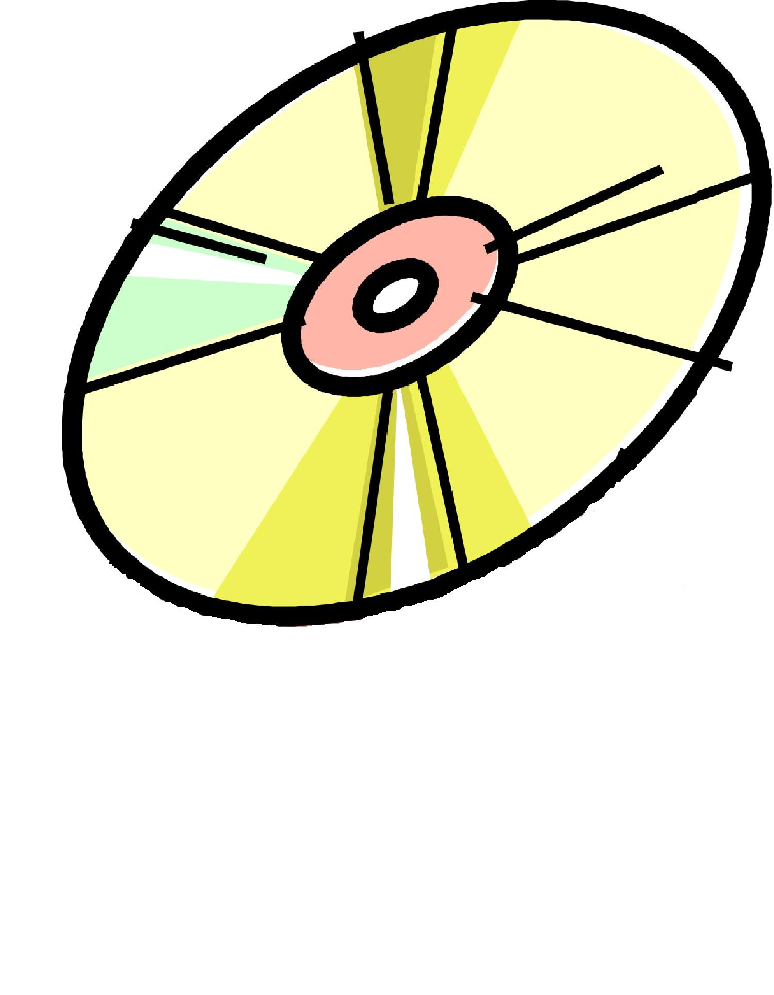
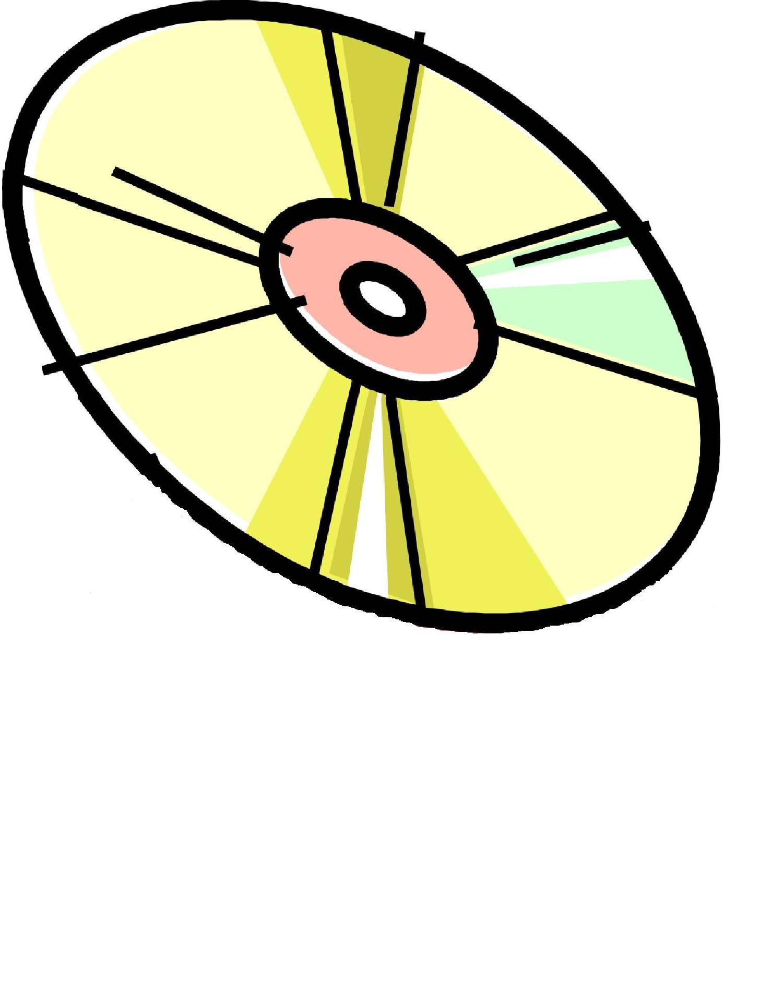
=very bad = the best
Review | CD Rating
- To my mind, this is easily the best album of the month. It is fantastic.
- There are a few good tracks on here but to be honest the rest of it is just OK.
- This is not a CD I’d recommend. The songs are dull and the melodies are awful.
- She has a unique voice and her beautiful lyrics and catchy tunes make you want to listen again and again.
- The first time I listened to this I’m afraid I was bored. The tunes all sound the same and the vocals are rubbish. Overall, this album is a waste of money. Don’t buy it.

Learning Activity 4

Reading

Identifying music reviews

A Reading – Unscrambling the sentences

A trainee journalist has mixed up some different reviews by mistake. Can you identify the parts which belong to the music review? Highlight them.

The latest blockbuster from Disney is a visual feast full of colourful animation. The guitar and bass will make you tap your feet. The characters in this new edition have more super-powers and longer lives than in the first edition of the game. Unfortunately, her second album is fairly dull and predictable. The lyrics are rather repetitive and start to be annoying after a few minutes. You will find the plot extremely exciting and the climax is a big surprise. There are a couple of interesting tracks, but overall this will be a flop. This fantasy-drama is not to be missed.

B Reading – Sequencing information in a review

Read the review on the next page and label the paragraphs with the correct description. Write the letters in the boxes next to the text. The first one has been done for you.

Descriptions:
- An overview of the whole album / genre information
- Name of singer / CD
- Evaluation – positive or negative overall / recommendation
- Context-setting – e.g. reference to previous hits / CDs
- Descriptions of individual songs – usually the best / worst

Please refer to the print version
for the review used in this activity.

Music review

7.
a + b
1.

2.

3.

4.

5.

6.


Learning Activity 5

Writing

A music review

A Homework Assignment – Preparing to write a music review
Select a CD to review. It may be by your favourite artist or one that you have never listened to before. Listen to it a few times and make notes in the boxes below.

Name of singer / group: | Name of album: |  | First impressions (Your opinion after the first listening):
Do some background research – is this the singer’s first album? Can you add any interesting facts about the singer / the album’s production?

Which musical genre is it? (circle one)
pop | rock | ballad | classical | folk | traditional | rap | hip-hop | soul | other (what?)

Write some notes about the style / sound: |  | What instruments are used?
Choose two or three songs that are especially good / bad. Write their names and a few words to describe them:
1.

2.

3.

What is your final feeling about the album?

Write a recommendation or conclusion:

B Writing – A music review

Now write a music review using the skeleton structure:
The (e.g. first)_______album (album name) ‘___________’ from (artist’s name)_________________ is (first opinion)___________________. This (adjective)_____________ example of (genre)_____________ will make you want to (verb)_____________.

Her / his / their (voices / musical instrument(s))_____________ sound(s) like (noun)__________. The first number (song name) ‘__________’ is a (adjective)_____________ song with a ____________ rhythm. The (e.g. fourth)_____________ track (song name) ‘__________________’ has a (adjective)_____________ melody and (adjective)_____________ lyrics.

Overall, this album is (adjective)_____________________________and (adjective)________________. (Don’t) (verb)_______________ it.

Write a second review of another album. Use a similar structure.



