Reviews: Video Games



Learning Activity 1

Speaking and Vocabulary
Introduction to video games

A Speaking – Online games
Work in pairs. Write the names of three online games in the table below and fill in the answers to the questions.

Name of game: | 1. | 2. | 3.
Type of game:

Who would play this game?

Why would this game appeal to those people?

B Vocabulary – Video games
Match the gaming words or phrases to the definitions. Some have been done for you.

1. R.P.G. |  | - Fighting
2. simulation | e | - Categories that games are in, e.g. role-playing games, strategy games, driving games.
3. combat |  | - A role-playing game: A type of game where the player controls a character, on a quest. During the game, the character earns experience points for completing tasks or beating enemies, and becomes increasingly powerful.
4. addictive |  | - Massive Multiplayer Online Role-Playing Game: This online game allows hundreds or even thousands of users to play a game together.
5. violent |  | - "Sims" recreate a particular situation in detail. Flight sims, for example, give the player full control of the plane. Other types of Sims replicate driving a race car, coaching a sports team, running a city, or even dating.
6. fantasy |  | - Using actions that are intended to hurt or kill people.
7. portray | h | - A machine that you play video games on, e.g. X-box, Playstation, Wii.
8. console |  | - To show or describe someone / something in a particular way.
9. first-person shooter game | l | - An exciting or unusual situation or experience which is unlikely to happen in real-life.
10. strategy |  | - Using decision-making skills to make a plan so you can reach a goal.
11. genre |  | - This word describes something that you want to keep doing because you like it so much.
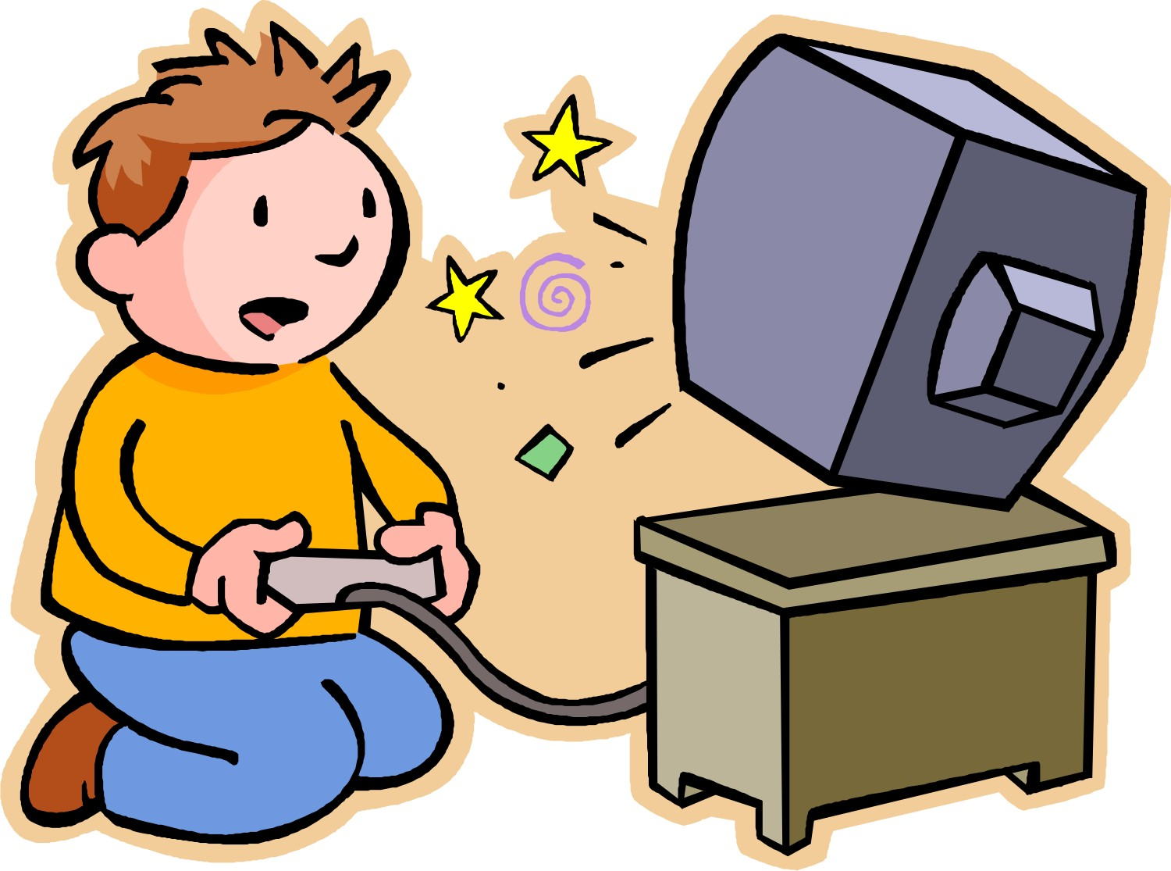  12. MMORPG |  | - This is a computer and video game genre where the player sees the action through the eyes of the main character, virtual reality-style.


Learning Activity 2
Listening, Grammar and Speaking
Are video games bad for you?

A Listening – Identifying people’s points of view
Listen to the conversation about video games and decide who says each phrase. Write speaker A (woman) or speaker B (man) next to each phrase.
1. “I don’t think video games are good for you.”
2. “I think they’re good because…”
3. “Another positive point is…”
4. “Surely there are some benefits.”
5. “I really don’t see that as a good thing.”

6. “I still think there are many plus points.”

B Grammar – Organising your points
The speakers used various ways of indicating what they might say next and to put their points in order whilst speaking. Some of these ‘signposts’ are listed below. Put them in the appropriate category.

- Good idea!
- An argumentative essay, is that right?
- Let’s begin by introducing…
- So firstly we can say…

- There’s one final point I want to make about…
- Really! I think that’s taking it a bit far.

- But what about…?
- So, to summarise…

Introducing your topic
Responding to someone’s comment
Clarifying / checking understanding
Adding more comments
Rounding up / ending the discussion

C Speaking – What do you think?
Here are some statements related to the conversation you listened to. Colour in the bars below each statement to show how much you agree or disagree. Compare with your partner and explain your answers.

ME MY PARTNER
Agree Disagree |  |  |  | Agree Disagree
1. Video games can help people to learn new skills.
2. Playing on a computer in all your spare time makes you a boring person.
3. There are no benefits to playing computer games.
4. Online games are dangerous.
5. Parents should have more control over what their children play.
Learning Activity 3


Reading and Writing

A first draft of an argumentative essay

A Preparation – Mindmap
Work in groups to brainstorm ideas for and against computer games. Make a mindmap to organise your points.

B Reading – An example essay

Look at the following extract from a student’s essay about computer games. Which sentence:

- makes a positive claim?
- makes a negative claim?
- gives an example?
- makes a conclusion?
- justifies the writer’s claim?
- evaluates all the evidence?
- makes a comparison?

Write the letters in the brackets after each part of the essay. You may need to use the sentences more than once.

Should computer games be banned for under-18’s?

Computer games are bad for your health ( ). Doctors have found that playing computer games for more than five hours a day can make some people violent ( ). Computer games targeting boys are usually violent ‘first shooter’ games, whereas games for girls promote stereotypical interests such as fashion and make-up ( )+ ( ). However, it is not all bad news. Computer games may have some benefits too ( ). Researchers have discovered that using computer games to help children who are in hospital can reduce their pain ( ). The children who played computer games needed less pain relief and were more relaxed than the ones who just rested after their treatments ( ). However, they only played for an hour a day.
Considering these different views, it is hard to decide who is right as there are both advantages and disadvantages ( ). In my opinion, computer games should be controlled so that children do not become addicted, but they can also be useful for us so we should not ban them altogether ( ).

C Writing – Organising your ideas

(a) Look at the extract from the example essay in Learning Activity 3B on S107. In what order are the different parts? Fill in the ‘recipe’ for an argumentative essay with words from the first box.

evaluatepositive or negative claim (x2)comparisonjustify (x2)conclusion

- Make a __________.
- _____________ your claim.
- Give an example.
- Make a ___________.
- Make another __________.
- _____________ your second claim.
- _____________ all the evidence.
- Give a ___________.

 The order of the steps above might change and you can repeat the steps if you need to. For example, you might make three or four positive and negative claims followed up by a justification and examples.

(b) Practise stages 1-8 from the box above (stages 5 and 6 are repeated) by matching the heads and tails of the following sentences.

- Simulation games have some benefits because … |  | - … such as online strategy games and fashion-based Sims.
- Most teenagers have a console at home, for example … |  | - … computer games are dangerously addictive.
- Research by doctors in the USA has found that … |  | - … we can summarise that computer games are safe when used in moderation.
- Looking at both sides of the argument … |  | - … becoming addicted to computer games according to research.
- Games that appeal to girls are becoming more popular … |  | - … they allow players to act out real-life situations in a safe way.
- Boys are more at risk of … |  | - … Playstation 3 or Nintendo.

D Writing – A first draft

Write a first draft of an argumentative essay. Follow the steps suggested above to help organise your ideas.
Computer games should be banned for children under 16. Do you agree or disagree with this statement? Write about 200 words presenting your arguments.

Learning Learning Activity 4

Grammar


Error correction

A Grammar – Finding the mistakes

A student has written an essay answering the question in Learning Activity 3D on S108. The teacher has used a correction code to help the student find and correct the mistakes. Look at the code and then correct the mistakes. There is one mistake in every line. The first one has been done for you.

^ a missing word
sp spelling mistake
wo word order
vf verb form / tense
ww wrong word
pl plural
Line no.

1 ^
2 pl
3 vf
4 ww
5 vf
6 ww
7 sp

8 ^
9 wo
10 ^
11 sp
12 vf
13 ^
14 wo

15 pl
16 ww
17 ^
18 vf
19 sp
20 ww

as
(1)I don’t think computer games cause as much harm ^ people say
(2)they do. There are many benefit to playing computer games, for
(3)example, improved motor skills. Studies have show that young
(4)children can actually improve their able to use their hands by
(5)play hand-held computer games regularly. Some games can help
(6)with their reading comprehensive, mathematical skills and
(7)problem-sloving abilities.

(8)Doctors in USA have done research in hospitals and found that
(9)certain medical conditions could be helped by patients providing
(10)with computer games play. One example is the case of a ten-
(11)year-old boy whose ilness caused him to pick his lip, causing
(12)scarring. Previous treatments had failed so the boy was gave
(13)video game console to keep his hands occupied. Two
(14)later weeks the affected area had healed.

(15)It is wrong to say that computer games can isolate child
(16)because we usually play games with your friends over the
(17)Internet and it is a way of together just like in real life. I play
(18)shoot-’em-up games with a lot of killing, but that is not
(19)make me behave more aggressively becuase I know they are
(20)not real and it is not part of my reality life.

B Self and peer feedback – Checking your work

Go back to your first draft and check thoroughly for mistakes, then swap with a partner and check each other’s work. Use a correction code like the one used above to indicate the mistakes, then complete the checklist and feedback sheets for your partner on S110 and S111.


A checklist for editing your partner’s work

Yes, always
Most of the time 
No

Are plurals and singulars used
correctly?

Is there an interesting range of
vocabulary?

Are the correct word forms used
(e.g. adjectives / nouns)?

Are the spellings correct? Yes, always
Most of the time
No

Is the essay clearly organised in Yes, always
paragraphs? Most of the time
No 

Does it use the typical steps for an
argumentative essay?

Is it quite easy to read and understand?Yes, always
Most of the time
No

Grammar
Has s/he used the correct tense?
Do the subjects and verbs agree?
Vocabulary
Yes, always
Most of the time
No
Yes, always
Most of the time
No

Yes, definitely
It’s not bad
No, not really
Yes, always
Most of the time
No

Organisation
Yes, always
Most of the time
No


Give your partner some tips on how to improve her / his essay:

Next time you should try to…

You could use more / less…

And finally, give some positive feedback:

You are good at…

Use the feedback you have received to write a second improved draft of your essay.

