Listening Task: Dinosaurs

Task Description

Miss Chan would like you to present information on the display board in a question-and-answer format. Listen to the programme and complete the fact sheet below following Miss Chan’s instructions in brackets.

Follow the instructions in the Question-Answer Paper and the recording to complete the task. You will have one minute to read the questions before the recording begins. At the end of the programme, you will have two minutes to tidy up your answers.

The Dinosaur Fact Sheet
- Q: Which of the following terms did the name dinosaur come from? (Circle the correct answer.)
A: ‘dinosauria’ / dinosauriba’ / ‘dinosaurika’

- Q: Were most of the dinosaurs terrible? (Fill in the blank with correct answer.)
A: No, because most of them ______________________________.

- Q: What did dinosaurs eat? (Write the percentage on the lines.)
A:

________________35%
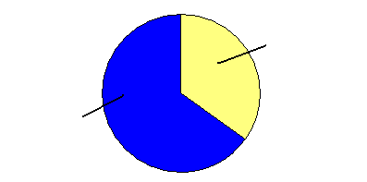

________________65 %

- Q: Were all dinosaurs born as eggs? (Circle the correct answer.)
A: Yes / No / Not sure

- Were dinosaurs the biggest animals? (Circle the correct answer.)
A: Yes / No / Not sure

- Q: How big was the biggest dinosaur? (Fill in the numbers.)
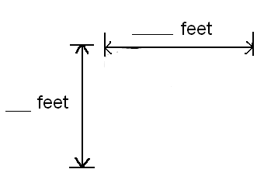A:

- Q: How small was the smallest dinosaur?
(Draw in the box the animal that is of similar size as the smallest dinosaur.)
A:

- Q: How many different species of dinosaurs were there?
(Circle the correct answer.)
A: around a hundred / around a thousand / around a million

- Q: How did dinosaurs walk? (Fill in ONE word only in each blank.)
A: Dinosaurs walked on _________ legs or_________ legs or both.

- Q: Do dinosaurs still exist on Earth ? (Circle the correct answer.)
A: Yes / No / Not sure

