Listening Task: Halloween

Task Description  You will listen to a story of Crazy Chris, Carol and Sensible Steve going trick-or-treating on Halloween night.  Follow the instructions in the Question-Answer Paper and the recording to complete the task. You will have one minute to read the questions before the recording begins. At the end of the story, you will have two minutes to tidy up your answers. | 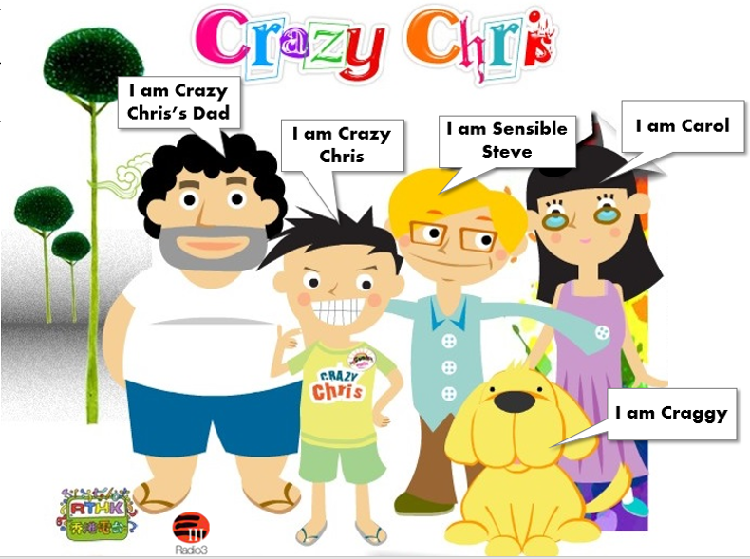

Answer the following questions by circling the correct answers or filling in the blanks with the correct answers.

- Crazy Chris liked Halloween very much because …
- he could dress up as a superhero.
- he could do scary things to other people.
- he could collect a lot of candy.
- he could go trick-or-treating.

- Carol thought Sensible Steve’s costume was…
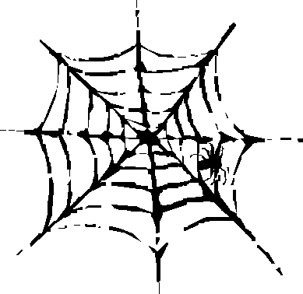
- scary.
- funny.
- old.
- beautiful.

- What did Carol wish to dress up as?
- a superhero
- a super monster
- a super model
- a super dog

- Craggy…
- dressed up as a werewolf.
- dressed up as a monster.
- dressed up as a dog.
- did not dress up.
- Which of the adjectives best describes the house?
- warm
- comfortable
- airy
- scary

- Carol said she had a bad feeling about this. The word ‘this’ refers to…
- going over to the house
- trick-or-treating
- Crazy Chris
- getting a lot of candy

- How did Crazy Chris feel about the old man?
He felt ____________________ with the old man because he did not know anything about trick-or-treating.

- Sensible Steve said, ‘It’s OK, Chris. We’ll get some at the next house’ because he believed that the old man ______________________________________________________________.

- Which of the following can best describe what happened to the old man after he had given Crazy Chris, Sensible Steve and Carol the candy?
- He passed away.
- He went away.
- He ate the candy with the children.
- He went trick-or-treating with the children.

- How did Crazy Chris feel about the trick-or-treating?
- angry
- sad
- tired
- excited

- What did Chris’s Dad say about the old man?
- The old man had moved away.
- The old man liked children a lot.
- The old man had died.
- The old man had a lot of candy.

