

Listening Task: Pets

Task Description
You will listen to a radio interview of a parrot trainer, Sharon Kwok, talking about her parrot and her dog. Listen to the interview and answer the questions.

Follow the instructions in the Question-Answer Paper and the recording to complete the task. You will have one minute to read the questions in part 1before the recording begins. At the end of the interview, you will have two minutes to tidy up your answers.

Part 1: The parrot
Listen to the first part of the radio interview. Complete the profile of Sharon’s parrot. Fill in ONE word
only in each blank.
PET PROFILE #1
  - Name: _______________
  - Type of parrot: _______________ Cockatoo
  - Age: ________ years old
  - Normal life span: ______ to ______ years
  - It is not always easy to keep a parrot as pet because it is
n_____________ and it may get psychological problems such as
____________________.
  - Bobo looks like a big c_____________ b_____________ and a big
w_____________ fluffy thing.
  - Does Bobo like anything special? Yes, it likes _______________.
  - Keeping a parrot is a “huge commitment” because
- _______________________________________________________; and
- ___________________________________________________________.

Part 2: The dog
Listen to the second part of the radio interview. Complete the profile of Sharon’s dog. Fill in one word
only in each blank.
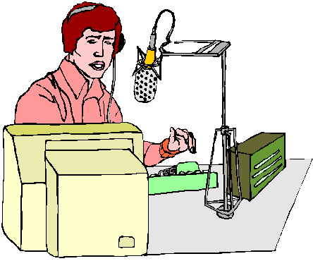

PET PROFILE #2
- Name: _______________
- Why does it have such a name? Because it has a w_______________ mouth and its t_______________ are sticking out the wrong way.
- Type of dog: A mix of Pekinese and Giant Russell
- Age: Around _________ to ________ years old
- How can we tell its age? From its _______________

