SOWIT Video Series – “Rome was not Built in a Day”
(Video link: www.edb.gov.hk/sowit_Rome1)

Lesson Plan

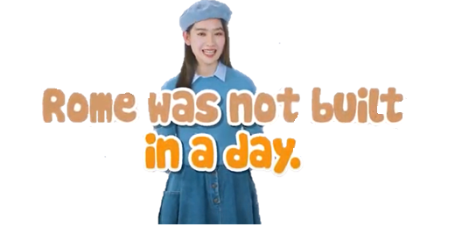
Suggested Levels
Upper Primary/Junior Secondary
Summary of the Learning Task
Students watch the SOWIT video “Rome was not Built in a Day”, which is about a scholar who was determined to publish a new and reliable dictionary for use by all students in the town. They are then guided to understand the meaning of the saying “Rome was not built in a day”, learn about the related positive values and attitudes (e.g. be proactive, be positive, cherish what we have), and write a reflection on their personal experience about the saying ‘Rome was not built in a day”.
Learning Objectives
Content
- To understand the meaning of the saying “Rome was not built in a day.” through a story presented in the context of a video

Language
- To explore the story elements of the video (e.g. characters, setting, problem, solution)
- To show determination using the sentence pattern “I should … because …”

Values and Attitudes
- To cultivate positive values and attitudes (e.g. be proactive, be positive, cherish what we have)
Sharing Learning Intentions
1. Introduce the objectives of the learning activities.
Pre-viewing
Part A: Making Predictions about the Story Elements
- Refer students to Activity Sheet: Part A.
- Draw students’ attention to the pictures below, which depict the character, scenes of the SOWIT video “Rome was not Built in a Day” and the saying, and guide them to make predictions.
- Discuss with students their observations.
- After playing the video, have students check whether their predictions are correct.
Viewing
Part B: Understanding the Story Elements
- Refer students to Activity Sheet: Part B.
- Introduce the story elements (i.e. characters, setting, problem, solution) before playing the video and instruct students to note down some key points for each element while watching the video.
- Play the video “Rome was not Built in a Day”.
- Discuss with students the story elements of the video.
Post-viewing
Part C: Characterisation
- Refer students to Activity Sheet: Part C.
- Guide students to compare and analyse how the main character (i.e. the scholar) looks at the two stages of the story:
- elicit from students some adjectives describing the main character’s appearances;
- have students discuss how the main character accomplished his complicated task in a very long period of time;
- invite students to suggest some adjectives to describe the personality of the main character based on what he did throughout the period; and
- discuss with students why the main character refused to get the task done quickly.
- Play the video again whenever necessary.
- Have students reflect if they would do the same as what the main character did in the same situation or a similar one.
Post-viewing
Part D: Understanding the Saying of Wisdom
- Refer students to Activity Sheet: Part D.
- Revisit the meaning of the saying “Rome was not built in a day.” with students (i.e. the more complicated a task is, the more patience and time we need to complete it).
- Remind students that we cannot expect to see results in a short period of time.
- Get students to share an incident in which they spent a long period of time working on a task/pursuit, learning something, etc. and a satisfactory result was finally achieved.
SOWIT Video Series – “Rome was not Built in a Day”
Activity Sheets
(Pre-viewing)
Part A: Making Predictions about the Story Elements
- What do you think the video is about? What do you think the saying “Rome was not built in a day.” means? Write your thoughts in the table below.

 | Prediction | Confirmation  (Was your prediction correct?)
The character | - Who was he?
The scenes | - What was the story about?
The saying | - What does this saying mean?

(Viewing)

Part B: Understanding the Story Elements
- Watch the video and complete the story elements below:

- Who was the main character?

(b) Where did the story take place?

Story Elements

(c) What problem did the students face?

- How did the main character help the students?

(Post-viewing)

Part C: Characterisation
1. Analyse the main character’s appearances at two different stages of the story by completing the chart below:
- How did he look after he had completed the publication of the new dictionary?
- How did the main character look before he started working on the new dictionary?

- What did he do to achieve his goal of publishing the new dictionary?

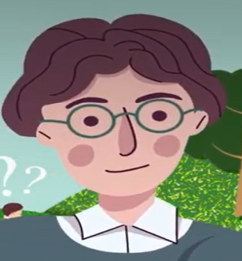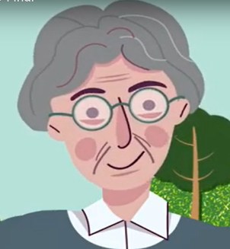

He looked (i) ___________ with (ii) _______________on his face. His hair was (iii) _____________.

He looked (i) _____________.
He hair was (ii)___________.
(ii)
(i)

- How did the appearances of the main character tell you about his personality? Why?

________________________________________________________________________________________________________________
________________________________________________________________________________________________________________
________________________________________________________________________________________________________________

Part D: Understanding the Saying of Wisdom
- What is the message conveyed by the story?
________________________________________________________________
________________________________________________________________

- What is the meaning of the saying “Rome was not built in a day”?
________________________________________________________________
________________________________________________________________

- In the story, Mr Scholar’s determination and perseverance helped him achieve his goal. In about 150 words, share an experience about a task/pursuit which you spent much time and effort on to accomplish. You may include the following details in your work and use the sentence pattern “I should … because …”:
Where did it take place?

When did it happen?

My accomplishment

What happened?/
What did you do?

How did you feel?/ What did you learn from it?

Who was/were involved?

SOWIT Video Series – “Rome was not Built in a Day”
Activity Sheets (Suggested Answers)

Part A: Making Predictions about the Story Elements
1(a) | He was a teacher/scholar. (Accept any reasonable answers.)
1(b) | The story was about a teacher/scholar who worked hard to publish a new dictionary for students because they could not find meanings of new words from their outdated dictionaries. (Accept any reasonable answers.)
1(c) | To complete a complicated task, we cannot expect to see results in a short period of time. (Accept any reasonable answers.)

Part B: Understanding the Story Elements
1(a) | A scholar/Mr Scholar.
1(b) | In a small town.
1(c) | The students could not find new words and their meanings from their outdated dictionaries. (Accept any reasonable answers.)
1(d) | Mr Scholar decided to write a brand new dictionary for all students in the town. (Accept any reasonable answers.)

Part C: Characterisation
1(a) | - young  - brown
1(b) | - He travelled to different places, listened and wrote down every new word he learned. (Accept any reasonable answers.)  - He checked his notes against some old books patiently at night, and made sure every single word was correct. (Accept any reasonable answers.)
1(c) | - old  - wrinkles  - grey
2. | Before Mr Scholar began his work, he was young. He became old when the dictionary was completed. It could reflect that Mr Scholar was a hardworking and determined person because he devoted a lot of his time to the task, which took years and maybe decades. He did not give up but persisted until he accomplished the task. (Accept any reasonable answers.)

Part D: Understanding the Saying of Wisdom
- A complicated task will take a long time to complete and should not be rushed.
- The more complicated a task is, especially one requiring attention to details and quality, the more patience and time we need to complete it. We cannot expect to see results in a short period of time.
- Accept any reasonable answers.

