SOWIT Video Series – “Count Your Blessings”
(Video link: www.edb.gov.hk/sowit_blessings)

Lesson Plan
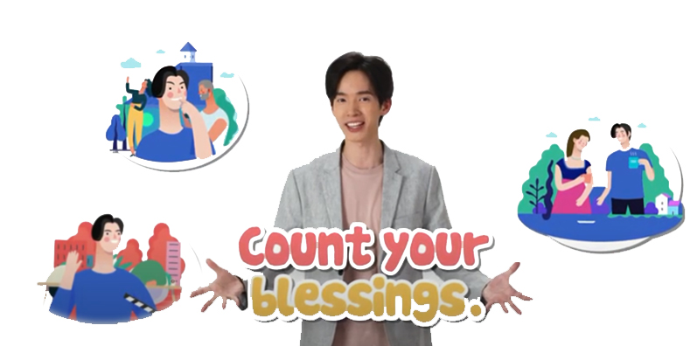

Suggested Levels
Upper Primary/Junior Secondary
Summary of the Learning Task
Students watch the SOWIT video “Count Your Blessings”, which is about a farmer who learnt to appreciate and cherish what he had from one of his harvests. They are then guided to understand the meaning of the saying “Count your blessings”, learn about the related positive values and attitudes (e.g. be grateful, cherish what we have, be positive), and write a reflection on their personal experience.

Learning Objectives
Content
- To understand the meaning of the saying “Count your blessings.” through a story presented in the context of a video

Language
- To explore the story elements of the video (e.g. characters, setting, problem, solution)
- To show appreciation and express gratitude using the sentence pattern “I am thankful/grateful for… because…”

Values and Attitudes
- To cultivate positive values and attitudes (e.g. be grateful, cherish what we have, be positive)

Sharing Learning Intentions
- Introduce the objectives of the learning activities

Pre-viewing
Part A: Making Predictions about the Story Elements
- Refer students to Activity Sheet: Part A.
- Draw students’ attention to the picture below, which depicts a scene of the SOWIT video “Count Your Blessings”:
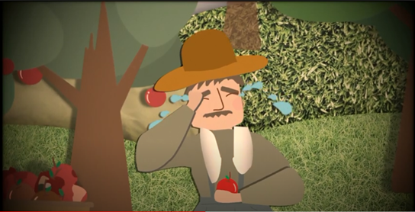

- Guide students to make predictions about the story elements by drawing their attention to the visual clues captured in the picture (e.g. tears, wrinkled apples, orchard, the outfit of the man).
- Discuss with students their observations.
Viewing
Part B: Understanding the Story Elements
- Refer students to Activity Sheet: Part B.
- Introduce the story elements (i.e. characters, setting, problem, solution) before watching the video and instruct students to note down some key points for each element while watching the video.
- Play the video “Count Your Blessings”.
- Discuss with students the story elements of the video.

Post-viewing
Part C: Characterisation
- Refer students to Activity Sheet: Part C.
- Guide students to analyse the emotional change of the main character (i.e. the farmer) by drawing their attention to
  - the farmer’s emotion at the beginning and at the end of the story; and
  - the cause of the change in the farmer’s emotion.
- Play the video again whenever necessary.
- Draw students’ attention to the dialogue below, which creates the turning point of the farmer’s emotion:
  - The farmer’s son: Dad, you’re home!
[Offering a warm welcome to the farmer]
  - The farmer’s daughter: Daddy, are you tired?
[Showing how the family cares about the farmer’s feelings]
  - The farmer’s wife: The apples from this harvest are small but sweet. How wonderful!
[Helping the farmer find the bright side of his harvest]
Part D: Understanding the Saying of Wisdom
- Refer students to Activity Sheet: Part E.
- Revisit the meaning of the saying “Count your blessings.” with students (i.e. to be grateful for the good things in our lives and not to get too upset about the bad things).
- Invite students to count their blessings and share their thoughts with their classmates using the sentence pattern “I am thankful/grateful for… because…”.
- Ask students to identify a problem that they encountered before and write a reflection on “Count your blessings”.

SOWIT Video Series – “Count Your Blessings”
Activity Sheets
(Pre-viewing)
Part A: Making Predictions about the Story Elements
- Study the picture below, which depicts a scene of the SOWIT video “Count Your Blessings”. What do you think the video is about? Write down your thoughts in Boxes (a) – (d).

- Where did the story take place?

(b) Who was the man?

(d) What had happened?

(c) How did he feel?

(Viewing)

Part B: Understanding the Story Elements
- Watch the video and complete the story elements below:

(b)

(a)

(c)
A bad harvest of small and wrinkled
apples

(d)

Story Elements
(Post-viewing)

Part C: Characterisation
- Analyse the farmer’s emotional change in the story by completing the chart below:
- Describe the farmer’s emotion at the end of the story.
- Describe the farmer’s emotion at the beginning of the story.

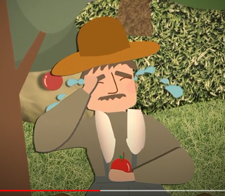
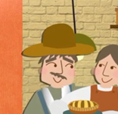
Cause of the change in the farmer’s emotion

(d)
(c)
(b) (Think about what the farmer’s children did when the farmer was home.)

- What did the farmer and his wife think about this year’s harvest?
The farmer: ________________________________________________________________________________________________
The farmer’s wife: ___________________________________________________________________________________________
- Compare the views of the farmer and his wife on the harvest.
______________________________________________________________________________________________________________________________________________________________________________________________________________________
Part D: Understanding the Saying of Wisdom

- What is the message conveyed by the story?

_____________________________________________________________
_____________________________________________________________

- What is the meaning of the saying “Count your blessings”?

_____________________________________________________________
_____________________________________________________________
- Let’s take a moment to count your blessings. Write them down in the space below and share them with your classmates (e.g. “I am thankful/grateful for… because…”).
Count your blessings.

- In the story, the farmer’s wife was able to help the farmer find the bright side of the problem (i.e. the apples were small but sweet). In about 150 words, share your personal experience and write a reflection on “Count Your Blessings”. You may include the following details in your work:

What was the problem you encountered? | What was the bright side of the problem?  (I am thankful/grateful for… because…)

What have you learnt from the experience?

SOWIT Video Series – “Count Your Blessings”
Activity Sheets (Suggested Answers)

Part A: Making Predictions about the Story Elements
1(a) | An orchard (Accept any reasonable answers.)
1(b) | A farmer (Accept any reasonable answers.)
1(c) | Sad/unhappy/upset (Accept any reasonable answers.)
1(d) | The apples were wrinkled./The harvest was bad. (Accept any reasonable answers.)

Part B: Understanding the Story Elements
1(a) | A farmer, the farmer’s family (his wife, son and daughter)
1(b) | - A forest/garden/an orchard full of apple trees  - The farmer’s home
1(c) | A bad harvest of small and wrinkled apples
1(d) | The support from the farmer’s family helped the farmer find the bright side of his life.

Part C: Characterisation
1(a) | Sad/unhappy/upset/disappointed
1(b) | The farmer’s children felt joyful and gave a warm welcome to the farmer when he came home.
1(c) | The farmer’s children asked about the farmer’s feelings to show how they cared about him.
1(d) | The farmer’s wife appreciated the sweetness of the apples though they were small.
1(e) | Cheerful/grateful/happy/contented
2. | - The farmer: bad  - The farmer’s wife: wonderful
3. | The farmer got upset about his work when he saw that his apples were small and wrinkled. However, his wife was able to find the bright side of the harvest – the apples were small but sweet.

Part D: Understanding the Saying of Wisdom
- When you are down or troubled, you can count your blessings and try to find the bright side of the situation.
- To be grateful for the good things in our lives and not to get too upset about the bad things
- Accept any reasonable answers.
- Accept any reasonable answers.

