SOWIT Video Series – “The Early Bird Catches the Worm”
(Video link: www.edb.gov.hk/sowit_bird)

Lesson Plan 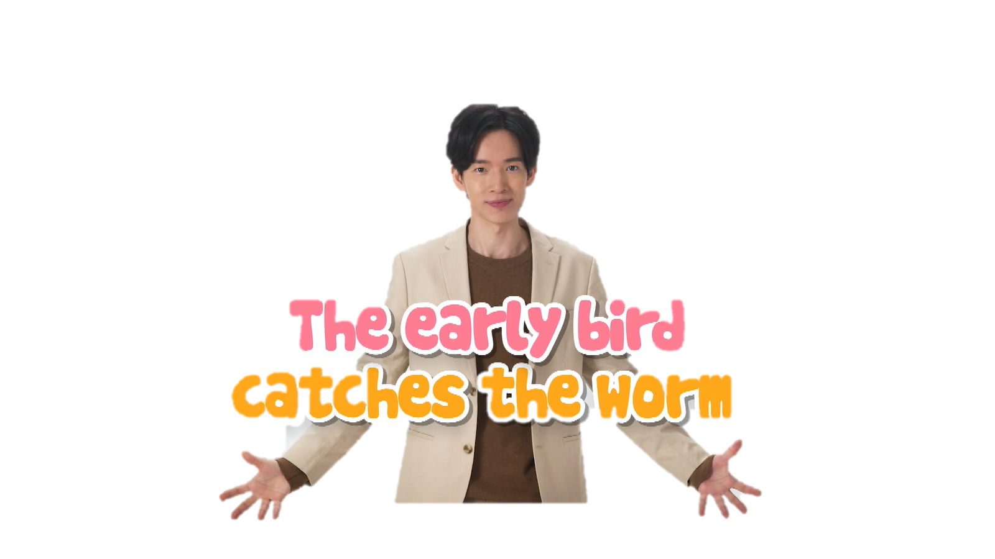

Suggested Levels
Upper Primary/Junior Secondary
Summary of the Learning Task
Students watch the SOWIT video “The Early Bird Catches the Worm”, in which two passionate scientists competed to be the first to land on the moon. They are then guided to understand the meaning of the saying “The early bird catches the worm”, learn about the related positive values and attitudes (e.g. be proactive, be perseverant, be optimistic, be diligent), and write an email giving advice on how to achieve success.
Learning Objectives
Content
- To understand the meaning of the saying “The early bird catches the worm.” through a story presented in the context of a video
Language
- To explore the story elements of the video (e.g. characters, setting, problem, solution)
- To state the importance and benefits of being proactive, perseverant, optimistic and diligent using the sentence pattern “If I/we…, I/we will…”
Values and Attitudes
- To cultivate positive values and attitudes (e.g. be proactive, be perseverant, be optimistic, be diligent)

Sharing Learning Intentions
- Introduce the objectives of the learning activities
Pre-viewing
Part A: Making Predictions about the Story Elements
- Refer students to Activity Sheet: Part A.
- Draw students’ attention to the picture below, which depicts a scene of the SOWIT video “The Early Bird Catches the Worm”:
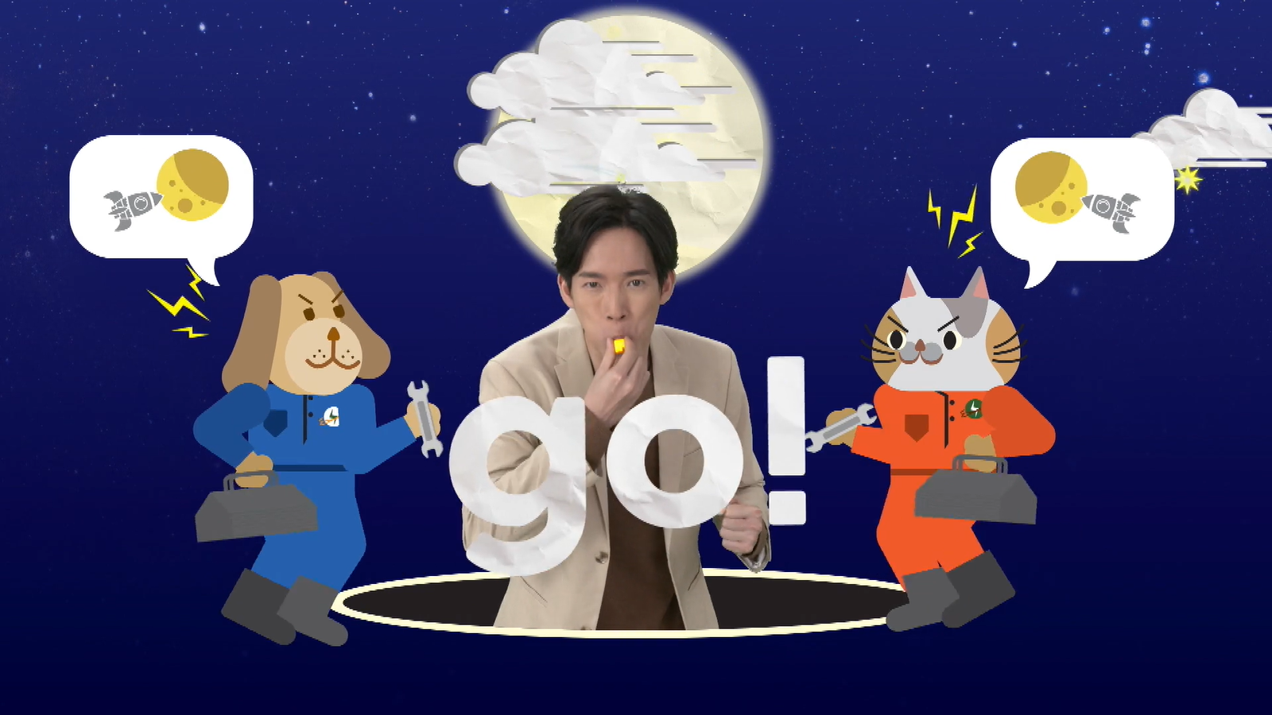
- Guide students to make predictions about the story plot by drawing their attention to the visual clues captured in the picture (e.g. the moon, rockets, whistle, outfits, spanners).
- Discuss with students their observations.

Viewing
Part B: Understanding the Story Elements
- Refer students to Activity Sheet: Part B.
- Introduce the story elements (i.e. characters, setting, problem, solution) before watching the video and instruct students to note down some key points for each element while watching the video.
- Play the video “The Early Bird Catches the Worm”.
- Discuss with students the story elements of the video.

Post-viewing
Part C: Comparison of Characters
- Refer students to Activity Sheet: Part C.
- Guide students to compare Dr. Woofenstein and Dr. Kittenberg, including:
  - their personalities;
  - their time management;
  - their attitude towards work; and
  - their achievement.
- Play the video again whenever necessary.
- Discuss with students the attributes and elements that are key to success, for example:
  - motivation/determination/passion/courage/confidence/patience/optimism/
flexibility/diligence
  - being able to work under pressure
  - experience
  - support from others
Part D: Understanding the Saying of Wisdom
- Refer students to Activity Sheet: Part E.
- Revisit the meaning of the saying “The early bird catches the worm.” with students (i.e. you will have an advantage if you do something immediately or before anyone else does it).
- Invite students to brainstorm what they can do to be proactive in daily life and share their thoughts with their classmates using the sentence pattern “If I/we…, I/we will…”.
- Ask students to write an email to advise Dr. Kittenberg on how to achieve his target.

SOWIT Video Series – “The Early Bird Catches the Worm”
Activity Sheets
(Pre-viewing)
Part A: Making Predictions about the Story Elements
- Study the picture below, which depicts a scene of the SOWIT video “The Early Bird Catches the Worm”. What do you think the video is about? Write down your thoughts in Boxes (a) – (d).

- Who were these characters?

(b) What were they doing?

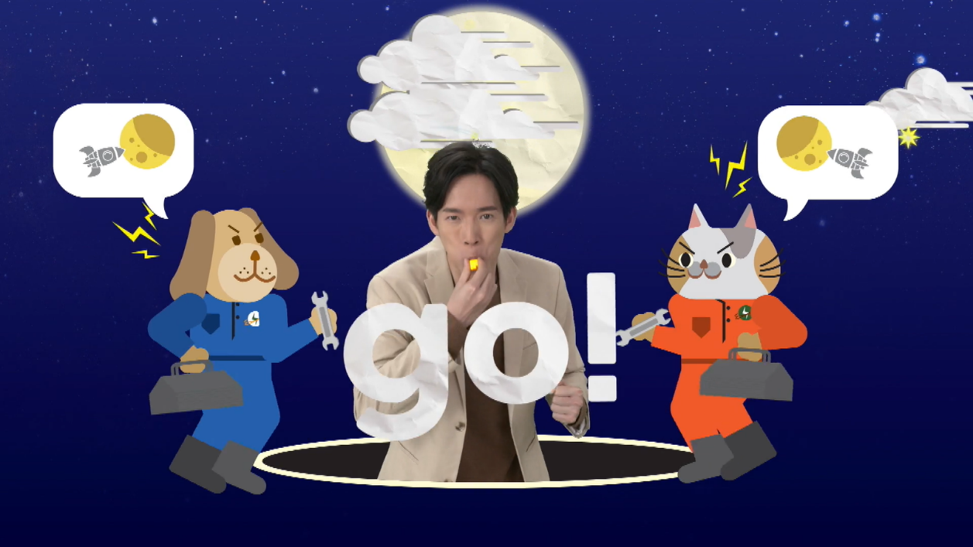

(d) What was their shared target?

(c) Where did this story take place?

(Viewing)

Part B: Understanding the Story Elements
- Watch the video and complete the story elements below:

(b) Dr. Woofenstein’s and Dr. Kittenberg’s stations

(a)

(d)

(c)

Story Elements
(Post-viewing)
Part C: Comparison of Characters
- Compare Dr. Woofenstein’s and Dr. Kittenberg’s personal attributes:
 | Personality | Time management | Attitude towards work | Achievement
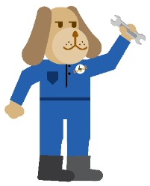  Dr. Woofenstein | (a) | (b) | (c) | (d) being the first scientist to land on the moon
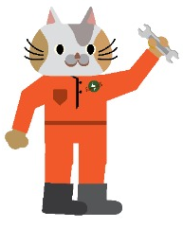  Dr. Kittenberg | (e) | (f) | (g) | (h)

- Which character do you like better? Why?

___________________________________________________________________________________________________________

- What other attributes and elements are the key to success?

___________________________________________________________________________________________________________
Part D: Understanding the Saying of Wisdom

- What is the message conveyed by the story?

_______________________________________________________________

_______________________________________________________________

- What is the meaning of the saying “The early bird catches the worm”?

_______________________________________________________________

_______________________________________________________________

- Let’s brainstorm how we can be proactive in daily life. Write down your ideas in the space below and share them with your classmates (e.g. “If I/we…, I/we will…”).

Example: If we start exam revision earlier, we will have more time to consolidate what we have learnt and go over areas which we find difficult.

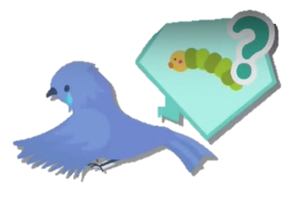

The Early Bird Catches the Worm

- Although Dr. Kittenberg wasn’t the first to land on the moon, he hoped that he could be the first to land on Mars. In about 150 words, write an email to Dr. Kittenberg advising him on how to achieve his target. You may include the following details in your work:

Dr. Kittenberg’s problems | Your advice (“If you…, you will….”)
e.g. He always woke up late.

Other advice on achieving the target (“If you…, you will….”)
e.g. If you do more research well before the experiment, you will be able to predict possible problems and avoid them.

SOWIT Video Series – “The Early Bird Catches the Worm”
Activity Sheets (Suggested Answers)

Part A: Making Predictions about the Story Elements
1(a) | Two competitors/scientists/engineers and a judge. (Accept any reasonable answers.)
1(b) | They were having a competition. (Accept any reasonable answers.)
1(c) | The earth, the space and the moon (Accept any reasonable answers.)
1(d) | To land on the moon (Accept any reasonable answers.)

Part B: Understanding the Story Elements
1(a) | Dr. Woofenstein, Dr. Kittenberg
1(b) | Dr. Woofenstein’s and Dr. Kittenberg’s stations (given)
1(c) | Dr. Woofenstein and Dr. Kittenberg encountered different problems and distractions when building their rockets.
1(d) | Dr. Woofenstein solved the problems right away, stayed focused and became the first to land on the moon.

Part C: Comparison of Characters
1(a) | Serious/Self-disciplined/Diligent/Persistent (Accept any reasonable answers)
1(b) | Made the most of his day by waking up early (Accept any reasonable answers.)
1(c) | Proactive/Committed/Persistent/Diligent (Accept any reasonable answers.)
1(d) | Being the first scientist to land on the moon (given)
1(e) | Lazy/Laid-back/Unmotivated/Playful (Accept any reasonable answers.)
1(f) | Did not make good use of his time as he woke up late and constantly left his station to rest and play (Accept any reasonable answers.)
1(g) | Irresponsible/Easily distracted/Inattentive (Accept any reasonable answers.)
1(h) | Nil
2. | Accept any reasonable answers.
3. | Motivation/determination/passion/courage/confidence/patience/optimism/  flexibility/diligence/being able to work under pressure/experience/support from others (Accept any reasonable answers.)

Part D: Understanding the Saying of Wisdom
- Being proactive, optimistic, perseverant and diligent will give us an advantage and is one of the keys to success. (Accept any reasonable answers.)
- We will have an advantage if we do something immediately or before anyone else does it.
- Accept any reasonable answers.
- Accept any reasonable answers.

