**SOWIT Video Series – “One Good Turn Deserves Another”**

**(Video link:** [www.edb.gov.hk/sowit_good_turns](http://www.edb.gov.hk/sowit_good_turns))

**Lesson Plan**

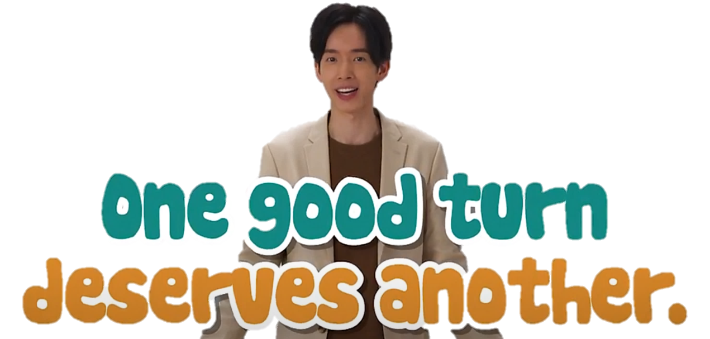

|  |
| --- |
| **Suggested Levels** |
| Upper Primary/Junior Secondary |
| **Summary of the Learning Task** |
| Students watch the SOWIT video “One Good Turn Deserves Another”, which is about a monkey who saved a turtle from a forest fire in return for her assistance in crossing a river earlier. They are then guided to understand the meaning of the saying “One good turn deserves another”, learn about the related positive values and attitudes (e.g. be grateful, cherish what we have, be positive, be optimistic), and write a short “Thank-you” note and/or a reflection to show their appreciation for someone’s kindness. |
| **Learning Objectives** |
| **Content**   * To understand the meaning of the saying “One good turn deserves another.” through a story presented in the context of a video   **Language**   * To identify the story elements of the video (e.g. characters, setting, problem, solution) * To explore the visual clues of the video (e.g. images, sounds, music, colours) * To show appreciation and express gratitude using the sentence patterns *“Thank you for helping me with my work/studies…”* and *“I am thankful/grateful for… because…”*   **Values and Attitudes**   * To cultivate positive values and attitudes (e.g. be grateful, cherish what we have,   be positive and be optimistic) |
| **Sharing Learning Intentions** |
| 1. Introduce the objectives of the learning activities |
| **Pre-viewing** |
| **Part A: Making Predictions about the Theme of the Video**  1. Refer students to *Activity Sheet: Part A*.  2. Draw students’ attention to the following two pictures:  (Picture A) (Picture B)     * Guide students to make predictions about the theme of the video by drawing their attention to the visual clues captured in the pictures (e.g. a teardrop, a hand got trapped, a man helped the gorilla, a heart, a smiling face). * Discuss with students their observations. |
| **Viewing** |
| **Part B: Understanding the Story Elements**   1. Refer students to *Activity Sheet: Part B*. 2. Introduce/Revisit the story elements (i.e. characters, setting, problem, solution) with students before watching the video. 3. Have students read the summary of the story to find out the possible key words to be noted while watching the video OR instruct them to note down the key points while watching the video and write the points in complete sentences. 4. Play the video “One Good Turn Deserves Another”. 5. Discuss with students their work. |
| **Post-viewing** |
| **Part C: Understanding Emotions/Feelings by Exploring the Visual Clues in the Video**   1. Refer students to *Activity Sheet: Part C*. 2. Play the video “One Good Turn Deserves Another” again. 3. Draw students’ attention to the use of sounds and music in different situations, which show the emotional change of the characters (e.g. the monkey hummed when he was walking with some fruits in his hands) [Showing how relaxed the monkey might feel] 4. Discuss with students their work. |
| **Part D: Understanding the Saying of Wisdom**   1. Refer students to *Activity Sheet: Part D*. 2. Revisit the meaning of the saying “One good turn deserves another.” with students (i.e. to be grateful for the help or kindness from people, and do them a favour in return). 3. Invite students to reflect and share their thoughts with their classmates using the sentence patterns “*Thank you for helping me with my work/studies…”* and *“I am thankful/grateful for… because…*”*.* 4. Ask students to think of a person who has helped or been kind to them, and write a short “Thank-you” note and/or a reflection to show their appreciation and express gratitude. |

**SOWIT Video Series – “One Good Turn Deserves Another”**

**Activity Sheets**

**(Pre-viewing)**

**Part A: Making Predictions about the Theme of the Video**

1. Study the two pictures below. How did the gorilla feel in Picture A and Picture B? How do you know about his feelings? What do you notice from the visual images used in these two pictures? What is the possible message to be conveyed?

**(Picture A)**

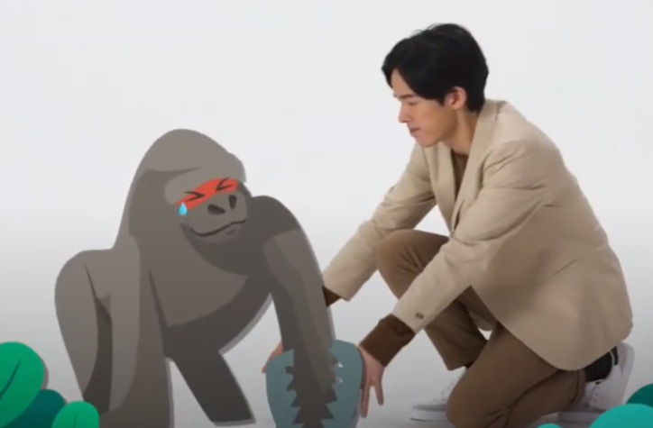

(**Picture B)**

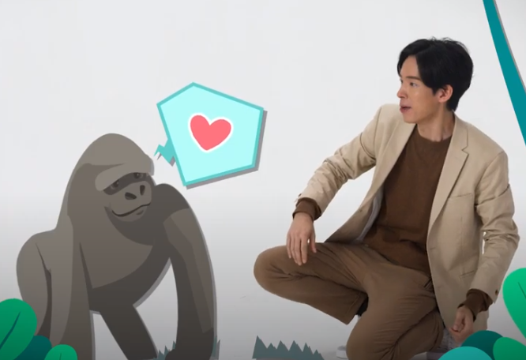

Read the description below and circle the most appropriate words given.

With the **(a) tear/sweat** in the gorilla’s eye in Picture A, he looked **(b) pained/excited**.

However, in Picture B, he looked **(c)** **thankful/regretful** as a **(d) diamond/heart** was

shown.

The possible message to be conveyed through these two pictures is that we should

**(e) be thankful for/forget about** someone’s help.

**(Viewing)**

**Part B: Understanding the Story Elements**

1. Watch the video. Complete the story map with the most appropriate words taken from the video.

**Characters and Setting**

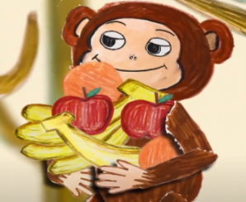 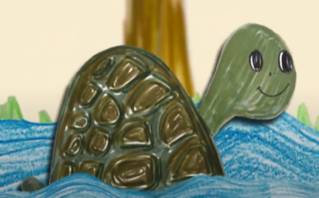 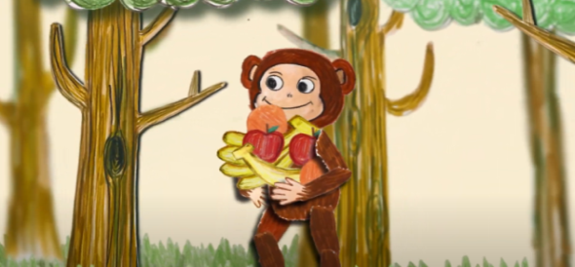

1. ***Mr ______________*** *and* ***(b) Ms _____________*** *lived in a* ***(c)_____________****.*

**Problem 1 and Solution 1**

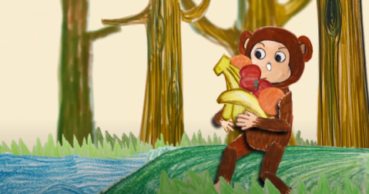 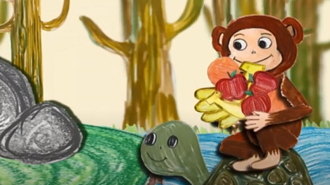

*One day, he couldn’t* ***(d) __________*** *the river. Luckily, she carried him to the* ***(e)___________*** *bank.*

**Problem 2 and Solution 2**

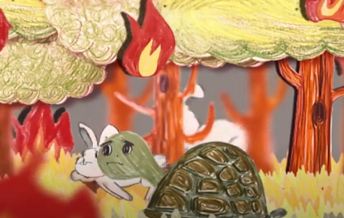 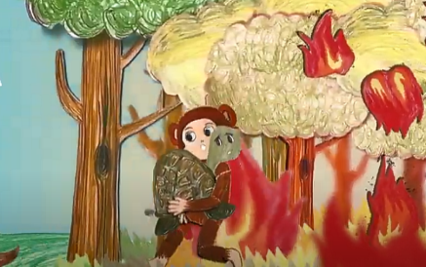

*A* ***(f)___________*** *suddenly broke out in the forest. She was too slow to* ***(g)_________________*** *but he saved her at once because* ***(h)__________________________________________________*** *when he needed help earlier. In the end, both of them left the forest safely.*



1. Watch the video. Complete the story map in complete sentences below.

**Setting**

(a) They ___________________

_______________________

_______________________

_

**Characters**

e.g.

The story is about Mr Monkey and Ms Turtle.

**(c) Solution 1**

**(b) Problem 1**

**(d) Problem 2**

**(e) Solution 2**

**(Post-viewing)**

**Part C: Understanding Emotions/Feelings by Exploring the Visual Clues in the Video**

1. Look at the pictures below, which depict several scenes of the SOWIT video “One Good Turn Deserves Another”. Then watch the video again carefully. Pay attention to the sounds made by the characters in different situations. What sounds did they make? What do these sounds mean? Circle the most appropriate words provided.

**Sound words**

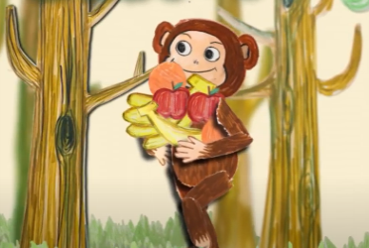

The monkey looked **(d) exhausted/surprised.**

The monkey looked **(b) relaxed/exhausted.**

When the monkey was walking near the raging river, he **(c)** **puffed/gasped** because he could not cross it.

When the monkey was walking with some fruits in his hands in the forest, he **(a) hummed/puffed**.

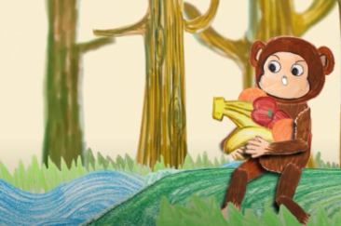

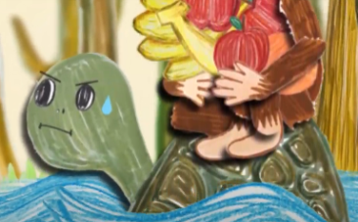

The turtle **(e)** **gasped/puffed** when she crossed the river as the monkey was very heavy.

The turtle looked **(f)** **surprised/exhausted.**

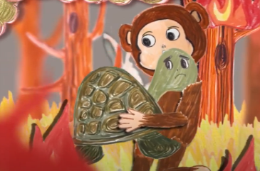

The forest was on fire. Both the monkey and the turtle **(g)** **puffed/hummed** when they ran out.

They both looked **(h)** **exhausted/relaxed.**

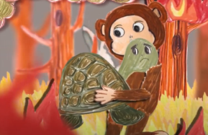**Music**

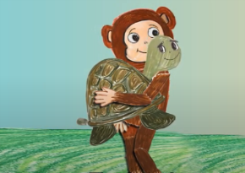

When the monkey was running out of the forest with the turtle, the music was **(i) fast/calm**. It shows that both of them were **(j)** **nervous/relaxed**.

When the monkey and the turtle were in a safe place, the music was **(k)** **fast/calm**. It shows that they were **(l) nervous/relaxed**.

1. Fill in the blanks with appropriate words.

So, **(a) *___________ _________*** and**(b) *___________*** can show the emotions or feelings of the characters.

**Part D: Understanding the Saying of Wisdom**

1. What is the message conveyed by the story?

___________________________________________________________________

___________________________________________________________________

1. What is the message of the saying “One good turn deserves another”? Blacken the most appropriate description.

|  |  |  |
| --- | --- | --- |
|  | (a) | We should take it for granted that people ought to be kind or help us when we are in trouble. |
|  | (b) | We should thank people who are kind or have helped us before by doing a favour to them in return. |
|  | (c) | We should only thank those people who are kind or have helped us before by giving them a hand once. |
|  | (d) | We should be kind or help people because they will do us a favour in return in the future. |

1. Do you have family members or friends who are kind or always help you when you are in trouble? Take action and express your gratitude now! Write a short “Thank-you” note, and show your appreciation by using the sentence pattern “*Thank you for helping me with my work/studies…/I am thankful/grateful for… because…”*.

____________________

________________________________________________________________________________________________________________________________________________________________________________________________________________________________________________________________________________________________

________________________________________________________________________________________________________________________________________________________________________________________________

Love,

____________________

1. In the story, the monkey was able to do a good turn to the turtle by saving her in the forest fire. Someone may have helped you when you encountered difficulties. Did you do him/her a favour in return, or have the chance to do so? In about 150 words, share your personal experience and write a reflection on your personal experience about the saying “One good turn deserves another”. You may include the following details in your work.

|  |  |
| --- | --- |
| What was the problem you encountered? | Did you do him/her a favour in return? Why?  *(I am thankful/grateful for…because….)* |
|  |  |

|  |
| --- |
| What have you learnt from the experience? |
|  |

**SOWIT Video Series – “One Good Turn Deserves Another”**

**Activity Sheets (Suggested Answers)**

**Part A: Making Predictions about the Theme of the Video**

1(a) tear

1(b) pained

1(c) thankful

1(d) heart

1(e) be thankful for

**Part B: Understanding Story Elements**

**(fill in the blanks)**

1(a) Mr **Monkey**

1(b) Ms **Turtle**

1(c) forest

1(d) cross

1(e) opposite

1(f) fire

1(g) evacuate

1(h) she gave him a hand

**(write in complete sentences)**

2(a) They lived in a forest.

2(b) Mr Monkey could not cross the river.

2(c) Ms Turtle carried him to the opposite bank.

2(d) A fire suddenly broke out in the forest. Ms Turtle was too slow to evacuate.

2(e) Mr Monkey picked her up and ran out of the forest with her. They were safe.

(Accept any reasonable answers.)

**Part C: Understanding Emotions/Feelings by Exploring Visual Clues in the video**

1(a) hummed 1(b) relaxed

1(c) gasped 1(d) surprised

1(e) puffed 1(f) exhausted

1(g) puffed 1(h) exhausted

1(i) fast 1(j) nervous

1(k) calm 1(l) relaxed

2(a) sound words 2(b) music

**Part D: Understanding the Saying of Wisdom**

1. We should be kind and help others whenever possible. It is important for us to do a helpful or kind act for someone who has done something good for us.
2. b
3. Accept any reasonable answers.
4. Accept any reasonable answers.