SOWIT Video Series – “The Grass is Always Greener on the Other Side
of the Fence”
(Video link: www.edb.gov.hk/sowit_grass)

Lesson Plan
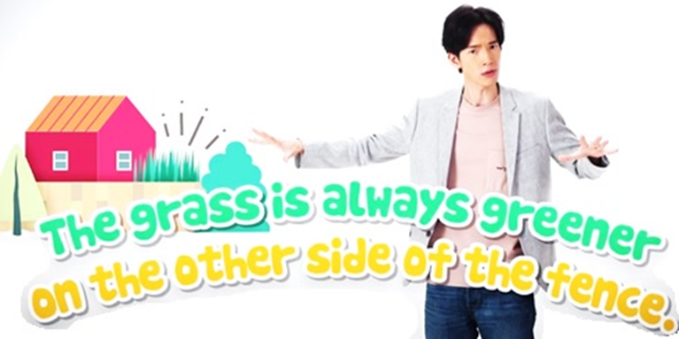
Suggested Levels
Upper Primary/Junior Secondary
Summary of the Learning Task
Students watch the SOWIT video “The Grass is Always Greener on the Other Side of the Fence”, in which Mr Whale and Ms Bird learnt a lesson about cherishing the things they have and understanding that other people’s lives may not be as desirable as they appear to be. Students are then guided to understand the meaning of the saying “The grass is always greener on the other side of the fence”, learn about the related positive values and attitudes (e.g. be grateful, be positive, cherish what we have), and design a poster to promote the message of “Staying Positive”.
Learning Objectives
Content
- To understand the meaning of the saying “The grass is always greener on the other side of the fence.” through a story presented in the context of a video
Language
- To learn the vocabulary items that describe feelings
- To explore the story elements of the video (e.g. setting, conflict, twist, resolution)
- To make suggestions on how to stay positive using the sentence pattern “To stay positive, I will…”
Values and Attitudes
- To cultivate positive values and attitudes (e.g. be grateful, be positive, cherish what we have)
Sharing Learning Intentions
- Introduce the objectives of the learning activities.
Pre-viewing
Part A: Making Predictions about the Story Elements
- Refer students to Activity Sheet: Part A.
- Draw students’ attention to the pictures below, which reflect the feelings of the characters (Mr Whale and Ms Bird) in the SOWIT video “The Grass is Always Greener on the Other Side of the Fence”:

- Elicit from students the feelings of the characters by choosing the appropriate adjectives from the list given. Introduce the adjectives using examples (e.g. I am feeling miserable because my dog is sick./I am upset as I didn’t do well in the English exam./We are blessed with the fine weather during the trip.).
- Have students make predictions about the story elements by drawing their attention to the setting and engaging them in guessing why the characters were upset.
- Discuss with students their observations.

Viewing
Part B: Understanding the Story Elements
- Refer students to Activity Sheet: Part B.
- Introduce the story elements (i.e. setting, conflict, twist, resolution) before watching the video and instruct students to note down some key points for each element while watching the video.
- Play the video “The Grass is Always Greener on the Other Side of the Fence”.
- Discuss with students the story elements of the video.

Post-viewing
Part C: Understanding the Theme of the Story
- Refer students to Activity Sheet: Part C.
- Guide students to analyse the theme of the story by identifying:
  - how Mr Whale and Ms Bird perceived their lives and how they felt;
  - the problems that Mr Whale and Ms Bird encountered in reality; and
  - the change in Mr Whale and Ms Bird.
- Explain the theme of the story (i.e. others’ lives may not be as desirable as they appear to be). Remind them that everyone has his/her challenges and they should cherish the things they have instead of focusing on the problems they face.
- Play the video again whenever necessary.

Part D: Understanding the Saying of Wisdom
- Refer students to Activity Sheet: Part D.
- Revisit the meaning of the saying “The grass is always greener on the other side of the fence.” with students (i.e. other people always seem to be in a better situation than you but they may not be) and the message conveyed (i.e. instead of envying others, we should cherish what we have).
- Highlight that staying positive is one of the keys to deal with challenges. Ask students to suggest how we can stay positive and have them share with their classmates using the sentence pattern “To stay positive, I will…”.
- Instruct students to design a poster to promote the message “Staying Positive”. Brainstorm possible titles and images to use with students.
- Select a few posters and invite students to introduce their design.

SOWIT Video Series – “The Grass is Always Greener on the Other Side
of the Fence”
Activity Sheets

(Pre-viewing)

Part A: Making Predictions about the Story Elements
- Look at the facial expressions of the characters in the pictures below. How do they feel?

Put a tick () against the adjectives that describe how the characters feel.

upset |  | blessed |  | thankful
sad |  | grateful |  | miserable

- Make a guess of where the characters were and what had happened to them. Complete the boxes below.
- Mr Whale
Mr Whale

- Where was he?

ii) What had happened to him?

- Ms Bird
Ms Bird

ii) What had happened to her?

- Where was she?

(Viewing)

Part B: Understanding the Story Elements
- Watch the video and complete the storyline below.

(Post-viewing)

Part C: Understanding the Theme of the Story
- Analyse the change in Mr Whale’s and Ms Bird’s feelings by completing the diagrams below:
Appearance
Reality

- Why did Mr Whale and Ms Bird feel upset at the beginning of the story? __________________________________________________________________

- What caused the change in the end?
__________________________________________________________________
Part D: Understanding the Saying of Wisdom
- What is the message conveyed by the story?
_____________________________________________________________
_____________________________________________________________

- What is the meaning of the saying “The grass is always greener on the other side of the fence”?
_____________________________________________________________
_____________________________________________________________

- There are different challenges in our lives, but there are always solutions to the problems. One of the ways to deal with challenges is to stay positive. Write down the things you do to help you stay positive in the diagram below and share them with your classmates (e.g. “To stay positive, I will try to find a positive side in everything.”).

- Design an A4 poster to promote the message of “Staying Positive”. Think of an attractive title and use eye-catchy images to draw readers’ attention. Be prepared to introduce your design in the class.

SOWIT Video Series – “The Grass Is Always Greener on the Other Side of the Fence”
Activity Sheets (Suggested Answers)

Part A: Making Predictions about the Story Elements
- Upset, sad, miserable
- (a) Mr Whale
- He was in the ocean.
- He was hungry as there was insufficient food./
He was worried about being hunted as food./
He was lonely and did not have any friends. (Accept any reasonable answers.)
(b) Ms Bird
- She was in the sky.
- She had been looking for food/shelter and was exhausted./
She was lonely as she did not have any friends. (Accept any reasonable answers.)

Part B: Understanding the Story Elements
1(a) In the ocean and the sky
1(b) They were both upset about their lives./Both of them believed the other was leading a happier life.
1(c) They had a chat and had a better understanding of the problems faced by each other.
1(d) Yes. They no longer focused on their problems and they were satisfied with their own lives.

Part C: Understanding the Theme of the Story
1(a) fly freely in the sky
1(b) swim freely in the ocean
1(c) Sad/Upset/Miserable (Accept any reasonable answers.)
1(d) The ocean was heavily polluted and Mr Whale could not swim freely.
1(e) Ms Bird often came across bad weather and had to look for shelter on land.
1(f) Dissatisfied/Discontented (Accept any reasonable answers.)
2. They believed others led a happier life than themselves.
- They had a chat and a better understanding of the problems faced by each other.

Part D: Understanding the Saying of Wisdom
- Other people always seem to be in a better situation than you but they may not be.
- Instead of envying others, we should cherish what we have as other people’s lives may not be as desirable as they appear to be.
- Accept any reasonable answers.
- Students’ own design

