SOWIT Video Series – “Gratitude Turns What We Have into Enough”
(Video link: www.edb.gov.hk/sowit_gratitude)

Lesson Plan
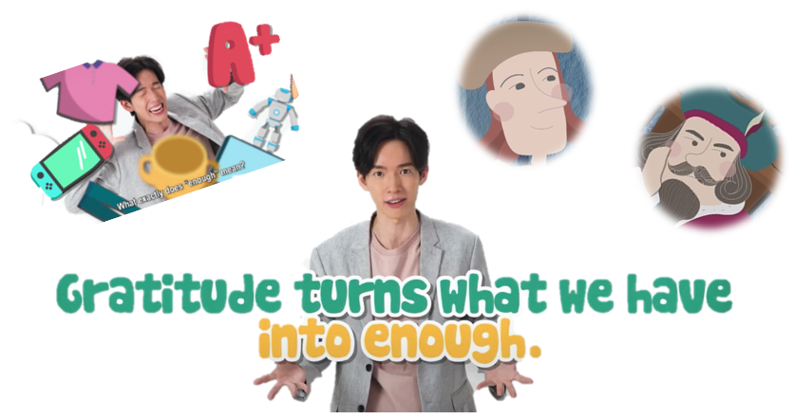

Suggested Levels
Upper Primary/Junior Secondary
Summary of the Learning Task
Students watch the SOWIT video “Gratitude Turns What We Have into Enough”, which is about a wealthy man who was surprised by a painter’s refusal to accept his offer for painting more portraits for him and thus paid a visit to the painter’s home to find out about what a contented life was like. Students are then guided to understand the meaning of the saying “Gratitude turns what we have into enough”, learn about the related positive values and attitudes (e.g. be grateful, cherish what we have, be positive), and express their gratitude to the person(s) they appreciate.
Learning Objectives
Content
- To understand the meaning of the saying “Gratitude turns what we have into enough.” through a story presented in the context of a video
Language
- To explore the story elements of the video (e.g. characters, setting, problem, solution)
- To express gratitude using the sentence pattern “I am grateful for…because…”
Values and Attitudes
- To cultivate positive values and attitudes (e.g. be grateful, cherish what we have, be positive)
Sharing Learning Intentions
- Introduce the objectives of the learning activities
Pre-viewing
Part A: Making Predictions about the Story Elements
- Refer students to Activity Sheet: Part A.
- Draw students’ attention to the picture below, which depicts a scene of the SOWIT video “Gratitude Turns What We Have into Enough”:
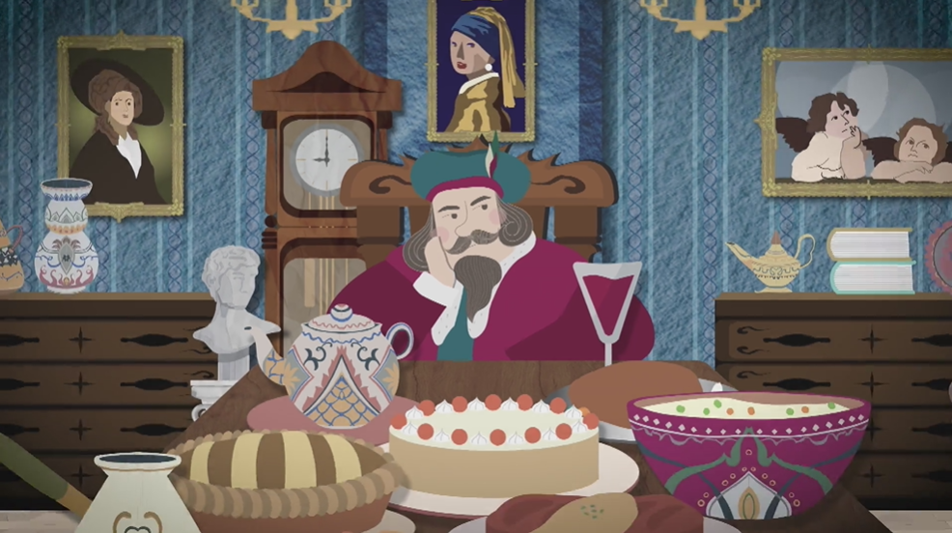
- Guide students to make predictions about the story elements by drawing their attention to the visual clues captured in the picture (e.g. the furnishings of the mansion, the gourmet food, the outfit, the facial expression of the man).
- Discuss with students their observations.

Viewing
Part B: Understanding the Story Elements
- Refer students to Activity Sheet: Part B.
- Introduce the story elements (i.e. characters, setting, problem, solution) before watching the video and instruct students to complete Part B1 (i.e. the table about the characters and setting) and Part B2 (i.e. rearrange the events in the order of occurrence) while watching the video.
- Play the video “Gratitude Turns What We Have into Enough”.
- Discuss with students the answers to Activity Sheet: Part B.
- Discuss with students the problem (i.e. the wealthy man was surprised by the painter, who refused to accept his offer for painting more portraits for him) and the solution (i.e. the wealthy man paid a visit to the painter’s home to find out about what a contented life was like) of the story.

Post-viewing
Part C: Characterisation
- Refer students to Activity Sheet: Part C.
- Guide students to circle the adjective(s) that best describe(s) the feelings of the characters, think of the reasons for their feelings and write them down by drawing their attention to
  - the visual clues captured in the video;
  - the events (e.g. at the beginning of the story, the wealthy man had a lot of treasures and antiques); and
  - what the characters said (e.g. “What a magnificent painting indeed!”).
- Play the video again whenever necessary.
Part D: Understanding the Saying of Wisdom
- Refer students to Activity Sheet: Part D.
- Ask students to complete Questions 1-3.
- Discuss with students the message conveyed by the story (i.e. true happiness is only possible when we realise what we have is already enough).
- Discuss with students the meaning of the saying “Gratitude turns what we have into enough” (i.e. to embrace the richness and beauty of the life we have).
- Ask students to answer the questions “Why did the painter refuse my offer? What exactly does ‘enough’ mean?” for the wealthy man in order to help them reflect on what “enough” means.
- Invite students to think of the person(s) they appreciate and express their gratitude to the person(s) or thing(s) using the sentence pattern “I am grateful for… because…”.
- Ask students to work in pairs and share their words of gratitude with their partner.

SOWIT Video Series – “Gratitude Turns What We Have into Enough”
Activity Sheets

(Pre-viewing)

Part A: Making Predictions about the Story Elements
- The picture below depicts a scene of the SOWIT video “Gratitude Turns What We Have into Enough”. What do you think the video is about? Answer the questions in Boxes (a) – (d).
(b) Who was the man?

- Where did the story take place?

(c) What did he have?

(d) How did he feel? Can you guess
why?

(Viewing)

Part B: Understanding the Story Elements
- Complete the table about the characters and setting of the story by filling in the blanks. The first one has been done as an example.

Characters
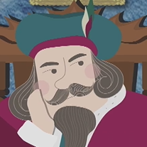 | e.g. a wealthy man
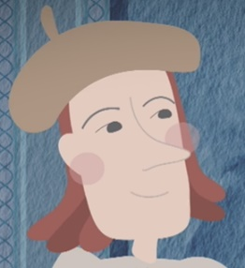 | a _______________
Setting
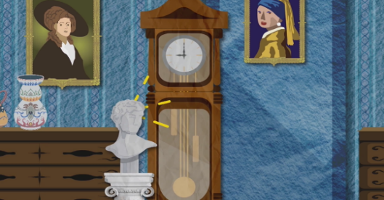 | the wealthy man’s ____________________
 | the painter’s _____________________

- The following pictures show the events of the story. Number the pictures in the order of occurrence. The first one has been done as an example.

Events
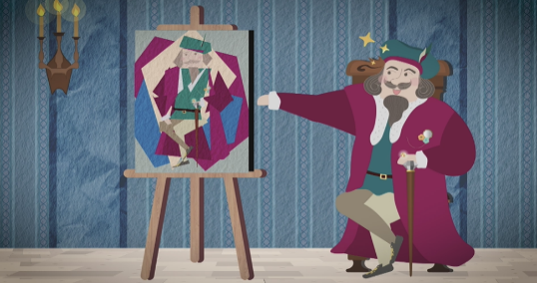  (a) | 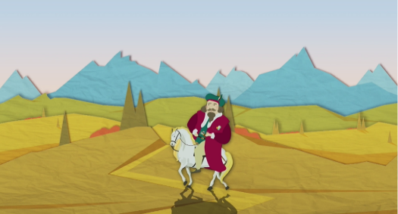  (b)
( ) | ( )
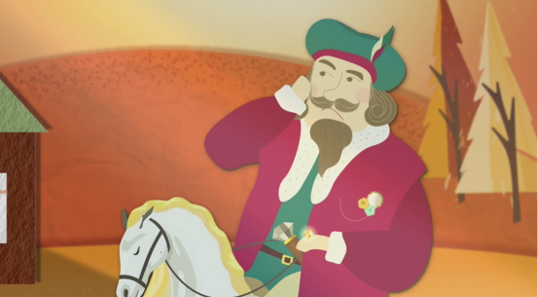  (c) | 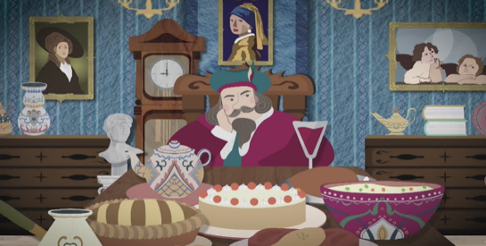  (d)
( ) | e.g. ( 1 )
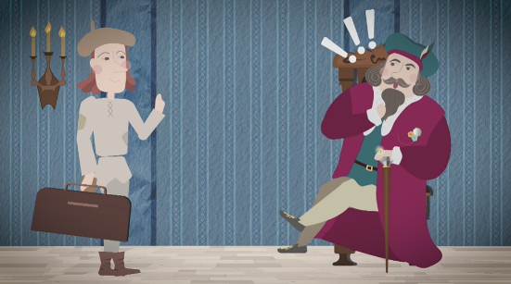  (e) | 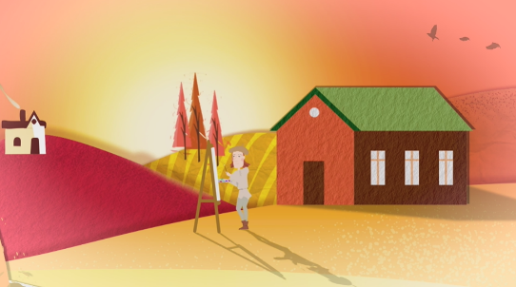  (f)
( ) | ( )
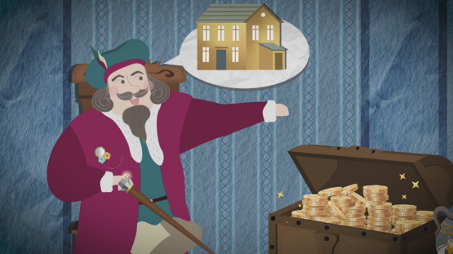  (g) | 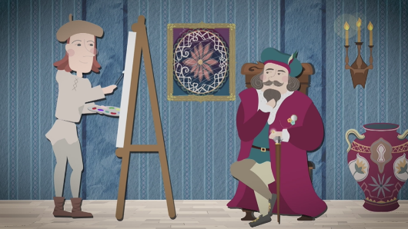  (h)
( ) | ( )

(Post-viewing)

Part C: Characterisation
Think of the feelings of the wealthy man and the painter at different stages of the story. In each of the following events, circle the adjective that best describes their feelings, and give reasons in the space provided. The first one has been done as an example.

Events | Feelings of the characters | Reasons
- At the beginning of the story, the wealthy man had a lot of treasures and antiques.  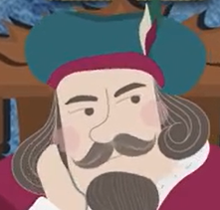 | e.g. joyful/troubled  grateful/dissatisfied | e.g. He was not satisfied with what he had. He wanted to have something more.
- “What a magnificent painting indeed!”  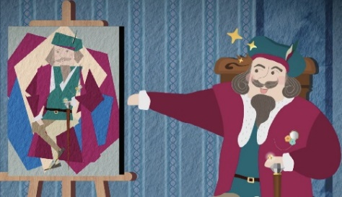 | joyful/troubled  grateful/dissatisfied
- “You must stay and paint more for me. I’ll give you riches beyond measure.”  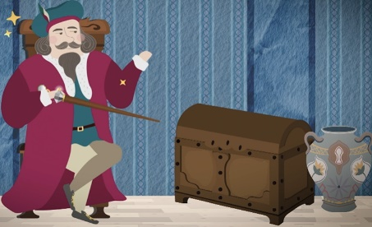  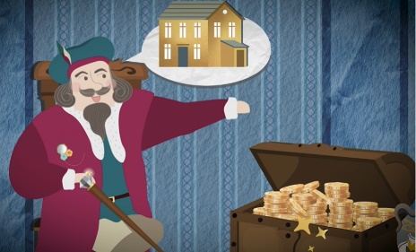 | joyful/troubled  grateful/dissatisfied

Events | Feelings of the characters | Reasons
- “I’m sorry. I only need to be paid what I’m owed. That’s already enough.”  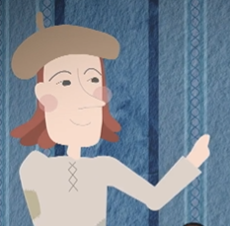 | joyful/troubled  grateful/dissatisfied
- The painter refused the wealthy man’s offer.  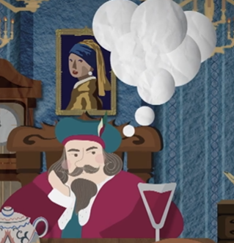 | joyful/troubled  grateful/dissatisfied
- The painter was painting outside his cottage home.  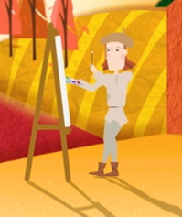 | joyful/troubled  grateful/dissatisfied
Part D: Understanding the Saying of Wisdom
Answer Questions 1-3 by circling the best option.

1. | Which character was leading a joyful life?
(a) | the painter
(b) | the wealthy man

2. | What is the message conveyed by the story? True happiness is only possible when we ___.
(a) | have good painting skills
(b) | are given everything we want
(c) | are kind and helpful to others
(d) | realise what we have is already enough

3. | What does the saying “Gratitude turns what we have into enough.” remind us? We should ___.
(a) | be grateful when receiving a gift
(b) | be thankful when we are successful or happy
(c) | embrace the richness and beauty of the life we have
(d) | be helpful and kind to someone who has done something good for us

- The wealthy man asked himself, “Why did the painter refuse my offer? What exactly does ‘enough’ mean?”. Can you answer these two questions for the wealthy man?
The painter refused the wealthy man’s offer probably because …

“Enough”, to the painter, may mean …

In the end, how would the wealthy man answer his own question – “What exactly does ‘enough’ mean?”?

- Think of the person(s)/thing(s) you appreciate. Express your gratitude with supporting details (e.g. “I am grateful for… because…”) in the space provided.

- Work in pairs. Share your words of gratitude with your partner.
SOWIT Video Series – “Gratitude Turns What We Have into Enough”
Activity Sheets (Suggested Answers)

Part A: Making Predictions about the Story Elements
1(a) | a mansion/the house of a wealthy man/a palace
1(b) | a wealthy man/the king
1(c) | treasures/antiques/paintings/delicious food
1(d) | feelings: dissatisfied/sad/unhappy  reasons: he wanted to have something more/he was lonely/his work was boring
(Accept any reasonable answers.)

Part B: Understanding the Story Elements
1 | Characters: e.g. a wealthy man  a painter  Setting: the wealthy man’s mansion  the painter’s cottage home  (Accept any reasonable answers.)
2 | - 3 | - 6 | - 8 | - 1
 | - 5 | - 7 | - 4 | - 2

Part C: Characterisation
 | Feelings of the characters | Reasons
(a) | e.g. dissatisfied | e.g. The wealthy man was not satisfied with what  he had. He wanted to have something more.
(b) | joyful | The wealthy man liked the painting very much.
(c) | dissatisfied | The wealthy man was not satisfied with having only one portrait. He wanted the painter to paint more for him.
(d) | grateful | The painter was grateful for the money he earned and thought that it was already enough.
(e) | troubled | The wealthy man did not understand why the painter refused his offer.
(f) | joyful | The painter was enjoying his life.
(Accept any reasonable answers.)

Part D: Understanding the Saying of Wisdom
1 (a) | 2 (d) | 3 (c)

- Suggested answers (Accept any reasonable answers.)
The painter refused the wealthy man’s offer probably because …

he was contented to receive the pay for his painting service. This was enough and he did not want more than that.

“Enough”, to the painter, may mean …

living a life that he chose – receiving the pay for his service, enjoying painting at his leisure, probably in the vicinity of his home and its serene beauty.

In the end, how would the wealthy man answer his own question – “What exactly does ‘enough’ mean?”?

He would say that he already had enough – enough money, treasures and antiques. Lots of people had far less money or riches than he did, but they were contented and happy, like the painter. He could also learn to enjoy things not acquired with/measured by money (e.g. nature, family, friendship, favourite pastimes).
We cherish what we have, including the richness and beauty of our life, then we find what we have is already enough.

- Accept any reasonable answers.

- Accept any reasonable answers.

