SOWIT Video Series – “Home is Where the Heart is”
(Video link: www.edb.gov.hk/sowit_home)

Lesson Plan

Suggested Levels
Upper Primary/Junior Secondary
Summary of the Learning Task
Students watch the SOWIT video “Home is Where the Heart is”, which is about a young man who missed his parents very much when studying abroad and learnt to be grateful for and cherish his family and home. They are then guided to understand the meaning of the saying “Home is where the heart is”, and the related positive values and attitudes (e.g. be grateful, cherish what we have), and write a story about their personal experience.
Learning Objectives
Content
- To understand the meaning of the saying “Home is where the heart is.” through a story presented in the context of a video
Language
- To explore the story elements of the video (e.g. characters, setting, problem, solution)
- To show affection and gratitude using the sentence pattern “No matter…”/“…, no matter…”
Values and Attitudes
- To cultivate positive values and attitudes (e.g. be grateful, cherish what we have)

Sharing Learning Intentions
- Introduce the objectives of the learning activities
Pre-viewing
Part A: Making Predictions about the Story Elements
1. Refer students to Activity Sheet: Part A.
- Draw students’ attention to the picture below, which depicts a scene of the SOWIT video “Home is Where the Heart is”:
- Guide students to make predictions about the story elements by drawing their attention to the visual clues captured in the picture (e.g. ferry, luggage, age of the characters, gestures).
- Discuss with students their observations.

Viewing
Part B: Understanding the Story Elements
- Refer students to Activity Sheet: Part B.
- Introduce the story elements (i.e. characters, setting, problem, solution) before watching the video and instruct students to note down some key points for each element while watching the video.
- Play the video “Home is Where the Heart is”.
- Discuss with students the story elements of the video.

Post-viewing
Part C: Use of Symbols
- Refer students to Activity Sheet: Part C.
- Guide students to analyse the symbols used in the story, for example,
  - the dark sky and the pouring rain;
  - the big waves;
  - the snowy weather; and
  - the soup that the young man’s mother made.
- Play the video again whenever necessary.
- Draw students’ attention to the images and guide them to understand what the symbols represent:
  - The dark sky and the pouring rain symbolise a stormy situation and tears respectively. They represent the young man’s sadness and worries.
  - The big waves make the sea very rough and they symbolise the challenges which make studying abroad difficult.
  - The heavy snow/bitter cold can be related to loneliness and adversities.
  - The soup is warm and it symbolises the care and love from the family.
Part D: Understanding the Saying of Wisdom
- Refer students to Activity Sheet: Part E.
- Revisit the meaning of the saying “Home is where the heart is.” with students (i.e. your home will always be the place for which you feel the deepest affection, no matter where you are).
- Invite students to reflect on the unconditional support and guidance from their family and share their thoughts with their classmates using the sentence pattern “No matter…”/“…, no matter…”.
- Ask students to write a recount of an incident that shows how important their home and family is to them.

SOWIT Video Series – “Home is Where the Heart is”
Activity Sheets
(Pre-viewing)
Part A: Making Predictions about the Story Elements
- Study the picture below, which depicts a scene of the SOWIT video “Home is Where the Heart is”. What do you think the video is about? Write down your thoughts in Boxes (a) – (d).

(a) Who were these people?

(b) What were they doing?

(c) How did they feel?

(d) Why was the boy leaving?

(Viewing)

Part B: Understanding the Story Elements
- Watch the video and complete the story elements below:

(b) The young man’s school in a foreign country

(a)

(c)

(d)

Story Elements
(Post-viewing)
Part C: Use of Symbols
- Analyse the symbols used in the story and what they represent:
- The dark sky and the pouring rain: _________________________  _____________________________________________________ | - The big waves: _________________________________________  ______________________________________________________
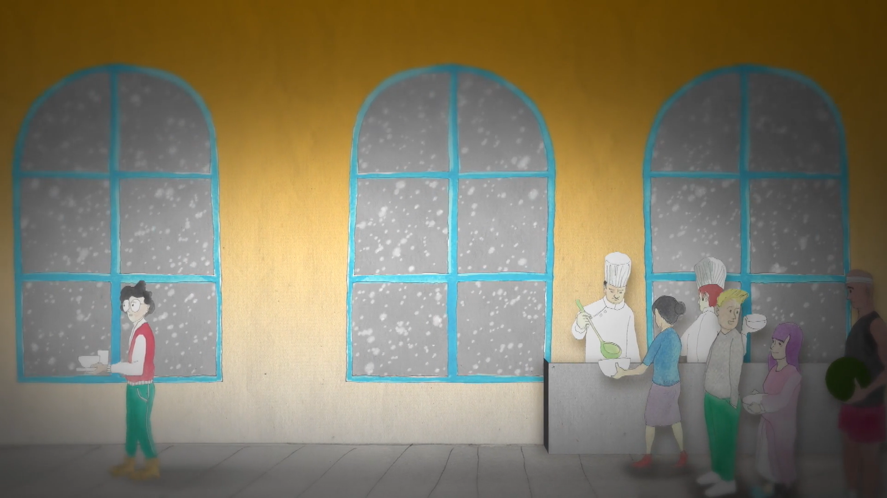  - The snowy weather: _____________________________  _____________________________________________________ | 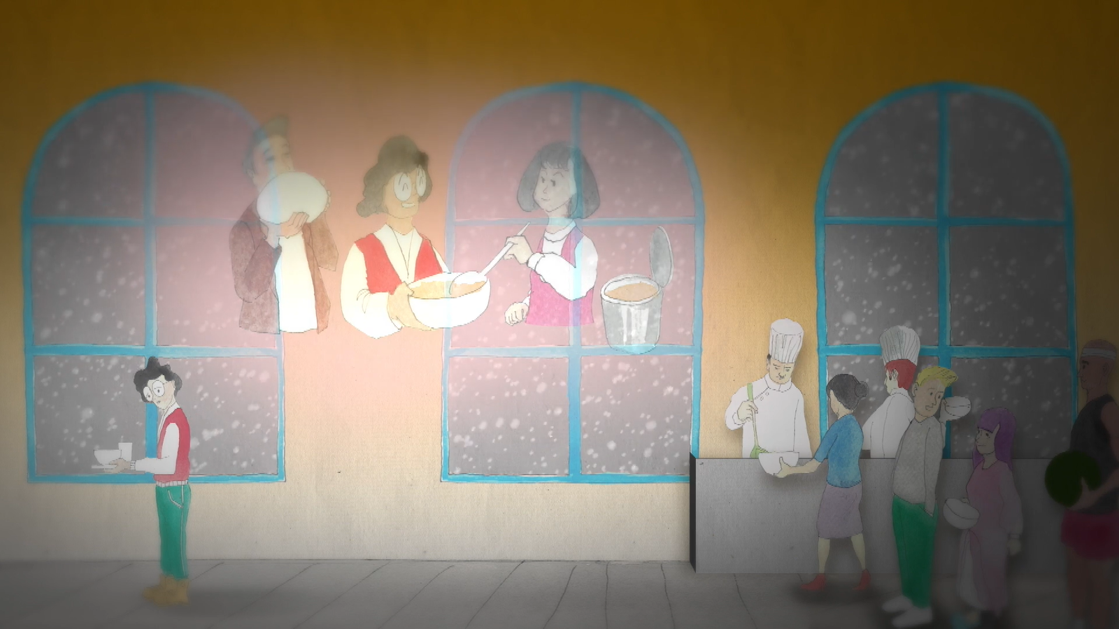  - The soup the young man’s mother made: ____________________  _____________________________________________________

- How do symbols help you understand a story better?
________________________________________________________________________________________________________
- Can you think of other symbols that are used in the video “Home is Where the Heart is”?
________________________________________________________________________________________________________
Part D: Understanding the Saying of Wisdom

- What is the message conveyed by the story?

________________________________________________________________

________________________________________________________________

- What is the meaning of the saying “Home is where the heart is”?

________________________________________________________________

________________________________________________________________

- Let’s express our gratitude and affection for the unconditional love and support from our home and family. Write them down in the space below and share them with your classmates (e.g. “No matter…”/“…, no matter…”).

Example: No matter how tired she is, my mother listens to me sharing about the happenings at school.

- In the story, the young man’s parents supported him and helped him overcome his problems no matter how far away he was. In about 150 words, write a recount of an incident that shows how important your home and family is to you. You may include the following details in your work:

When did it happen?

Where did it take place?

An incident
What happened?

SOWIT Video Series – “Home is Where the Heart is”
How did you feel?

Who was/were involved?

Activity Sheets (Suggested Answers)

Part A: Making Predictions about the Story Elements
1(a) | A family (father, mother and son) (Accept any reasonable answers.)
1(b) | They were saying goodbye/bidding farewell to each other. (Accept any reasonable answers.)
1(c) | Sad/unhappy/upset (Accept any reasonable answers.)
1(d) | The son was leaving for his study. (Accept any reasonable answers.)

Part B: Understanding the Story Elements
1(a) | A young man, his parents
1(b) | The young man’s school in a foreign country (given)
1(c) | The young man could not adapt to the new environment and missed his parents.
1(d) | The support from the young man’s parents helped him overcome the challenges of studying abroad by himself.

Part C: Use of Symbols
1(a) | The young man’s sadness and worries about the challenges ahead. (Accept any reasonable answers.)
1(b) | The difficulties that the young man might encounter (e.g. the study, living in a foreign country, human relationships) (Accept any reasonable answers.)
1(c) | The young man’s loneliness/Things that the young man found it hard to adapt to (Accept any reasonable answers.)
1(d) | The care/love/warmth/support from the young man’s family (Accept any reasonable answers.)
2. | Symbols help readers/viewers visualise complex concepts. (Accept any reasonable answers.)
3. | Accept any reasonable answers.

Part D: Understanding the Saying of Wisdom
- When we face difficulties, our family will support and encourage us no matter where we are.
- Your home will always be the place for which you feel the deepest affection, no matter where you are.
- Accept any reasonable answers.
- Accept any reasonable answers.

