SOWIT Video Series – “Prevention is Better than Cure”
(Video link: www.edb.gov.hk/sowit_prevention)

Lesson Plan
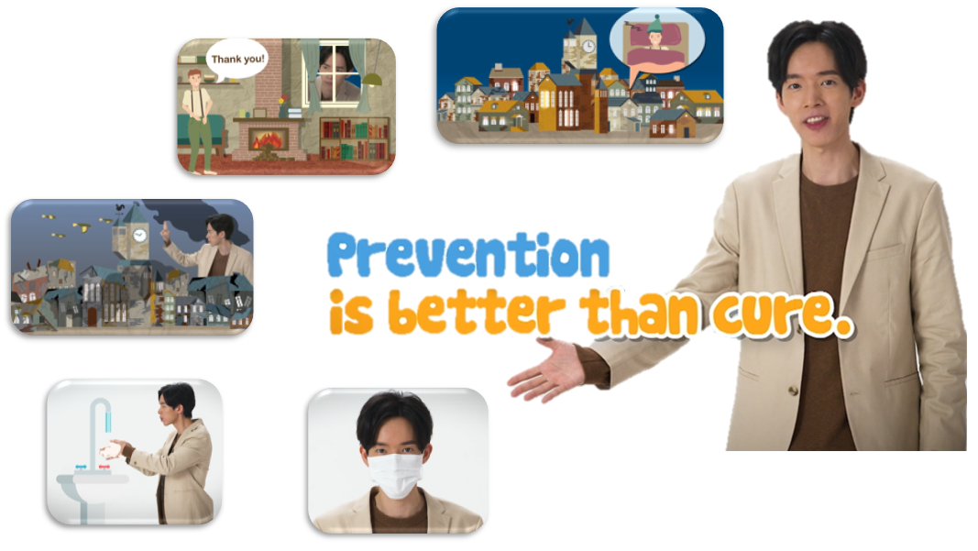

Suggested Levels
Upper Primary/Junior Secondary
Summary of the Learning Task
Students watch the SOWIT video “Prevention is Better than Cure”, which is about how the presenter stopped a fire from happening. Students are then guided to understand the meaning of the saying “Prevention is better than cure”, learn about the related positive values and attitudes (e.g. be proactive, be positive, cherish what we have), and write a reflection on their personal experience about the saying “Prevention is better than cure”.
Learning Objectives
Content
- To understand the meaning of the saying “Prevention is better than cure.” through a story presented in the context of a video
Language
- To explore the story elements of the video (e.g. characters, setting, problem, solution)
- To use adjectives to describe a person/an experience (e.g. forgetful, careful, undesirable, painful)
Values and Attitudes
- To cultivate positive values and attitudes (e.g. be proactive, be positive, cherish what we have)

Sharing Learning Intentions
- Introduce the objectives of the learning activities
Pre-viewing
Part A: Making Predictions about the Story Elements
- Refer students to Activity Sheet: Part A.
- Draw students’ attention to the picture below, which depicts a scene of the SOWIT video “Prevention is Better than Cure”:
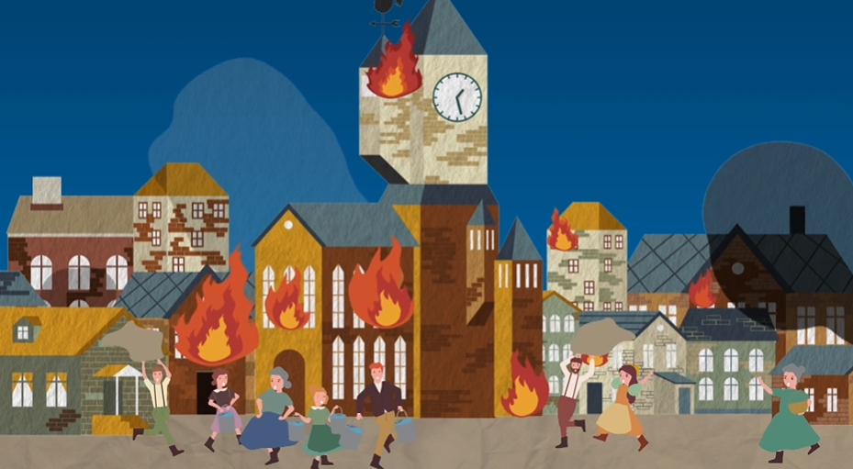
- Guide students to make predictions about the story elements by drawing their attention to the visual clues captured in the picture (e.g. the time, the place, the fire, what the villagers were doing).
- Discuss with students their observations.

Viewing
Part B: Understanding the Story Elements
- Refer students to Activity Sheet: Part B.
- Introduce the story elements (i.e. characters, setting, problem, solution) before watching the video and instruct students to complete Part B1 (i.e. the table about the characters and setting) and Part B2 (i.e. rearrange the events in the order of occurrence) while watching the video.
- Play the video “Prevention is Better than Cure”.
- Discuss with students the answers to Activity Sheet: Part B.
- Discuss with students the problem (i.e. A fire broke out and spread quickly. The entire village was ruined.) and the solution (i.e. The presenter worked magic. He turned the clock back and reminded a careless villager to rearrange the firewood properly. The fire was prevented.) of the story.

Post-viewing
Part C: Characterisation
- Refer students to Activity Sheet: Part C.
- Guide students to circle the adjective(s) that best describe(s) the feelings of the characters, think of the reasons for their feelings and write them down by drawing their attention to
  - the visual clues captured in the videos;
  - the events (e.g. some villagers were putting out the fire while some simply ran away); and
  - what the characters said (e.g. “You should arrange your firewood properly. Do you want a fire to break out?”).
- Play the video again whenever necessary.

Part D: Understanding the Saying of Wisdom
- Refer students to Activity Sheet: Part D.
- Ask students to answer Questions 1 – 4.
- Discuss with students the message conveyed by the story (e.g. prevention is better than cure/it is better to stop something bad from happening than it is to deal with it after it has happened).
- Ask students to write a reflection on their personal experience about the saying “Prevention is better than cure”.
- Encourage students to use adjectives (e.g. forgetful, careful, undesirable, painful) to describe themselves and the experience.

SOWIT Video Series – “Prevention is Better than Cure”
Activity Sheets

(Pre-viewing)
Part A: Making Predictions about the Story Elements
- The picture below depicts a scene of the SOWIT video “Prevention is Better than Cure”. What do you think the video is about? Answer the questions in Boxes (a) – (d).
(b) What happened to the houses there?

- When and where did the story take place?

(d) Guess the cause of the fire and how it could be prevented.

(c) Who were the people? What were they doing?

(Viewing)

Part B: Understanding the Story Elements
- Complete the table about the characters and setting of the story by filling in the blanks. The first one has been done as an example.

Characters
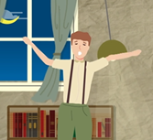 | e.g. the man whose house first caught fire
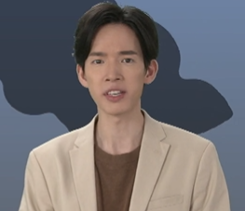 | the ___________________
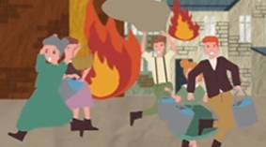 | the ___________________
Setting
Place: ___________________

Time: ___________________

- The following pictures show the events of the story. Number the pictures in the order of occurrence. The first one has been done as an example.

Events
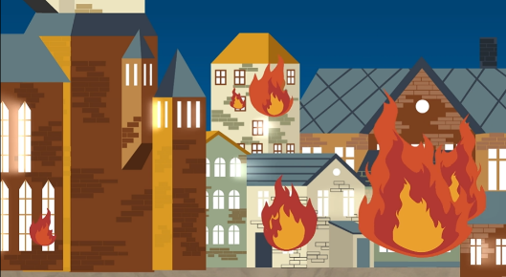  (a) | 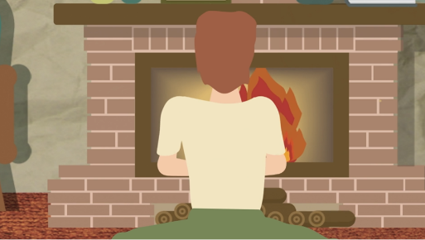  (b)
e.g. ( 1 ) | ( )
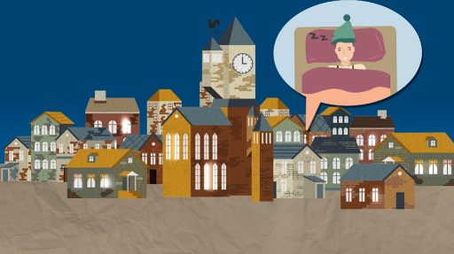  (c) | 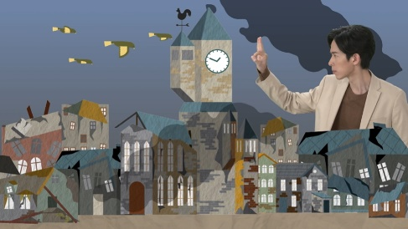  (d)
( ) | ( )
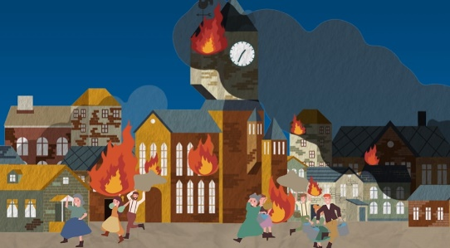  (e) | 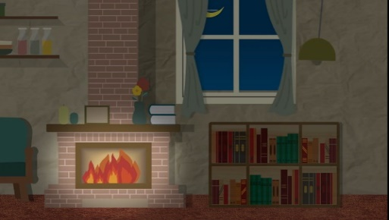  (f)
( ) | ( )
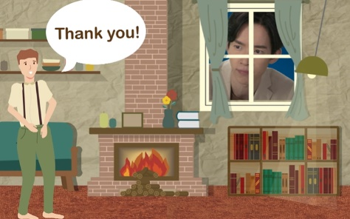  (g) | 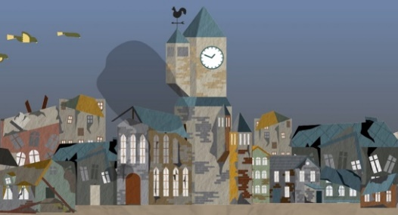  (h)
( ) | ( )

(Post-viewing)
Part C: Characterisation
- Think of the feelings of the villagers and the man whose house first caught fire at different stages of the story. In each of the following events, circle the adjective that best describes their feelings, and give reasons in the space provided. The first one has been done as an example.

Events | Feelings of the characters | Reasons
- Some villagers were putting out the fire while some simply ran away.  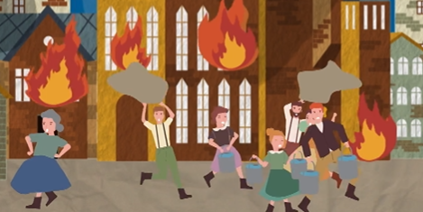 | e.g. ashamed/ comfortable/grateful/ panicking /tired | e.g. The situation was very dangerous. The villagers might get hurt.
- The man was about to walk away though the firewood was not arranged properly.  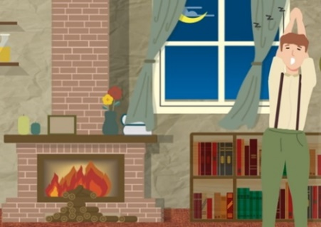 | ashamed/  comfortable/grateful/ panicking/tired

Events | Feelings of the characters | Reasons
- The presenter: “You should arrange your firewood properly. Do you want a fire to break out?”  The man: “Of course not! Thank you for the reminder.”  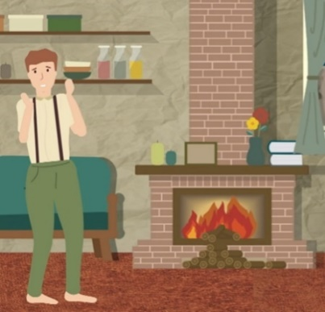  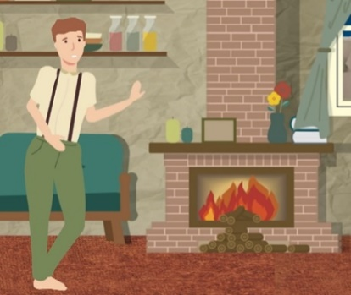 | The man:  ashamed/  comfortable/grateful/ panicking/tired  ashamed/  comfortable/grateful/ panicking/tired
- After the man rearranged the firewood, the fire did not happen.  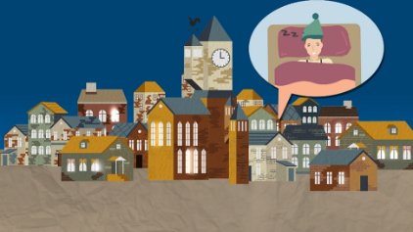 | ashamed/  comfortable/grateful/ panicking/tired

Part D: Understanding the Saying of Wisdom
Answer the following questions about the story.

- Did the man want a fire to start? How do you know?

__________________________________________________________________________________________________________________________________________
- What was the cause of the fire?

__________________________________________________________________________________________________________________________________________
- Could the fire be prevented? How?
__________________________________________________________________________________________________________________________________________
- What is the message conveyed by the story?
__________________________________________________________________________________________________________________________________________

        - In the story, the villagers were in a great panic because of the fire which ruined the entire village. However, with the help of the presenter, who worked magic and turned the clock back, the fire was prevented. In about 150 words, write a reflection on your personal experience about the saying “Prevention is better than cure”. You may include the following details in your work.

What was the problem you encountered? | What was the consequence?

What have you learnt from the experience?

SOWIT Video Series – “Prevention is Better than Cure”
Activity Sheets (Suggested Answers)

Part A: Making Predictions about the Story Elements
1(a) | When: night time/one night  Where: a village
1(b) | What happened: the houses were on fire
1(c) | Who: villagers/people living in the village  What they were doing: putting out the fire/running away
1(d) | Cause of the fire: faulty electrical appliances/heaters getting too close to curtains, clothes, etc.  How the fire could be prevented: take precautions beforehand/all the time/make sure the electrical appliances are in good condition/make sure the heaters are not too close to curtains, clothes, etc.
(Accept any reasonable answers.)

Part B: Understanding the Story Elements
1 | Characters: e.g. the man whose house first caught fire  the presenter  the villagers  Setting: Place: a village  Time: one night/night time  (Accept any reasonable answers.)

2 | (a) 1 | (b) 6 | (c) 8 | (d) 4
 | (e) 2 | (f) 7 | (g) 5 | (h) 3

Part C: Characterisation
1. | Feelings of the characters | Reasons
(a) | e.g. panicking | e.g. The situation was very dangerous. The villagers might get hurt.
(b) | tired | The man was yawning.
(c) | ashamed  grateful | The man felt ashamed when he noticed that his carelessness might cause a fire.  The man was grateful for the presenter’s reminder.
(d) | comfortable | Since the fire was prevented, the villagers had a peaceful night’s sleep.
(Accept any reasonable answers.)

Part D: Understanding the Saying of Wisdom
- The man did not want a fire to start because he felt ashamed when he noticed that his carelessness might cause a fire. (Accept any reasonable answers.)
- The firewood was not arranged properly./Some pieces of firewood were placed very near the fireplace and caught fire. (Accept any reasonable answers.)
- The fire could be prevented by arranging the firewood properly. (Accept any reasonable answers.)
- Prevention is better than cure./It is better to stop something bad from happening than it is to deal with it after it has happened. (Accept any reasonable answers.)
- Accept any reasonable answers.

