SOWIT Video Series – Every Cloud Has a Silver Lining
(Video link: www.edb.gov.hk/sowit_silver)

Lesson Plan

Suggested Levels
Upper Primary/Junior Secondary
Summary of the Learning Task
Students watch the SOWIT video “Every Cloud Has a Silver Lining”, which is about a passionate football player, Tom, who got injured in his debut match but did not give up his goal and eventually became his team’s manager. Students are then guided to understand the meaning of the saying “Every cloud has a silver lining”, learn about the related positive values and attitudes (e.g. be optimistic and hopeful), and write a reflection on their personal experience.
Learning Objectives
Content
- To understand the meaning of the saying “Every cloud has a silver lining.” through a story presented in the context of a video
Language
- To explore the story elements of the video (e.g. characters, setting, problem, solution)
- To describe feelings (e.g. in great pain, contented, joyful)
- To show appreciation and express gratitude using the sentence pattern “I am thankful/grateful for… because…”
Values and Attitudes
- To cultivate positive values and attitudes (e.g. be optimistic and hopeful)
Sharing Learning Intentions
1. Introduce the objectives of the learning activities.
Pre-viewing
Part A: Making Predictions about the Story Elements
- Refer students to Activity Sheet: Part A.
- Draw students’ attention to the pictures below, which depict the character, scenes of the SOWIT video “Every Cloud Has a Silver Lining” and the saying, and guide them to make predictions.

- Discuss with students their observations.
- Play the video and have students check whether their predictions are correct.
Viewing
Part B: Understanding the Story Elements
- Refer students to Activity Sheet: Part B.
- Introduce the story elements (i.e. characters, setting, problem, solution) before playing the video and instruct students to note down some key points for each element while watching the video.
- Play the video “Every Cloud Has a Silver Lining”.
- Discuss with students the story elements of the video.
Post-viewing
Part C: Characterisation
- Refer students to Activity Sheet: Part C.
- Guide students to write down Tom’s feelings at different stages of the story and the reasons by drawing their attention to the visual clues captured in the video, and the events (e.g. Tom practised hard for the football competition; he was injured in his debut match).
- Discuss with students the attributes Tom possessed which led him to success.
- Play the video again whenever necessary.
Part D: Understanding the Saying of Wisdom
- Refer students to Activity Sheet: Part D.
- Guide students to understand the message conveyed by the story (i.e. as long as we stay optimistic and hopeful, we can always find a positive way forward).
- Revisit the meaning of the saying “Every cloud has a silver lining.” with students (i.e. every difficult or unpleasant situation has a positive side to it).
- Guide students to share their personal experience and write a reflection on the saying.
- Remind students that they can use the sentence pattern “I am thankful/grateful for… because…” to show the positive side of a difficult or unpleasant situation.

SOWIT Video Series – “Every Cloud Has a Silver Lining”
Activity Sheets
(Pre-viewing)
Part A: Making Predictions about the Story Elements
- What do you think the video is about? What do you think the saying “Every cloud has a silver lining.” means? Write down your thoughts in the table below.

 | Prediction | Confirmation  (Was your prediction correct?)
The character | - Who is he?
The scenes | - What is the story about?
The saying | - What does this saying mean?

(Viewing)
Part B: Understanding the Story Elements
1. Watch the video and complete the story elements below:
(b) Where did the story take place?

(c) What was Tom’s problem?

- Who was Tom, the main character? What was his dream?

(d) How did Tom solve the problem?

Story Elements

(Post-viewing)
Part C: Characterisation
- Think of Tom’s feelings and the reasons for the feelings at different stages of the story. Write them down in the space provided. The first one has been done as an example.

Events | Tom’s feelings | Reasons
- Tom was practising football alone at sunset.  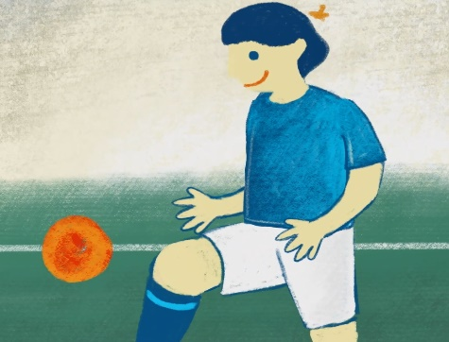 | e.g.  passionate about football/  determined to win/tired | e.g.  He was practising even when all his teammates had gone back home.
- Tom was injured in his debut match.
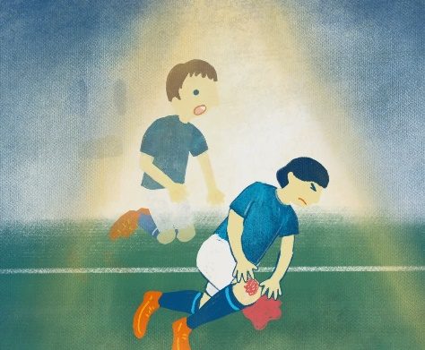
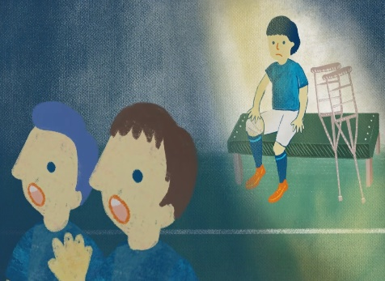
- Tom sat on the sidelines and watched his team play.
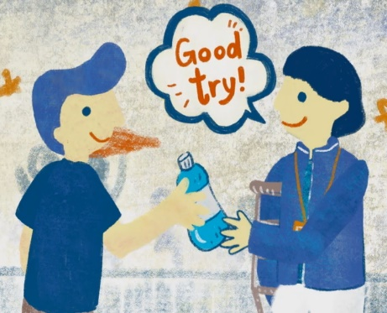
- Tom became his team’s assistant coach.
- The team ultimately won the whole competition.

- Tom did not give up his passion for football even after he got injured. What did he do to continue his dream?
______________________________________________________________________________________________________________________________________________________
___________________________________________________________________________

- While Tom was injured, he developed his talent as a football coach. He led his team to win the championship and became the team’s manager eventually. What attributes did Tom possess which led him to success?
______________________________________________________________________________________________________________________________________________________
___________________________________________________________________________

Part D: Understanding the Saying of Wisdom
Answer the following questions.
- What is the message conveyed by the story?
__________________________________________________________________________
__________________________________________________________________________
- What is the meaning of the saying “Every cloud has a silver lining”?
___________________________________________________________________________
___________________________________________________________________________

- In the story, Tom could not play in the football matches because of his injury. Facing such a big difficulty, he did not give up. Instead, he took this opportunity to become his team’s assistant coach. He developed another talent successfully and became the team’s manager eventually. In about 150 words, share your personal experience and write a reflection on “Every cloud has a silver lining”. You may include the following details in your work:

What was the problem you encountered? | What was the positive side of the problem?  (I am thankful/grateful for… because…)

What have you learnt from the experience?

SOWIT Video Series – “Every Cloud Has a Silver Lining”
Activity Sheets (Suggested Answers)

Part A: Making Predictions about the Story Elements
1. | (a) | A football player/a student.
 | (b) | The character’s experience of getting injured in a football match and how he overcame the challenge to win the championship.
 | (c) | Every difficult or unpleasant situation has a positive side to it.
(Accept any reasonable answers.)

Part B: Understanding the Story Elements
1. | (a) | Tom was a football player.
 | (b) | The story took place in football fields.
 | (c) | Tom was injured in his debut match. He could not play in the remaining matches.
 | (d) | He did not give up. He decided to become his team’s assistant coach. He used his knowledge to draw up strategies and led his team to win the championship.
(Accept any reasonable answers.)

Part C: Characterisation
 |  | Tom’s feelings | Reasons
1. | (a)  (b) | passionate about football/determined to win/tired (given)  sad/disappointed/in great pain | He was practicising even when all his teammates had gone back home. (given)  He was hurt and could not play in the remaining matches.
 | (c) | bored/lonely/distant from the field | He could only watch the football matches but not play in them.
 | (d) | contented/cheerful/satisfied | He used his knowledge to draw up strategies and led his team to win one match after another.
 | (e) | proud/joyful/confident | He led his team to win the championship. He proved himself to be a capable coach.
2. Tom decided to become his team’s assistant coach and used his knowledge to contribute to his team.
- Tom did not give up. He stayed optimistic and hopeful when facing adversity. He found a positive side to his difficulty.
(Accept any reasonable answers.)

Part D: Understanding the Saying of Wisdom
- As long as we stay optimistic and hopeful, we can always find a positive way forward. (Accept any reasonable answers.)
- Every difficult or unpleasant situation has a positive side to it.
(Accept any reasonable answers.)
- Accept any reasonable answers.

