SOWIT Video Series – “There is Light at the End of the Tunnel”
(Video link: www.edb.gov.hk/sowit_tunnel)

Lesson Plan
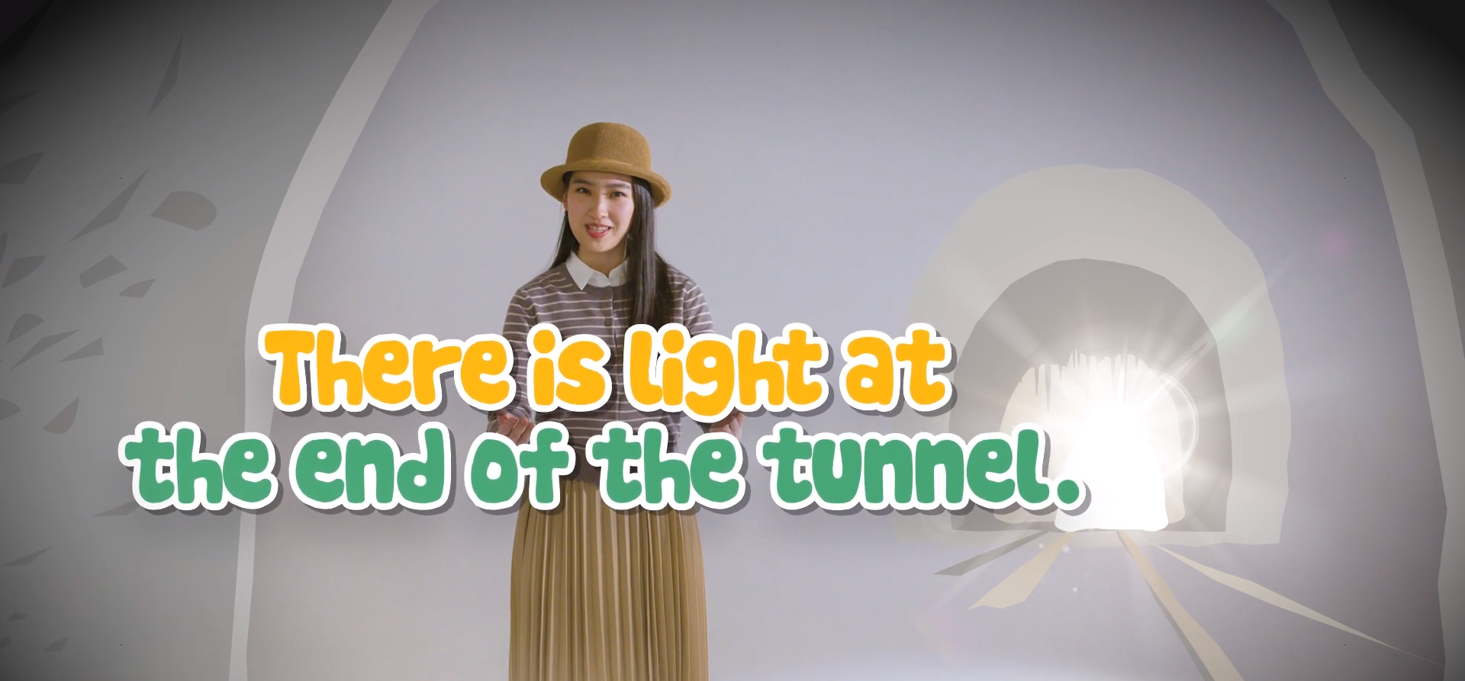

Suggested Levels
Upper Primary/Junior Secondary
Summary of the Learning Task
Students watch the SOWIT video “There is Light at the End of the Tunnel”, which is about a pole vaulter who did not give up challenging the world record even when he failed and injured himself. They are then guided to understand the meaning of the saying “There is light at the end of the tunnel”, learn about the related positive values and attitudes (e.g. resilience, perseverance, optimism), and give a presentation on their personal experience.

Learning Objectives
Content
- To understand the meaning of the saying “There is light at the end of the tunnel.” through a story presented in the context of a video
- To explore the lesson learnt from the story of the main character

Language
- To learn the vocabulary (e.g. “determined”, “optimistic”, “hardship”, “difficult”, “improvement”) related to overcoming hardship

Values and Attitudes
- To cultivate positive values and attitudes (e.g. resilience, perseverance, optimism)

Sharing Learning Intentions
1. Introduce the objectives of the learning activities.

Pre-viewing
Part A: Making Predictions about the Story Elements
- Refer students to Activity Sheet: Part A.
- Draw students’ attention to the picture below, which depicts a scene of the SOWIT video “There is Light at the End of the Tunnel”:
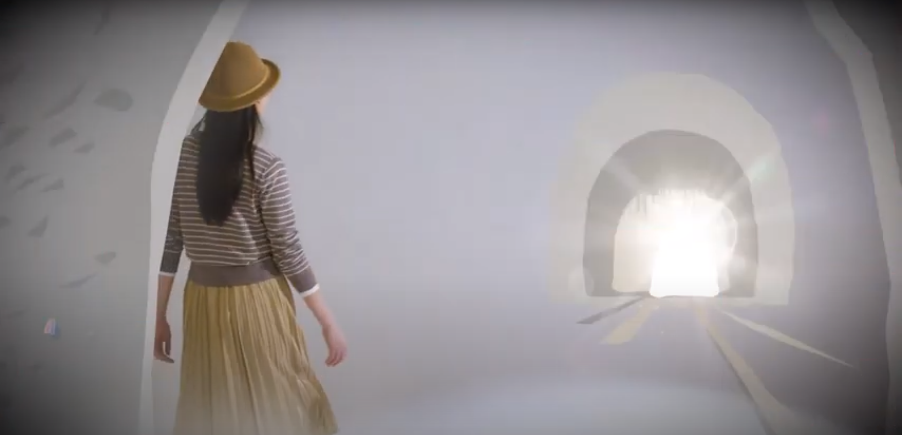

- Guide students to make predictions about the theme of the video by drawing their attention to the visual clues captured in the picture and ask the following questions:
- Where do you think the girl is?
(Suggested answer: a tunnel, a cave, an enclosed place)
- What do you think the white spot is?
(Suggested answer: light, sunshine)
- How would you feel if you were kept in this place for a long time? Why?
(Suggested answer: tired/worried/sad because it seems there is no way out/I don’t know when I could leave this place/I want to go home)
- What would you do if you were kept in this place for a long time? Why?
(Suggested answer: I would try to escape from this place by using all the possible means because I don’t want to stay there anymore.)
- How would you feel when you see the white spot?
(Suggested answer: hopeful, happy)

- Discuss with students their observations.

Viewing
Part B: Understanding the Message of the Story
- Refer students to Activity Sheet: Part B.
- Play the video “There is Light at the End of the Tunnel”.
- Instruct students to complete the table in Question 1 after watching the video.
- Go over the answers of Question 1 with students.
- Guide students to work out the symbolic meaning of “tunnel” and “light” by relating the expressions to Peter’s story.
- Highlight the importance of perseverance by going over the quote with students.
- Recap the key messages presented in the story.

Post-viewing
Part C: Learning the Vocabulary about Overcoming Hardship
- Refer students to Activity Sheet: Part C.
- Instruct students to complete the table in Question 1. Elicit from them the good qualities they can learn from Peter when facing hardship and the respective examples.
- Draw students’ attention to the parts of speech of the five targeted vocabulary items (i.e. “determined”, “optimistic”, “hardship”, “difficult”, “improvement”). Remind them to consult the dictionary when necessary.
- Have students complete the table in Question 2 and the summary in Question 3.

Part D: Understanding the Saying of Wisdom
- Refer students to Activity Sheet: Part D.
- Revisit the meaning of the saying “There is light at the end of the tunnel.” with students (i.e. to describe signs of improvement in a situation that has been bad for a long time, or signs that a long and difficult piece of work is almost finished).
- Invite students to share their experience in overcoming a challenge using the vocabulary learnt in Activity Sheet: Part C.
- Ask students to collect a piece of news/information of a famous person who inspires them and best exemplifies the saying “There is light at the end of the tunnel”.

SOWIT Video Series – “There is Light at the End of the Tunnel”
Activity Sheets
(Pre-viewing)

Part A: Making Predictions about the Story Elements
Study the picture below and share your answers to the following questions with your classmates.

- Where do you think the girl is?
______________________________________________________________

- What do you think the white spot is?
______________________________________________________________

- How would you feel if you were kept in this place for a long time? Why?
______________________________________________________________
______________________________________________________________

- What would you do if you were kept in this place for a long time? Why?
______________________________________________________________
______________________________________________________________

- How would you feel when you see the white spot?
______________________________________________________________

(Viewing)

Part B: Understanding the Message of the Story

- The following pictures show the events of the story in the video “There is Light at the End of the Tunnel”. After watching the video, complete the following table by identifying the sequence of events and fill in the blanks with the words provided in the box. The first one has been done as an example.

failed | treatments | hard | determined
injured | goal | succeeded | tough
Events | Sequence | What happened?
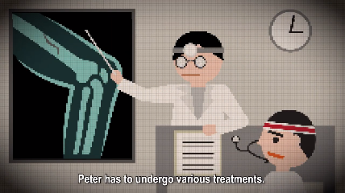  (a) | (i) ____ | Peter visited the doctor and he had to undergo various (ii) _________________.
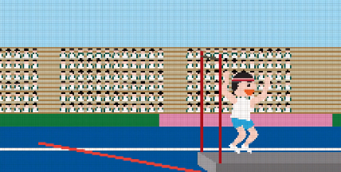  (b) | (i) ____ | After his recovery, Peter joined the competition again. He finally (ii) ______________ and broke the world record.
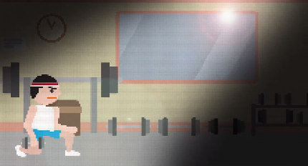  (c) | (i) ____ | Although the recovery and training process was (ii) __________, Peter tried very (iii) __________ in order to achieve his (iv) __________.
(d) | e.g. 1 | Peter was a pole vaulter. He trained tirelessly and was e.g. determined to challenge the world record.
(e) | (i) ____ | Peter (ii) ___________ in the first attempt in the competition.
(f) | (i) ____ | Peter had an accident in his second attempt and (ii) ____________ his leg.
- What do “tunnel” and “light” symbolise in the story?

“tunnel”: ___________________________________________________________
“light”: ____________________________________________________________

- Complete the following quote from the video. What have you learnt from Peter’s experience?

By being determined and (i) o____________, Peter made steady (ii) p____________ and eventually achieved (iii) s____________. Never (iv) g____ u___ in the face of (v) h____________!

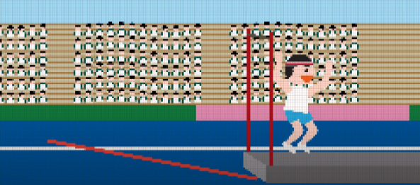
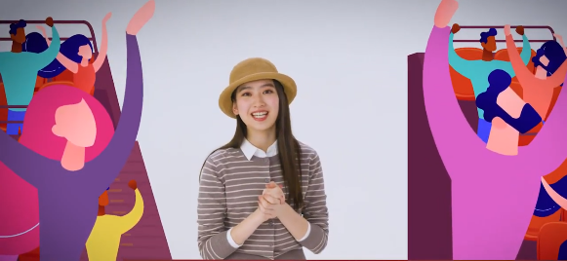

  - Things I have learnt from Peter’s experience:

(Post-viewing)

Part C: Learning the Vocabulary about Overcoming Hardship

- In the video, Peter has set some good examples for us to follow when we are having a difficult time. The table below summarises some good qualities you can learn from Peter on his journey of breaking the world record. Find an example to illustrate each of the good qualities. The first one has been done for you as an example.

Good Qualities of Peter | Examples
Peter was determined. | e.g. Peter set a goal in breaking the world record.
Peter never gave up. | (a)
Peter was optimistic. | (b)
Peter was hard-working. | (c)

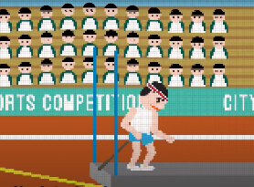
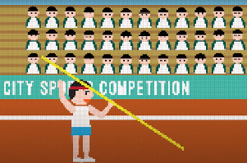

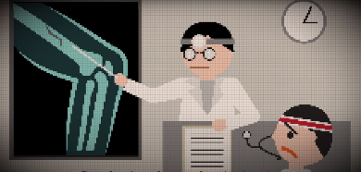

- Complete the following table about the five vocabulary items related to overcoming hardship. You may use a dictionary to help you.

 | Noun | Verb | Adjective
i) |  | / | optimistic
ii) |  |  | determined
iii) |  | / | difficult
iv) | hardship | /
v) | improvement |  | /

- Complete a summary about Peter’s story in breaking the world record by using the vocabulary in No.2.
Peter was a pole vaulter who had a strong (a) _____________________ in breaking the world record. Even though he was not successful in his first few attempts, he did not feel upset and he stayed (b) _____________________ in face of (c) _____________________. Unfortunately, he hurt his leg during one of the competitions. Luckily, Peter was not discouraged. He kept training and (d) _____________________ a lot in his recovery process. Finally, Peter succeeded and broke the world record. Peter’s story reminds us that there is always hope in every (e) _____________________ situation and we should never give up easily.

Part D: Understanding the Saying of Wisdom
- What is the message conveyed by the story?
___________________________________________________________________
___________________________________________________________________

- What is the meaning of the saying “There is light at the end of the tunnel”?
___________________________________________________________________
___________________________________________________________________

- Do you have a similar experience of being in a difficult situation for a long time but finally overcoming the challenge? Share the experience with your classmates in a 1-minute presentation. Try to incorporate the vocabulary learnt in Part B in your presentation. You may include the following ideas in your presentation:
- What was the challenge? How did you feel at first?
- What did you do to overcome the challenge?
- What was the result?
- How did you feel at the end?
- What did you learn from the experience?

You may begin by saying:
Hello everyone! Today I would like to share my experience on ______________.

- Peter’s perseverance and determination inspired us not to give up easily. Is there anyone (e.g. a celebrity, a famous person in history, an athlete) who encourages you to move forward despite hardship? Collect a piece of news/information of someone who exemplifies the saying “There is light at the end of the tunnel”. Stick it in the box below and share with your classmates how this person inspires you.

SOWIT Video Series – “There is light at the end of the tunnel”

SOWIT Video Series – “There is Light at the End of the Tunnel”
Activity Sheets (Suggested Answers)

Part A: Making Predictions about the Story
- A tunnel/a cave/an enclosed place
- Light/sunshine
- Tired/worried/sad because it seems there is no way out/I don’t know when I could leave this place/I want to go home
- Try to escape from this place by using all the possible means because I don’t want to stay there anymore
- Hopeful/happy
(Accept any reasonable answers.)

Part B: Understanding the Message of the Story
- (a) (i) 4 (ii) treatments
(b) (i) 6 (ii) succeeded
(c) (i) 5 (ii) tough (iii) hard (iv) goal
(d) (i) 1 (ii) determined (given)
(e) (i) 2 (ii) failed
(f) (i) 3 (ii) injured

- “tunnel”: A difficulty/the long and tough recovery process
“light”: Success/signs of improvement in Peter’s recovery
(Accept any reasonable answers.)

- (i) optimistic
(ii) progress
(iii) success
(iv) give up
(v) hardship
(vi) Accept any reasonable answers.

Part C: Learning the Vocabulary about Overcoming Hardship
- (a) Peter kept trying even when he failed in his first and second attempts.
(b) Even though Peter got hurt, he stayed positive and kept practising.
(c) Peter trained tirelessly every day.
(Accept any reasonable answers.)

 | Noun | Verb | Adjective
i) | optimism | / | optimistic
ii) | determination | determine | determined
iii) | difficulty | / | difficult
iv) | hardship | / | hard
v) | improvement | improve | /

- (a) determination
(b) optimistic
(c) hardship
(d) improved
(e) difficult

Part D: Understanding the Saying of Wisdom
- Despite hardship, we should never give up as there is always hope after being in a bad/difficult situation for a long time.
- There is always hope after hardship./There will be signs of improvement in a situation that has been bad for a long time.
- Accept any reasonable answers.
- Accept any reasonable answers.

