**SOWIT Video Series – “Where There’s a Will, There’s a Way”**

**(Video link:** [www.edb.gov.hk/sowit_there_s_a_will](http://www.edb.gov.hk/sowit_there_s_a_will))

**Lesson Plan**



|  |
| --- |
| **Suggested Levels** |
| Upper Primary/Junior Secondary |
| **Summary of the Learning Task** |
| Students watch the SOWIT video “Where There’s a Will, There’s a Way”, which is about a man and his descendants who were very determined to dig a tunnel through a mountain for the benefits of the villagers. They are then guided to understand the meaning of the saying “Where there’s a will, there’s a way”, learn about the related positive values and attitudes (e.g. cherish what we have, be positive, be optimistic), and write a short description about their dream job and how they can achieve their goals. |
| **Learning Objectives** |
| **Content**   * To understand the meaning of the saying “Where there’s a will, there’s a way.” through a story presented in the context of a video   **Language**   * To identify the story elements of the video (e.g. characters, setting, problem, solution) * To explore the use of images to show the characters’ emotions/feelings * To show determination using the sentence pattern “*To achieve my goal, I will have to ….*”   **Values and Attitudes**   * To cultivate positive values and attitudes (e.g. cherish what we have, be positive, be optimistic) |
| **Sharing Learning Intentions** |
| 1. Introduce the objectives of the learning activities |
| **Pre-viewing** |
| **Part A: Making Predictions about the Theme of the Saying of Wisdom**   1. Refer students to *Activity Sheet: Part A*. 2. Guide students to make predictions about the theme of the saying “Where there’s a will, there’s a way.” by identifying the appropriate meanings of the words “will” and “way”. 3. Invite students to share and make reflection on their experiences. |
| **Viewing** |
| **Part B: Understanding the Story Elements**   1. Refer students to *Activity Sheet: Part B*. 2. Introduce/Revisit the story elements (i.e. characters, setting, problem, solution) with students before watching the video. 3. Have students look at the pictures to find out the plot while watching the video. 4. Play the video “Where There’s a Will, There’s a Way”. 5. Discuss with students their work. |
| **Post-viewing** |
| **Part C: Understanding Emotions/Feelings by Exploring Images in the Video**   1. Refer students to *Activity Sheet: Part C*. 2. Play the video “Where There’s a Will, There’s a Way.” again. 3. Draw students’ attention to the use of images in objects and characters in the video   (e.g. a huge mountain and tiny huffing men).  [Showing how difficult it was for people to climb over the mountain frequently]   1. Guide students to understand the emotions/feelings of the characters through analysing their facial expressions. 2. Have students draw the facial expressions of a character and discuss with them their work. |
| **Part D: Understanding the Saying of Wisdom**   1. Refer students to *Activity Sheet: Part D*. 2. Revisit the meaning of the saying “Where there’s a will, there’s a way.” with students (i.e. if you are determined enough, you will find a way to achieve what you want, even if it is very difficult). 3. Have students write about their dream job and share how they can achieve their goals with determination using the sentence pattern “*To achieve my goal, I will have to …, … and …*”. |

**SOWIT Video Series – “Where There’s a Will, There’s a Way”**

**Activity Sheets**

**(Pre-viewing)**

**Part A: Making Predictions about the Theme of the Saying of Wisdom**

You will watch a video about the saying of wisdom (SOW) “Where there’s a will, there’s a way”. What do the words “will” and “way’ mean in this SOW? Choose the most appropriate answers to Questions 1-3 below. Then, think of the answer to Question 4 and share your idea with your teacher and classmates.

1. What does the word “will” mean in this SOW?

**will /** wɪl **/**

1. a strong desire to do something

* *Ann had a strong will to win the race after receiving four months’ training.*

1. a legal document that tells what a person wants to do to his or her money and property after death

* *Father left me some money in his will.*

1. used to make a request, to invite someone to do something

* *Will you give me Sandy’s phone number?*

1. What does the word “way” mean in this SOW?

**way /** weɪ **/**

1. A road or path to go from one place to another physically

* *The tourists lost their way and had to ask for help.*

1. The qualities of what someone is doing

* *She often greeted her customers in a warm and friendly way.*

1. A method of doing something

* *There are many ways to cook the dish.*

1. What is the part of speech of the words “will” and “way” in this SOW?
2. Nouns
3. Verbs
4. Adjectives
5. What is the possible theme of this SOW? Share your idea with your teacher and classmates.

__________________________________________________________________

__________________________________________________________________

**(Viewing)**

**Part B: Understanding the Story Elements**

1. Look at the pictures below, which depict several scenes of the SOWIT video “Where There’s a Will, There’s a Way”. Read the description and watch the video again. Match the pictures with the story elements provided. Write the numbers in the brackets.

|  |  |
| --- | --- |
| **1)**    The man and his son kept digging the tunnel, and they completed the task at last. | **2)**  The villagers were tired. They complained and dropped out very quickly. |
| **3)**    There was a huge mountain which blocked their way. They were exhausted to climb over the mountain repeatedly. | **4)**  A man lived with his family members in a village. |
| **5)**    They invited other villagers to dig a tunnel through the mountain with them. | |

1. **Characters and setting: ( )**
2. **Problem 1: ( ) (c) Solution 1: ( )**
3. **Problem 2: ( ) (e) Solution 2: ( )**

**(Post-viewing)**

**Part C: Understanding Emotions/Feelings by Exploring the Images in the Video**

The pictures below depict some scenes of the SOWIT video “Where There’s a Will, There’s a Way”. Watch the video and pay attention to the images of objects and characters. Circle the most appropriate words provided.

1.

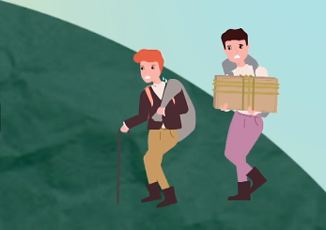

The mountain was **(a) huge/tiny**; in comparison, the men were **(b) tall/short**.

The difference between the size of the mountain and the men shows that it was **(c) easy/hard** for people to climb over the mountain.

2.

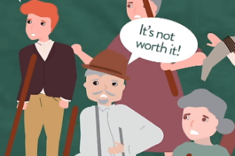

The villagers showed **(a) upturned/downturned** mouths after they dug for some time.

The facial expressions of the villagers show that most of them were **(b) willing/unwilling** to continue to offer help.

3.

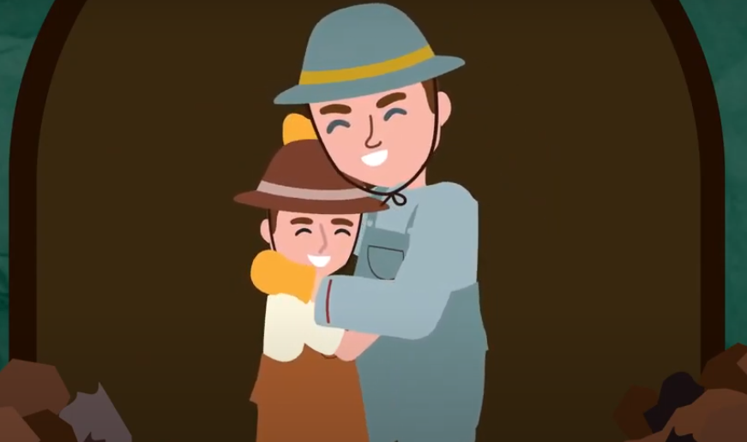

Both the man and his son showed **(a) narrowed/**

**widened** eyes and **(b) upturned/downturned** mouths after completing the task of digging a tunnel through the mountain.

The facial expressions of the man and his son show that they were **(c) excited/shocked** when their effort finally paid off.

4. (a) Draw the possible facial expression.



The villagers were shocked but excited to know that the tunnel was built at last.



So, (b) ***___________,*** especially facial expressionscan show the emotions or feelings of the characters.

**Part D: Understanding the Saying of Wisdom**

1. What is the message conveyed by the story?

__________________________________________________________________

1. The villagers got excited and were willing to join the man and his son in digging a tunnel through the mountain. But they dropped out soon and one old villager said it was not worth it. What did he mean? Do you agree and why?

____________________________________________________________________ ____________________________________________________________________

1. What is the meaning of the saying “Where there’s a will, there’s a way” ?

______________________________________________________________________________________________________________________________________

1. What do you want to be when you grow up? Why do you like this job and feel that it suits you? What will you have to do to achieve your goal? Write a short description about your dream job, and show your determination by suggesting at least three important things to prepare for the job using the sentence pattern “*To achieve my goal, I will have to …, … and …*”.

_________________________________________________________________

____________________________________________________________________________________________________________________________________________________________________________________________________________________________________________________________________

_________________________________________________________________

____________________________________________________________________________________________________________________________________________________________________________________________________________________________________________________________________

_________________________________________________________________

_________________________________________________________________

**SOWIT Video Series – “Where There’s a Will, There’s a Way”**

**Activity Sheets (Suggested Answers)**

**Part A: Making Predictions about the Theme of the Saying of Wisdom**

1. (a)

2. (c)

3. (a)

4. Accept any reasonable answers.

**Part B: Understanding the Story Elements**

1(a) 4

1(b) 3

1(c) 5

1(d) 2

1(e) 1

**Part C: Understanding Emotions/Feelings by Exploring Images in the Video**

1(a) huge (b) short (c) hard

2(a) downturned (b) unwilling

3(a) narrowed (b) upturned (c) excited

4(a) Suggested answer (Accept any reasonable answers.)



4(b) images

**Part D: Understanding the Saying of Wisdom**

* + 1. The story illustrates that where there’s a will, there’s a way.
    2. Suggested answer (Accept any reasonable answers.)

The old villager said it was not worth it probably because he thought the mountain was huge and it would take the villagers a long time and enormous effort to finish the task. It was not worth the time and effort. I understand the difficulty faced by the villagers. But the man and his son as well as the descendant(s) succeeded in building the tunnel through the mountain with their great effort and determination, and the villagers enjoyed great convenience. It was worth it after all.

* + 1. If you are determined enough, you’ll find a way to achieve what you want.
    2. Accept any reasonable answers.