Jorinda and Jorindel
by The Brothers Grimm

There was once an old castle that stood in the middle of a deep gloomy wood, and in the castle lived an old fairy. Now this fairy could take any shape she pleased. All the day long she flew about in the form of an owl, or crept about the country like a cat; but at night she always became an old woman again. When any young man came within a hundred paces of her castle, he became quite fixed, and could not move a step till she came and set him free; which she would not do till he had given her his word never to come there again: but when any pretty maiden came within that space she was changed into a bird, and the fairy put her into a cage, and hung her up in a chamber in the castle. There were seven hundred of these cages hanging in the castle, and all with beautiful birds in them.  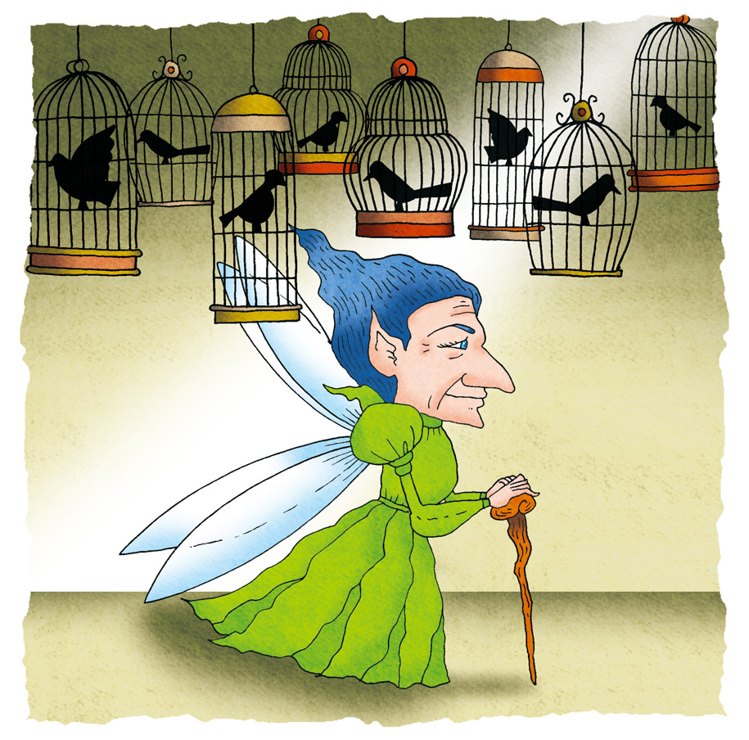 | 5  10
Now there was once a maiden whose name was Jorinda. She was prettier than all the pretty girls that ever were seen before, and a shepherd lad, whose name was Jorindel, was very fond of her, and they were soon to be married. One day they went to walk in the wood, that they might be alone; and Jorindel said, 'We must take care that we don't go too near to the fairy's castle.' It was a beautiful evening; the last rays of the setting sun shone bright through the long stems of the trees upon the green underwood beneath, and the turtle-doves sang from the tall birches. | 15
Jorinda sat down to gaze upon the sun; Jorindel sat by her side; and both felt sad, they knew not why; but it seemed as if they were to be parted from one another for ever. They had wandered a long way; and when they looked to see which way they should go home, they found themselves at a loss to know what path to take. | 20
The sun was setting fast, and already half of its circle had sunk behind the hill: Jorindel on a sudden looked behind him, and saw through the bushes that they had, without knowing it, sat down close under the old walls of the castle. Then he shrank for fear, turned pale, and trembled. Jorinda was just singing, | 25
'The ring-dove sang from the willow spray,
Well-a-day! Well-a-day!
He mourn'd for the fate of his darling mate,
Well-a-day!'
when her song stopped suddenly. Jorindel turned to see the reason, and beheld his Jorinda changed into a nightingale, so that her song ended with a mournful /jug, jug/. An owl with fiery eyes flew three times round them, and three times screamed: | 30
'Tu whu! Tu whu! Tu whu!'
Jorindel could not move; he stood fixed as a stone, and could neither weep, nor speak, nor stir hand or foot. And now the sun went quite down; the gloomy night came; the owl flew into a bush; and a moment after the old fairy came forth pale and meagre, with staring eyes, and a nose and chin that almost met one another. | 35
She mumbled something to herself, seized the nightingale, and went away with it in her hand. Poor Jorindel saw the nightingale was gone but what could he do? He could not speak, he could not move from the spot where he stood. At last the fairy came back and sang with a hoarse voice: | 40
'Till the prisoner is fast,
And her doom is cast,
There stay! Oh, stay!
When the charm is around her, | 45
And the spell has bound her,
Hie away! away!'
On a sudden Jorindel found himself free. Then he fell on his knees before the fairy, and prayed her to give him back his dear Jorinda: but she laughed at him, and said he should never see her again; then she went her way. | 50
He prayed, he wept, he sorrowed, but all in vain. 'Alas!' he said, 'what will become of me?' He could not go back to his own home, so he went to a strange village, and employed himself in keeping sheep. Many a time did he walk round and round as near to the hated castle as he dared go, but all in vain; he heard or saw nothing of Jorinda.
At last he dreamt one night that he found a beautiful purple flower, and that in the middle of it lay a costly pearl; and he dreamt that he plucked the flower, and went with it in his hand into the castle, and that everything he touched with it was disenchanted, and that there he found his Jorinda again. | 55
In the morning when he awoke, he began to search over hill and dale for this pretty flower; and eight long days he sought for it in vain: but on the ninth day, early in the morning, he found the beautiful purple flower; and in the middle of it was a large dewdrop, as big as a costly pearl. Then he plucked the flower, and set out and travelled day and night, till he came again to the castle. | 60
He walked nearer than a hundred paces to it, and yet he did not become fixed as before, but found that he could go quite close up to the door. Jorindel was very glad indeed to see this. Then he touched the door with the flower, and it sprang open; so that he went in through the court, and listened when he heard so many birds singing. At last he came to the chamber where the fairy sat, with the seven hundred birds singing in the seven hundred cages. When she saw Jorindel she was very angry, and screamed with rage; but she could not come within two yards of him, for the flower he held in his hand was his safeguard. He looked around at the birds, but alas! There were many, many nightingales, and how then should he find out which was his Jorinda? While he was thinking what to do, he saw the fairy had taken down one of the cages, and was making the best of her way off through the door. He ran or flew after her, touched the cage with the flower, and Jorinda stood before him, and threw her arms round his neck looking as beautiful as ever, as beautiful as when they walked together in the wood. | 65  70  75
Then he touched all the other birds with the flower, so that they all took their old forms again; and he took Jorinda home, where they were married, and lived happily together many years: and so did a good many other lads, whose maidens had been forced to sing in the old fairy's cages by themselves, much longer than they liked. | 80

Jorinda and Jorindel
by The Brothers Grimm

Learning Activity 1
Pre-reading

1. In groups, share a story you have read, or a film you have watched, about love that rises above all obstacles.

2. The following are the opening lines of the story ‘Jorinda and Jorindel’, which you are about to read:

“There was once an old castle that stood in the middle of a deep gloomy wood, and in the castle lived an old fairy. Now this fairy could take any shape she pleased.”

In groups, discuss the following:
- What will be the story about? Is it sad or happy?
- What characters do you think will appear in the story?
- Do the opening lines attract you to read on? Why or why not?
- Which of the following ways of beginning a story does the writer use?
  - asking a question
  - giving the reader a surprise
  - setting the scene (describing who the main character is and/or where the story takes place, so as to prepare the reader for what is going to happen)
  - describing the middle of an action
  - giving part of a dialogue
- Can you think of some other ways to begin a story?

3. The words in the shaded box are taken from ‘Jorinda and Jorindel’. Before you read the story, you might like to work out the meanings of these words by completing the passage below. You may use a dictionary to help you.

gloomy mournful chamber maiden shepherd wept disenchanted trembled cage meagre

Jason had long wanted to visit his family’s old house. The last person to live in it was his a)____________ aunt. She was 90 when she died and had never married. The old house was so dark and b)____________ that he was frightened to go inside. When he did enter, he c)__________. This was because he saw a crow sitting on an empty d)___________, giving a e)__________, sad sound. He found an old f)____________ which used to be the bedroom of the man who long ago looked after the sheep in the farm. There was a photo of him on the wall. He was a tall, g)__________ man with grey hair. He had been a h)____________ all his life and when Jason saw how he lived he was so sorry for him that he i)____________ until the tears were a pool at his feet. He became so j)____________ with his family’s past that he swore never to enter the house again.

Learning Activity 2
While-reading

A. Understanding the plot

1. Read the following statements about paragraphs 1- 6 of the story. Decide whether they are true (T) or false (F). If the statement is false, provide the correct details in the Remarks column.

Statement | T/F | Remarks
The fairy lives in a castle, and has the power to change pretty girls into birds.
Jorinda is a shepherd and Jorindel is a pretty girl.
Jorinda and Jorindel take care not to go near the fairy’s castle.
Jorinda and Jorindel are lost in the wood.
Jorinda turns into an owl.
Jorindel turns into a stone.
The fairy takes the nightingale away.

2. Answer the following questions about paragraph 7 to the end of the story.

        - Jorindel goes to a strange village after the fairy has left him. Why is it strange?
_____________________________________________________________________
_____________________________________________________________________

        - What power does the “beautiful purple flower” have?
_____________________________________________________________________

        - How long does Jorindel take to find the flower?
_____________________________________________________________________

        - There are many nightingales in the castle. How does Jorindel know which one is Jorinda?
_____________________________________________________________________
_____________________________________________________________________

        - What happens in the end?
_____________________________________________________________________
_____________________________________________________________________
- Exploring the characters

The Fairy
What kind of fairy is she? What do the lines below suggest about her appearance and personal qualities? You might like to make use of the following words/expressions or use your own. You can put more than one word or expression in each box. An example has been done for you.
ugly, jealous of pretty girls, powerful, capable of changing shapes, angry and unforgiving, enjoy seeing others suffer, wilful, cruel

All the day long she flew about in the form of an owl, or crept about the country like a cat; but at night she always became an old woman again. (para. 1)

…but when any pretty maiden came within that space she was changed into a bird, and the fairy put her into a cage… (para. 1)

…the old fairy came forth pale and meagre, with staring eyes, and a nose and chin that almost met one another. (para. 5)

…but she laughed at him (Jorindel), and said he should never see her again… (para. 7) | enjoy seeing others suffer; evil
…the fairy had taken down one of the cages, and was making the best of her way off through the door. (para. 11)

Jorindel
Write down in the table below how you feel about Jorindel before and after he has had his dream of the “beautiful purple flower”. Explain your answer.
(For example, for 1, one might say: Jorindel looks weak and ordinary. He has lost the ability to speak, feel and move any part of his body.)

Before | Remarks
1. When Jorinda is turned into a bird, Jorindel falls under the spell of the fairy’s magic and cannot move, speak or weep.

2. After the fairy takes Jorinda away, Jorindel spends his time keeping sheep and wandering around the castle.

After
3. After looking for the flower for eight days without any success, he continues his search and finds it on the ninth day.

4. With the help of the flower, he goes to the fairy’s castle, rescues Jorinda and frees the other maidens.

Jorinda
Which of the following words best describes Jorinda? Come up with your own description if none of them are suitable. Be ready to explain your answer.

pretty sympathetic innocent selfish weak sad

- Exploring the setting

1. Re-read paragraph 4. Match the descriptions on the right with the objects on the left.
Sun | • | • fiery eyes, screaming “Tu whu”
Castle | • | • mournful
Song of the nightingale | • | • old walls
The owl | • | • fast setting

2. In groups, discuss how the descriptions of different aspects of the setting help us to understand the situation that the lovers are in.

- Exploring the theme

Why does Jorindel keep trying to go back to the castle, despite the danger? What does this suggest?
________________________________________________________________________
________________________________________________________________________

- Exploring the ending

There are different ways of ending a story, e.g. a comment, an exclamation, a success (i.e. the characters achieving their goal), a dialogue, a surprise. Does the ending of Jorinda and Jorindel belong to any of these? Explain your answer.
________________________________________________________________________
________________________________________________________________________

Learning Activity 3
Post-reading

1. Opening
Now that you have a good understanding of the story, write two or three opening sentences for the story so that it will begin in a different way. You may refer to Questions 2(c) and 2(d) of Learning Activity 1 for ideas on ways of starting your story.

2. Closing
Imagine one of the following occurs in the last paragraph of the story. Select one of these options and provide a different ending to the story:
- one of the birds is an owl (i.e. the fairy); or
- one of the birds flies out of the window before Jorindel’s flower can touch it.
You may refer to Part E of Learning Activity 2 for ideas on ways of writing your ending.
Glossary

Paragraph 1
deep gloomy (line 1)
“gloomy” is an adjective that means dark, giving a feeling of something quite frightening or depressing. The word “deep” here can be replaced by “very”.
owl (line 3)
a bird that lives and hunts by night
paces (line 5)
an old way of measuring distance; one pace means one step
chamber (line 9)
an old name for a room

Paragraph 2
maiden (line 11)
a young unmarried woman
shepherd (line 12)
a person who looks after sheep
turtle-doves (line 17)
a kind of bird
birches (line 17)
a kind of tree

Paragraph 4
nightingale (line 31)
a bird famous for its song
Tu whu! Tu whu! Tu whu! (line 33)
the sound made by an owl

Paragraph 5
fixed as a stone (line 34)
a simile that means that Jorindel could not move
weep (line 34)
cry

Paragraph 6
mumbled (line 38)
said something too softly and not clearly enough
a hoarse voice (line 41)
a voice that sounds rough, and is not good to listen to

Paragraph 9
costly (line 56)
expensive
disenchanted (line 57)
restored to the original form as the evil magic is destroyed

Paragraph 10
dewdrop (line 62)
a small drop of water that forms on the grass

Paragraph 11
rage (line 70)
anger
safeguard (line 71)
something that protects one against danger



