Metaphor and Simile

We use simile and metaphor when we want to compare something with something else.

- Simile

Similes compare two things which are very different in order to create an image that makes our writing more interesting. We write similes the same way as we write comparative adjectives.

Example A
Ming has a beautiful voice. She sings like a bird.
(birds are known to be beautiful singers)

Example B
Philip was a great athlete. He could run as fast as a horse.
(horses are known to be fast runners)

- Metaphor

Just now we learnt that when we say something is like another thing, this is known as a simile. However, if we want to make the comparison more powerful we don’t say something is like something else. We will say that something is something else, and we call this metaphor.

Example C
Amanda loves Simon. He is the light in her dull life.

Example D
Walter watches TV all day. He is a real couch potato.

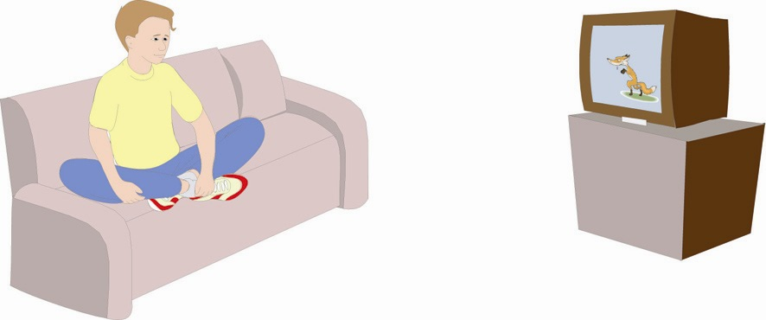

Example C is a good example of a metaphor which is very common in English – Simon’s love brightens up Amanda’s otherwise unexciting life. The metaphor in Example D means that Walter doesn’t move all day and just sits on his couch (sofa) and watches TV.

Many of these common English metaphors can cause problems for language learners. It is, however, possible to understand what these metaphors mean by looking at the rest of the sentence, what we call the context.

In the example “Jo was feeling blue after her cat died”, we see the sentence is a metaphor(M) because we are saying that Jo IS something and not LIKE something. If it was a simile we would use “as + as” or “like” (something).

In the sentence, the context is that “her cat died”. One might therefore guess that Jo was not feeling happy. Indeed, the metaphor in this example is “feeling blue”. In English, blue is usually associated with sadness.
Learning Activity

Now here is a list for you to try. Answer these questions:

First, identify if it is a simile or a metaphor by writing “S” or’ “M” at the end of the sentence.
Then underline the part of the sentence which is the simile or metaphor. Finally, choose the correct meaning.

e.g. When it is very cold at night I pull up my covers and I’m as snug as a bug in a rug. (S)

- It feels good in my bed when it is cold.
- There were bugs in my bed.
- I was too cold to stay in bed.

1. Bertha is the apple of her father's eye. ( )

- Bertha’s father loves her.
- Bertha’s father is angry with her.
- Bertha’s father sells apples.

2. Chang has a heart of stone. He never cried when his Grandmother died. ( )

- Chang is a very sensitive person.
- Chang is so happy his grandmother died.
- Chang doesn’t really care about anything.

3. Ken’s mother was as proud as a peacock when he became a doctor. ( )

- Ken’s mother wanted him to become a teacher.
- Ken’s mother thought he hadn’t studied hard enough.
- Ken’s mother was really happy for him.

