Presenting Social Issues in Speaking

As you should probably be aware, in Part 3 of this module, you will need to present your research findings and your opinions of a social issue your group has chosen. But how? We can, of course, do so either orally or in writing. However, in this unit, we will focus on how we communicate our analysis and views through oral presentations.

Learning Activity 1

In Chinese or in English, you probably have already done many oral presentations at school.

- Now think about the last presentation you did and share your experience with a classmate by answering the questions below.

  - What was the title?

  - How long was the presentation?

  - Did you give your presentation individually? Or in a group?

If you presented in a group, how many were in your group?

  - Did you use visual aids? What kind of visual aids did you use?

  - Did you enjoy the experience? Why or why not?

- Do you remember any good presentation you have attended? In pairs, share your experiences and answer the following questions.

  - What in the presentation impressed you most?

  - What do you think makes a presentation effective? Brainstorm as many qualities as possible and put them down below.

e.g. The presenter should speak loudly and clearly.
______________________________________________________________
______________________________________________________________
______________________________________________________________
______________________________________________________________
______________________________________________________________
Learning Activity 2

You will now watch two presentation videos about consumerism.

- Before you watch the videos, in pairs, answer the questions below:

  - What is consumerism?
______________________________________________________________
______________________________________________________________

  - Do you think Hong Kong is a consumerist city? Explain your reasons.
______________________________________________________________
______________________________________________________________
______________________________________________________________

- While you are watching the two presentations, consider which one is better and complete the table below.

When you have finished, discuss your answers in groups.

Presentation ___ is better. | Presentation ___ is not very good.
Reasons: | Reasons:

Learning Activity 3

Four important elements that make an effective presentation are listed on the left. Match them with the descriptions on the right. Write the number of the corresponding element in the given space.

What makes an effective presentation?
- Organisation | e.g. __3__ A suitably loud and clear voice  _____ Strong conclusion – to summarise main points and leave the audience still thinking about what you said after the presentation  _____ Interesting and original ideas  _____ Clear signposting words like firstly, secondly, to conclude, to link different parts / ideas  _____ Looking at everyone in the audience  _____ Proper use of colours, pictures, sound effects and animations for emphasis  _____ Strong introduction – to explain content and arouse interest  _____ Elaboration of points  _____ Appropriate timing  _____ Correct use of pausing for emphasis and stress on the right words  _____ Relevant points and examples  _____ Appropriate use of gestures for emphasis  _____ Clear and simple messages or diagrams which help to make the presentation more effective
- Content

- Delivery (voice, eye contact and body language)

- Visual aids

Learning Activity 4

To make your presentations audience-friendly, you should use some phrases to signpost different parts of your presentations.

- In groups of four, you will do a ‘running dictation’ of useful signposts that can be used in oral presentations. Your teacher will give you the rules. In groups, complete the following table as instructed.

Useful phrases for presentations
To sequence points | e.g. First of all
To indicate movement to a new point
To provide an example
To show a contrast
To sum up and conclude
- Can you think of more useful signposts in presentations? Discuss with your group and add them to the list above.
- The following is the script of a presentation on Internet addiction. On your own, complete it with signposts you have learnt in (a) and (b) or any signposts you find appropriate.
Script of a Presentation on Internet Addiction

Good morning everyone. I’m here today to talk about Internet addiction. (1)_______________ by asking you a question. Have your parents and teachers ever told you that you’re ‘addicted’ to the Internet? Yes, right? So, what is ‘Internet addiction’ really?
Internet addiction is defined as excessive use of the Internet and its features such as online games and chat programs. This is a worldwide phenomenon and is particularly common in developed countries. (2)________________, in mainland China, an estimated 3.2% of teenagers are addicted to Internet use and in Hong Kong 15.4% are addicted.
(3)___________________ why so many people are addicted to the Internet. Hong Kong is a place with a large population and very little space. Using the Internet can help young people to establish their own identities online, without interference from their family or others. Another reason that encourages Internet use is that the Internet is becoming cheaper and more easily accessible every day. (4)_________________, free Internet connection is provided in almost all government buildings and public areas. Teenagers are therefore quick to take advantage of the Internet for fun, collecting information and staying in touch with friends. (5)___________________, this healthy activity can lead to addiction when the Internet is used as a way of escaping problems in the family or at school, or relieving feelings of helplessness, guilt, or anxiety.
(6)__________________ how Internet addiction affects the addicts and their families. Like alcoholics or drug abusers, Internet addicts tend to be depressed and have low self-esteem. Since they usually spend many hours behind the computer screen, this can affect their job, friendships, romantic relationships and educational opportunities. (7)__________________ the impact on the addicts, ____________________ how their families are affected as a result too. The parents of young Internet addicts are unlikely to understand the attraction of cyberspace, so they may ask their addicted children to reduce the time they spend online. When their children refuse, they are likely to feel irritated, angry and sometimes even helpless, which can create tension and conflict within the family.
(8)___________________ how the problem of Internet addiction can be solved. (9)___________________, at school, extra-curricular activities should be provided to encourage Internet addicts to develop other hobbies. Also, family counselling sessions can help in combating addiction and allow parents to understand youth culture and why the Internet is so important to their children. (10)________________ that social welfare organisations have a role to play in addressing the problem too. Lastly, courses should be provided to allow Internet addicts to build their self-confidence and ability to communicate, along with other skills needed in human interaction.
Now, (11)________________________________. I have discussed the definition of Internet addiction and the global spread of this phenomenon. I have also talked about the factors that contribute* to the growth of Internet addiction and how Internet addiction affects the addicts and their families. And (12) ______________, I have suggested a few solutions to combat this problem.
I hope you found this presentation useful and I am happy to answer any questions you have about this issue.
Learning Activity 5

Body language refers to communication through body movements and gestures. It is very important in oral presentations because it sends messages about how confident you are, how much preparation you have done, what you think is important, etc. to your audience.

- Do you know what the following body movements refer to? Demonstrate the ones you know to the person next to you.

stand upright | keep looking at your feet | hold your notes or the table all the time
point to relevant parts of visual aids | pound your fist | count with your fingers as you say ‘firstly’, ‘secondly’, etc.
put both hands into your pockets | cross your arms | move one or two steps forwards / backwards
turn your back to the audience | shake your head as you say ‘no’, ‘never’, etc. | point your finger at the audience
put your hand out a little, palm up, as you refer to the audience | slouch and lean on the table (as if you feel too tired to carry the weight of your body) | play with your hair / finger

- In pairs, decide which of the gestures above should be definitely avoided in oral presentations. Cross them out and discuss why.

- In pairs, decide which of the above can be used to stress important points in oral presentations. Put ticks next to them and discuss how you can use them.
Learning Activity 6

Visual aids like pictures, photos and graphs are very helpful in oral presentations. With the help of tools like PowerPoint and overhead transparencies, the use of visual aids is becoming easier and easier.

What should people do and not do when they use PowerPoint in presentations? Below are some tips but they are not complete. In pairs, fill in each blank with one letter.

DOs
- Use short phrases or k__ __ points only.
- Use d __ __ __ __ __ __ __ to show relationships, trends, etc. instead of using textual description.
- Introduce complicated ideas o __ __ step at a time. This allows the audience time to slowly take in the points.
- To avoid making language mistakes, p __ __ __ __ __ __ __ __ the slides before the presentation.
- Familiarise yourself with the PowerPoint until you know when to c __ __ __ __ the mouse for the next slide / point.
DON’Ts
- Do not put e __ __ __ __ word you say on the slides. PowerPoint is to ASSIST you, not REPLACE you.
- Do not use many different f __ __ __ styles and sizes on the same slide. This is confusing for the audience to read, so be consistent.
- Do not use font colour similar to the b __ __ __ __ __ __ __ __ __ colour. You can use the ‘Design Template’ to avoid this.
- Do not use unnecessary s __ __ __ __ effects and animation, as they will distract your audience from you.
- Do not stand in f __ __ __ __ of the screen.

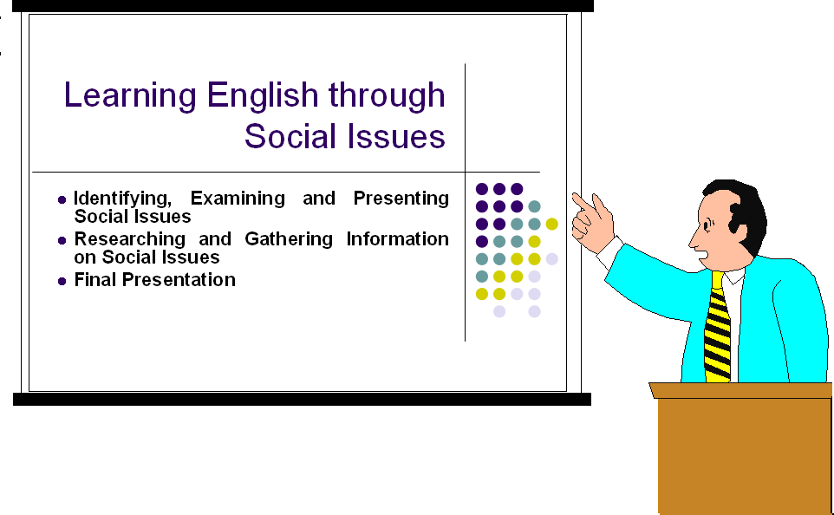

Learning Activity 7

Some of you will take turns to do a presentation in groups. While you are watching other groups present, use the peer evaluation forms given by your teacher to give feedback to them.

Use the space below to plan your presentation.

