Module Introduction and Sports Vocabulary

Sports and Games

Learning Activity
Vocabulary

Identify the following sports and games and write their names in the right column.

e.g. divided into track and field | a t h l e t i c s
- played with bat, net and shuttlecock | b _ _ _ _ _ _ _ _
- a bat and ball game very popular in the USA and Japan | b _ _ _ _ _ _ _
- wheels and paddles needed | c _ _ _ _ _ _
- an indoor game aiming at a board with a pointed object | d _ _ _ _
- jumping into water | d _ _ _ _ _
- fighting with special swords | f _ _ _ _ _ _
- played on a course with 19 holes | g _ _ _
- using the bars and horse | g _ _ _ _ _ _ _ _ _
- graceful movement on the ice | i _ _ - _ _ _ _ _ _ _
- a Japanese martial art | j _ _ _
- involving fast cars | m _ _ _ _ - _ _ _ _ _ _
- 100m, 200m and so on | r _ _ _ _ _ _
- indoor game on a table with long cues | s _ _ _ _ _ _
- a wall, racquets and a ball needed | s _ _ _ _ _
- uses various strokes, lanes and water | s _ _ _ _ _ _ _
- a bat, ball and table game | t _ _ _ _ - _ _ _ _ _ _
- Korean martial art | t _ _ _ _ _ _ _ _
- a Chinese martial art | t _ _ - _ _ _
- played at Wimbledon’s courts | t _ _ _ _ _
- hitting the ball with hands, arms or fists | v _ _ _ _ _ _ _ _ _

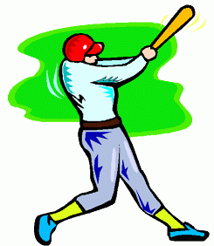
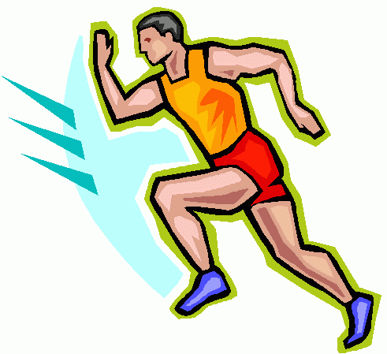
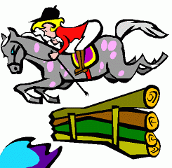
Letters Page

Learning Activity
Reading and Vocabulary

You are going to read some simple letters written by sports fans.

- Read the letters and choose the most suitable heading for each from the list below:
    - Should Aim Higher?
    - We Did It!
    - Poor Judgement
    - Sad News
    - It’s A Red World
    - Starting Winning Or Else…

1. Wasn’t Manchester United’s win against Chelsea on Friday one of the best games ever? Are there any of your readers who still doubt the Reds are the world’s greatest? If so, they are not facing reality!  Kurt | 2. It doesn’t seem fair to me that giant basketball players are allowed to use baskets of the same height as the rest of us. Sure, it must be easy to get the ball through the hoop when you are on a level with it. I say move the basket up and down according to the average height of the team.  Ricky

3. What’s wrong with Real Madrid this year? They just don’t seem to be scoring goals. If they don’t get more points soon they’ll be in big trouble. Maybe the manager should think of some transfers. They need some powerful forwards to get the ball in the net.  Vickie | 4. Did you see the referee in the Shatin-Taipo game? I know you should not argue with referees’ decisions, but it’s hard not to when they make so many mistakes. Dave Tong fouled Mike So really badly, but the referee was far away in a dream world of his own.  Shame!  Guy

5. We had a really great basketball match here on Saturday. The visiting team was far in the lead, we took a time-out, our coach changed our tactics and we became unstoppable, dribbling past the other guys and ending up so far in the lead that I thought our opponents would cry. No, to be fair - they took defeat gracefully and we enjoyed playing them - but it is nice to win!  Smiley | 6. I hope everyone is feeling sympathy for Tracey Lai after her injury on Sunday at the big Hong Kong AAA Meet*. She had been running so well and was the favourite for the 200m, her best event, when she damaged a muscle during the hop, skip and jump. As a result Grace Hung took first, but she said herself it wasn’t a real victory without Tracey competing. Let’s hope she’s fully fit for the international meet next month or Hong Kong will be without one of its stars.  Batman
* Hong Kong AAA Meet – an athletics event organised by the Hong Kong Amateur Athletic Association (HKAAA)
- Find words from the letters on page S2 which mean the following and write them in the boxes provided. The numbers in brackets indicate the letters from which the words can be found.

Meaning | Word(s)
- victory (1)
- nickname of famous team (1)
- ring of metal (2)
- group of players (2, 5)
- getting points (3)
- buying and selling players (3)
- played wrongly, breaking rules (4)
- judge (4)
- break (5)
- trainer (5)
- method of play (5)
- moving the ball (5)
- hurt to the body (6)
- athletics occasion (6)
- an example of field events (6)

