Supplementary Materials 1
Module Introduction and Sports Vocabulary

Sports People

Learning Activity
Vocabulary

Solve the crossword below, which is made up of the names for different people related to sports. The hints on the next page may help you if you have trouble solving the clues. One has been done for you as an example.
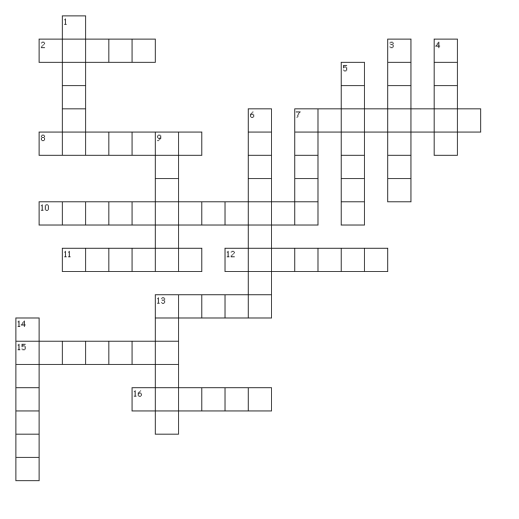
C O A C H
Across  - A/An ___________ trains sports players  - A/An ___________ stops the other side from hitting the goal  - A/An ___________ rides on two wheels  - A/An ___________ has big muscles  - A/An ___________ judges  - A/An ___________ runs on the track  - A/An ___________ moves on snow  - A/An ___________ plays for fun  - A/An ___________ is a group of sports teams or players who play against each other to see who is best | Down  - A/An ___________ is on horseback  - A/An ___________ works on the bars  - A/An ___________ punches  - A/An ___________ holds up cards to show offence and controls a match  - A/An ___________ watches a sports event  - A/An ___________ jumps into the water  - A/An ___________ moves on ice  - A/An ___________ rides the waves  - A/An ___________ leads the sports team
Hints

Across
7. the players who try to score are the strikers
10. he is particularly strong in his arms
11. for example, in tennis
15. not a professional player

Down
- Hong Kong has a famous club named after them
3. the sport is performed in a gym and ends in “ics”; take these letters off and you have the person
5. for example, in football, problems are referred to him
6. the word begins with “spect-”, which means related to the eyes, e.g. “spectacles” is another word for eye-glasses, and “inspect” means looking at something closely

