Picture Dictation

***LT 2.4***

Example (2) – Fresh Fruit and Vegetable Stall

**Aunt Mary is going to tell you the fruit and vegetables she can see on a stall. Listen and complete the picture of the stall.**

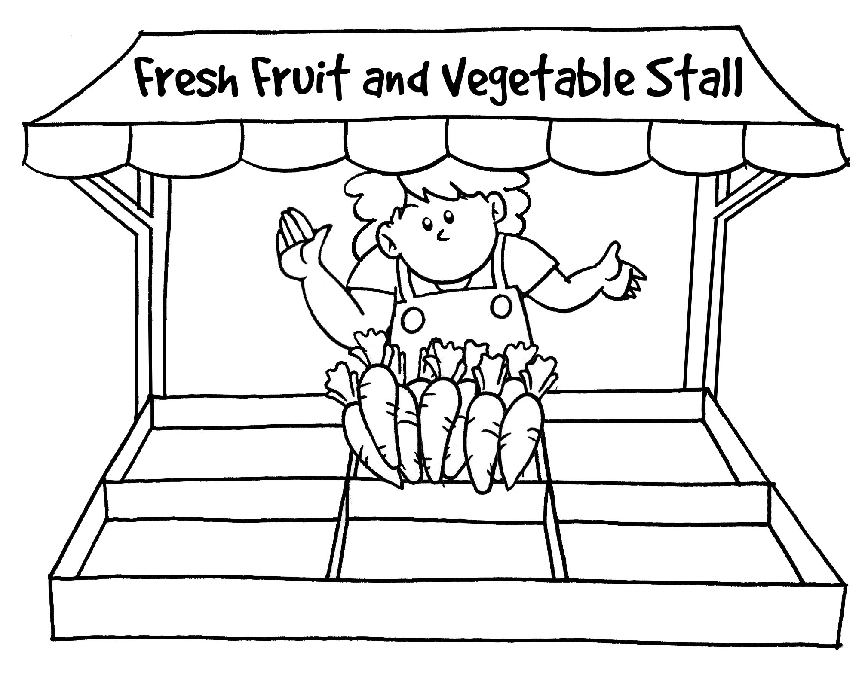

***LT 2.4***

***(Extended Activity 1)***

1. **Listen and colour the fruit and vegetables.**
2. **Label the fruit and vegetables in the spaces provided.**

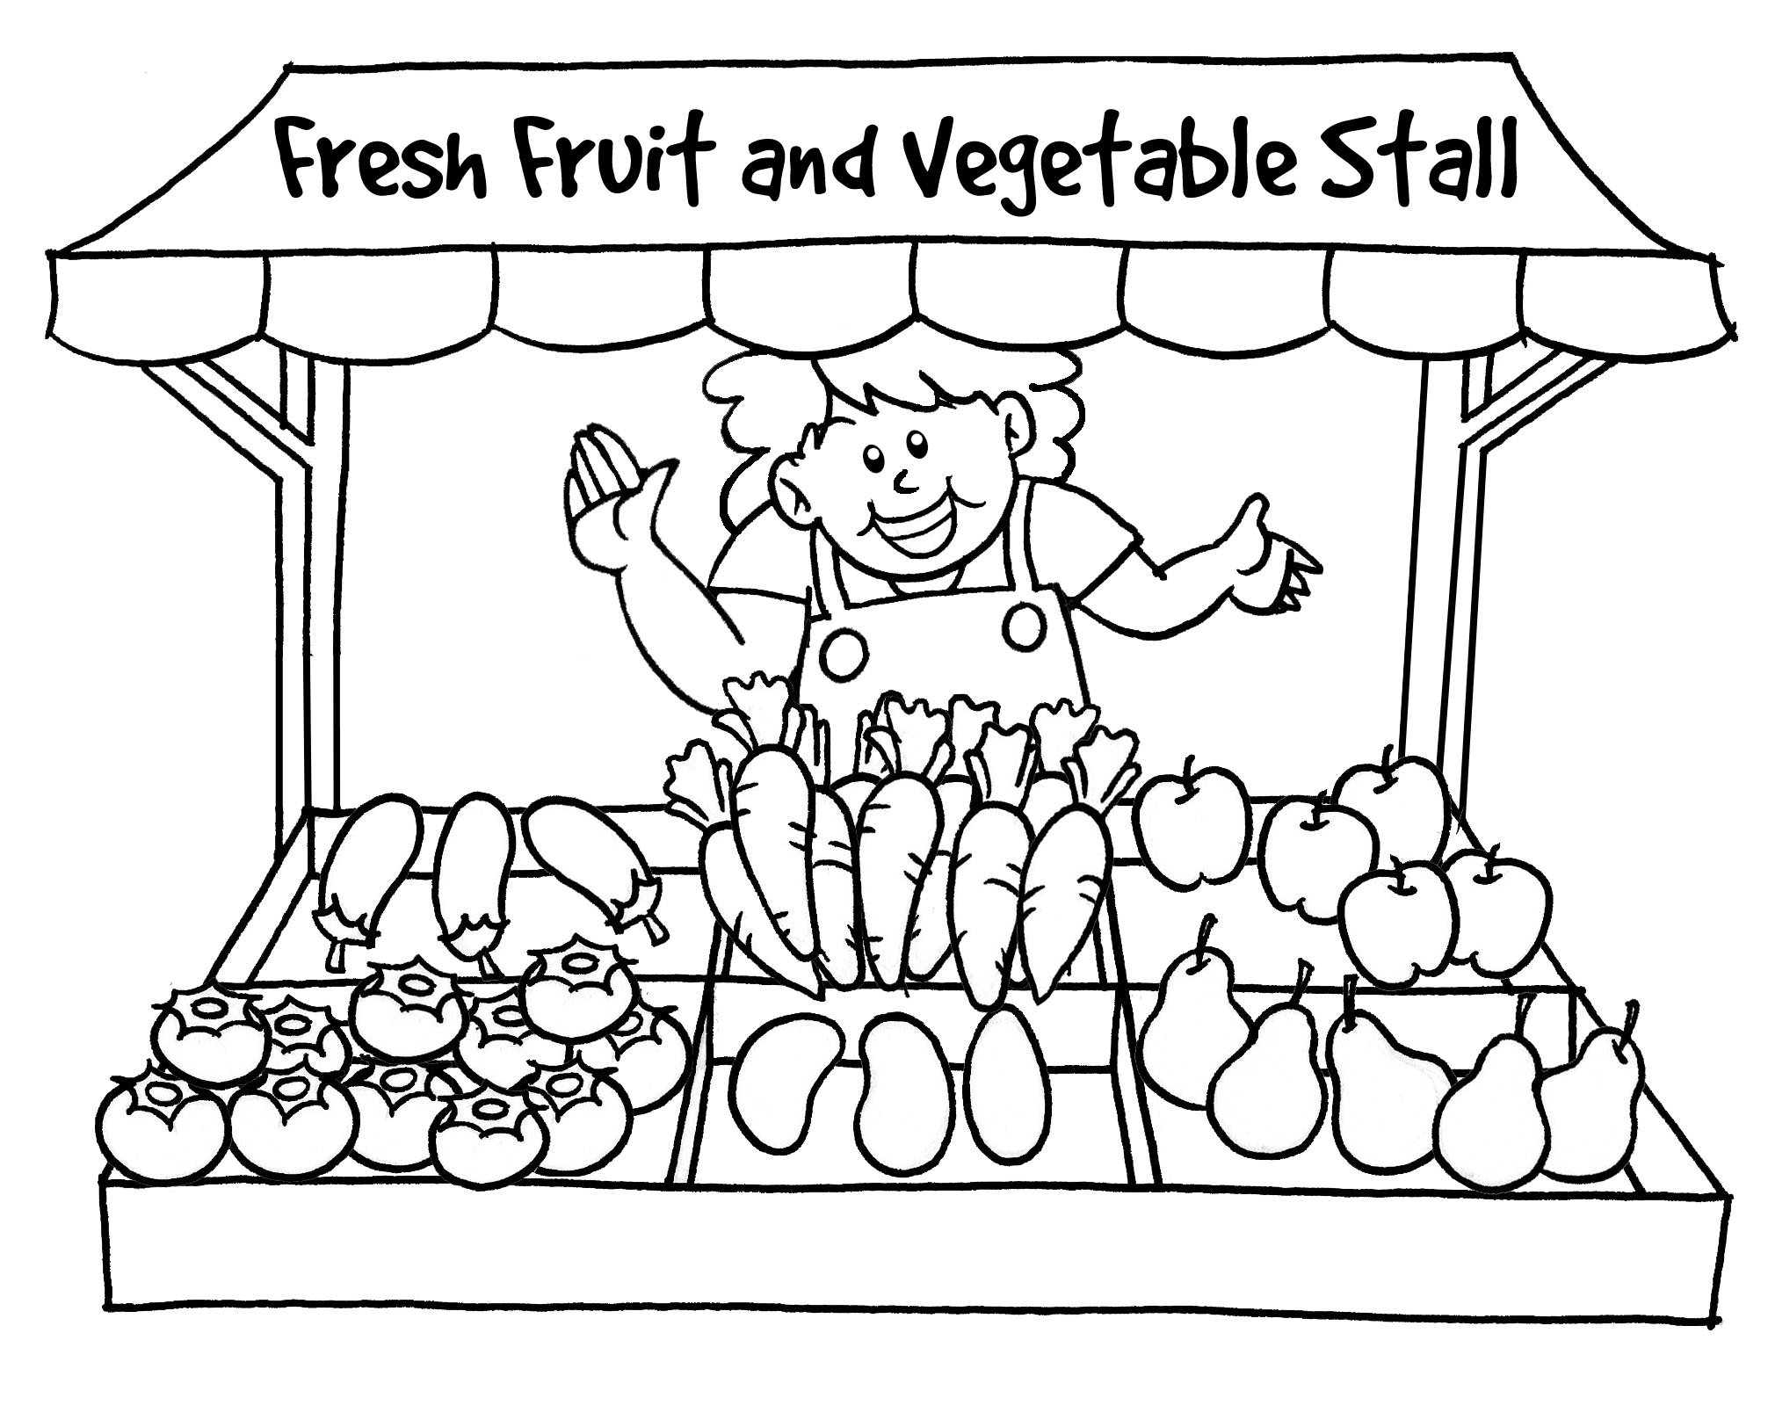

e.g. carrots

***LT 2.4***

***(Extended Activity 2)***

**Write about the picture. Follow the example.**



(e.g.) There are many carrots in front of Mrs Chan. They are fresh.

**Answer Keys**

***LT 2.4***



**Script**

(Audio Clip No. 8)

Fresh Fruit and Vegetable Stall

Aunt Mary is going to tell you the fruit and vegetables she can see on a stall. Listen and complete the picture of the stall.

1. Mrs Chan is the owner of Fresh Fruit and Vegetable Stall. She is helpful and friendly. She always smiles. WritingIcon
2. There are many carrots in front of Mrs Chan. WritingIcon
3. There are some apples on the right of the carrots. WritingIcon
4. There are a few eggplants next to the carrots. WritingIcon
5. There are some pears in front of the apples. WritingIcon
6. There are a few mangoes next to the pears. WritingIcon
7. There are many tomatoes on the left of the mangoes. WritingIcon

*WritingIcon An 8-second pause for drawing different parts of the picture*

***LT 2.4***

***(Extended Activity 1)***

**Answer Keys**



***eggplants***

***apples***

***pears***

***tomatoes***

***mangoes***

e.g. carrots

**Script**

(Audio Clip No. 9)

Fresh Fruit and Vegetable Stall – Extended Activity 1

a. Listen and colour the fruit and vegetables.

1. I could see many carrots on the stall. They are orange in colour. WritingIcon

2. I could see some apples. They are pink. WritingIcon

3. I could see a few eggplants. They are white. WritingIcon

4. I could see some pears. They are yellow. WritingIcon

5. I could see a few mangoes. They are green. WritingIcon

6. I could see many tomatoes. They are red. WritingIcon

1. Label the fruit and vegetables in the spaces provided.

You have 2 minutes to label the fruit and vegetables. (Play background music for 2 minutes)

That’s the end of the activity.

*WritingIcon An 8-second pause for colouring different parts of the picture*